NAME: DARSH MEHTA

UID: 2018130023 BATCH: B

CLASS: T.E. COMPS

**EXPERIMENT 1**

AIM: Study the different types of physical layer wired and wireless connections.

# THEORY:

## PHYSICAL LAYER

Physical layer in the OSI model plays the role of interacting with actual hardware and signalling mechanism. Physical layer is the only layer of OSI network model which actually deals with the physical connectivity of two different stations. This layer defines the hardware equipment, cabling, wiring, frequencies, pulses used to represent binary signals etc.

Physical layer provides its services to Data-link layer. Data-link layer hands over frames to physical layer. Physical layer converts them to electrical pulses, which represent binary data. The binary data is then sent over the wired or wireless media.

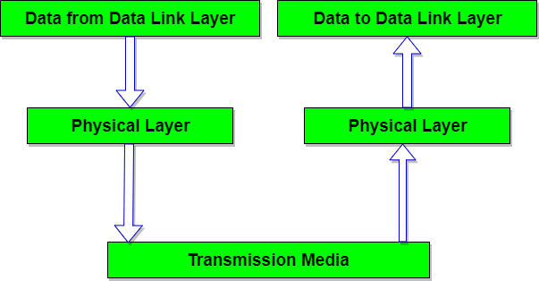

## WIRED CONNECTIONS

Wired connections are by far the most common. The main media in use are **coaxial cable, twisted pairs and fibre optics**. For each of these, specific network technologies or specifications have been designed. The medium must have properties that will ensure a reasonable error performance for a guaranteed distance and rate of date delivery (speed). It must also support **two-way or multiway** communications.

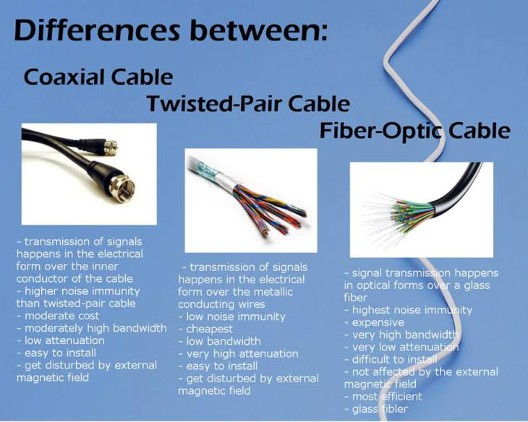

## Ethernet

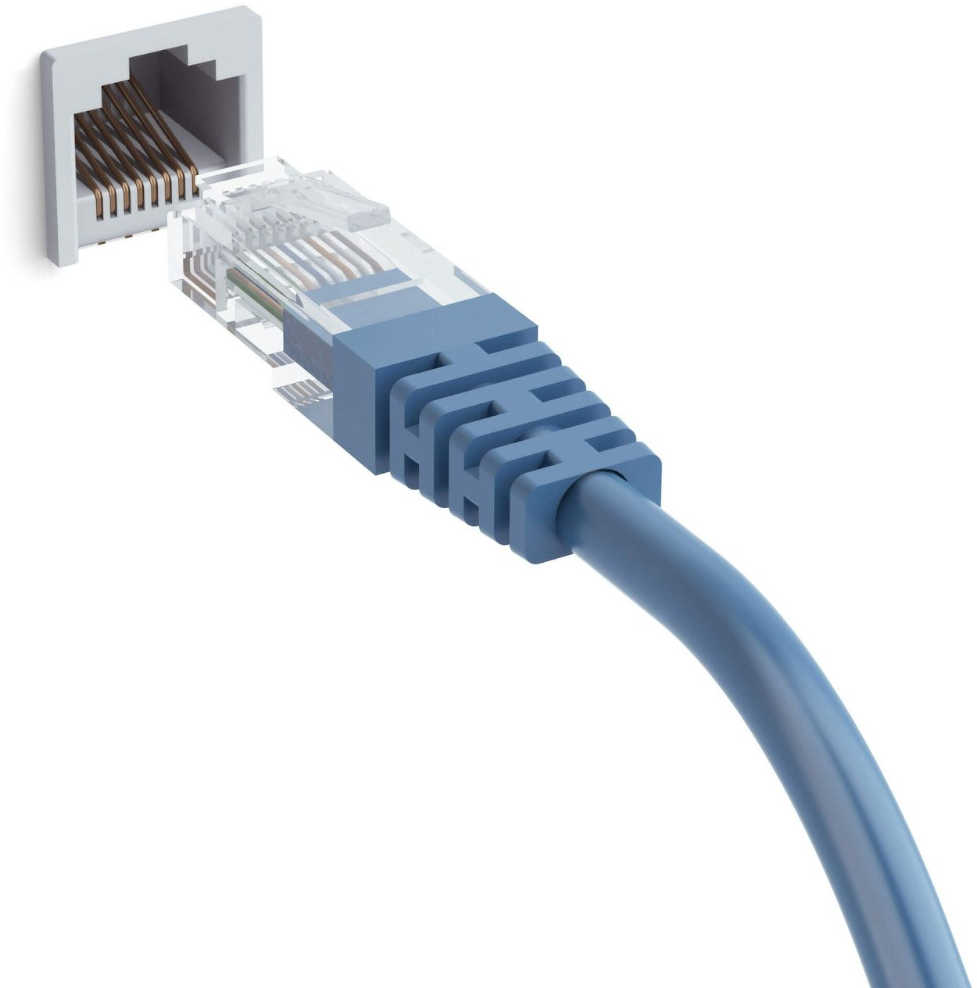An Ethernet cable is a common type of network cable used with wired networks. Ethernet cables connect devices such as PCs, routers, and switches within a **local area network**. These physical cables are limited by length and durability.[3]

The Ethernet physical layer has evolved over its existence starting in 1980 and encompasses multiple physical media interfaces and several orders of magnitude of **speed from 1 Mbit/s to 400 Gbit/s**. The physical medium ranges from bulky **coaxial cable** to **twisted pair** and **optical fiber** with a standardized reach of up to 40 km. In general, network

protocol stack software will work similarly on all physical layers.[4]

Ethernet Specifications :

* + - Range

Over deployed multi-mode cabling ethernet supports ranges of between 240 m and 300 m with 400/500 MHz·km modal bandwidth. It also supports 10 km over single-mode fiber.

* + - Modulation

Ethernet uses biphase modulation to transmit data bits, this is accomplished by using a Manchester encoded bit-stream. Ethernet does not use IQ modulation because it is not bandwidth limited by the FCC.

Ethernet Scalability :

Ethernet is a family of computer networking technologies commonly used in local area networks (LAN), metropolitan area networks (MAN), and wide area networks(WAN).

Ethernet is currently the most widely used technology in enterprise networking. Unfortunately, it is widely acknowledged that Ethernet does not have the scalability to meet the emerging networking needs of large enterprises. Ethernet does not scale well to large networks. The flat MAC address space, whilst having obvious benefits for the user and administrator, is the primary cause of this poor scalability. Ethernet exhibits scalability issues on networks of more than a few thousand devices, such as costly and energy-dense address table logic and storms of broadcast traffic. Ethernet’s inability to handle networks containing loops also presents a scalability problem.

Ethernet Schematic View :

The ESP32 Ethernet PHY interface is shown in the schematic below. It mainly consists of three sections:

* + - The PHY chip or interface
    - The 50 MHz oscillator
    - Jack and magnetics

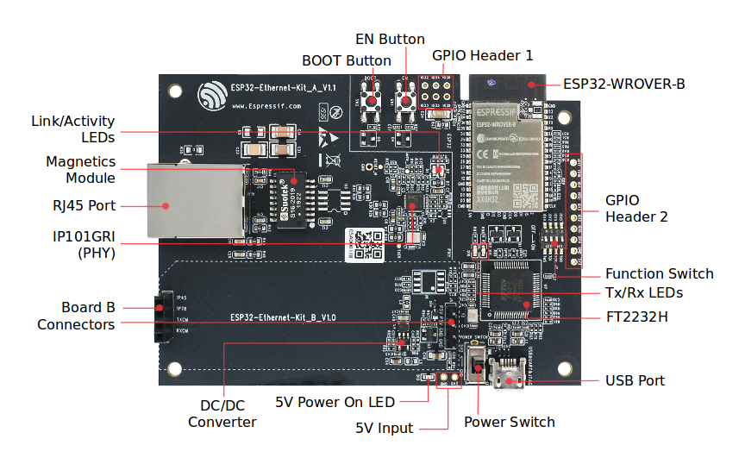

*Schematic View ESP32 Ethernet PHY interface*

The main sections of ESP32 Ethernet PHY interface are:

* + - Pull-up resistors on the ESP32 side of the PHY chip.
    - Series termination resistors for reducing signal reflection and ringing.
    - The 50-ohm pullups on the ethernet jack side of the PHY chip.
    - Proper magnetic jack. Most ethernet jacks are low cost and do not contain any magnetics… you cannot use those directly. You will need external inductive components for using plain old RJ-45 connectors.

## Universal Serial Bus (USB)

The Universal Serial Bus was designed to standardize the connection of peripherals to personal computers, both to communicate with and to supply electric power. It has largely replaced interfaces such as serial ports and parallel ports and has become commonplace on a wide range of devices. Examples of

peripherals that are connected via USB include computer keyboards and mice, video cameras, printers, portable media players, disk drives, and network adapters.

USB Specifications :

* + - Range:
      * The USB 1.1 standard specifies that a standard cable can have a maximum length of 5 meters (16 ft 5 in) with devices operating at full speed (12 Mbit/s), and a maximum length of 3 meters (9 ft 10 in) with devices operating at low speed (1.5 Mbit/s).
      * USB 2.0 provides for a maximum cable length of 5 meters (16 ft 5 in) for devices running at high speed (480 Mbit/s).
      * The USB 3.0 standard does not directly specify a maximum cable length, requiring only that all cables meet an electrical specification: for copper cabling with AWG 26 wires, the maximum practical length is 3 meters (9 ft 10 in).
    - Modulation :
      * At the input, the device communicates via MIDI and USB protocols. At the output is tension. Its value is managing by pulse-width modulation.
      * Pulse-width modulation (PWM) is used for controlling the amplitude of digital signals in order to control devices and applications requiring power or electricity. It essentially controls the amount of power, from the perspective of the voltage component, that is given to a device by cycling

the on-and-off phases of a digital signal quickly and varying the width of the "on" phase or duty cycle.

* + - Other specifications :
      * Two important aspects of USB are its support capability and total bandwidth. It is capable of supporting 127 devices and has a total bandwidth of 12 Mbit per second which is equal to 1.5 MB per second. Working of a 12 Mbit (full speed device) or a 1.5 Mbit (low-speed device) depends on the total bandwidth of the USB.
      * USB 2.0 has a maximum signaling rate of 480 Mbit/s and USB 3.0 has a usable data rate of up to 4 Gbit/s (500 MB/s).

USB Schematic View :

Hardware design for USB is actually quite minimal, which is a big plus for us. However, what you quickly find out with USB is that the easy hardware design means the communication and control software is very complex, we'll see more about that in the theory and software sections. The main devices used in the circuit are the PIC 18F4455, USB Connector, and LM7805.

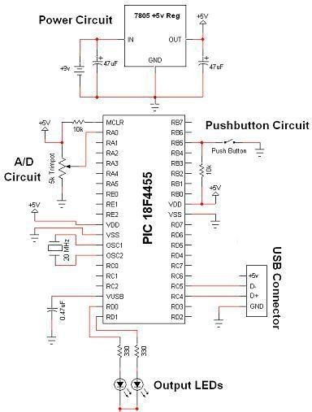Schematic Specifics

1. Power Circuit

The +5v output from the power circuit comes from the LM7805 regulator. Notice the 47uF capacitors on the input and output. These are meant to be DC filtering capacitors, which smooth out the constant DC voltage being fed to the microcontroller from the 7805 regulators.

1. USB Connection and Output LEDs Make sure you double-check your USB pinout. A common mistake when wiring the PIC to the USB connector is getting the D+ and D- signals backward. So if you're sure that the PIC is running your perfect code, but the USB device isn't coming up properly, switch D+ and D-, it

might just magically fix your problem! The output LEDs will be simple 'toggle' LEDs. The program running on our laptop will be able to toggle them on and off with the push of a button.

1. A/D and Push Button Circuits

The A/D circuit is a standard 3 pin, Connected to Power, Signal Out, and Ground circuit. The signal output goes into RA0 which is the Analog to Digital converter. After the PIC converts this signal it should send the data to the laptop via USB. The laptop will visually display the trimpot's value. The push-button will do a similar thing when the button is pushed, the laptop application should update with a notification that it has been pressed. These are simple ideas, but when done over USB they become rather complicated as we'll see in the theory section.

**2.3. POWER LINES**



Power Line communication (PLC) is Layer-1 (Physical Layer) technology which uses power cables to transmit data signals. In PLC, modulated data is sent over the cables. The receiver on the other end de-modulates and interprets the data. Because power

lines are widely deployed, PLC can make all powered devices controlled and monitored. PLC works in half-duplex. There are two types of PLC:

○ Narrow band PLC

○ Broadband PLC

Narrow band PLC provides lower data rates up to 100s of kbps, as they work at lower frequencies (3-5000 kHz).They can be spread over several kilometers.

Broadband PLC provides higher data rates up to 100s of Mbps and works at higher frequencies (1.8 – 250 MHz).They cannot be as much extended as Narrowband PLC.

## WIRELESS CONNECTIONS

## Wireless networking is a method by which homes, telecommunications networks and business installations avoid the costly process of introducing cables into a building, or as a connection between various equipment locations. This implementation takes place at the physical level (layer) of the OSI model network structure.

## ● Advances in MOSFET technology, and the wide adoption of RF CMOS (radio frequency CMOS), power MOSFET and LDMOS (lateral diffused MOS) devices led to the increase of digital wireless networks by the 1990s, and further advances led to increased bandwidth in the 2000s.

## Most of the essential elements of wireless networks are built from MOSFETs, including the mobile transceivers, base station modules,routers, RF power amplifiers, telecommunication circuits, RF circuits,and radio transceivers, in networks such as 2G, 3G, and 4G.

* 1. **Bluetooth**

Bluetooth wireless technology is a short range communications technology intended to replace the cables connecting portable unit and maintaining high levels of security. Bluetooth technology is based on **Ad-hoc technology** also known as **Ad-hoc Pico nets**, which is a local area network with a very limited coverage.

The usage of Bluetooth has widely increased for its special features.

* Bluetooth offers a uniform structure for a wide range of devices to connect and communicate with each other.
* Bluetooth technology has achieved global acceptance such that any Bluetooth enabled device, almost everywhere in the world, can be connected with Bluetooth enabled devices.
* Low power consumption of Bluetooth technology and an offered range of up to ten meters has paved the way for several usage models.
* Bluetooth offers interactive conference by establishing an adhoc network of laptops.
* Bluetooth usage model includes cordless computer, intercom, cordless phone and mobile phones.

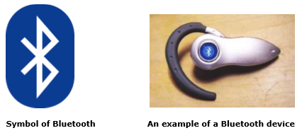

Bluetooth Specifications :

* + - Range

The Bluetooth Core Specification mandates a range of not less than 10 meters (33 ft), but there is no upper limit on the actual range.

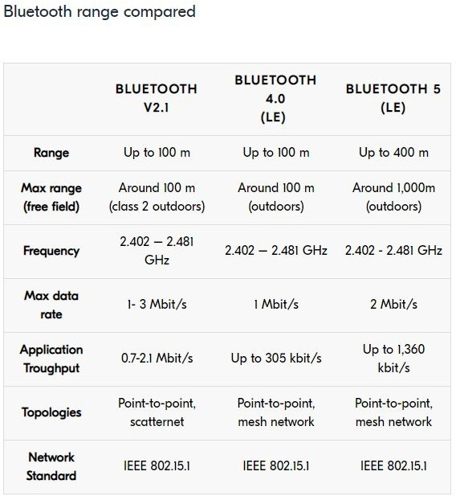

* + - Modulation
      * Originally, Gaussian frequency-shift keying (GFSK) modulation was the only modulation scheme available.
      * Since the introduction of Bluetooth 2.0+EDR, π/4-DQPSK (differential quadrature phase-shift keying) and 8-DPSK modulation may also be used between compatible devices.
      * Devices functioning with GFSK are said to be operating in basic rate (BR) mode where an instantaneous bit rate of 1 Mbit/s is possible. The term Enhanced Data Rate (EDR) is used to describe π/4-DPSK and 8-DPSK schemes, each giving 2 and 3 Mbit/s respectively.

Bluetooth Scalability :

* + - The primary constraining factor in the scalability of a system that uses any wireless communications technology concerns the fact that radio is a shared resource with a finite capacity.

Bluetooth has been developed to facilitate wireless local area networks (LANs), in which the networks of different handheld computing terminals and mobile

terminals can communicate and exchange data - even on the move or when there is no line-of-sight between the terminals.

Bluetooth Schematic View :

The Bluetooth Module is a low-power embedded Bluetooth v2.0+EDR module with a built-in high-output antenna. The module is a fully Bluetooth compliant device for data communication with a transmission power of up to +8dBm and receiver sensibility of down to -83dBm combined with low power consumption. The Bluetooth Module delivers opportunities for rapid ad-hoc connections and the possibility of automatic, unconscious, connections between WPCOMs. The complete circuit diagram of the Bluetooth Module is given in the figure.

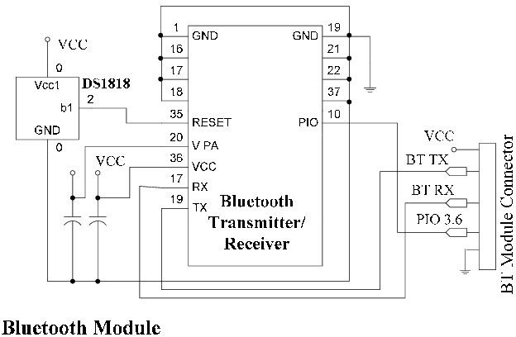

## Wi-Fi

Wi-Fi is a family of wireless network protocols, based on the IEEE

* 1. 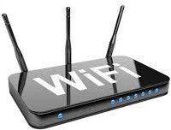family of standards, which are commonly used for local area networking of devices and Internet access. Wi‑Fi is a trademark of the non-profit Wi-Fi Alliance, which restricts the use of the term Wi-Fi Certified to products that successfully complete interoperability certification testing.

Wi-Fi Specifications :

The full list of versions of Wi-Fi is:

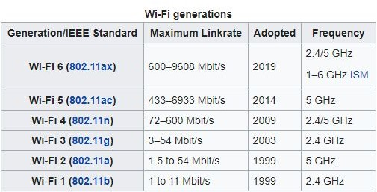

* + - Range
      * A wireless network's range can vary wildly depending on the type of network. A standard home network using one wireless router can serve a single-family dwelling, but often not much more.
      * Business networks with grids of access points can serve large office buildings, and wireless hotspots spanning several square miles have been built in some cities.
      * A general rule of thumb in home networking says that Wi-Fi routers operating on the 2.4 GHz band can reach up to 150 feet indoors and 300 feet outdoors. Older 802.11a routers that ran on 5 GHz bands reached approximately one-third of these distances.
      * Newer 802.11n and 802.11ac routers that operate on both 2.4 GHz and 5 GHz bands reach greater distances.
    - Modulation

WiFi systems use two primary radio transmission techniques:

* + - * 802.11b (<=11 Mbps) − The 802.11b radio link uses a direct sequence spread spectrum technique called complementary code keying (CCK).

The bitstream is processed with a special coding and then modulated using Quadrature Phase Shift Keying (QPSK).

* + - * 802.11a and g (<=54 Mbps) − The 802.11a and g systems use 64-channel orthogonal frequency division multiplexing (OFDM). In an OFDM modulation system, the available radio band is divided into a number of sub-channels and some of the bits are sent on each. The transmitter encodes the bitstreams on the 64 subcarriers using Binary Phase Shift Keying (BPSK), Quadrature Phase Shift Keying (QPSK), or one of two levels of Quadrature Amplitude Modulation (16, or 64-QAM). Some of the transmitted information is redundant, so the receiver does not have to receive all of the sub-carriers to reconstruct the information.

Wi-Fi Scalability :

* + - Compared to cell phones and similar technology, Wi-Fi transmitters are low power devices. In general, the maximum amount of power that a Wi-Fi device can transmit is limited by local regulations, such as FCC Part 15 in the US. Equivalent isotropically radiated power (EIRP) in the European Union is limited to 20 dBm (100 mW).
    - To reach requirements for wireless LAN applications, Wi-Fi has higher power consumption compared to some other standards designed to support wireless personal area network (PAN) applications. For example, Bluetooth provides a much shorter propagation range between 1 and 100m[74] and so in general have a lower power consumption. Other low-power technologies such as ZigBee have fairly long range, but much lower data rate. The high power consumption of Wi-Fi makes battery life in some mobile devices a concern.

Wi-Fi Schematic View :

ESP8266 is a UART-WiFi transparent transmission module with ultralow power consumption, specially designed for the needs of a new connected world. It offers a complete and self-contained Wi-Fi networking solution, allowing it to either host the application or to offload all Wi-Fi networking functions from another application processor.

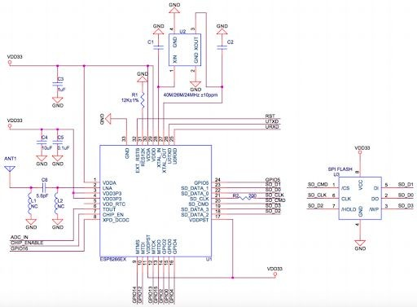

*Schematic View ESP8266 - WiFi Module*

ESP8266 has powerful on-board processing and storage capabilities that allow it to be integrated with the sensors and other application-specific devices through its GPIOs with minimal development up-front and minimal loading during runtime. Its high degree of on-chip integration allows for minimal external circuitry, and the entire solution, including the front-end module, is designed to occupy minimal PCB area. ESP8266 Serial Wifi Wireless Transceiver Module is suitable for Uno, Mega 2560, and Nano.

**3.3**. **Near Field Communication (NFC)**

● Near-Field-Communication (NFC) is a set of communication protocols for communication between two electronic devices over a distance of 4 cm or less. NFC offers a low-speed connection with simple setup that can be used to bootstrap

more-capable wireless connections.

● NFC devices can act as electronic identity documents and keycards. They are used in contactless payment systems and allow mobile payment replacing or supplementing systems such as credit cards and electronic ticket smart cards. NFC tags are

passive data stores which can be read, and under some circumstances written to, by an NFC device. They typically contain data (as of 2015 between 96 and 8,192 bytes) and are read-only in normal use, but may be rewritable.

● Like other "proximity card" technologies, NFC is based on inductive coupling between two so-called antennas present on NFC-enabled devices—for example a smartphone and a printer—communicating in one or both directions, using a

frequency of 13.56 MHz in the globally available unlicensed radio frequency ISM band using the ISO/IEC 18000-3 air interface standard at data rates ranging from 106 to 424 kbit/s.

* 1. **Cellular Networks**

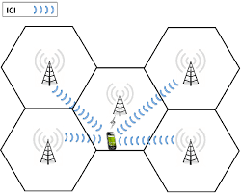

A cellular network or mobile network is a radio network distributed over land areas called cells, each served by at least one fixed-location transceiver, known as a cell site or base station. In a cellular network, each cell characteristically uses a different set of

radio frequencies from all their immediate neighbouring cells to avoid any interference.

● When joined together these cells provide radio coverage over a wide geographic area. This enables a large number of portable transceivers (e.g., mobile phones, pagers, etc.) to communicate with each other and with fixed transceivers and telephones anywhere in the network, via base stations, even if some of the transceivers are moving through more than one cell during transmission.

* Although originally intended for cell phones, with thedevelopment of smartphones, cellular telephone networks routinely carry data in addition to telephone conversations:

○ Global System for Mobile Communications (GSM): The GSM network is divided into three major systems: the switching system, the base station system, and the operation and support system. The cell phone connects to the base system station which then connects to the operation and support station; it then connects to the

switching station where the call is transferred to where it needs to go. GSM is the most common standard and is used for a majority of cell phones.

○ Personal Communications Service (PCS): PCS is a radio band that can be used by mobile phones in North America and South Asia. Sprint happened to be the first service to set up a PCS.

○ D-AMPS: Digital Advanced Mobile Phone Service, an upgraded version of AMPS, is being phased out due to advancement in technology. The newer GSM networks are replacing the older system.

* 1. **Zigbee**

Zigbee is an IEEE 802.15.4-based specification for a suite of

high-level communication protocols used to create personal area

networks with small, low-power digital radios, such as for home

automation, medical device data collection, and other

low-power low-bandwidth needs, designed for small scale

projects which need wireless connection. Hence, Zigbee is a

low-power, low data rate, and close proximity (i.e., personal area)

wireless ad hoc network.

● Its low power consumption limits transmission distances to

10–100 meters line-of-sight, depending on power output and

environmental characteristics. Zigbee devices can transmit data

over long distances by passing data through a mesh network of

intermediate devices to reach more distant ones. Zigbee is

typically used in low data rate applications that require long

battery life and secure networking (Zigbee networks are secured

by 128 bit symmetric encryption keys.) Zigbee has a defined rate

of 250 kbit/s, best suited for intermittent data transmissions from

a sensor or input device.

● The ZigBee Smart Energy 2.0 specifications define an Internet Protocol-based communication protocol to monitor, control,inform, and automate the delivery and use of energy and water. It is an enhancement of the ZigBee Smart Energy version 1 specifications. It adds services for plug-in electric vehicle charging, installation, configuration and firmware download, prepay services, user information and messaging, load control,demand response and common information and application

# REFERENCES :

1. <https://www.google.com/search?q=physical+layer+of+osi+model&sxsrf=ALeKk0024cswae9Jxo-QpPdQG4Se-moE4w:1597137181159&tbm=isch&source=iu&ictx=1&fir=Yw5ewfN1U1yc5M%252CjWntHejhEECZ1M%252C_&vet=1&usg=AI4_-kSAKTD5LPILCZqU51t7qEhIuqqmyg&sa=X&ved=2ahUKEwiDqdzS55LrAhWUxzgGHUdBAcwQ_h0wAHoECAQQBA&biw=1396&bih=657#imgrc=Yw5ewfN1U1yc5M>
2. <https://www.tutorialspoint.com/data_communication_computer_network/physical_layer_introduction.htm#:~:text=Physical%20layer%20is%20the%20only,services%20to%20Data%2Dlink%20layer.>
3. <https://www.google.com/search?q=coaxial+cable,+twisted+pairs+and+fibre+optics&sxsrf=ALeKk02hoOuhrKEepwdNUQYA5EsfCor35g:1597137729570&source=lnms&tbm=isch&sa=X&ved=2ahUKEwjq45zY6ZLrAhVhzDgGHej0Aj8Q_AUoAXoECA8QAw&biw=1396&bih=612#imgrc=SdQCAv0HMP2HLM>
4. <https://www.tutorialspoint.com/computer_fundamentals/computer_ports.htm>
5. <https://en.wikipedia.org/wiki/Bluetooth>
6. <https://www.tutorialspoint.com/wireless_communication/wireless_communication_bluetooth.htm>
7. <https://www.tutorialspoint.com/wi-fi/index.htm>
8. <https://www.androidauthority.com/what-is-nfc-270730/>
9. <https://en.wikipedia.org/wiki/Overhead_power_line#:~:text=An%20overhead%20power%20line%20is,suspended%20by%20towers%20or%20poles.>

# CONCLUSION:

From this experiment, I learned about the Physical Layer, the types of Wired and Wireless Connections. For each of these connections, I studied their specification, their scalability in the various network architecture, and their schematic view.