**2CS701 Compiler Construction**

|  |  |
| --- | --- |
| **Practical 5** | |
| **Rollno:** 19BCE236 | **Name:** Samariya Darsh |
| **Date:** 31-09-2022 | **Batch:** D1 |

**Aim**

To implement a calculator in YACC: Syntax Directed Translation

**Code:**

**prac_5.y**

%{

#include <iostream>

#include <string>

#include <map>

#include <cmath>

static std::map<std::string, int> value;

int yylex();

int yyparse();

void yyerror(const char *s) { std::cout << s << std::endl; }

%}

%union { int i; std::string *s; }

%token<i> INT

%token<s> VAR

%type<i> E

%right '='

%left '+' '-'

%left '*' '/' '%'

%right '^'

%%

SS : S SS

| S

;

S : E ';' {std::cout << "Answer: " << $1 << std::endl;}

;

E : INT {$$ = $1;}

| VAR {$$ = value[*$1]; delete $1;}

| VAR '=' E {$$ = value[*$1] = $3; delete $1;}

| E '+' E {$$ = $1 + $3;}

| E '-' E {$$ = $1 - $3;}

| E '*' E {$$ = $1 * $3;}

| E '/' E {$$ = $1 / $3;}

| E '%' E {$$ = $1 % $3;}

| E '^' E {$$ = pow($1,$3);}

;

%%

int main() { yyparse(); }

**prac_5.l**

%option noyywrap

%{

#include <cstdlib>

#include <string>

#include "y.tab.h"

using namespace std;

%}

%%

([_a-zA-Z](0-9)*)+ {yylval.s = new string(yytext); return VAR;} [0-9]+ {yylval.i = atoi(yytext); return INT;} [-+*/%^=;] {return *yytext;}

[.\n\t] ;

%%

**Input:**

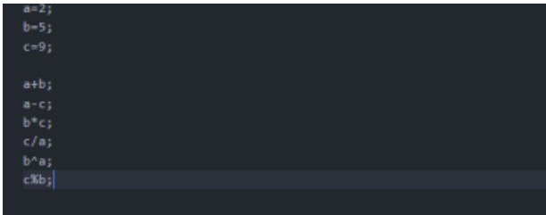

**Output**

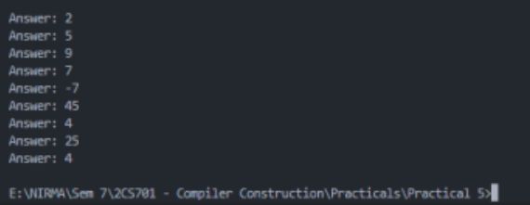

**Conclusion**

In this practical, we learnt how to perform some basic arithmetic calculations using parser and lexer.