**2CS701 Compiler Construction**

|  |  |
| --- | --- |
| **Practical 8** | |
| **Rollno:** 19BCE236 | **Name:** Samariya Darsh |
| **Date:** 07-11-2022 | **Batch:** D1 |

# Aim:

To implement Type checking.

# Program:

//To implement type checking #include<stdio.h> #include<stdlib.h>

int main()

{

int n,i,k,flag=0;

char vari[15],typ[15],b[15],c; printf("Enter the number of variables:"); scanf(" %d",&n); for(i=0;i<n;i++)

{

printf("Enter the variable %d:",i); scanf(" %c",&vari[i]);

printf("Enter the variable-type %d (float-f,int-i):",i); scanf(" %c",&typ[i]); if(typ[i]=='f') flag=1;

}

printf("Enter the Expression(end with $):"); i=0;

getchar(); while((c=getchar())!='$')

{

}

k=i;

b[i]=c; i++;

for(i=0;i<k;i++)

{

if(b[i]=='/')

{

flag=1; break;

}

}

for(i=0;i<n;i++)

{

if(b[0]==vari[i])

{

if(flag==1)

{

if(typ[i]=='f')

{

printf("\nthe datatype is correctly defined..!\n"); break;

}

else

{

printf("Identifier %c must be a float type..!\n",vari[i]); break;

}

}

else

{

printf("\nthe datatype is correctly defined..!\n"); break;

}

}

}

return 0;

}

# Output:

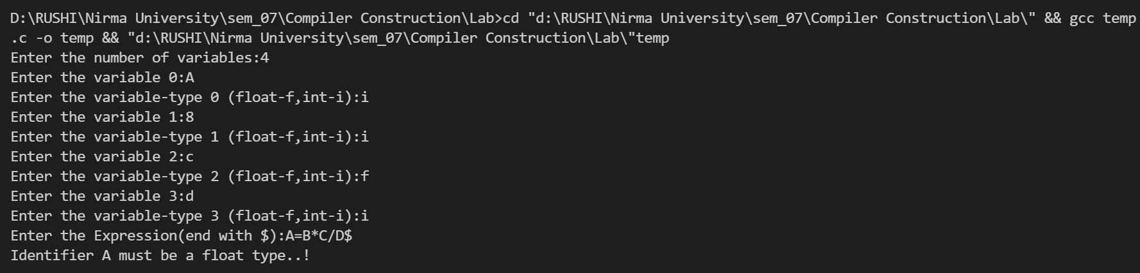

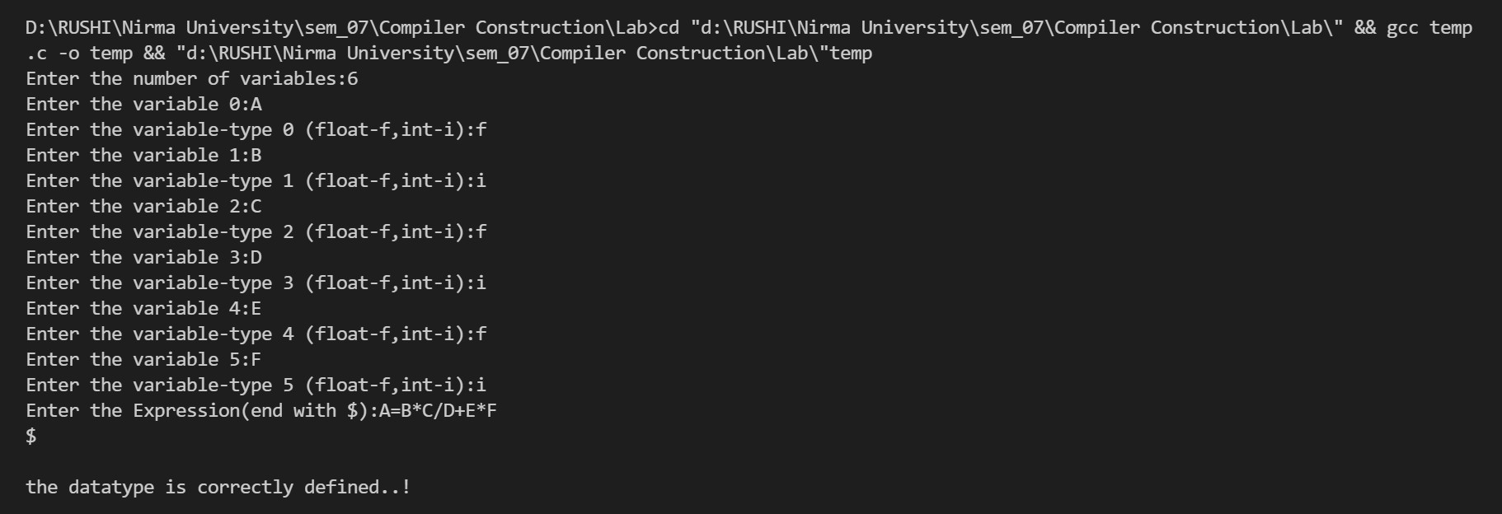

Conclusion:

From this practical we learnt how to implement Type checking.