2CS701 Compiler Construction
Practical 10
Rollno: 19BCE236 | Name: Samariya Darsh
Date: 19-11-2022 | Batch: D1

Aim:To implement Code Optimization techniques: Implement any code optimization technique.

Code:

#include <stdio.h>


#include <string.h>

struct op {

char l;

char r[20];

} op[10], pr[10];

void main() {

int a, i, k, j, n, z = 0, m, q;

char *p, *l;

char temp, t;

char *tem;

printf("Enter the Number of Values:"); scanf("%d", &n);

for (i = 0; i < n; i++) {

printf("Enter expression: ");

char * exp;

scanf("%s",exp);

op[i].l = exp[0];

strcpy(op[i].r,(exp+2));

}

printf("Intermediate Code\n");

for (i = 0; i < n; i++) {

printf("%c=", op[i].l);

printf("%s\n", op[i].r);

}

for (i = 0; i < n - 1; i++) {

temp = op[i].l;

for (j = 0; j < n; j++) {

p = strchr(op[j].r, temp);

if (p) {

pr[z].l = op[i].l;

strcpy(pr[z].r, op[i].r);

z++;

}

}

}

pr[z].l = op[n - 1].l;

strcpy(pr[z].r, op[n - 1].r);

z++;

printf("\nAfter Dead Code Elimination\n"); for (k = 0; k < z; k++) {

printf("%ct=", pr[k].l);
printf("%s\n", pr[k].r);


}

for (m = 0; m < z; m++) {

tem = pr[m].r;

for (j = m + 1; j < z; j++) {

- = strstr(tem, pr[j].r); if (p) {

t = pr[j].l;

pr[j].l = pr[m].l;

for (i = 0; i < z; i++) { l = strchr(pr[i].r, t); if (l) {

a = l - pr[i].r; printf("pos: %d", a); pr[i].r[a] = pr[m].l;

}

}

}

}

}

printf("\nEliminate Common Expression\n"); for (i = 0; i < z; i++) {

printf("%c\t=", pr[i].l);

printf("%s\n", pr[i].r);

}

for (i = 0; i < z; i++) {

for (j = i + 1; j < z; j++) {

q = strcmp(pr[i].r, pr[j].r);

if ((pr[i].l == pr[j].l) && !q) {

pr[i].l = '\0';

strcpy(pr[i].r, '\0');

}

}

}

printf("Optimized Code\n");

for (i = 0; i < z; i++) {

if (pr[i].l != '\0') {

printf("%c=", pr[i].l);

printf("%s\n", pr[i].r);

}

}

getchar();

}

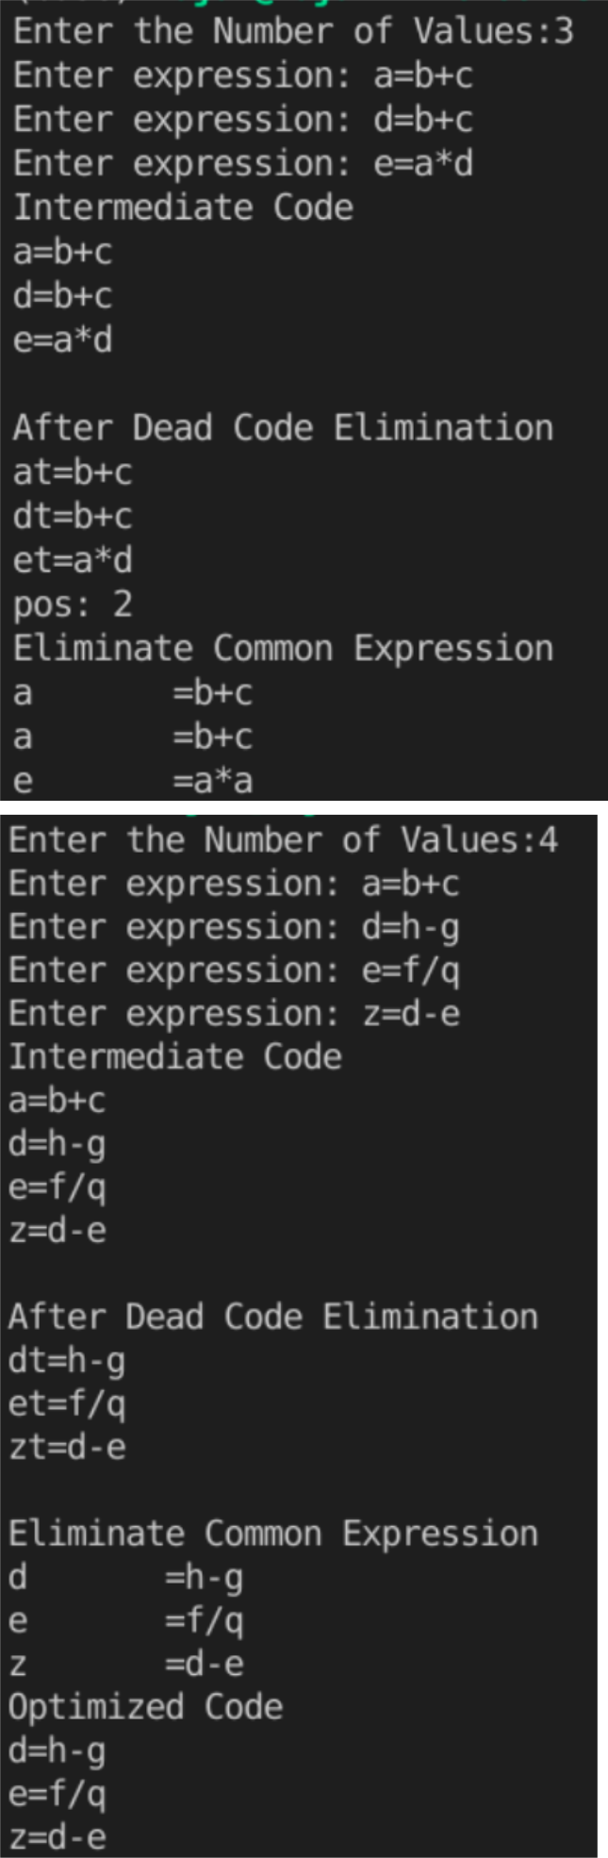
Output:

