2CS701 Compiler Construction
Practical 4
Rollno: 19BCE236 | Name: Samariya Darsh
Date: 25-10-2022 | Batch: D1

Aim:

To implement the Left most derivation removal algorithm.

Program:

#include<stdio.h>

#include<string.h>

#define SIZE 10 int

main ()

{

char non_terminal; char

beta,alpha; int num;

char production[10][SIZE]; int

index=3;

printf("Enter Number of Production : ");

scanf("%d",&num);

printf("Enter the grammar as E->E-A :\n"); for(int

i=0;i<num;i++)

{

scanf("%s",production[i]);

}

for(int i=0;i<num;i++)

{

printf("\nGRAMMAR : : : %s",production[i]); non_terminal=production[i][0]; if(non_terminal==production[i][index]) {

alpha=production[i][index+1]; printf(" is

left recursive.\n");

while(production[i][index]!=0 && production[i][index]!='|')

{

index++;

}

if(production[i][index]!=0)

{

beta=production[i][index+1];

printf("Grammar without left recursion:\n");

printf("%c->%c%c\'",non_terminal,beta,non_terminal);

printf("\n%c\'->%c%c\'|E\n",non_terminal,alpha,non_terminal);

}

else

{

printf(" can't be reduced\n");

}

}

else
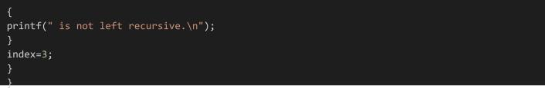

Output:
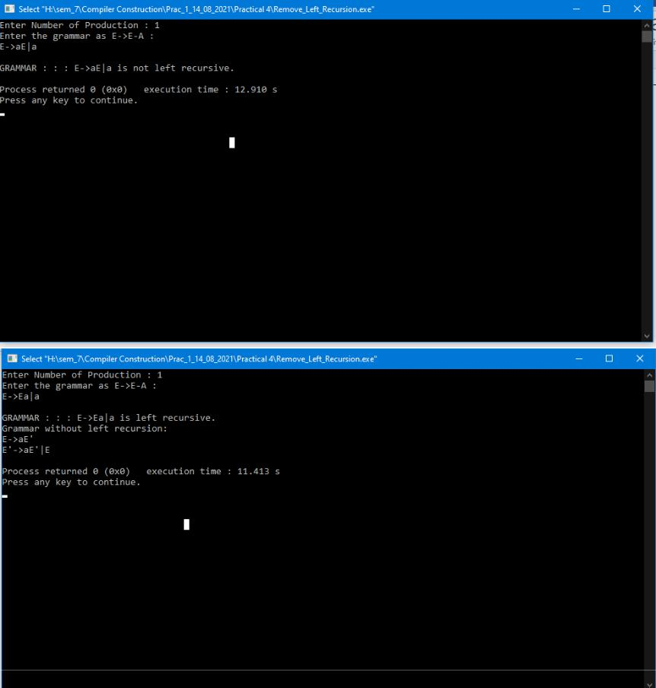

Conclusion:

From this practical we learnt how to remove left most derivation from a grammar.

