**WEEK 5**

**Superset Id - 6373920**

**ACCOUNT:**

**Code:**

AccountApplication.java  
  
package com.cognizant.account;

import org.springframework.boot.SpringApplication;

import org.springframework.boot.autoconfigure.SpringBootApplication;

@SpringBootApplication

public class AccountApplication {

    public static void main(String[] args) {

        SpringApplication.run(AccountApplication.class, args);

    }

}

**AccountController:**

package com.cognizant.account;

import org.springframework.web.bind.annotation.*;

import java.util.Map;

@RestController

public class AccountController {

    @GetMapping("/accounts/{number}")

    public Map<String, Object> getDetails(@PathVariable String number) {

        return Map.of("number", number, "type", "savings", "balance", 234343);

    }

}

**Application :**

server.port=8080

**OUTPUT:**

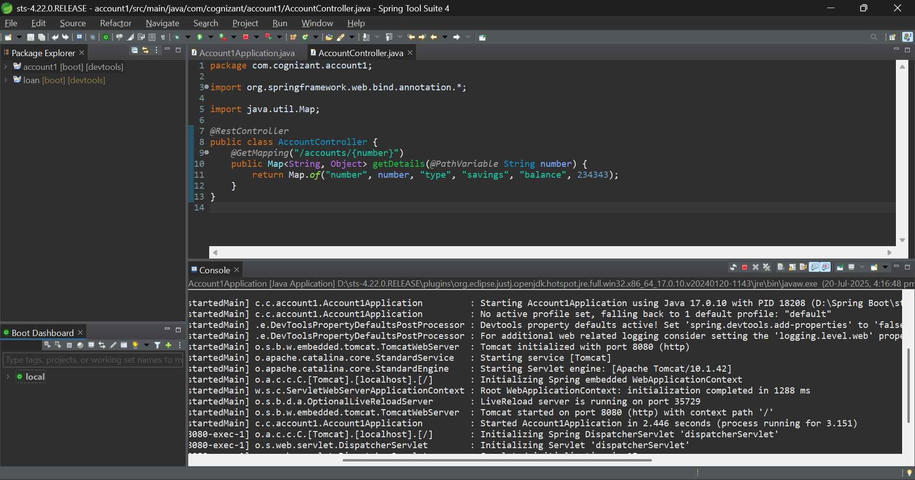

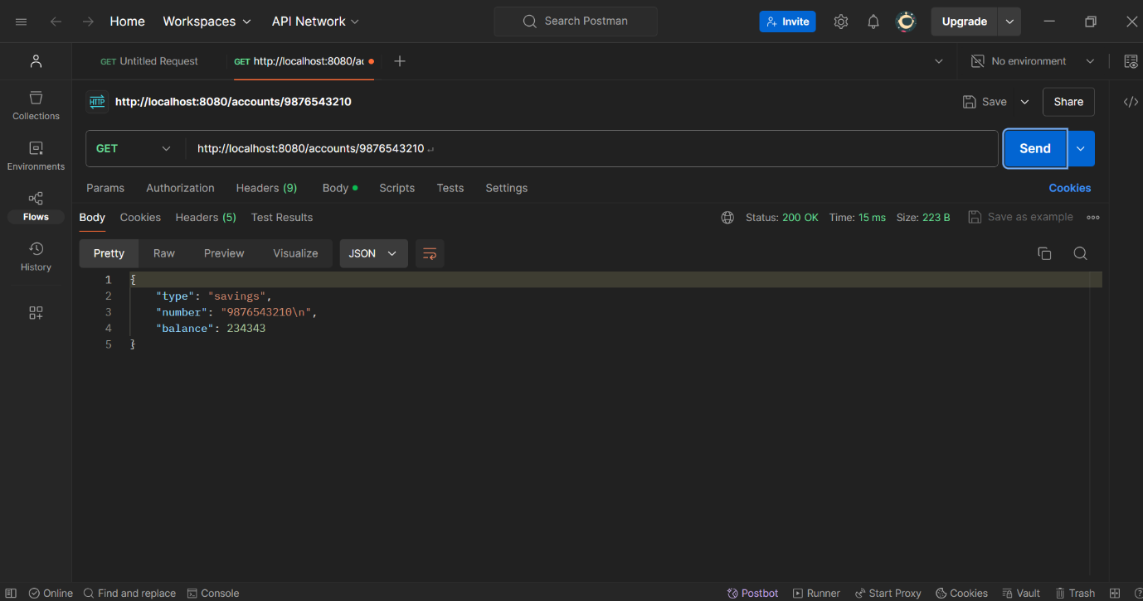

**Loan:**

**LoanApplication :**

package com.cognizant.loan;

import org.springframework.boot.SpringApplication;

import org.springframework.boot.autoconfigure.SpringBootApplication;

@SpringBootApplication

public class LoanApplication {

    public static void main(String[] args) {

        SpringApplication.run(LoanApplication.class, args);

    }

}

**LoanController :**

package com.cognizant.loan;

import org.springframework.web.bind.annotation.*;

import java.util.Map;

@RestController

public class LoanController {

    @GetMapping("/loans/{number}")

    public Map<String, Object> getDetails(@PathVariable String number) {

        return Map.of("number", number, "type", "car", "loan", 400000, "emi", 3258, "tenure", 18);

    }

}

**Application.properties :**

server.port=8080

**OUTPUT:**

