IdenTreeFier: User Guide

SFWRENG 3A04

Darsikan Anandarajah

Sanje Fernando

Simon Gyorkos

Navya Sachdeva

Alex Trudeau

1. **Introduction to IdenTreeFier**

IdenTreeFier is a mobile application developed for Android devices. It enables a user to identify a tree based on the tree’s properties, such as leaf and bark characteristics. A physical specimen of the tree is helpful in analyzing the tree’s characteristics, so this application should be primarily used in the field. However, IdenTreeFier is able to be used anywhere at your convenience. Simply pick up a leaf, and start IdenTreeFying!

1. **Getting Started**

Once the IdenTreeFier app is installed, open it up. Enabling location permissions is recommended, as it can help narrow down results when identifying a tree.

1. **Identifying a Tree**

IdenTreeFier will take you through a list of multiple choice questions that it will use to determine possible candidates for the tree in question. If you are unfamiliar with dendrology (the study of trees), the rest of the guide has some help on some of the terms used in the app.

*Q1. Conferous or Deciduous?*

*Q2. Leaflet Arrangement*

*Q3. Leaf Grouping*

*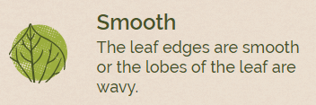Q4. Edge of the Leaf*

*Q5. Lobes or No Lobes?*

*Q6. Blade Structure*

*Q7. Leaf Base*

*Q8. Leaf Shape*

*Q9. Needles or Scales?*

*Q10. Needle Bundles*