**BUG:**

**Summary**

Contact Page > User able to successfully submit the “Contact Us” form without entering any data in “Message Field” and no error message is displayed

**Priority - Major**

**Environment:**

Production: <https://www.perfectward.com/>

**Browsers:**

**Mac OS**: Chrome V93. Firefox V92, Safari

**Windows**: Chrome V92, Firefox V92, Microsoft Edge

**Devices:**

**iOS**: iPhone X V13.2. iPhone 12 V14.3.2, iPhone 12 Pro V15

**Android**: Chrome V92, Firefox V92, Microsoft Edge

**Description**

No Error message is displayed to the user even if the “Message Field” is empty and “Contact Us” form is submitted.

**Steps to Reproduce:**

1. Launch the Perfect Ward site (<https://www.perfectward.com/>) in the browser
2. Check the site load and go to “Navigation bar” on the top
3. Click on “Contact” Tab
4. Check the Contact form appears
5. Enter the details in the form - First name, Last name, Email, Telephone, Role, Sector, Organisation, How did you hear About Us
6. Don’t enter any data in “Message” section
7. Select the box “I confirm that I have read and understood the Perfect Ward privacy policy and agree to its terms”
8. Click on “Submit” button
9. Check there is no “Error message appeared” for “Message” section

**Actual Results:**

No error message is appearing when the “Message field” is blank and submitted the form in Contact page

**Expected Results:**

Error message should appear if the “Message field” is not empty and user submits the form in Contact page. The message should “**The** **field is required**” as per the requirements.

**Screenshot attached for reference**

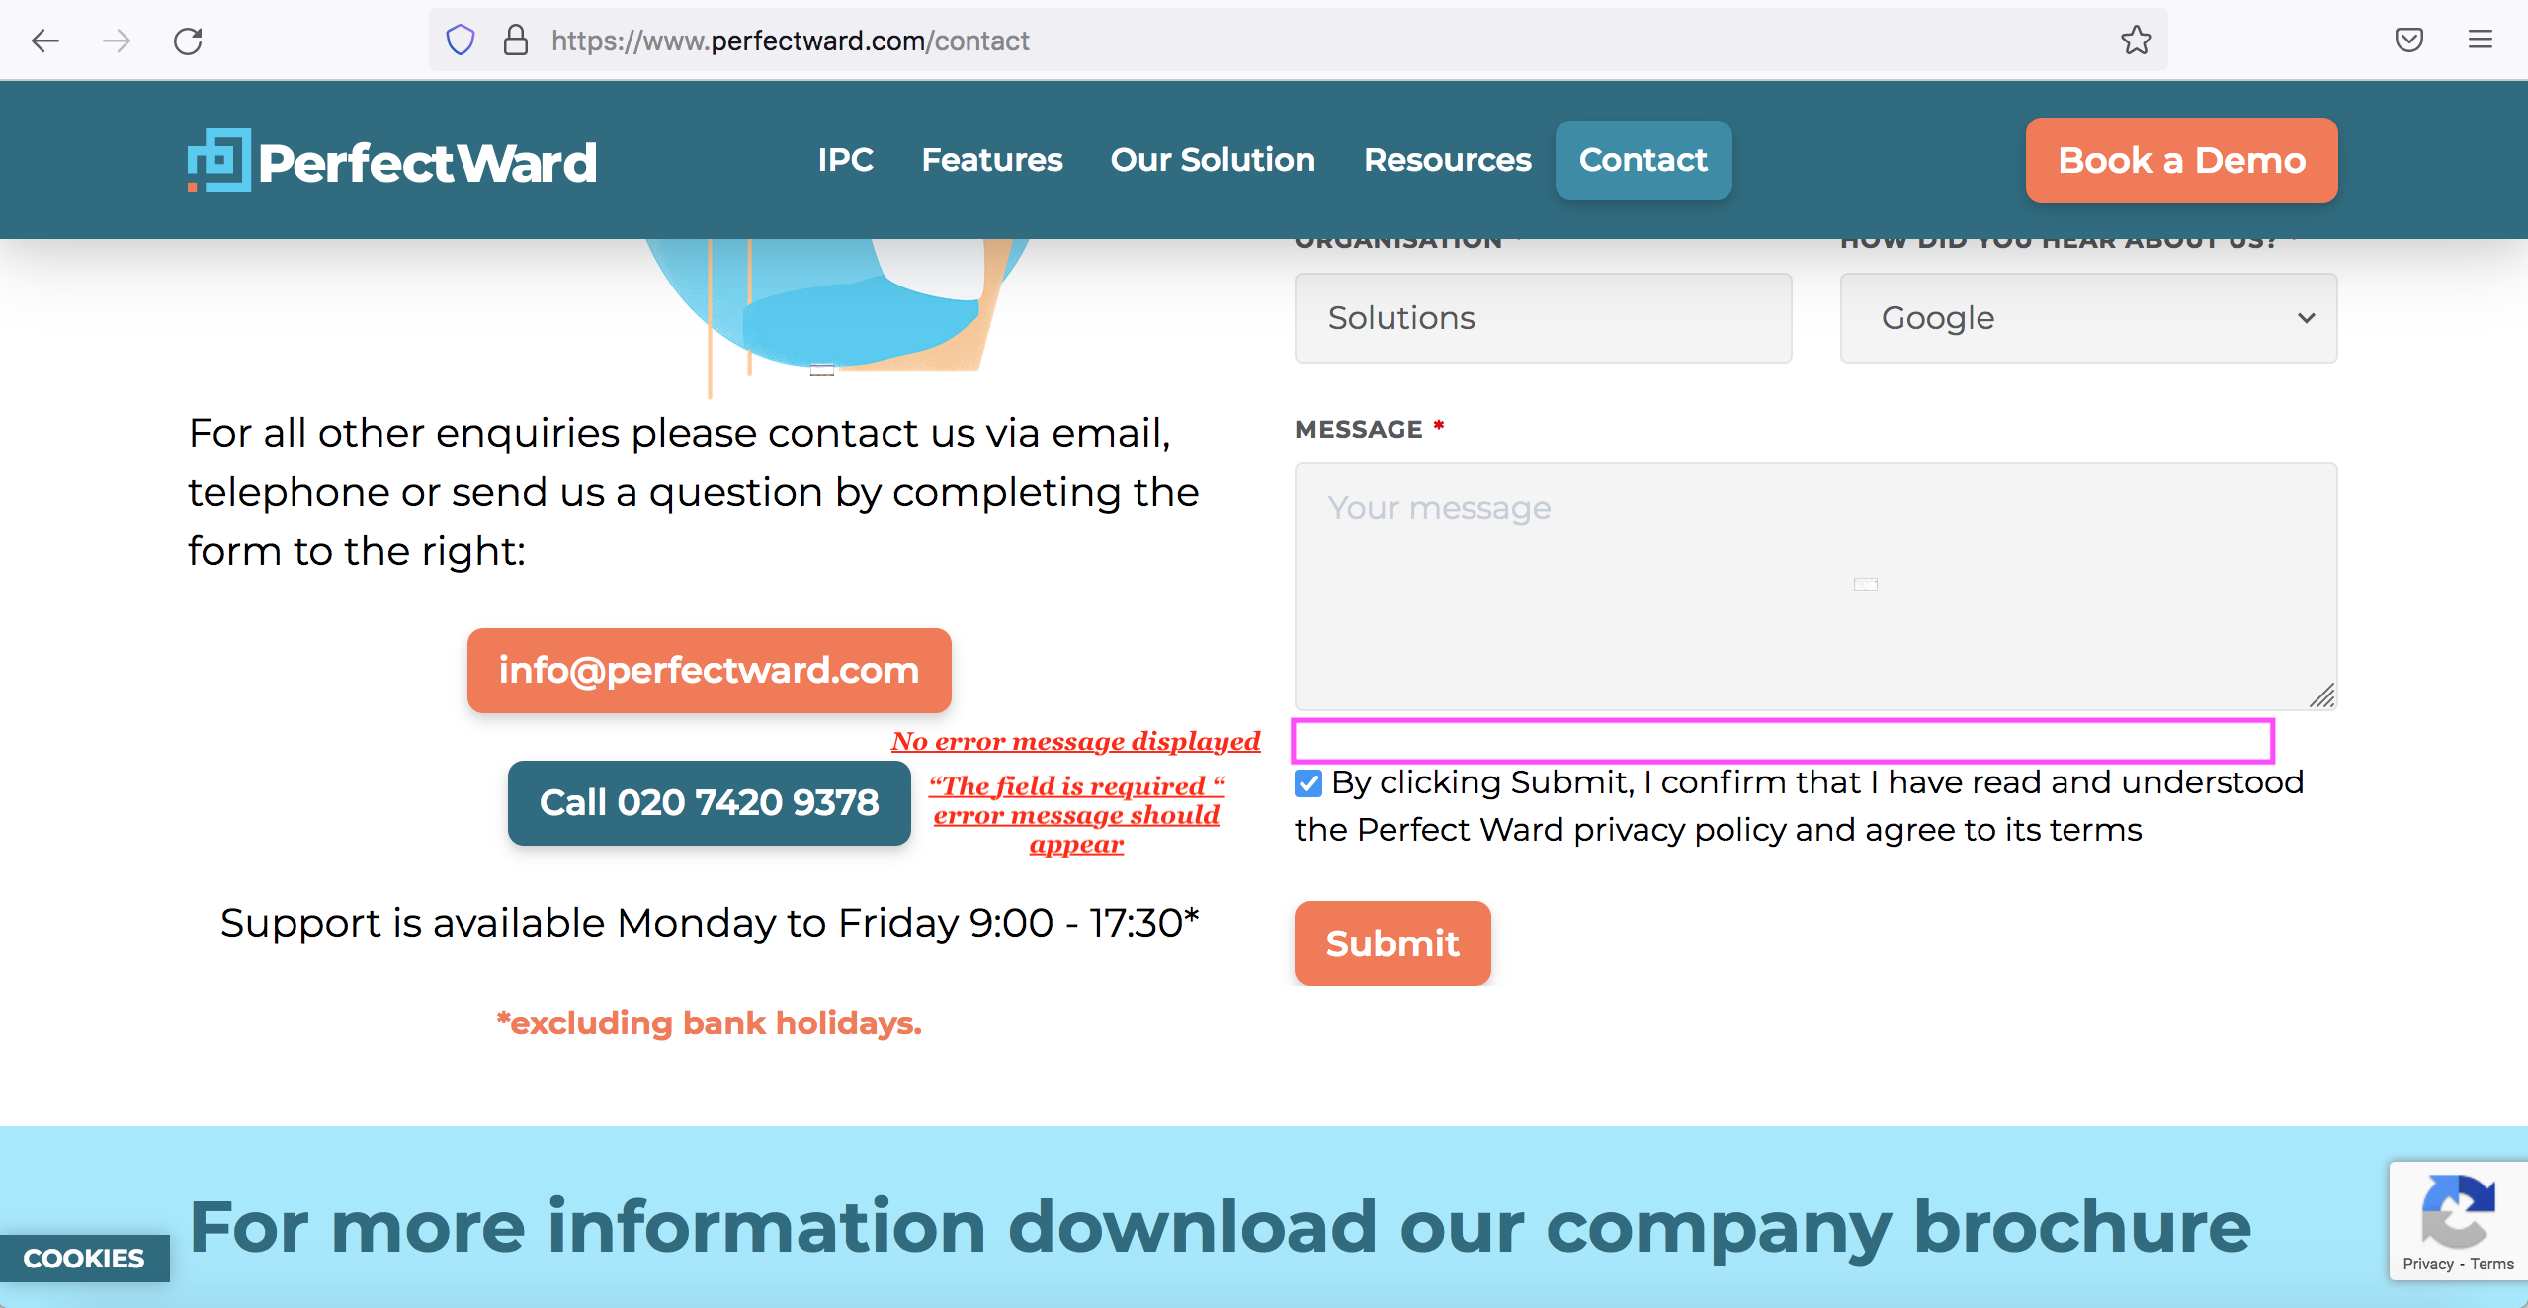I

Screenshot showing no error message and where need to be present.