## Business Problem

A wholesale food distributor is interested in opening a deli in Suffolk County NY. In over 30 years of operations, the group has found that delis are excellent customers and are a source of great profit. As such it is looking to expand its own business into that of the deli business.

## Data

The data used to conduct this analysis consists of the following:

* A listing of Suffolk County neighborhoods with central latitudinal and longitudinal coordinates.
* Food-related venue data for each neighborhood, including name of venue, venue latitudinal and longitudinal coordinates for venues that qualify.

The Suffolk county neighborhood data will be obtained from Foursquare. Using a default radius of 500 meters from the center of surrounding neighborhoods.

Data Acquisition and cleaning

Data was acquired from foursquare to determine the surrounding areas population of delis. Map presented below.

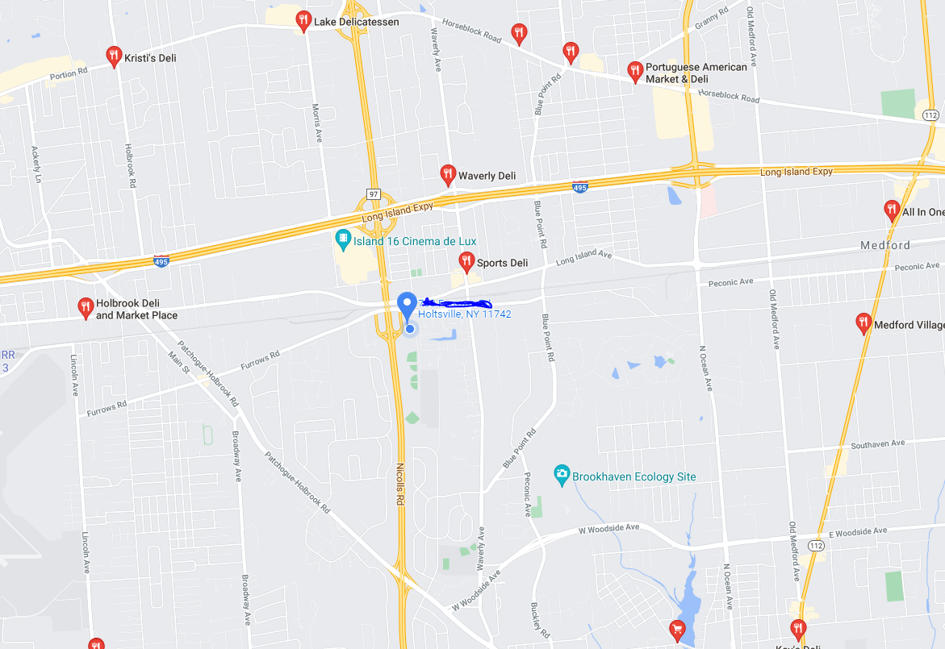

Data cleaning

For this evaluation data cleaning process were not taken as the information was straightforward showing the locations of nearby delis.

Predictive Modeling

No means of predictive monitoring was able to be established due to lack of current data. As this is a future endeavor data has to be collected on an ongoing basis.

Exploratory Data Analysis

The map data was analyzed to determine accessibility to the various location and distance from/to main highways. It was determined that the suggested position was in an ideal location.

Analysis

Locations and availability of local deli’s were evaluated. The proximity of the current location of operation was considered for accessibility and useability.

Conclusion

It was determined that due to the already utilized overhead and availability of the onsite kitchen as deli could be open on site. Given the nature of the business and the frequency of deliveries, primary clientele were identified to be delivery drivers