ASSIGNMENT 4

Darius Dinkins

2022-7-17

# Markdown Basics

## Favorite Foods

1. Spaghetti
2. Shrimp Pasta
3. Fried Chicken

## Images

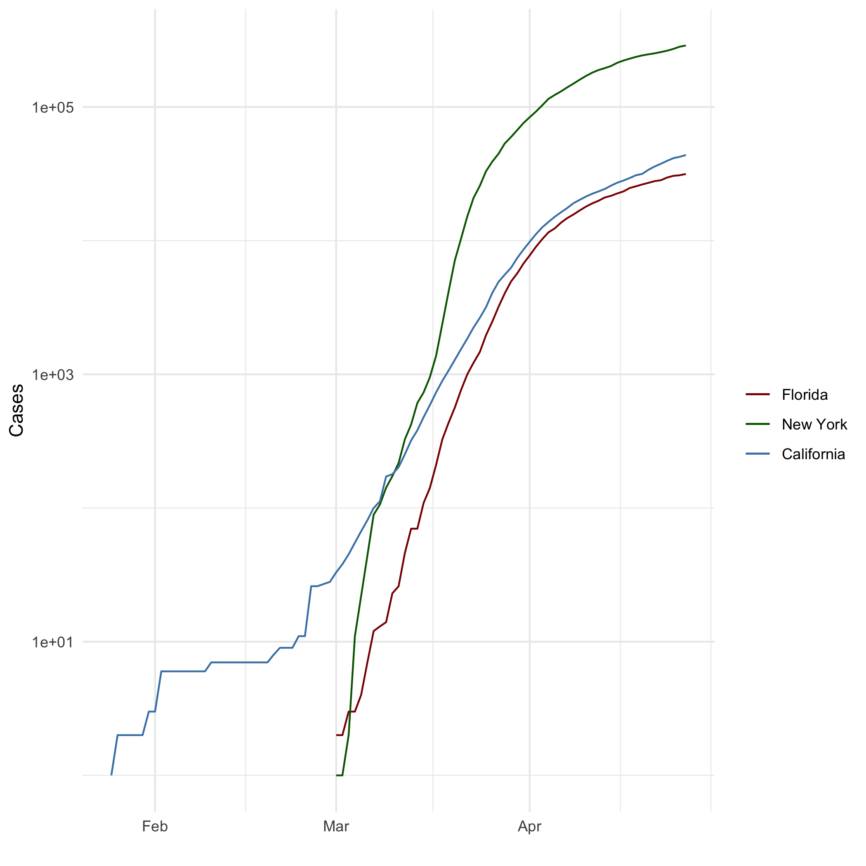

All Cases (Log Plot)

## Add a Quote

“I’ll be back”

## Add an Equation

$$2+2=4$$

## Add a Footnote

This is a footnote[^1]

## Add Citations

* R for Everyone
  + Lander, Jared P.. R for Everyone (Addison-Wesley Data & Analytics Series) (p. 346). Pearson Education. Kindle Edition.
* Discovering Statistics Using R
  + Field, Andy; Miles, Jeremy; Field, Zoe. Discovering Statistics Using R (p. 175). SAGE Publications. Kindle Edition.

# Inline Code

## NY Times COVID-19 Data

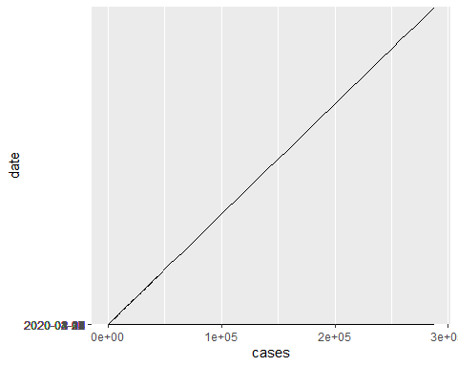

## R4DS Height vs Earnings

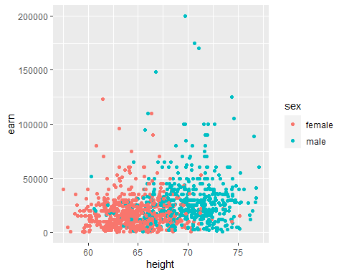

# Tables

## Create a dataframe called characters_df using the following information from LOTR  
name <- c("Aragon", "Bilbo", "Frodo", "Galadriel", "Sam", "Gandalf", "Legolas", "Sauron", "Gollum")  
race <- c("Men", "Hobbit", "Hobbit", "Elf", "Hobbit", "Maia", "Elf", "Maia", "Hobbit")  
in_fellowship <- c(TRUE, FALSE, TRUE, FALSE, TRUE, TRUE, TRUE, FALSE, FALSE)  
ring_bearer <- c(FALSE, TRUE, TRUE, FALSE, TRUE, TRUE, FALSE, TRUE, TRUE)  
age <- c(88, 129, 51, 7000, 36, 2019, 2931, 7052, 589)  
  
characters_df <- data.frame(name, race, in_fellowship, ring_bearer, age)  
  
## Sorting the characters_df by age using the order function and assign the result to the sorted_characters_df  
sorted_characters_df <- characters_df[order(age),]  
## Use `head()` to output the first few rows of `sorted_characters_df`  
head(sorted_characters_df)

## name race in_fellowship ring_bearer age  
## 5 Sam Hobbit TRUE TRUE 36  
## 3 Frodo Hobbit TRUE TRUE 51  
## 1 Aragon Men TRUE FALSE 88  
## 2 Bilbo Hobbit FALSE TRUE 129  
## 9 Gollum Hobbit FALSE TRUE 589  
## 6 Gandalf Maia TRUE TRUE 2019

## Select all of the ring bearers from the dataframe and assign it to ringbearers_df  
ringbearers_df <- characters_df[characters_df$ring_bearer == TRUE,]  
## Use `head()` to output the first few rows of `ringbearers_df`  
head(ringbearers_df)

## name race in_fellowship ring_bearer age  
## 2 Bilbo Hobbit FALSE TRUE 129  
## 3 Frodo Hobbit TRUE TRUE 51  
## 5 Sam Hobbit TRUE TRUE 36  
## 6 Gandalf Maia TRUE TRUE 2019  
## 8 Sauron Maia FALSE TRUE 7052  
## 9 Gollum Hobbit FALSE TRUE 589

## Knitr Table with Kable

knitr::kable(characters_df, caption = "One Ring To Rule Them All")

One Ring To Rule Them All

| name | race | in_fellowship | ring_bearer | age |
| --- | --- | --- | --- | --- |
| Aragon | Men | TRUE | FALSE | 88 |
| Bilbo | Hobbit | FALSE | TRUE | 129 |
| Frodo | Hobbit | TRUE | TRUE | 51 |
| Galadriel | Elf | FALSE | FALSE | 7000 |
| Sam | Hobbit | TRUE | TRUE | 36 |
| Gandalf | Maia | TRUE | TRUE | 2019 |
| Legolas | Elf | TRUE | FALSE | 2931 |
| Sauron | Maia | FALSE | TRUE | 7052 |
| Gollum | Hobbit | FALSE | TRUE | 589 |

## Pandoc Table

pandoc -s -o output.html characters_df | Name | Race | In Fellowship? | Is Ring Bearer? | Age | |———–|———–|—————-|—————–|——-:| | Aragon | Men | Yes | No | 88 | | Bilbo | Hobbit | No | Yes | 129 | | Frodo | Hobbit | Yes | Yes | 51 | | Sam | Hobbit | Yes | Yes | 36 | | Sauron | Maia | No | Yes | 7052 |

# References