Forecasting California's Day-Ahead Electricity Demand
A Machine-Learning Decision-Support Tool for Peak-Load Planning

Franky Hernandez  Master of Science in Applied Data Science  Shiley Marcos School of Engineering  University of San Diego  franciscohernandez@sandiego.edu | Jun Sik Ryu  Master of Science in Applied Data Science  Shiley Marcos School of Engineering  University of San Diego  junsikryu@sandiego.edu | Nikita Rogers  Master of Science in Applied Data Science  Shiley Marcos School of Engineering  University of San Diego  nikitarogers@sandiego.edu

INTRODUCTION
Balancing authorities forecast the electricity needed for each hour of the following day so they can schedule resources and coordinate reliable grid operations. That task is material in the California Independent System Operator (CISO) footprint, where actual annual peak demand fluctuated from 43,789 to 51,479 megawatts between 2014 and 2024 and where the planning forecast anticipates rising peak requirements through 2030 (California Independent System Operator, 2025). Forecast error can affect resource scheduling, reserve planning, and the ability of operators and planning analysts to prepare for high-demand hours.
This project asks: How accurately can historical demand and calendar-based variables predict each hour of the following day within the CISO balancing-authority footprint? Using public 2019–2025 records from the U.S. Energy Information Administration's Form EIA-930, the team will compare a same-hour previous-week seasonal-naive benchmark, regularized linear regression, and a tree-based ensemble using chronological validation (U.S. Energy Information Administration, n.d.). The intended users are electricity planning analysts and learners reviewing historical forecasts, hourly load profiles, and the magnitude and timing of daily peaks. We hypothesize that demand-history and calendar features will lower hourly and peak-magnitude errors relative to weekly persistence; whether a tree ensemble also improves on regularized linear regression will be tested rather than assumed. The proposed deliverables are a reproducible modeling pipeline and the California Peak Demand Planner, an interactive Streamlit application for historical model comparison and error interpretation. This exploratory tool will not provide dispatch instructions or real-time operational forecasts.

BACKGROUND
A balancing authority is responsible for maintaining the balance among electricity supply, demand, and interchange within its operational footprint. The California Independent System Operator is one such authority, but its CISO reporting footprint is not equivalent to all electricity demand statewide. Form EIA-930 provides public hourly records from balancing authorities, including actual demand, day-ahead demand forecasts, net generation, and total interchange. The U.S. Energy Information Administration (EIA) explains that balancing authorities prepare forecasts for each hour of the next day to support reliable coordination and that historical hourly submissions are available beginning in 2019 (U.S. Energy Information Administration, n.d.). These data permit a reproducible CISO case study. However, because the EIA's published day-ahead forecast is typically released on the operating day, it will be used as a retrospective reference rather than as a predictor or a proven pre-issuance benchmark unless its historical availability can be established.
California's changing demand environment increases the value of transparent forecasting analysis. CAISO reported that actual annual peak demand varied by more than 7,000 megawatts from 2014 through 2024, while the California Energy Commission's planning forecast projects CISO's annual peak to rise from 46,094 megawatts in 2025 to 52,940 megawatts in 2030 (California Independent System Operator, 2025; California Energy Commission, 2025). The California Energy Commission incorporates economic and demographic drivers, behind-the-meter photovoltaic generation, transportation electrification, data centers, and other policy-relevant changes into its longer-term demand outlook (California Energy Commission, 2025). Those planning forecasts operate on a different horizon from this capstone's day-ahead task, but they show why hourly demand shape and peak timing remain important as consumption patterns evolve.
The practical problem is not simply that electricity demand varies; planners must assess tomorrow's complete hourly load curve and identify potentially consequential peak hours before actual demand is observed. A credible day-ahead back-test may use only information available at a clearly defined forecast issuance time. Lagged demand or rolling features can leak future information if they include observations beyond that cutoff; retrospective data revisions introduce an additional limitation because current files may not reproduce the precise values available historically. EIA notes that near-real-time balancing-authority records may contain anomalies, revised values, and daylight-saving-time reporting problems (U.S. Energy Information Administration, n.d.). Accordingly, timestamp validation, data-quality rules, and documented input availability are integral to the research design.
The analytic objectives are to prepare and audit a reproducible CISO hourly demand series for 2019–2025; describe daily, weekly, and seasonal variation; create historical-demand and calendar predictors subject to a defined prior-day issuance cutoff; and compare models using mean absolute error (MAE), root mean squared error (RMSE), mean absolute percentage error (MAPE), daily peak-magnitude error, and peak-timing error. Chronological development periods will be used for model selection, with 2025 reserved as an untouched final holdout if the data audit supports this division. Daily peak metrics will be computed using complete operating days, recognizing that local daylight-saving transitions can create 23- or 25-hour days. The artifact will allow an analyst to select a historical test date, compare observed and predicted hourly curves, inspect peak hours and model diagnostics, and identify cases warranting further review. The conceptual workflow proceeds from source acquisition and audit to availability-aware feature engineering, chronological model comparison, held-out evaluation, interpretation, and presentation in the California Peak Demand Planner.

LITERATURE REVIEW

Forecasting Foundations and Feature Design
Recent scholarship treats short-term load forecasting as a family of related regression problems whose appropriate methods depend on forecast horizon, aggregation level, feature availability, and evaluation design. Nti et al. (2020) systematically reviewed 77 studies published from 2010 through 2020 and found that artificial-intelligence methods, particularly artificial neural networks, dominated the most frequently used approaches. The review is valuable because it organizes algorithms, influencing factors, forecasting horizons, and error metrics; however, the diversity of datasets and study designs limits any claim that one algorithm is universally superior. Its central implication for this project is that model comparison must be tied to the CISO day-ahead decision context rather than to a general ranking of methods.
Feature design is equally important. Aguilar Madrid and Antonio (2021) developed machine-learning models for 168-hour load forecasts and emphasized the roles of lagged demand, calendar structure, and weather. Their comparison shows that interpretable regression can train quickly but may struggle with irregular profiles, while more flexible learners can capture nonlinear relationships at the cost of additional tuning. Javed et al. (2021) likewise used exploratory analysis, autocorrelation, temporal variables, and climate variables before comparing linear and nonlinear models. A single-hidden-layer neural network produced the lowest error in their Lahore case study, whereas greater network depth increased complexity and overfitting risk. Because both studies concern particular systems and climates, their numerical performance cannot be transferred directly to CISO; their stronger contribution is evidence that feature selection, seasonality analysis, and model complexity should be evaluated together.

Model Complexity and Time-Series Validation
Broad comparative studies caution against assuming that complexity guarantees better forecasts. López Martín et al. (2021) tested classical machine-learning models, dynamic-mode methods, convolutional and recurrent networks, sequence-to-sequence architectures, and deep ensembles on a common Spanish utility dataset. A one-week rolling window generally worked well, additional weather and calendar features did not improve every model, and simple linear models remained competitive for very short horizons. More complex convolutional-recurrent and ensemble architectures performed better as the horizon and uncertainty increased. The homogeneous comparison is a major benefit, but the single utility and the resource demands of deep models limit generalization and deployment relevance. For the capstone, these findings support a deliberate baseline-first design and make deep learning a stretch goal rather than a minimum requirement.
Validation choices can change which model appears best. Sankalpa et al. (2022) combined three parametric regression models with decision-tree and random-forest predictors in a voting ensemble for Thai load. They compared random, blocked, and expanding-window validation schemes and found that blocked validation most often tracked test error, while the voting model achieved the lowest test mean absolute percentage error across their groups. Holiday performance was weaker because fewer training examples were available, and the study used older, nonpublic data. More importantly, its linear models outperformed the tree models on that dataset. This evidence supports chronological or blocked evaluation, explicit treatment of holidays, and empirical comparison of linear and tree-based models rather than assuming an ensemble will win.

Deep Learning Benefits and Boundary Conditions
Deep learning can be useful when nonlinear temporal structure and sufficient training data justify its additional complexity. In a Panama power-system case study, Ibrahim et al. (2022) compared conventional machine-learning and deep-learning approaches using hourly demand, calendar, and meteorological variables. They identified previous-day and previous-week demand and temperature as informative predictors; their deep-learning regression model performed best for the one-hour-ahead task, but the 24-hour-ahead sequence problem was more difficult. Consequently, that favorable one-hour result does not establish superiority for this capstone's complete next-day hourly curve. Veeramsetty et al. (2022) combined principal component analysis with a recurrent neural network for hourly substation load in India, demonstrating a possible trade-off between reduced input dimensionality and modeling temporal dependence. Its evidence is bounded by a single substation and the added tuning and explanation burden of recurrent architectures. Together, these studies support treating deep learning and weather data as possible extensions rather than prerequisites for an interpretable CISO baseline.
Valgaev et al. (2020) provide an important counterweight to favorable case studies. Evaluating several feed-forward and recurrent neural-network designs across many residential buildings, they found that neural networks did not consistently improve wide-scale day-ahead forecasts and could underperform standardized load profiles. Performance varied with local-load characteristics, nonstationary, available history, and manual tuning. Their findings show why an accurate model for one customer or dataset may not generalize and why average error alone can hide meaningful variation. Although CISO load is more aggregated and smoother than individual-building load, the study reinforces the need for held-out chronological testing, transparent baselines, and clear boundary conditions.
Across the reviewed studies, three themes emerge. First, past load and calendar structure are consistently useful, although the additional value of weather depends on the data and forecast horizon (Aguilar Madrid & Antonio, 2021; Ibrahim et al., 2022; Javed et al., 2021). Second, increasingly complex models do not uniformly outperform simpler alternatives, especially when studies differ in aggregation level and prediction horizon (López Martín et al., 2021; Valgaev et al., 2020). Third, validation design materially affects the credibility of comparative claims (Sankalpa et al., 2022). The contribution proposed here is therefore practical, not algorithmic novelty: a reproducible, availability-aware comparison of daily hourly profiles and peak-specific errors on one public U.S. balancing-authority series, presented in a tool accessible to semi-technical reviewers. This approach can show when a flexible model adds value and when simpler baselines remain competitive. Results will be interpreted as historical back-test evidence, not proof of operational safety, savings, or performance in other grid regions.

DATA UNDERSTANDING

Data Summary
The analysis uses the U.S. Energy Information Administration’s Form EIA-930 full-history workbook for the California Independent System Operator (CISO). The analytic window covers 2,557 Pacific operating dates from January 1, 2019, through December 31, 2025, and contains 61,368 hourly records (U.S. Energy Information Administration, n.d.). The unit of analysis is one CISO hour ending, so the dataset is a regularly ordered time series rather than cross-sectional or panel data. EIA labels demand as an hourly integrated megawatthour value; because each interval is one hour, the value is numerically equivalent to the average megawatt load during that hour. This article retains the workbook’s megawatthour label. The workbook is a retrospective source and may include revisions made after original reporting; the analysis therefore does not reconstruct the exact information available at each historical issuance.
UTC time is the unique chronological key used for joins and lag calculations. Pacific operating date, hour ending, and local clock time support calendar features, daily peak calculations, and interpretation. The distinction matters on daylight-saving transitions because the series contains seven 23-hour operating days and seven 25-hour operating days. Table 1 identifies the fields used for the target, identifiers, audit trail, retrospective reference, and derived predictors.
Table 1
Variables Used in Data Understanding and Modeling
Variable | Role | Definition and use
UTC time | Identifier | Unique hour-ending timestamp used to sort records and construct lags without duplicate local clock times.
Local date and hour | Identifier / predictor | Pacific operating date and clock position used for daily grouping, peak timing, weekday, month, and cyclical time fields.
Adjusted demand | Target | Published CISO hourly demand in MWh after EIA’s adjustments; cleaned further only where values remain missing or anomalous.
Raw and imputed demand | Audit fields | Separate workbook fields used to quantify missing reports, identify EIA-filled values, and preserve the source history.
EIA demand forecast | Reference only | Agency-published forecast retained for retrospective comparison but excluded as a model predictor because historical pre-issuance availability is not established.
Calendar and history fields | Derived predictors | Weekend, holiday, cyclical hour and season terms, 48-hour and 168-hour lags, and cutoff-based demand summaries.

Exploratory Data Analysis
The source audit found all 61,368 expected UTC identifiers and no duplicate timestamps. Raw demand was missing for 118 hours (0.192%). EIA supplied imputed values for 94 hours (0.153% of the full series), leaving one 24-hour gap on November 2, 2024. Three published values fell outside EIA’s stated 10,000–70,877 MWh acceptable range for CISO. A conservative continuity check also identified 12 isolated downward discontinuities below 60% of both adjacent hours; one of these overlapped an EIA range error. The 24 missing adjusted values and 14 unique anomalous values were replaced with their 168-hour lags for continuity. This 60% anomaly threshold is a screening heuristic. These 38 author-applied fills represent 0.062% of the series. All affected rows retain flags, and synthetic or anomalous raw values are excluded as model targets, leaving 61,236 valid observed targets (99.785%).
Table 2
Data Quality Audit and Treatment
Issue | Count | Share | Treatment
Missing UTC identifiers | 0 | 0.000% | No timestamp rows added or removed.
Duplicate UTC identifiers | 0 | 0.000% | UTC remains the unique chronological key.
Missing raw demand | 118 | 0.192% | Retained in the audit trail; excluded as observed targets.
EIA-imputed demand | 94 | 0.153% | Used for continuity but not treated as an observed target.
Missing after EIA adjustment | 24 | 0.039% | Filled with the same UTC hour from the prior week.
EIA range errors | 3 | 0.005% | Replaced with the 168-hour lag and flagged.
Isolated discontinuities | 12 | 0.020% | Replaced only when below 60% of both adjacent hours; flagged.
Daylight-saving days | 14 | 0.548% of days | Preserved as seven 23-hour and seven 25-hour operating days.
After continuity treatment, hourly demand averaged 25,115 MWh, with a median of 24,214 MWh and a standard deviation of 4,726 MWh. The maximum was 51,104 MWh at the hour ending 6:00 p.m. Pacific on September 6, 2022. A global 1.5-interquartile-range rule marked 3,106 hours (5.06%), but these observations were not removed automatically. Most high values occur in coherent summer episodes and represent the peak-demand behavior the project is intended to forecast. These IQR flags are screening indicators, not confirmation of data errors, and no observations were removed solely for exceeding an IQR bound.
Figure 1
CISO Daily Demand from 2019 Through 2025
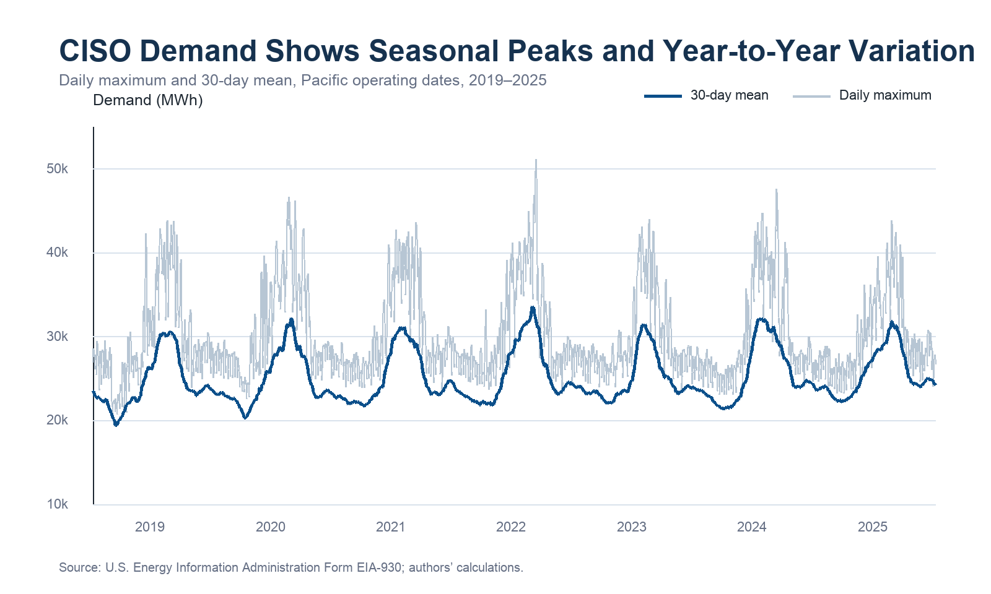
Note. Daily maxima vary substantially within each year, while the 30-day mean shows recurring summer peaks. The largest hourly value occurs during the September 2022 heat event.
Figure 1 shows recurring seasonality rather than a stable annual level. Mean demand was 28,996 MWh in summer and 22,321 MWh in spring. Annual maximum values also varied, reaching 51,104 MWh in 2022 compared with 43,860 MWh in 2025. These shifts support chronological validation and argue against randomly shuffling hours across training and test sets.
Figure 2
Average Hourly Demand by Season
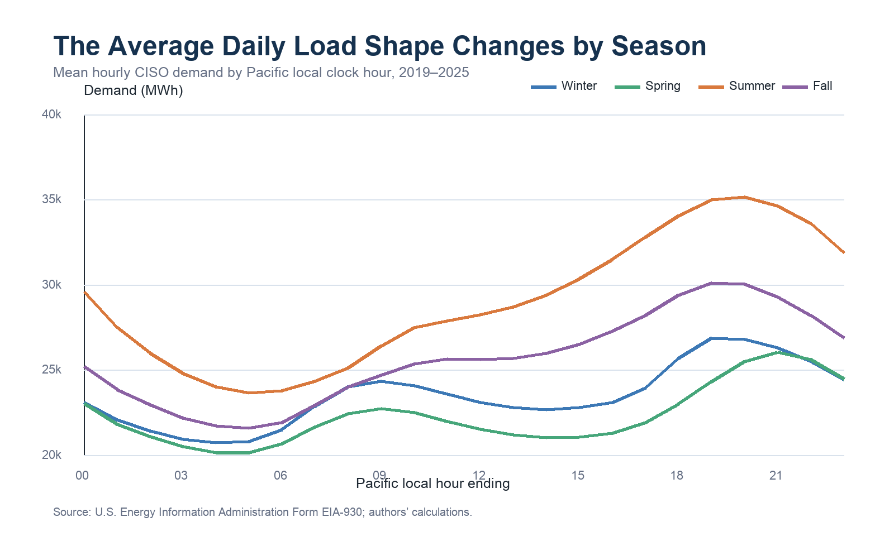
Note. Summer demand remains higher throughout the day and has the strongest evening peak. Spring has the lowest average profile.
Figure 3
Mean Demand by Month and Pacific Clock Hour
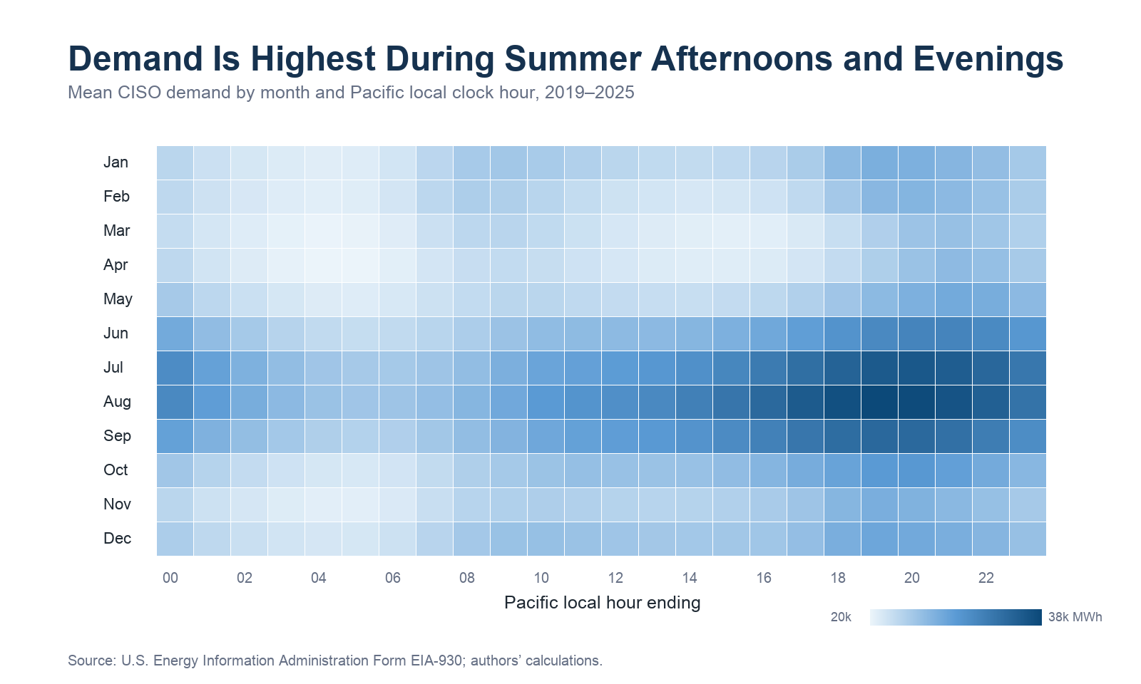
Note. The darkest cells occur in July through September during late afternoon and evening hours. August at the hour ending 7:00 p.m. has the largest month-hour mean, approximately 37,924 MWh.
The average hourly profile reaches its minimum near the hour ending 5:00 a.m. (21,555 MWh) and its maximum near the hour ending 8:00 p.m. (29,385 MWh). Weekday demand averages 25,748 MWh compared with 23,531 MWh on weekends. These differences justify hour, weekday, weekend, holiday, and annual-cycle terms. Demand is also strongly persistent: the target correlates 0.927 with a 24-hour lag, 0.843 with a 48-hour lag, and 0.841 with a 168-hour lag. The 24-hour relationship is strongest, but that field is not fully available for all target hours at the selected noon day-ahead cutoff. The 48-hour and 168-hour lags are therefore retained. Their correlation with each other is 0.774, while the 24-hour and 168-hour history means correlate 0.894. Regularization is consequently important for the linear model, whereas the tree ensemble can represent nonlinear interactions without requiring independent predictors.

METHODOLOGY

Data Preparation
Preparation begins by selecting CISO records assigned to Pacific operating dates in 2019–2025 and sorting them by UTC hour ending. UTC is retained for uniqueness across daylight-saving transitions, while the workbook’s local operating date and hour remain available for calendar features and daily peak metrics. Numeric demand fields are kept separate: raw demand documents what CISO reported, EIA-imputed demand records the agency’s treatment, published adjusted demand is the initial modeling series, and the final cleaned series applies the limited continuity rules described above. A target-observed flag prevents the 118 missing raw values and 14 unique anomalous values from being used as supervised targets.
No hourly rows are discarded because doing so would break lag alignment. The 38 author-filled continuity values use the same UTC hour 168 hours earlier, a causally ordered continuity replacement using an earlier timestamp. The raw, EIA-imputed, published, cleaned, and flag columns are all retained so the treatment remains reversible. The target is not log-transformed because the evaluation metrics and application should remain interpretable in MWh. Continuous inputs will be standardized only for regularized linear regression, with scaling parameters estimated inside each training fold. Tree-based models will use the unscaled fields. Model development will use 2019–2023 for initial training, 2024 for chronological validation and tuning, and 2025 as the untouched final holdout. Expanding or blocked validation will preserve time order, and no transformation will be fitted on validation or holdout data.
The modeling table retains all hours, including daylight-saving transitions. Daily peak analyses will report the seven 23-hour and seven 25-hour days explicitly and will include a sensitivity check that excludes transition days. This avoids silently forcing every local date into a 24-row structure. The EIA day-ahead forecast remains available for retrospective comparison but is excluded from predictors because the source documentation indicates that the current-day forecast is generally published during the operating day rather than at the project’s prior-day cutoff (U.S. Energy Information Administration, n.d.).

Feature Engineering
The forecast is defined as a batch prediction for the next Pacific operating day issued at 12:00 p.m. Pacific on the preceding day. Every predictor must be available at that cutoff. This definition prevents a common leakage error: although a 24-hour lag is highly predictive, the later hours of the preceding day have not occurred by noon and cannot be used to forecast the corresponding later hours of the next day. The minimum historical-load lags are therefore 48 hours and 168 hours. Cutoff summaries describe the most recent available 24 and 168 hours using means, standard deviations, minima, and maxima. The same summary values are attached to every target hour within an operating day.
Table 3
Engineered Feature Groups
Feature group | Fields | Rationale and availability
Calendar | Hour, weekday, weekend, holiday, month | Represents the daily and weekly patterns observed in EDA; known before issuance.
Cyclical time | Sine and cosine of hour, weekday, and day of year | Keeps adjacent clock and seasonal positions close without treating December and January as far apart.
Historical load | 48-hour and 168-hour demand lags | Captures recent and weekly persistence while remaining available at the noon prior-day cutoff.
Cutoff context | Prior 24-hour and 168-hour mean, standard deviation, minimum, maximum | Summarizes the load level and volatility observed before issuance; calculated once per target day.
Quality controls (audit only) | Observed-target, EIA-imputed, range-error, discontinuity, author-fill flags | Retained for eligibility and sensitivity analyses; target-dependent flags are never used as predictors.
Deferred | 24-hour lag, weather, generation, interchange, EIA forecast | Excluded initially because of cutoff leakage, added data alignment, scope, or uncertain pre-issuance availability.
Cyclical encodings allow the regularized model to represent smooth clock and annual relationships with fewer coefficients than full one-hot encodings. Raw hour, weekday, and month fields are retained for the tree ensemble, which can split on nonlinear interactions. The first 168 rows cannot contain every historical feature and are excluded from model fitting, leaving 61,200 feature-complete rows before the observed-target filter. Weather features remain a documented extension. Adding them now would require selecting representative stations and proving that forecast, rather than realized, weather values were available at issuance; using realized future weather would overstate day-ahead performance. Audit-only target and anomaly flags are excluded from model predictors.

ACKNOWLEDGMENTS
The authors used OpenAI Codex (GPT-5) (https://openai.com/codex/) to help identify open-access research candidates, organize literature themes, and prepare the initial Week 2 Introduction. OpenAI ChatGPT (GPT-6) (https://chatgpt.com/) was additionally used to review the Week 2 draft, check selected claims against publisher and agency sources, and propose targeted revisions concerning forecast availability, evaluation design, and literature synthesis. The authors reviewed the cited publisher and government sources, checked the draft against the project proposal and assignment requirements, edited the resulting text, and accept full responsibility for the submission. For the Week 4 milestone, the authors used OpenAI Codex to help develop and test the data-acquisition and preparation code, calculate EDA summaries, create data visualizations, and prepare an initial draft of the Data Summary, Exploratory Data Analysis, Data Preparation, and Feature Engineering sections. The authors reviewed the source workbook, inspected the generated tables and figures, validated the calculations against reproducible outputs, edited the prose, and accept full responsibility for the draft. OpenAI ChatGPT (GPT-6) also assisted with a targeted Week 4 review and proposed revisions to forecast-cutoff handling, unit tests, reproducibility instructions, and explanatory text. The team remains responsible for reviewing and verifying these changes before submission.

REFERENCES
Aguilar Madrid, E., & Antonio, N. (2021). Short-term electricity load forecasting with machine learning. Information, 12(2), Article 50. https://doi.org/10.3390/info12020050
California Energy Commission. (2025). CEDU 2024 demand side modeling. https://www.energy.ca.gov/data-reports/california-energy-planning-library/forecasts-and-system-planning/demand-side-2
California Independent System Operator. (2025). 2025 summer loads and resources assessment. https://www.caiso.com/content/summer-loads-resources-assessment/2025/index.html
Ibrahim, B., Rabelo, L., Gutierrez-Franco, E., & Clavijo-Buritica, N. (2022). Machine learning for short-term load forecasting in smart grids. Energies, 15(21), Article 8079. https://doi.org/10.3390/en15218079
Javed, U., Ijaz, K., Jawad, M., Ansari, E. A., Shabbir, N., Kütt, L., & Husev, O. (2021). Exploratory data analysis based short-term electrical load forecasting: A comprehensive analysis. Energies, 14(17), Article 5510. https://doi.org/10.3390/en14175510
López Martín, M., Sánchez-Esguevillas, A. J., Hernández-Callejo, L., Arribas, J. I., & Carro, B. (2021). Novel data-driven models applied to short-term electric load forecasting. Applied Sciences, 11(12), Article 5708. https://doi.org/10.3390/app11125708
Nti, I. K., Teimeh, M., Nyarko-Boateng, O., & Adekoya, A. F. (2020). Electricity load forecasting: A systematic review. Journal of Electrical Systems and Information Technology, 7, Article 13. https://doi.org/10.1186/s43067-020-00021-8
Sankalpa, C., Kittipiyakul, S., & Laitrakun, S. (2022). Forecasting short-term electricity load using validated ensemble learning. Energies, 15(22), Article 8567. https://doi.org/10.3390/en15228567
U.S. Energy Information Administration. (n.d.). About the EIA-930 data. Retrieved October 29, 2026, from https://www.eia.gov/electricity/930-content/about.html
Valgaev, O., Kupzog, F., & Schmeck, H. (2020). Adequacy of neural networks for wide-scale day-ahead load forecasts on buildings and distribution systems using smart meter data. Energy Informatics, 3, Article 28. https://doi.org/10.1186/s42162-020-00132-6
Veeramsetty, V., Chandra, D. R., Grimaccia, F., & Mussetta, M. (2022). Short term electric power load forecasting using principal component analysis and recurrent neural networks. Forecasting, 4(1), 149-164. https://doi.org/10.3390/forecast4010008

