Tea Brewing Information
Tea Type | Green | White | Yellow | Oolong | Red | Black/PuErh |  | Flower
Tea Type | 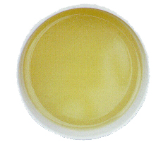 | 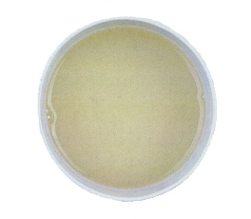 | 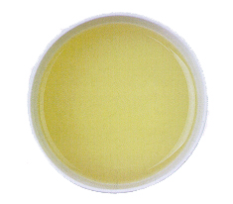 | 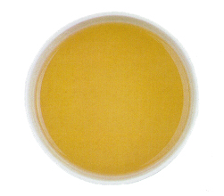 | 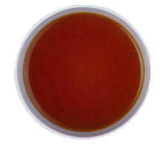 | 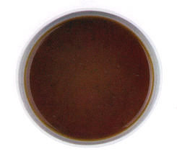 |  | 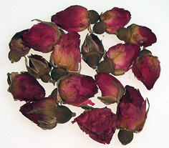
Tea Type | 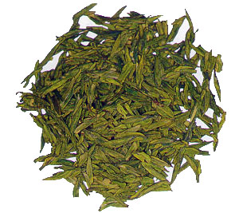 | 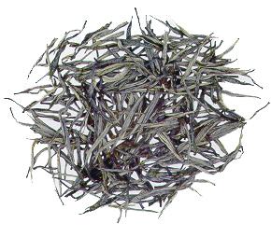 | 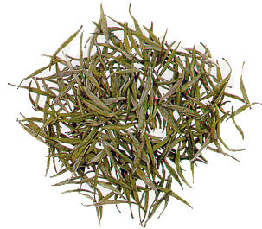 | 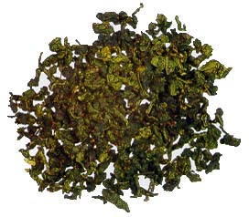 | 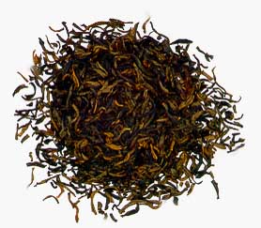 | 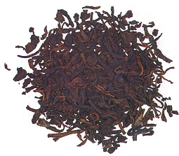 |  | 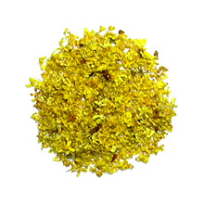
Tea Quantity | 1/3 of teapot |  |  |  |  |  |  | 2 tsp
Teapot Size | 100-500ml |  |  |  |  |  |  | 500ml
Teapot Type | Glass, Porcelain or Ceramic |  |  | Purple Clay or Porcelain |  |  |  | Glass or  Porcelain
Temperature (C) | 75-85 |  |  | 95-100 |  |  |  | 90-95
Brewing Guidelines
Step 1 | Heat up the serving teapot/teaware by rinsing with boiling water
Step 2 | Put in the tea leaves
Step 3 | Add water until the teapot overflows
Step 4 | Discard this water as to clean and heat the tea leaves
Step 5 | ENJOY using the following brewing times
Brewing Time (in Seconds)
1st Round | 5 | 5 | 5 | 5 | 5 |  | 5 | 120
2nd Round | 10 | 10 | 10 | 5 | 10 |  | 10 | 120
3rd Round | 20 | 20 | 20 | 10 | 20 |  | 20 | 180
4th Round | 60 | 60 | 60 | 20 | 30 |  | 30 | 180
5th Round |  |  |  | 30 | 60 |  | 30 | 240
6th Round |  |  |  | 40 |  |  | 40 | 240
7th Round |  |  |  | 60 |  |  | 60
8th Round |  |  |  |  |  |  | 60

Note: These brewing parameters serve as a general guideline only. We recommend that you try different brewing parameters according to your personal preference and taste.

Tea Brewing Information
Tea Type | 8 Treasure | Handcrafted Blooming Tea | Flavoured Tea | Flavoured Teabag
Tea Type | 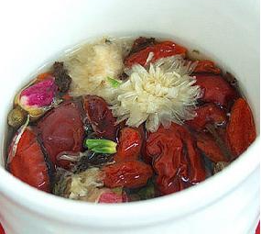 | 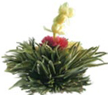 | 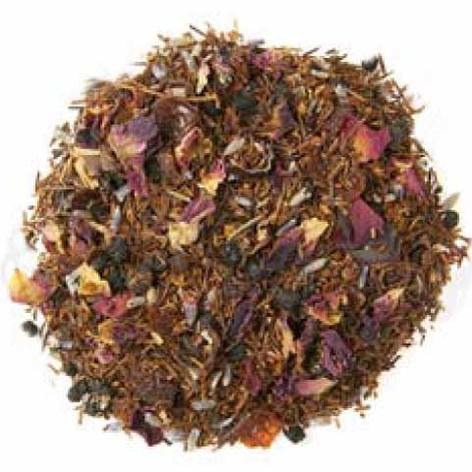 | 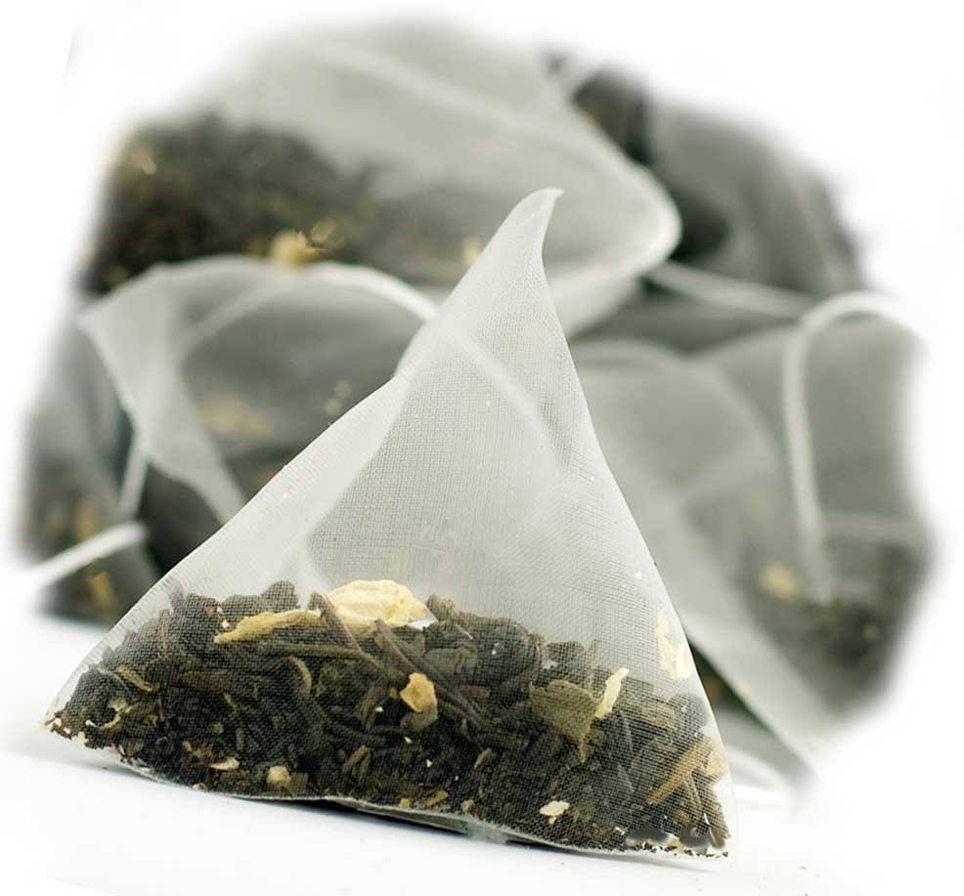
Tea Quantity | 1-12g pack | 1 Bloom | 1 tsp | 1
Teapot Size | 100-120ml | 1L | 250ml
Teapot Type | Glass, Porcelain or Ceramic
Temperature (C) | 100
Brewing Guidelines
Step 1 | Rinse with hot water | Place 1 bloom in teapot, rinse with hot water | Pour boiling water over tea
Step 2 | Add boiling water |  | Steep for 1-2 Minutes
Step 3 | Steep for 3-5 Minutes | Steep for 5 Minutes | Good for 2-3 Infusions
Step 4 | Good for 2-3 Infusions | Good for 3-4 Infusions | Add Sugar if Desired
Add. Infusions | 2-3 Minutes | 1-3 Minutes | 2-3 Minutes
 | Use a clear teapot to maximize visual effect
Ice Tea:
Tea Quantity |  | 1 Bloom | 5-6 tsp | 6 tea bags
Teapot Size |  | 1L
Brewing Guidelines
Step 1 |  | Place bloom in a heat resistant pitcher | Pour 315ml of boiling water over tea
Step 2 |  | Add 1-1/4 cups boiling water | Steep 2-3 minutes  Add sugar if desired
Step 3 |  | Steep for 5 Minutes | Pour tea into serving pitcher straining the tea /remove teabags
Step 4 |  | Fill pitcher with ice water | Add Ice & top with cold water

Note: These brewing parameters serve as a general guideline only. We recommend that you try different brewing parameters according to your personal preference and taste.

