Tea Brewing Information
Tea | Green | Black | Oolong | Red | White | Yellow | Flower | Flavour | Specialty
 | 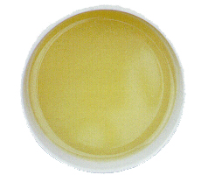 | 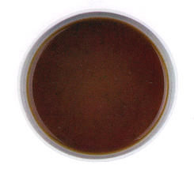 | 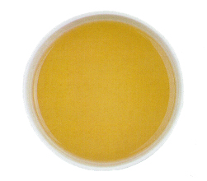 | 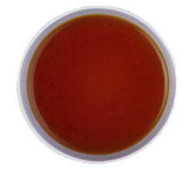 | 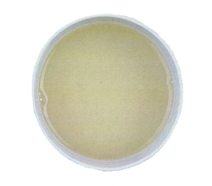 | 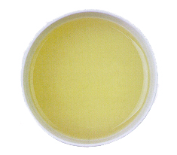 | 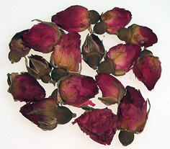 | See | See
 | 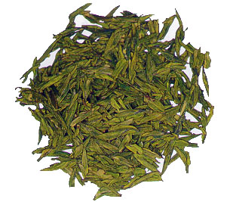 | 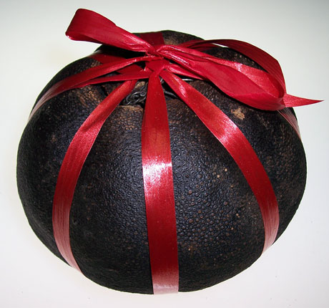 | 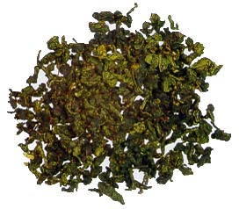 | 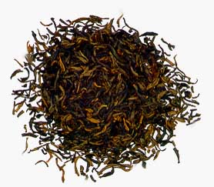 | 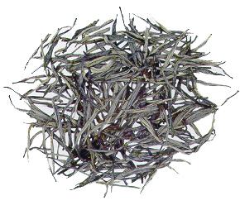 | 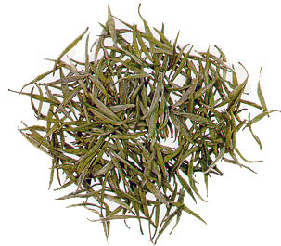 | 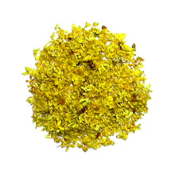 | Below | Below
Teapot (ml) | 100-500ml
Temperature (C) | 75-85 | 100 | 95-100 | 95-100 | 75-85 | 75-85 | 95-100
Brewing Guidelines
Step 1 | Heat up the serving teapot/teaware by adding boiling water
Step 2 | Put in the tea leaves
Step 3 | Add water until the teapot overflows
Step 4 | Discard this water as to clean and heat the tea leaves
Step 5 | ENJOY using the following brewing times
Brewing Time (in Seconds)
1st Round | 5 | 5 | 5 | 5 | 5 | 5 | 20
2nd Round | 10 | 10 | 5 | 10 | 10 | 10 | 30
3rd Round | 20 | 20 | 10 | 20 | 20 | 20 | 40
4th Round | 60 | 20 | 20 | 30 | 60 | 60 | 60
5th Round |  | 30 | 30 | 60 |  |  | 60
6th Round |  | 30 | 40
7th Round |  | 60 | 60
8th Round |  | 60

Note : These brewing parameters serve as a general guideline only. We recommend that you try different brewing parameters according to your personal preference and taste.

Tea Brewing Information
Tea | 8 Treasure | Handcrafted Blooming Tea | Flavour Tea
 | 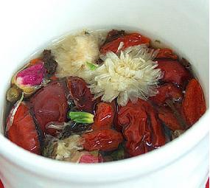 | 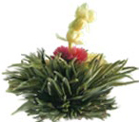 | 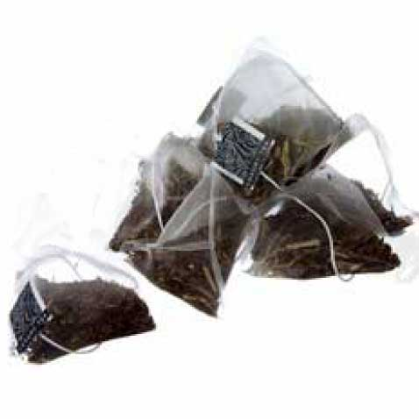
Teapot Size (ml) | 100-500ml |  | 250ml
Temperature (C) | 95-100 | 95-100 | 95-100
Brewing Guidelines
Step 1 | Use a clear teapot to to maximize visual effect
Step 1 | 1 Pack per tea cup serving | 1 Bloom per tea pot serving | 1 spoon/bag / serving
Step 2 | Rinse with hot water | Add boiling water | Add boiling water
Step 3 | Steep for 3-5 Minutes | Steep for 5 Minutes | Steep for 1-3 Minutes
Step 4 | Good for 2-3 Infusions | Good for 3-4 Infusions | Add Sugar if Desired
Add. Infusions |  | Additional Infusions: 1-3 Min.
Ice Tea: |  |  | As above, with 6 Tea Bags per Teapot.  Add Ice & Top with Cold Water

Note : These brewing parameters serve as a general guideline only. We recommend that you try different brewing parameters according to your personal preference and taste.

Chinese Tea Culture Canada Inc., Tel: 416-901-8188
www.c-tea-ca.com
www.chineseteaculturecanada.com

