A PROJECT REPORT
ON

CRIMECAST: Crime Analysis, Prediction and Sentiment Analysis
Using Machine Learning for Tamil Nadu Districts

Submitted in partial fulfilment of the requirements for the award of the degree of
[DEGREE NAME — e.g. B.E. / B.Tech / M.Sc.]
in
[DEPARTMENT — e.g. Computer Science and Engineering]

Submitted by
[STUDENT NAME]
Register No.: [REGISTER NUMBER]

Under the guidance of
[GUIDE NAME, Designation]

[COLLEGE / UNIVERSITY NAME]
[City, State]
Academic Year: 2025–2026

CERTIFICATE
This is to certify that the project report entitled “CRIMECAST: Crime Analysis, Prediction and Sentiment Analysis Using Machine Learning for Tamil Nadu Districts” submitted by [STUDENT NAME] (Register No. [NUMBER]) is a bonafide record of work carried out under my supervision. The contents of this report, in full or in parts, have not been submitted to any other Institute or University for the award of any degree or diploma.

Signature of the Guide Signature of the HOD

Place: _______________ Date: _______________

DECLARATION
I hereby declare that the project work entitled “CRIMECAST: Crime Analysis, Prediction and Sentiment Analysis Using Machine Learning for Tamil Nadu Districts” submitted to [College Name] is a record of original work done by me under the guidance of [Guide Name]. I further declare that this work has not been submitted elsewhere for any other degree or diploma.

Signature of the Candidate
Name: [STUDENT NAME]
Register No.: [NUMBER]

ACKNOWLEDGEMENT
I express my sincere gratitude to my project guide [Guide Name] for continuous guidance and encouragement. I thank the Head of the Department and faculty members of [Department] for their support. I also acknowledge open data initiatives and public reporting that make academic study of crime statistics possible. Finally, I thank my family and friends for their support during the project work.

INDEX
S.NO | CONTENTS | PAGE NO.
01. | INTRODUCTION
 | 1.1 COMPANY / ORGANIZATION PROFILE
 | 1.2 PROJECT OVERVIEW
02. | SYSTEM ANALYSIS
 | 2.1 FEASIBILITY STUDY
 | 2.2 EXISTING SYSTEM
 | 2.3 PROPOSED SYSTEM
03. | SYSTEM CONFIGURATION
 | 3.1 HARDWARE SPECIFICATION
 | 3.2 SOFTWARE SPECIFICATION
 | 3.3 ABOUT THE SOFTWARE
04. | SYSTEM DESIGN
 | 4.1 NORMALIZATION
 | 4.2 TABLE DESIGN
 | 4.3 INPUT DESIGN
 | 4.4 SFD / DFD
05. | SYSTEM DESCRIPTION
06. | TESTING AND IMPLEMENTATION
07. | CONCLUSION AND FUTURE SCOPE
08. | FORMS AND REPORT
09. | BIBLIOGRAPHY

Note: Page numbers can be filled after final print layout (or use Word Insert → Page Numbers / TOC).

01. INTRODUCTION

1.1 COMPANY / ORGANIZATION PROFILE
This project is developed in an academic setting as a decision-support prototype for district-level crime analysis in Tamil Nadu. The “client domain” is public-safety analytics: analysts, students, and researchers who work with SCRB/NCRB-style tables and contemporaneous news coverage.
Official crime statistics are typically published with lag, split across multiple tables (complaints, crimes against women, murder/homicide), and use inconsistent headers and district labels. Media coverage provides timely signals but is not a substitute for FIRs. CRIMECAST integrates both layers carefully: official-era numeric labels train models; news and sentiment support live monitoring and explanation.
The system is a college prototype. It is not a live police system, not an official SCRB forecast product, and must not be used for automated enforcement decisions.

1.2 PROJECT OVERVIEW
CRIMECAST (Crime Analysis, Prediction and Sentiment Analysis Using Machine Learning) is an end-to-end Python system with a Streamlit dashboard. It cleans multi-year Tamil Nadu district crime CSVs, trains regression models for counts and rates, scores news sentiment, produces 2026 scenario forecasts with uncertainty bands, and explains district risk using multi-source factors and model-based (SHAP-proxy / LIME-style) tools.
Major modules:
- Data acquisition & cleaning (SCRB/NCRB-style CSVs → ML-ready table)
- Model training (Ridge / Random Forest / Gradient Boosting with log targets)
- Prediction with official-history blend for sticky rates
- News harvest (Tamil + English) and sentiment scoring (DistilBERT / lexicon)
- 2026 multi-target forecasts (linear / last-year / blend) for TN38 districts
- Interactive dashboard: Live Feed, Map, Accuracy, Predict, Sentiment, Forecasts, Compare, Risk Explain, Health
- SQLite storage with optional CSV→DB migration (data/crimecast.db)
Primary prediction targets:
- Total complaints
- Murder incidence and murder rate
- Rape incidents (Sec. 376) and rape rate
- Cognizable crime rate (IPC+SLL)

02. SYSTEM ANALYSIS

2.1 FEASIBILITY STUDY

2.1.1 Technical Feasibility
The stack (Python, pandas, scikit-learn, Streamlit, Plotly, SQLite, optional transformers/DistilBERT) runs on a standard student laptop. Models are stored as joblib files; the dashboard needs no separate application server for demo. GeoJSON for Tamil Nadu districts is cached under assets/. Hence the project is technically feasible.

2.1.2 Operational Feasibility
Users operate via a sidebar navigation dashboard. Batch scripts (START_DASHBOARD.bat, news refresh, health check, CSV migrate) support non-expert operation. Outputs (CSV, HTML district briefs) support report writing. Operationally feasible for academic demos.

2.1.3 Economic Feasibility
Software used is free/open-source. No paid cloud API is required for core demos (news via public RSS-style harvest; sentiment has lexicon fallback). Economic cost is limited to student hardware time.

2.1.4 Schedule Feasibility
The pipeline is modular: clean → train → visualize → dashboard. Incremental delivery allowed partial reports earlier and full integration for final submission.

2.2 EXISTING SYSTEM
In conventional practice, analysts open separate spreadsheets for each crime category and year, clean them manually, and prepare charts in office tools. Problems include:
- Inconsistent column names and district spellings across years
- Risk of including aggregate “Total” rows (double counting)
- No systematic multi-algorithm model comparison
- Difficulty reproducing results after months
- News/sentiment disconnected from numeric crime tables
- No single interactive map for all 38 TN districts

2.3 PROPOSED SYSTEM
CRIMECAST automates discovery, cleaning, modelling, sentiment, forecasting, and visualization in one repository with a Streamlit UI.
Advantages of the proposed system:
- Reproducible ML-ready table (crimecast_ml_ready.csv / SQLite ds_ml_ready)
- Official-year training labels (≤2023 era) vs media-proxy years for maps only
- Temporal validation for honest accuracy claims
- History-blended predictions to preserve rate rankings (e.g. sticky murder rates)
- Live news heat with explicit “not FIR” labelling
- TN38 rollup (city units → parent districts; junk units dropped)
- Explainability (composite risk factors + LIME-style / importance×z proxy)
- District Compare with carve maps, per-lakh metrics, history, HTML briefs

03. SYSTEM CONFIGURATION

3.1 HARDWARE SPECIFICATION
Component | Minimum / Recommended
Processor | Intel i5 / AMD Ryzen 5 or better
RAM | 8 GB minimum; 16 GB recommended (DistilBERT)
Storage | 10 GB free (models, caches, news harvest)
Display | 1366×768 minimum; 1920×1080 recommended for dashboard
Network | Optional (first GeoJSON download; news refresh)

3.2 SOFTWARE SPECIFICATION
Software | Purpose
Windows 10/11 (or Linux/macOS) | Host OS
Python 3.10+ | Runtime
pandas, numpy, scikit-learn | Data & ML
Streamlit, Plotly | Interactive dashboard & charts
joblib | Model persistence
SQLite (built-in) | Local database data/crimecast.db
transformers + torch (optional) | DistilBERT sentiment
wordcloud (optional) | Sentiment word clouds
Git (optional) | Version control

3.3 ABOUT THE SOFTWARE
Python is chosen for scientific computing ecosystem maturity. Streamlit allows rapid UI without separate frontend frameworks. scikit-learn provides transparent classical regressors suitable for tabular district data. Plotly produces interactive choropleths. SQLite stores headlines, sentiment aggregates, forecasts, alert logs, and migrated CSV datasets without a separate DB server.
How to run the dashboard:
cd CRIMECAST
START_DASHBOARD.bat
or: py -3 -m streamlit run dashboard.py --server.port 8501
Browser: http://localhost:8501

04. SYSTEM DESIGN

4.1 NORMALIZATION
Although primary sources are denormalized yearly CSVs, the cleaned design moves toward analytical normal form suitable for ML:
- One observation grain: district_city × year (plus area_type flags)
- Separate fact families merged carefully (complaints, women crimes, murder)
- Removal of aggregate “Total / State” rows to avoid double counting
- Canonical district names via aliases and TN38 parent mapping (cities → districts)
- Rates stored separately from counts; population estimates fill missing lakhs
- Database tables split by concern: news_headlines, district_sentiment, rape_2026, alert_log, ds_* datasets
SQLite dataset tables (ds_ml_ready, ds_media_harvest, …) hold full frames for dashboard loads; structured tables hold key operational entities. This is a hybrid warehouse style appropriate for a prototype (not a full 3NF enterprise ERP schema).

4.2 TABLE DESIGN
A. File-based analytical tables
Table / File | Key fields | Role
crimecast_ml_ready.csv | district_city, year, rates, counts, features | ML training & maps
fitted_predictions.csv | district, year, target, actual, predicted | Trend history
training_metrics.csv | target, model, MAE, R², temporal_* | Model selection
rape_predictions_2026_*.csv | district, predicted, pred_low/high, risk | Scenario forecast
media_harvest_*.csv | date, district, headline, source, lang | News support
sentiment_scores.csv | text, polarity, label, crime_intensity | Sentiment corpus

B. SQLite (data/crimecast.db) — structured
Table | Purpose
meta | Key-value sync timestamps
news_headlines | Harvested headlines + optional scores
district_sentiment | Aggregated polarity / concern by district
rape_2026 | Forecast snapshot per district
alert_log | Persisted HIGH/MED operational alerts
dataset_registry | Catalogue of migrated CSV datasets
ds_ml_ready, ds_media_harvest, … | Full CSV frames in DB

4.3 INPUT DESIGN
Inputs to the system:
- Raw yearly CSVs under dataset/ (complaints, women crimes, murder/homicide)
- Optional SCRB/NCRB staged/drop-in files under dataset/scrb_ncrb/
- Dashboard controls: district, target, year, news time window, forecast method
- News refresh action (incremental harvest)
- Optional labeled sentiment text for TF-IDF training
Input validation includes year parsing, numeric coercion, junk district filtering, and TN38 resolution so maps and scoreboards remain consistent.

4.4 SFD / DFD
System Flow Diagram (SFD) and Data Flow Diagrams (DFD Level 0 / Level 1) document how data moves from sources through processes to users.
Figure 4.1 — Context diagram (DFD Level 0)
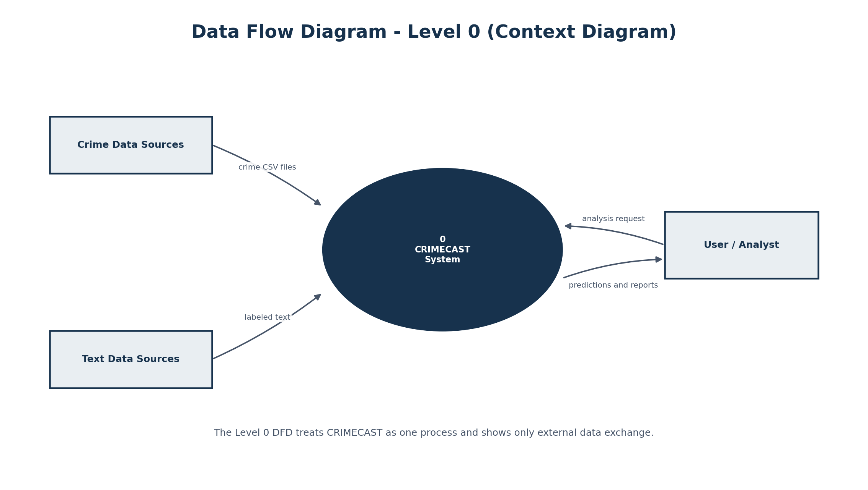
Figure 4.1 DFD Level 0 — CRIMECAST context
Figure 4.2 — DFD Level 1
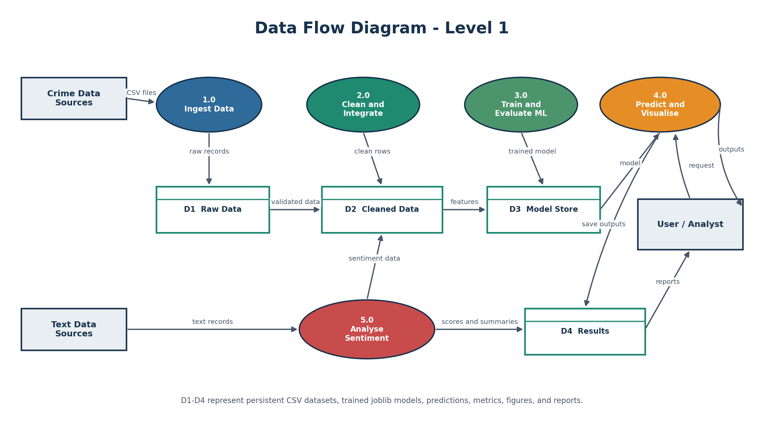
Figure 4.2 DFD Level 1 — major processes
Figure 4.3 — System flow
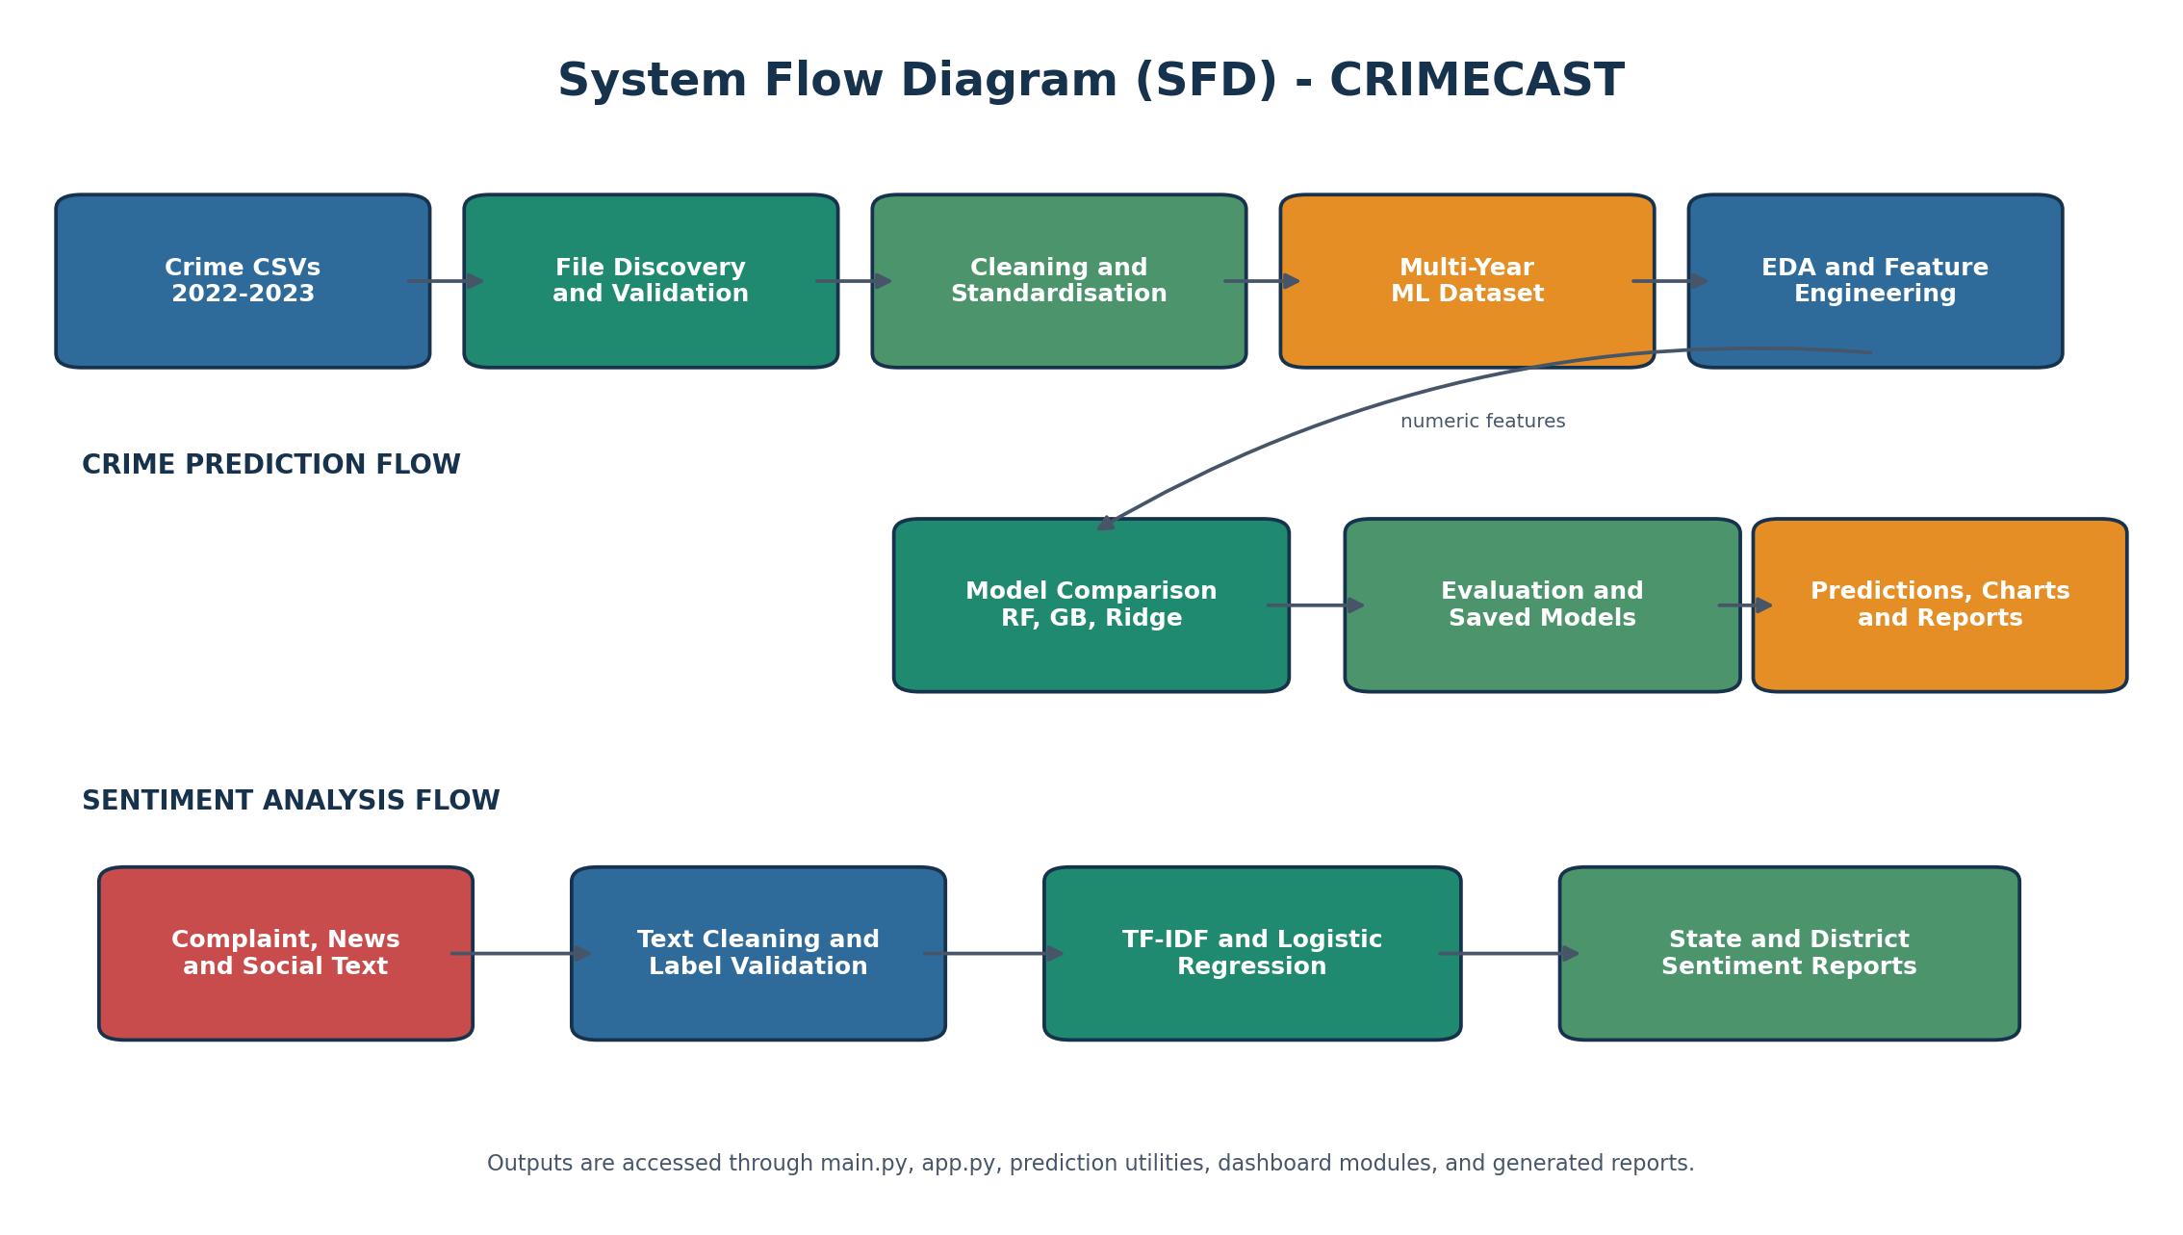
Figure 4.3 System flow diagram
Level-0 summary:
- External entities: Crime data sources; Text/news sources; User/Analyst
- Process 0: CRIMECAST System
- Outputs: Predictions, sentiment, 2026 scenarios, dashboard views, reports
Level-1 processes (typical):
- P1 Acquire / clean official tables
- P2 Feature engineering & ML-ready build
- P3 Train & evaluate models
- P4 Predict & blend with history
- P5 News harvest & sentiment
- P6 Forecast 2026 scenarios
- P7 Dashboard presentation & alerts

05. SYSTEM DESCRIPTION
This chapter describes functional modules as implemented in the repository.

5.1 Data Cleaning Module (clean_data.py)
Discovers supported year files, standardises headers, drops aggregate rows, coerces numerics, merges families into crimecast_ml_ready.csv. Flags distinguish official-era labels from thinner/proxy years used only as templates or map context.

5.2 Training Module (train_model.py)
For each target, builds a preprocessing pipeline (numeric impute/scale + categorical encoding), compares Dummy, Ridge, Random Forest, and Gradient Boosting (often on log targets). Selection emphasises temporal holdout where available. Artifacts: models/*.joblib, best_models.json, training_metrics.csv, training_report.md.
Best models (from current training_report.md):
Target | Best model | Temporal MAE | Temporal R²
Total complaints | gradient_boosting_log | 44760.44 | -0.87
Murder incidence | gradient_boosting_log | 11.52 | 0.44
Rape incidents | random_forest_log | 3.15 | 0.36
Murder rate | gradient_boosting_log | 0.73 | 0.50
Rape rate | ridge_log | 0.39 | 0.56
Cognizable rate | gradient_boosting_log | — | —

Honest note: temporal R² for some count targets is weak with short history — the dashboard Accuracy tab exposes this rather than hiding it.

5.3 Prediction Module (predict.py)
Resolves districts (including TN38 parents), builds feature rows for a requested year, runs the stored pipeline, and blends model output with multi-year official history (stronger weight for rates). populate_all_district_predictions fills the TN map.

5.4 Sentiment & News
News is harvested into media_harvest CSVs. Sentiment uses DistilBERT when available, else lexicon scoring. District concern scores drive the Sentiment map; word clouds visualise frequent terms per district.

5.5 2026 Forecast Engine (forecast_engine.py / predict_2026_*)
District-level scenarios for rape incidents, murder incidence, and total complaints. Methods: linear trend, last-year carry, 50/50 blend. City units roll into TN38; uncertainty bands widen with horizon. Not official SCRB forecasts.

5.6 Dashboard Modules (dashboard.py)
Tab | Function
Live Feed | News heat, HIGH alerts, alert log, how-it-works, health strip
District Map | Choropleth, heat matrix, per-lakh scoreboard
Accuracy Check | Training metrics, claims, blend accuracy, holdout backtest
Predict | Single-area predict + all-district map (no news fill)
Sentiment | Concern map + word clouds
2026 Forecasts | Multi-target, method toggle, map, uncertainty
District Compare | Carve maps + full metrics + history + briefs
Risk Explain | Composite factors + SHAP-proxy + LIME-style
Health | File/model/DB checks; CSV→DB migrate

5.7 Database Layer (db.py)
SQLite at data/crimecast.db. migrate_csv_to_db.py (or Health tab) loads main CSVs into ds_* tables. Dashboard loaders prefer DB then fall back to CSV. PostgreSQL is reserved for future multi-user deploy (env URL stub only).

06. TESTING AND IMPLEMENTATION
This chapter describes how CRIMECAST was implemented (environment and build steps) and how it was tested (strategy, formal cases, automated runner, UI checklist, and result figures).

6.1 Implementation Environment
Item | Detail
Language | Python 3.10+
Core libraries | pandas, numpy, scikit-learn, joblib
UI | Streamlit, Plotly
Storage | CSV files + SQLite (data/crimecast.db)
Optional | transformers/torch (DistilBERT), wordcloud
OS (demo) | Windows 10/11
Test runner | py -3 run_tests.py
Dashboard | py -3 -m streamlit run dashboard.py --server.port 8501

6.2 Implementation Steps
- Data preparation — place yearly CSVs under dataset/ (optional SCRB staging).
- Cleaning — clean_data / pipeline → dataset/cleaned/crimecast_ml_ready.csv.
- Training — train_model.py; review training_report.md and training_metrics.csv.
- Prediction — predict.py with official-history blend for rates.
- News & sentiment — harvest refresh; DistilBERT/lexicon scoring; word clouds.
- 2026 scenarios — forecast_engine / predict_2026 (linear · last-year · blend; TN38).
- Optional DB — migrate_csv_to_db.py or Health tab Migrate CSVs.
- Dashboard — streamlit run dashboard.py; walk Live → Map → Accuracy → Predict → 2026 → Compare.
- Exports — district brief HTML, accuracy CSV, figures, test terminal capture.

6.3 Testing Strategy
Testing is organised in layers P0–P4. Automated tests run without .bat files:
py -3 run_tests.py
py -3 project_docs/capture_test_terminal.py
Layer | Name | Purpose
P0 | Core unit | Districts, forecast math, layout, health structure
P1 | Unit + fixtures | clean_data, blend weights, alert rules, map aliases
P2 | Integration | predict_for_area; forecast_districts column contracts
P3 | Data quality | ML-ready / metrics / 2026 schema and non-negativity
P4 | UI / system | Manual checklist U1–U24; optional Streamlit AppTest

Type | What was checked in CRIMECAST
Unit testing | Column normalise, TOTAL drop, TN38, forecast bands, blend, alerts
Integration testing | Predict + populate; 2026 multi-target schema
Data-quality testing | Year range, no aggregates, non-negative counts, official flags
Model evaluation | CV / test / temporal MAE and R² (Accuracy tab + metrics CSV)
System / UI testing | Pages load; forecast/predict maps without news fill
Regression / self-test | 2026 engine remains sklearn-free

6.4 Formal Test Cases (ID · Steps · Expected · Actual)
Eight formal test cases. Full narrative: docs/FORMAL_TEST_CASES.md. UI walkthrough: docs/MANUAL_UI_CHECKLIST.md (U1–U24).
ID | Type | Steps (summary) | Expected | Actual / Status
TC-01 | Unit | District entities (to_tn38, junk) | Cities→parents; TN38=38 | Pass
TC-02 | Unit | clean_dataset drops TOTAL row | TOTAL removed; year set | Pass
TC-03 | Unit | Blend history rate vs count weights | 62%/35% hist; ≥0 | Pass
TC-04 | Unit | Alerts Thoothukudi>Madurai + 2026 HIGH | HIGH alerts raised | Pass
TC-05 | Integration | predict_for_area murder_rate Chennai | prediction≥0 | Pass/Skip*
TC-06 | Integration | forecast_districts rape linear | Schema + bands OK | Pass
TC-07 | Data quality | ML-ready quality rules | No TOTAL; non-neg | Pass
TC-08 | System/UI | Dashboard + P4 source checks | No crash; no news fill | Pass

*TC-05 may Skip if trained .joblib models are absent; unit and data-quality tests still run.
Test execution: command py -3 run_tests.py · Overall Pass if failures=0 and errors=0.
Figure 6.0 — Terminal output of py -3 run_tests.py
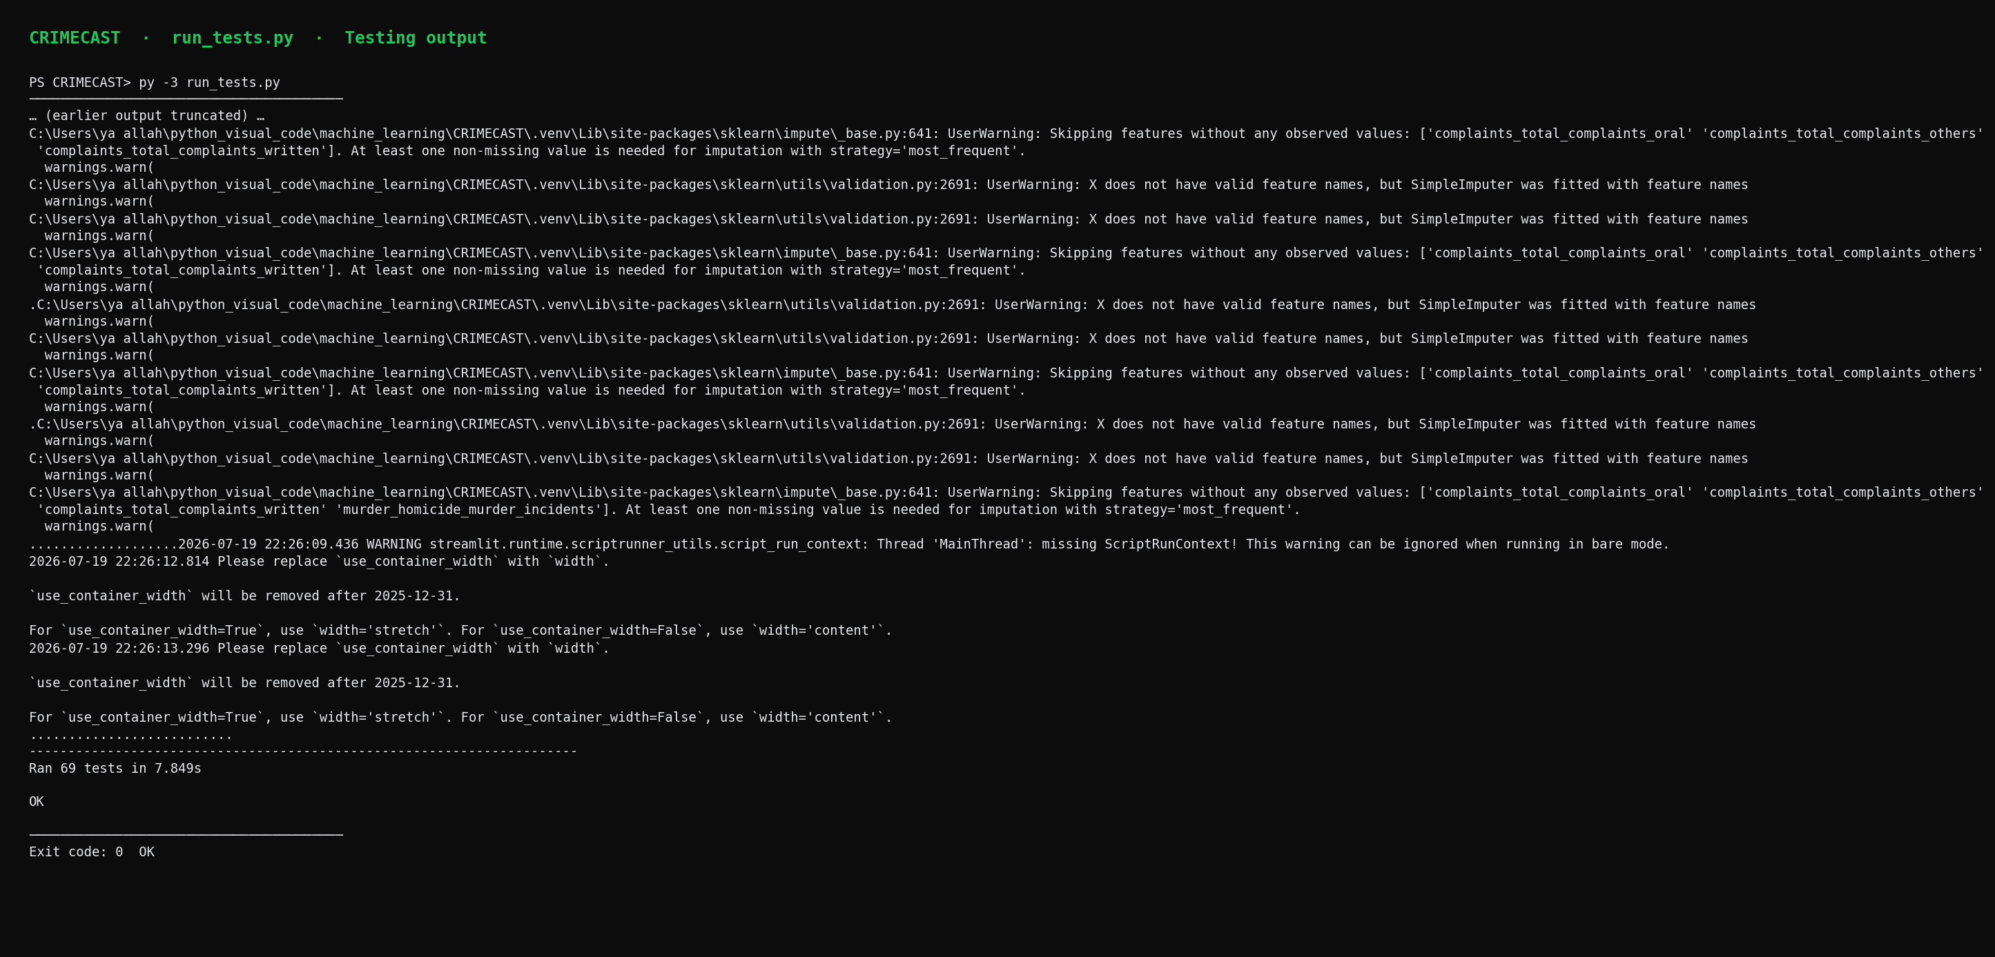
Figure 6.0 Automated test run (run_tests.py) — testing evidence for Forms/Report
Generate/update Figure 6.0: py -3 project_docs/capture_test_terminal.py

6.5 Implementation Modules Delivered
Module | File(s) | Outcome
Cleaning | clean_data.py | Multi-year ML-ready table
Training | train_model.py | Best model per target + metrics
Prediction | predict.py | District predict + history blend
Forecast 2026 | forecast_engine.py, predict_2026_* | Scenarios + uncertainty
Sentiment / news | sentiment_*, harvest CSVs | Concern map + word clouds
Dashboard | dashboard.py | Live through Health tabs
Database | db.py, migrate_csv_to_db.py | SQLite + CSV migrate
Testing | run_tests.py, tests/test_*.py | P0–P4 automated suite

6.6 Results Snapshot (current data — regenerated)
Figures below are regenerated from live project data into project_docs/figures/results/ (preferred over legacy model_outputs/figures). 2026 charts are scenarios, not SCRB facts; news volume is a media support layer, not FIRs.
Figure 6.1 — Actual vs predicted (fitted models)
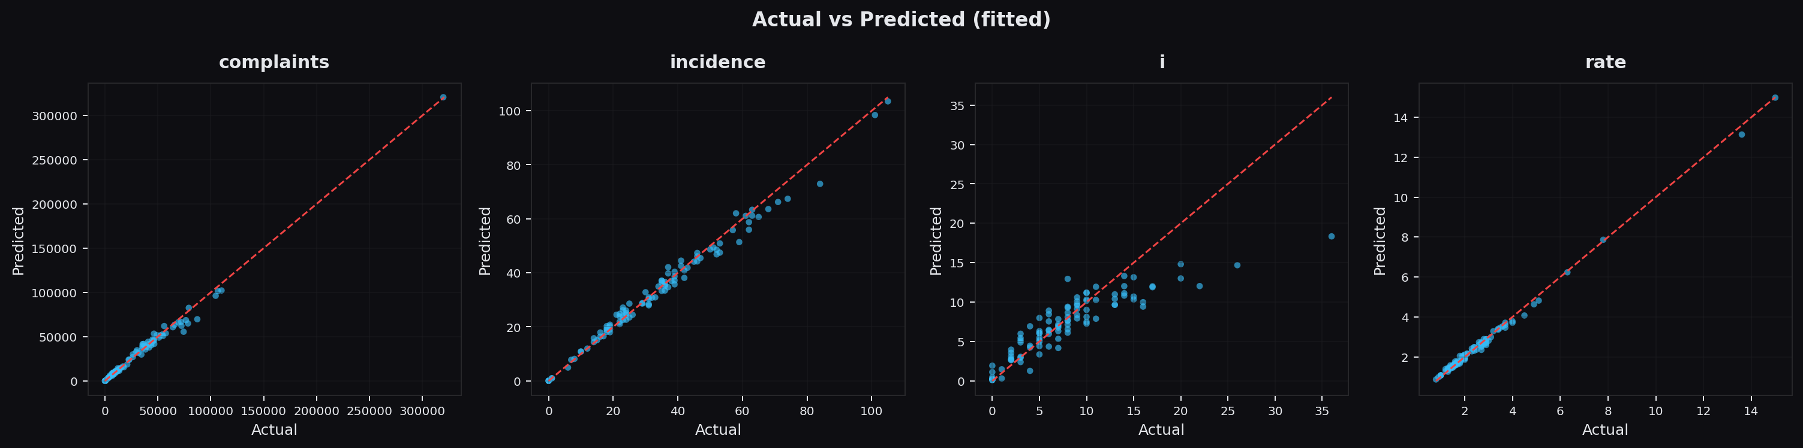
Figure 6.1 Actual vs predicted (current fitted_predictions)
Figure 6.2 — Top murder incidence (TN38, latest year)
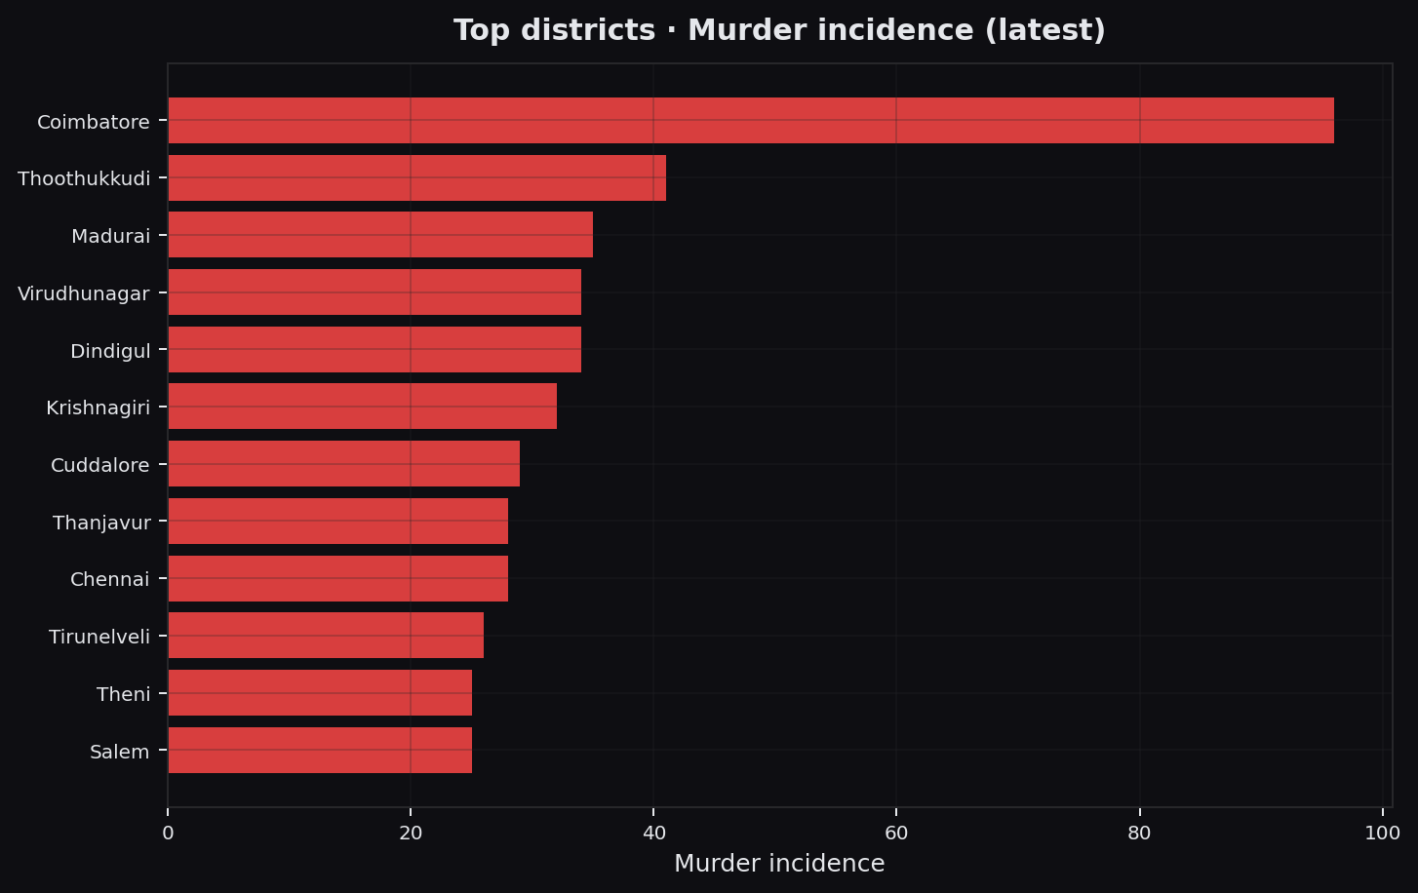
Figure 6.2 Top murder incidence — current ML-ready
Figure 6.3 — Top rape incidents Sec.376 (latest)
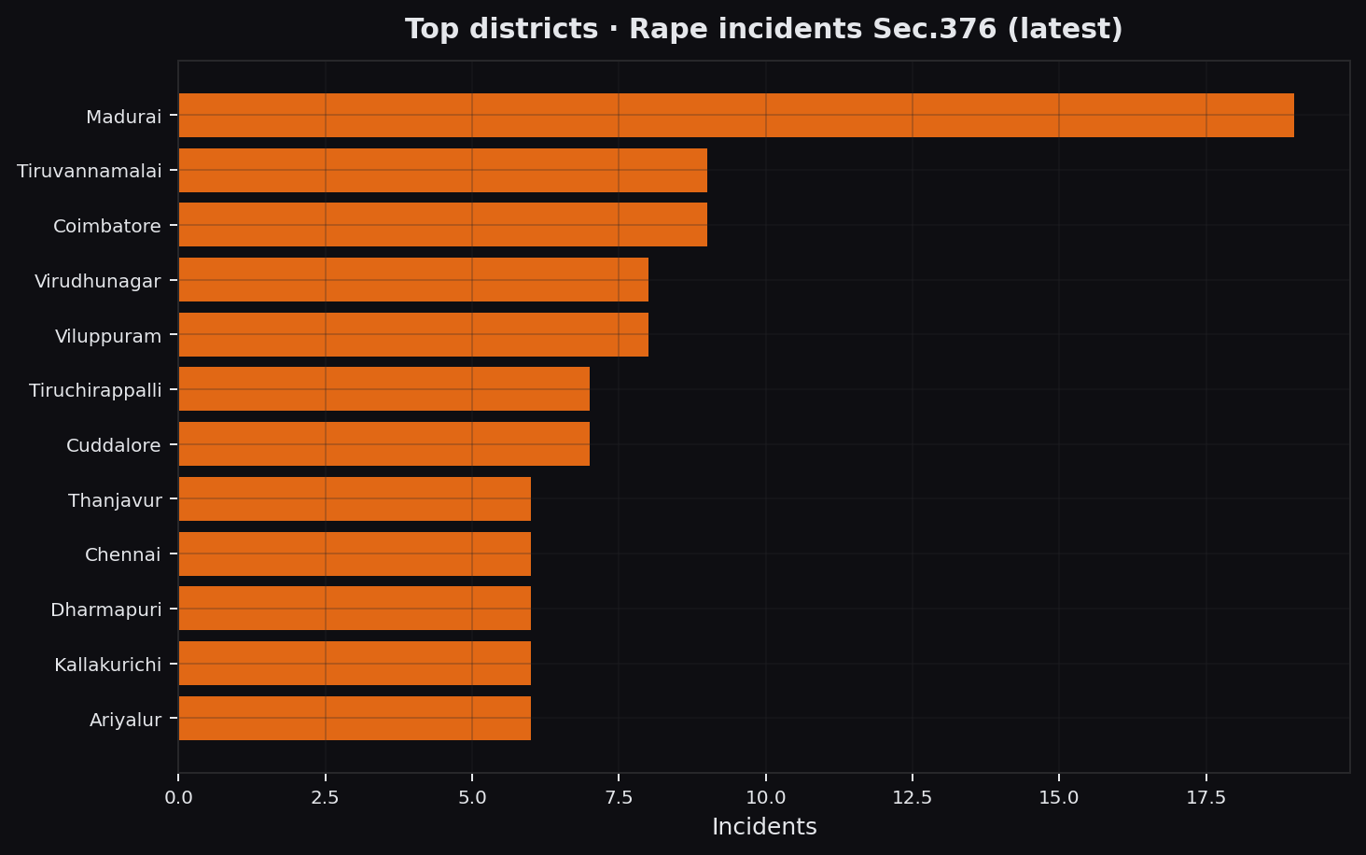
Figure 6.3 Top rape incidents — current ML-ready
Figure 6.4 — Best models Test R²
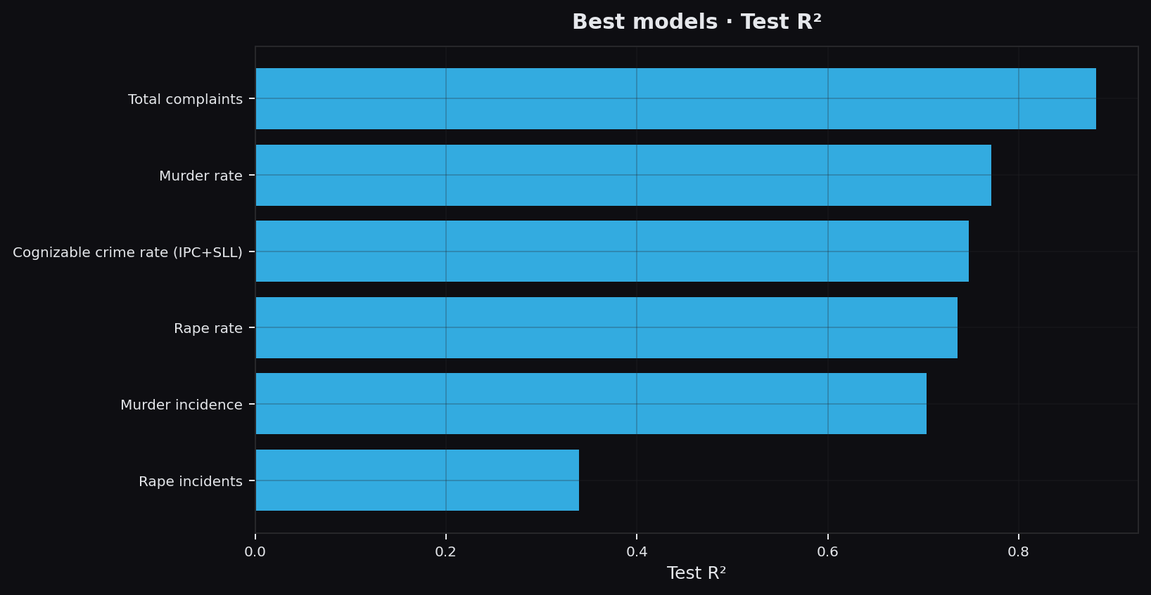
Figure 6.4 Training metrics — best models test R²
Figure 6.5 — 2026 rape scenario top 15 (TN38)
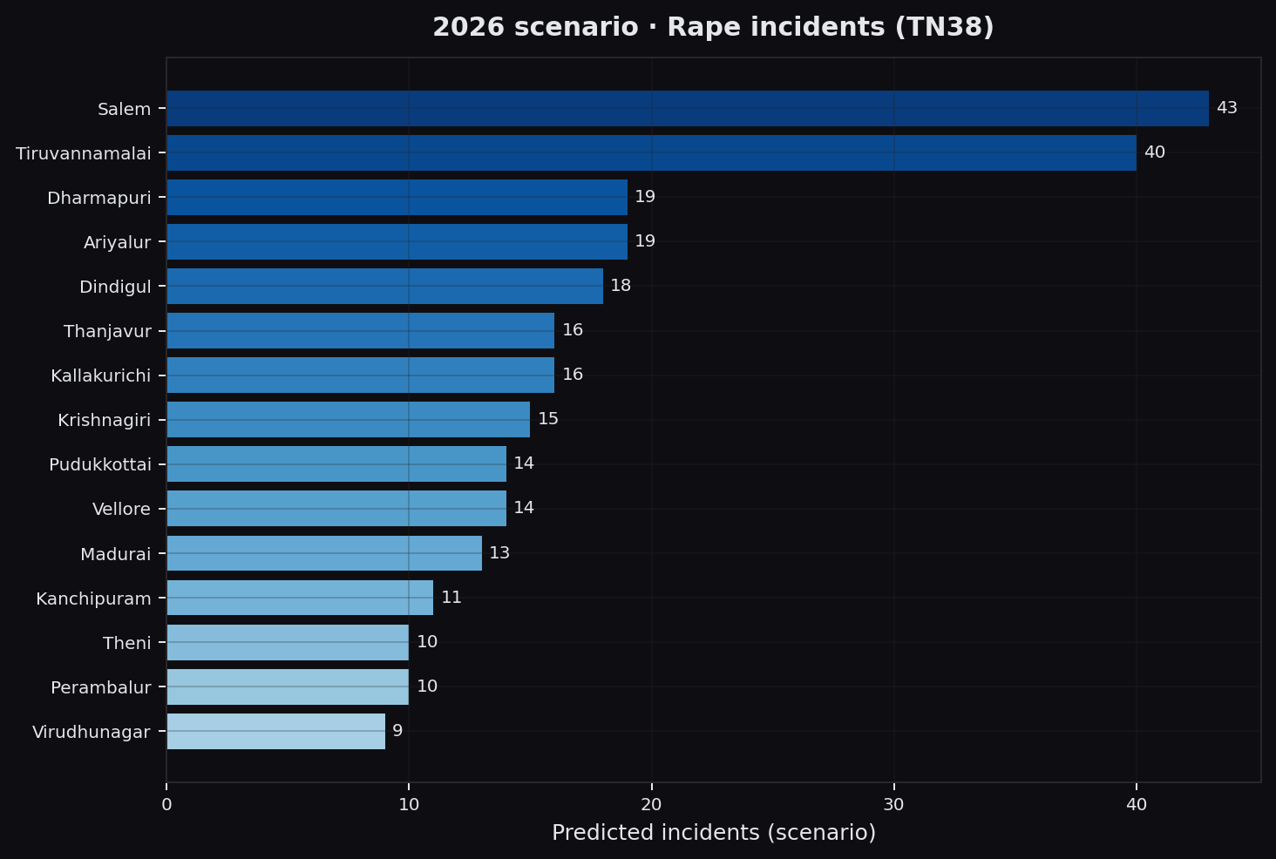
Figure 6.5 2026 scenario forecast — top districts (not official SCRB)
Figure 6.6 — 2026 risk category share
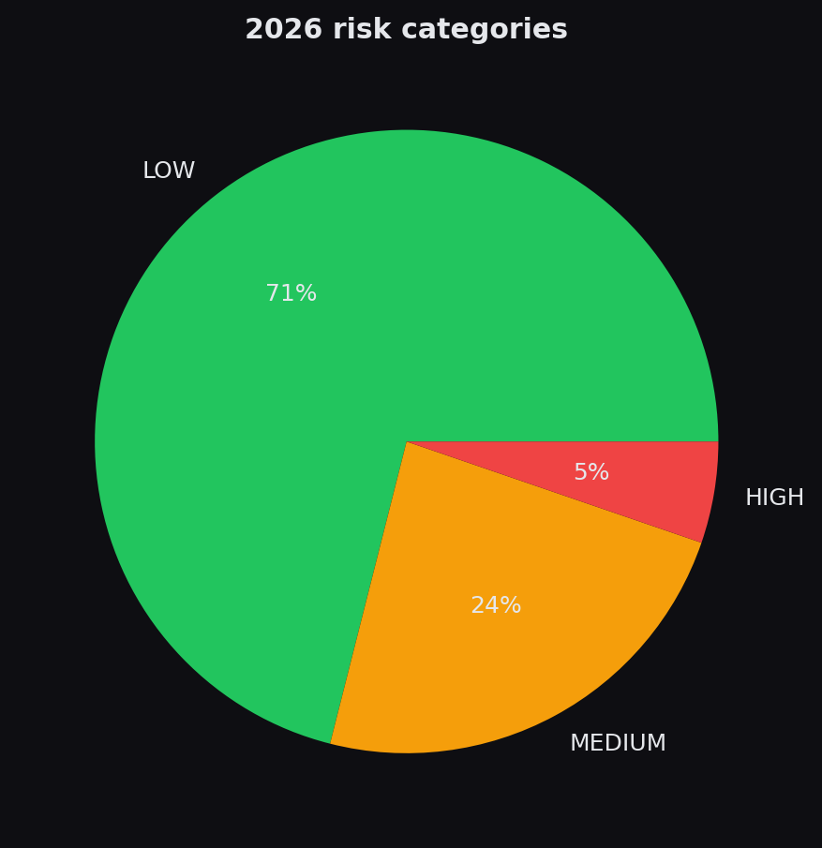
Figure 6.6 2026 risk categories
Figure 6.7 — News volume by district (media harvest)
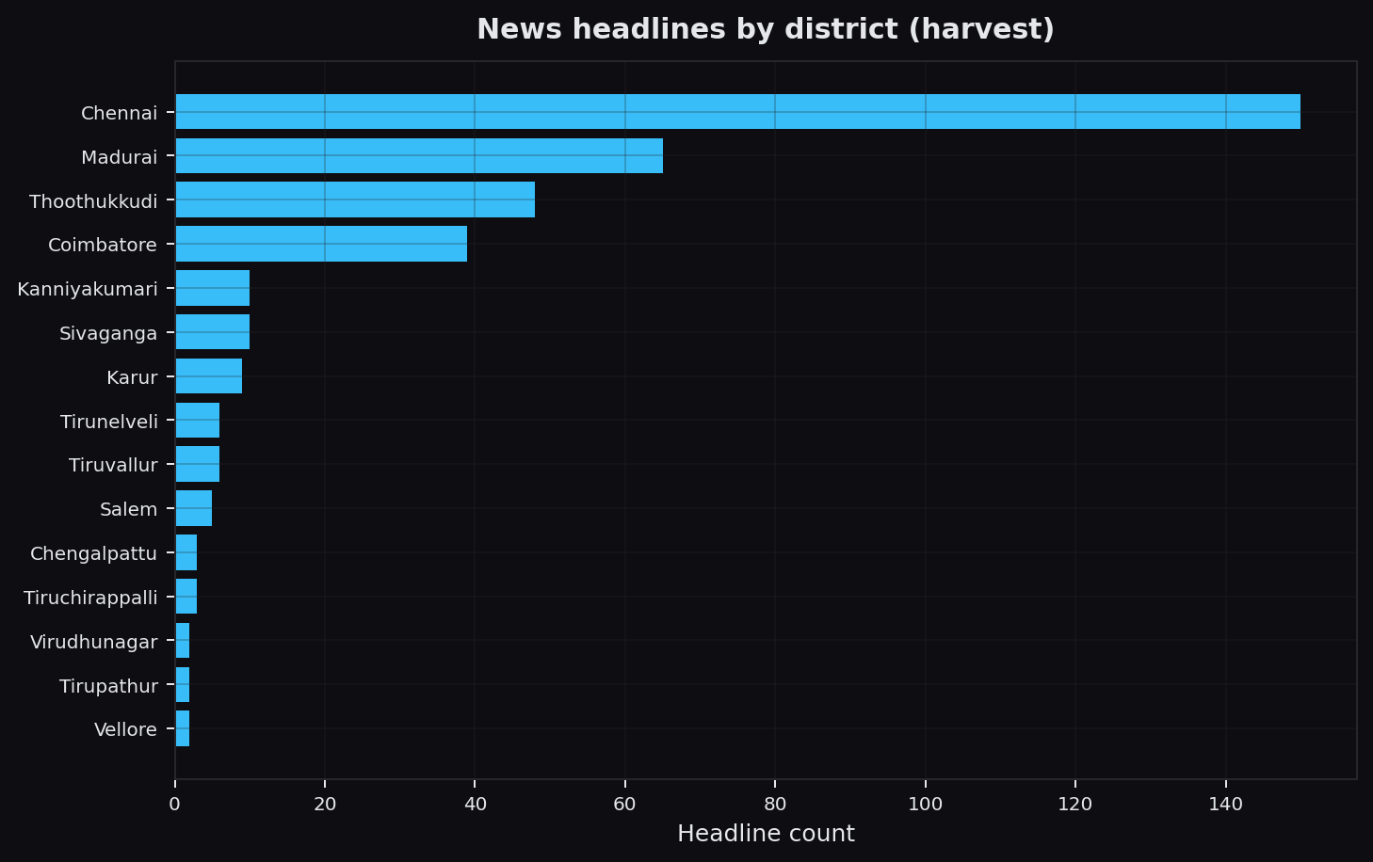
Figure 6.7 Current news harvest volume (support layer, not FIRs)

6.7 Limitations of Testing
- Integration predict tests skip when models are not trained.
- Streamlit AppTest is optional and may skip in heavy (torch) environments.
- Manual UI checklist remains the primary UI sign-off for viva.
- Short official time series limits temporal R² — reported honestly on Accuracy page.

07. CONCLUSION AND FUTURE SCOPE

7.1 Conclusion
CRIMECAST demonstrates a complete academic pipeline from messy multi-table crime CSVs to trained models, news-aware monitoring, scenario forecasts, and explainable district comparison. The design deliberately separates official training labels from media proxies, uses temporal evaluation, and presents uncertainty and limitations openly.
With limited official years, long-horizon forecasts remain scenarios. Within that constraint, the system is usable for teaching, demos, and structured analysis of Tamil Nadu district patterns.

7.2 Limitations
- Short official time series limits true forecasting power
- Media headlines ≠ registered crimes
- Some administrative units require aggressive alias/junk filtering
- DistilBERT optional dependency can fail in constrained environments (lexicon fallback)
- PostgreSQL multi-user backend not fully implemented (SQLite is production path for demo)

7.3 Future Scope
- Add more official years (pre-2022 SCRB + consistent 2024+ when published)
- Monthly series for seasonality-aware models
- Full PostgreSQL adapter for multi-user lab deployment
- Stronger causal / policy evaluation designs (not only predictive)
- Multilingual Tamil NLP beyond lexicon for headlines
- User authentication and audit logs for institutional use

08. FORMS AND REPORT
In a classical desktop system, “forms” are screens. In CRIMECAST, Streamlit pages serve as forms/reports. The following panels are regenerated from current project data (project_docs/figures/screenshots/) for the hard-copy annex — not legacy WhatsApp photos.
- Live Feed — news heat and alerts
- District Map — choropleth and scoreboard
- Accuracy Check — metrics and honesty statements
- 2026 Forecasts — scenario map / ranking
- District Compare — multi-district analysis
- Sentiment — concern / volume panel
- Health — readiness checklist
Figure 8.1 — Live Feed (form)
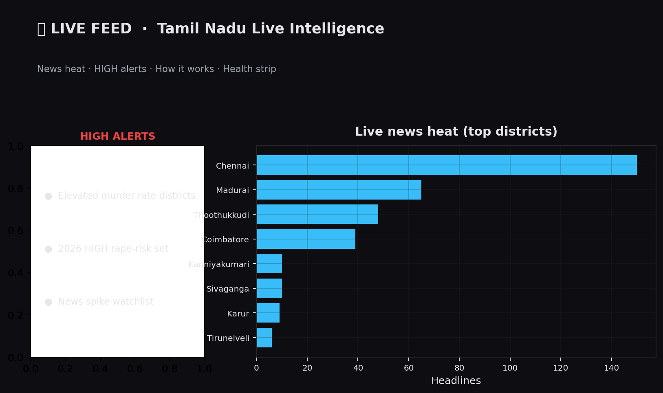
Figure 8.1 Form — Live Feed
Figure 8.2 — District Map & Scoreboard (form)
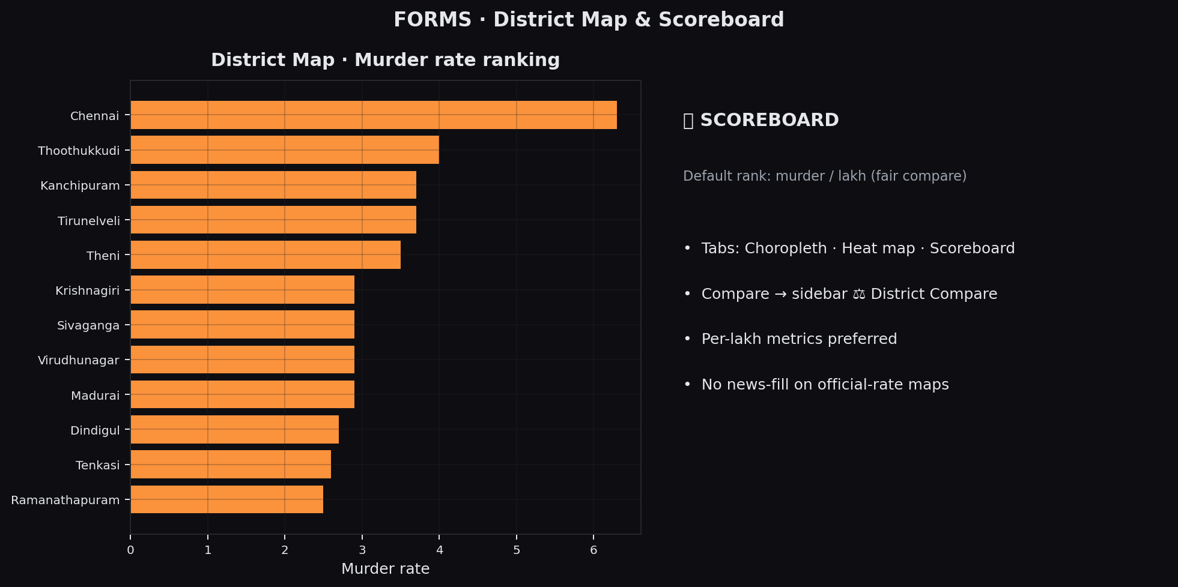
Figure 8.2 Form — District Map
Figure 8.3 — Accuracy Check (form)
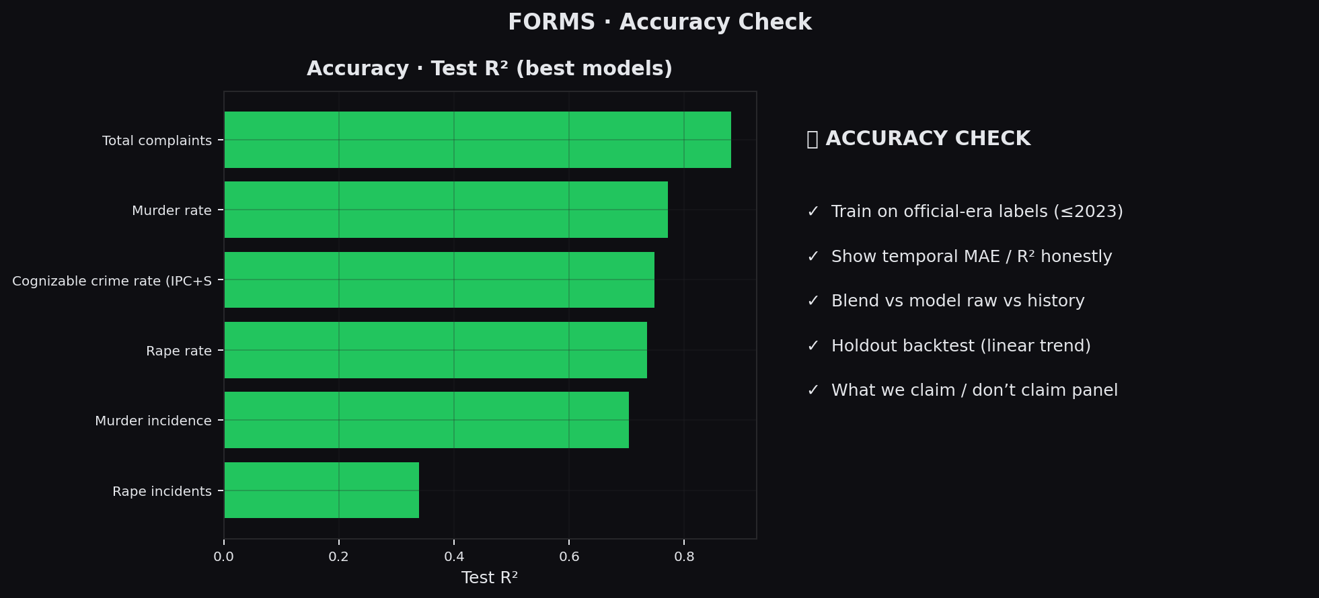
Figure 8.3 Form — Accuracy Check
Figure 8.4 — 2026 Forecasts (form)
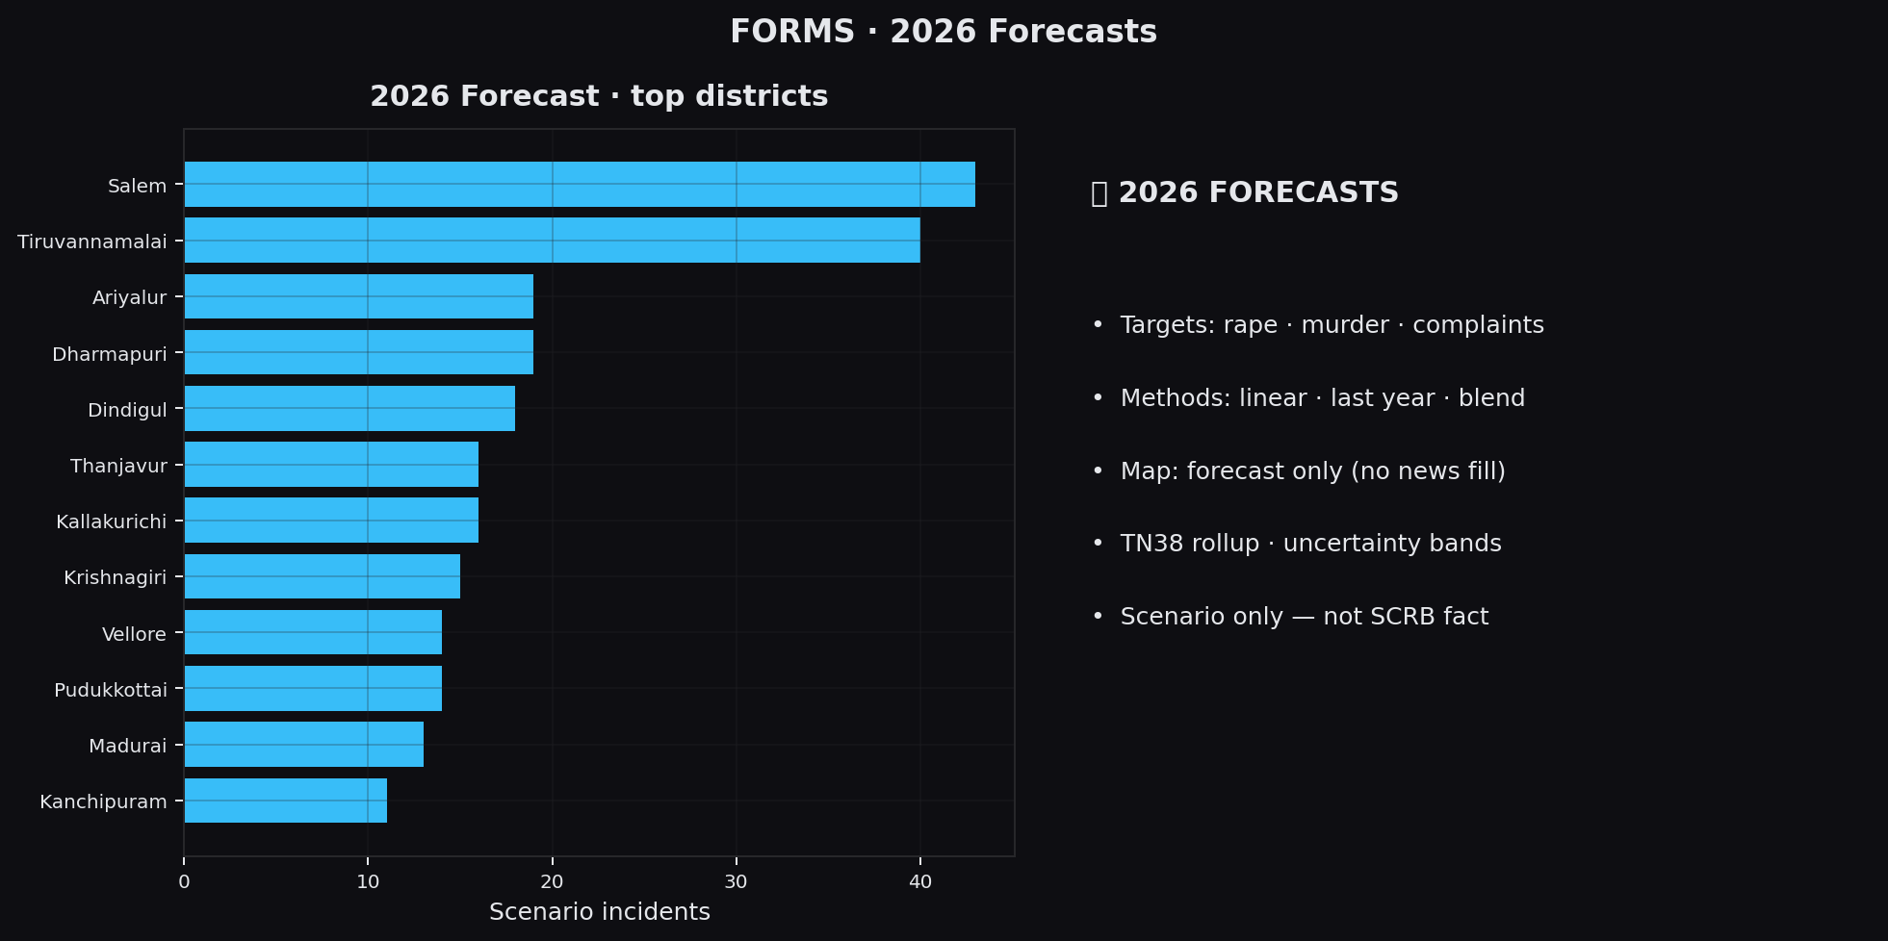
Figure 8.4 Form — 2026 Forecasts
Figure 8.5 — District Compare (form)
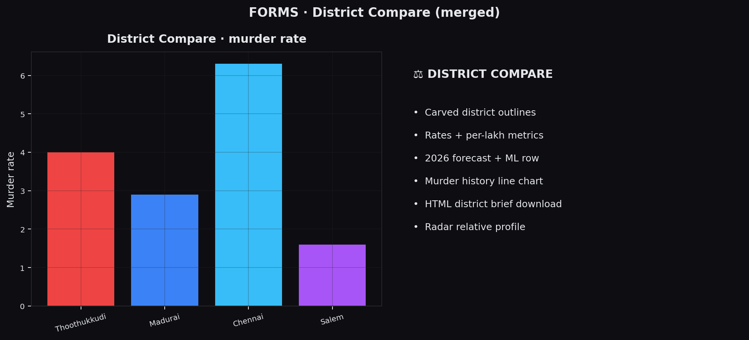
Figure 8.5 Form — District Compare
Figure 8.6 — Sentiment (form)
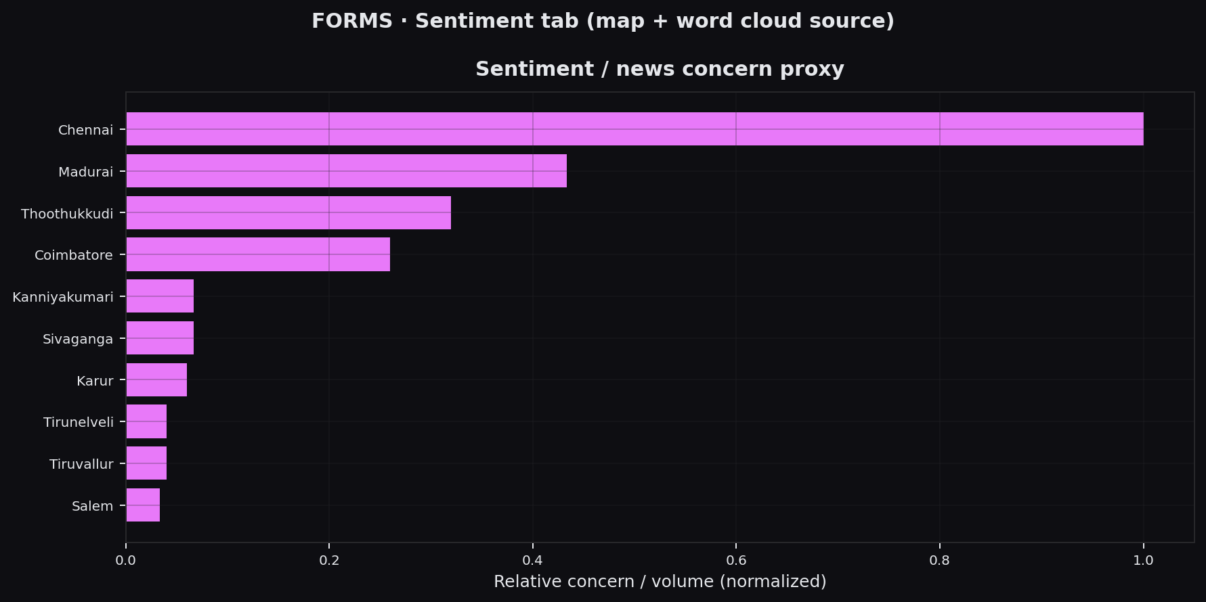
Figure 8.6 Form — Sentiment
Figure 8.7 — Health (form)
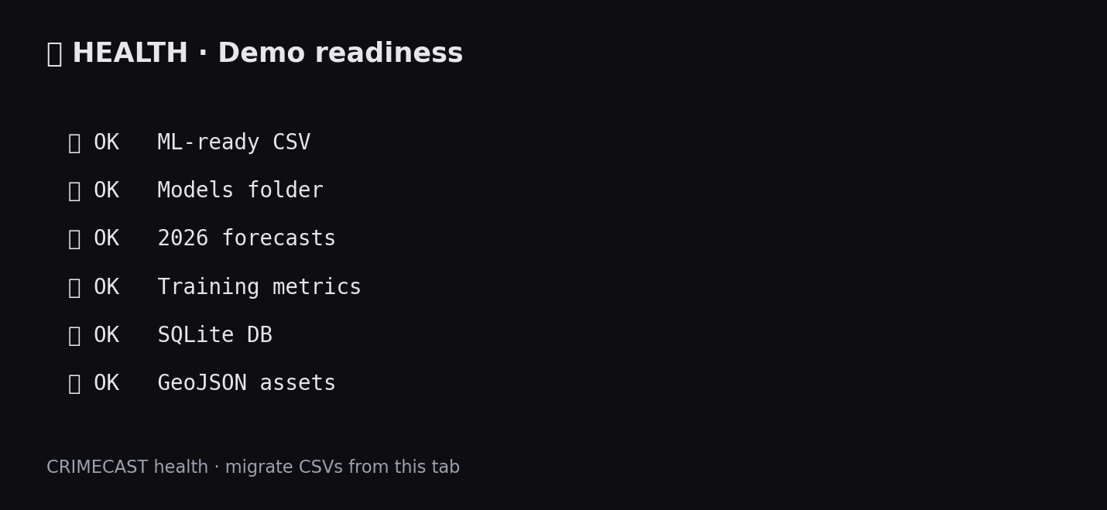
Figure 8.7 Form — Health check
Figure 8.8 — run_tests.py terminal (testing evidence)

Figure 8.8 Terminal screenshot — automated unit/integration tests
Generate/update this figure: py -3 project_docs/capture_test_terminal.py
Figure 8.9 — Report INDEX template (college structure)
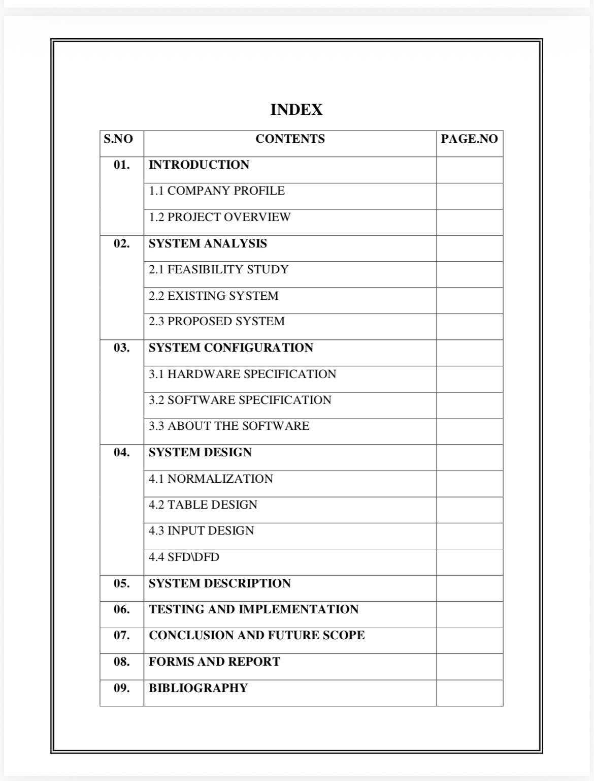
Figure 8.9 College INDEX structure (reference only)
Optional: after running the live Streamlit app, replace any panel above with a true browser screenshot (Win+Shift+S) for maximum realism in the bound book.
Printed annex suggestions:
- training_report.md (print or paste metrics table)
- rape_predictions_2026_report.txt
- One district brief HTML printed via browser Ctrl+P
- health_check output
- project_docs/figures/MANIFEST.md (list of regenerated assets)

09. BIBLIOGRAPHY
[1] National Crime Records Bureau (NCRB), Ministry of Home Affairs, Government of India — Crime in India (various years).
[2] State Crime Records Bureau (SCRB) / Tamil Nadu Police — district statistical tables (as available).
[3] OpenCity / public TN crime data portals — district CSV releases (e.g. 2023 sets used in academic workflows).
[4] Pedregosa et al., “Scikit-learn: Machine Learning in Python,” JMLR, 2011.
[5] McKinney, W., “Data Structures for Statistical Computing in Python” (pandas), Proc. of the 9th Python in Science Conference, 2010.
[6] Streamlit Inc., Streamlit Documentation — https://docs.streamlit.io/
[7] Plotly Technologies, Plotly.py Documentation — https://plotly.com/python/
[8] Sanh et al., “DistilBERT, a distilled version of BERT,” arXiv:1910.01108, 2019.
[9] Ribeiro, Singh, Guestrin, “Why Should I Trust You?” Explaining the Predictions of Any Classifier (LIME), KDD, 2016.
[10] Lundberg & Lee, “A Unified Approach to Interpreting Model Predictions” (SHAP), NeurIPS, 2017.
[11] Python Software Foundation, Python Language Reference — https://docs.python.org/3/
[12] SQLite Development Team, SQLite Documentation — https://www.sqlite.org/docs.html

— End of Report —
Fill bracketed fields [STUDENT NAME], [REGISTER NUMBER], [GUIDE], [COLLEGE] before final print.

