Project Group 3

Harrison Futch

Shayna Solomon

Module 10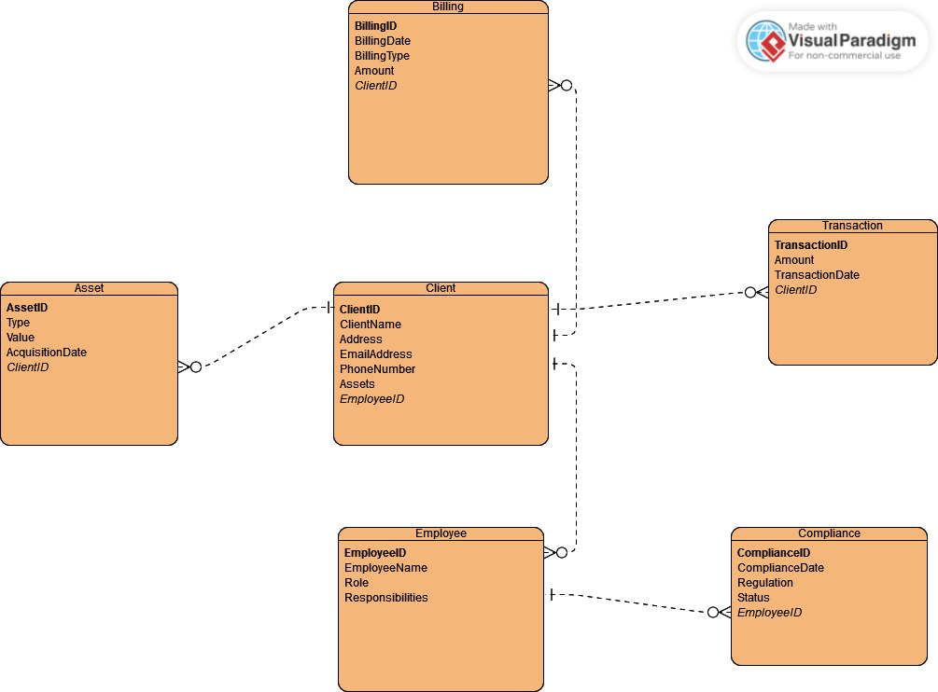

Finalized ERD that is put in 3NF.

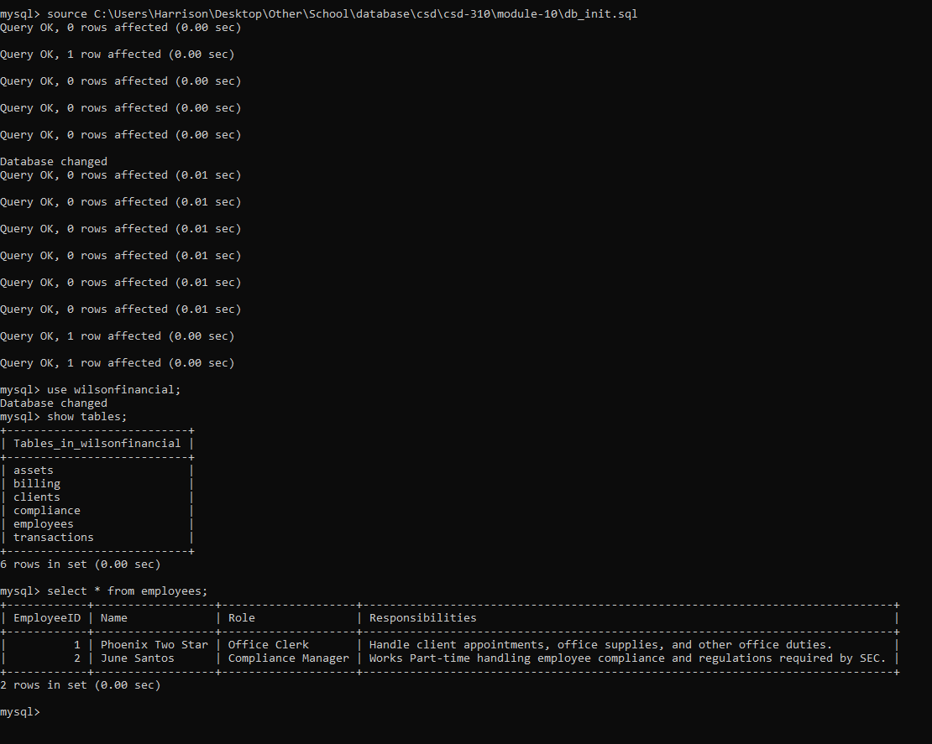

Database setup with the two records from the case study added.

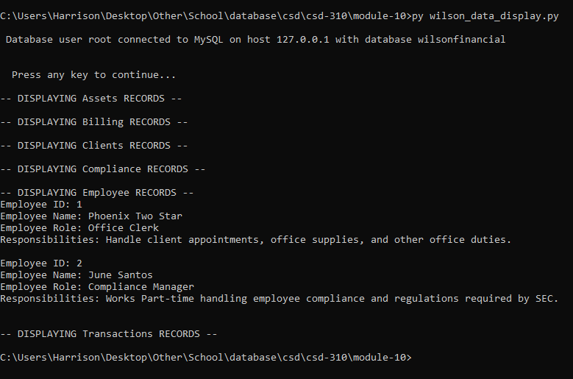

Displaying all data that we have from the case study.