Harrison Futch - https://github.com/darthrevan01/csd-310

Module 5.2 Assignment

Function One (GREATEST): This function allows users to find the highest numeric value in a list presented in the arguments that the user creates.

Alias: SELECT GREATEST(0,1,2,3,4,8) AS ‘Greater Num’;

Function Two (FIND_IN_SET): This is used when the user needs to find something specific in a list of strings in order to gain its information or be able to change it in some sort of way.

Alias: SELECT FIND_IN_SET(“s”, “a,b,c,s,i,s,b,e,r,s,u) AS ‘Letters In Set’;

Function Three (FORMAT): This function is used so that users can create numbers to look a specific way to match other information in a table or database. Could also be helpful when using numeric/mathematical functions

Alias:

Function One Screenshot

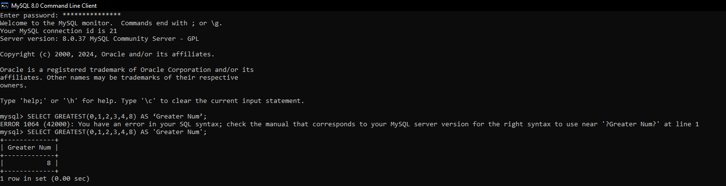

Function Two Screenshot

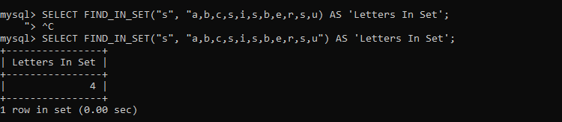

Function Three Screenshot

