Harrison Futch

Assignment 1.2 – GitHub set-up

8/16/2024

Deliverables:

1. <https://github.com/darthrevan01/csd-340>
2. 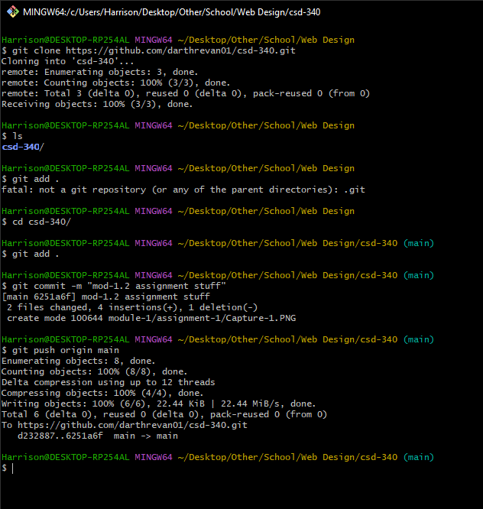
3. 