Harrison Futch

Module 10.2 Assignment

3/2/25

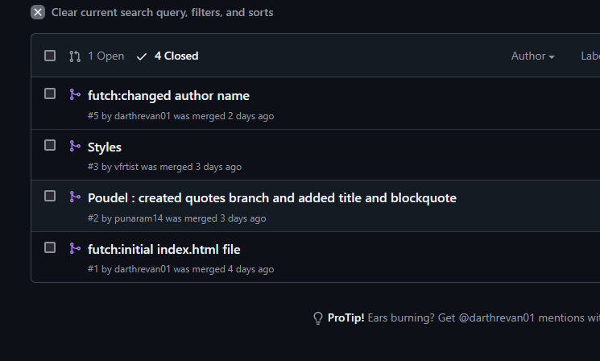

<https://github.com/vfrtist/GitLab>

username: darthrevan01