Weird issues (at 95% cuttoff):

* High confidence when but a mismatch in subtitles
  + Issue specifically with abrupt audio beginnings
  + Adding some silence to the beginning helps
    - Increases translation accuracy
    - Modifies confidence rating to below cutoff
  + Also reversed logic in npy.where comparison
* Solution:
  + Increase confidence threshold
    - Where 98.76% is highest recieved
  + Insert 150ms padding at beginning of troubled files to increase accuracy or decrease confidence
    - 150ms is barely noticeable if inserted and sounds much more natural

Example: BreakMale.wav

* Starts abruptly (sounds like part of the first word is missing)
* Without Silence-Padding: Confidence 98.76%.

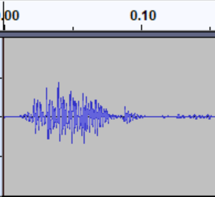

* With Silence-Padding (150ms): Confidence 94.48%

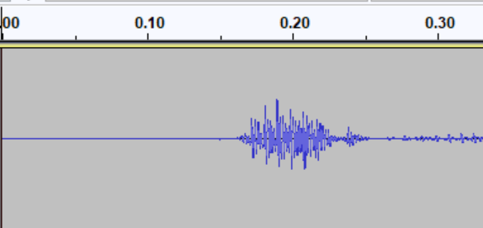

Solution Padding corrected the translation and decreased confidence to below 95% threshold

Example: you-call-that-fun.wav

* Starts Very abruptly
* Without Silence-Padding: Confidence: 96.41%
* With Silence-Padding (150ms): Confidence: 96.24%

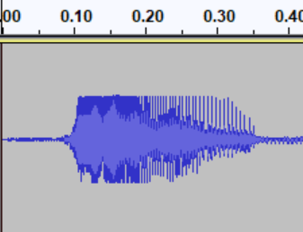

* Solution: increase confidence threshold to 98%

Example: bad-taste.wav

* Noisy file altogether
* Starts abruptly
* Without Silence-Padding: Confidence: 98.76%

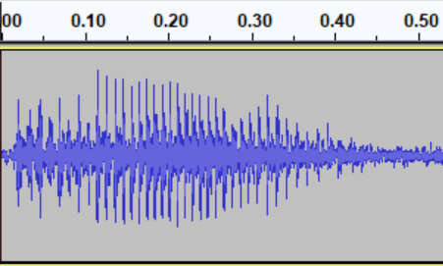

* With Silence-Padding(150ms): Confidence 98.76%

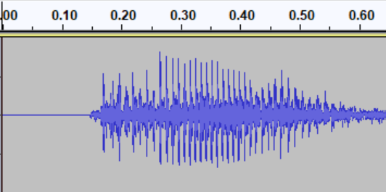

* Solution: When padding was added, translation became correct