Week 1 – Data Description and Visualization

Lecture 1 – Foundations and Sampling Methods

Identify a population and a sample for a given scenario

Question 1 (used in lecture)
A researcher wants to study the average height of all adult males in a city. She measures the height of 200 randomly selected adult males.
A. Population: All adult males in the city; Sample: The 200 measured adult males (1 point)
B. Population: All adult males in the city; Sample: All adult males in the country (0.5 points)
C. Population: All adult males in the country; Sample: The 200 measured adult males (0.5 points)
D. Population: All adults in the city; Sample: All adult males in the country (0 points)

Question 2 (used in lecture)
A survey is conducted to find out the average monthly expenditure on groceries of families living in a specific town. Data is collected from 150 randomly selected families.
A. Population: All families in the town; Sample: The 150 selected families (1 point)
B. Population: All families in the town; Sample: All families in the country (0.5 points)
C. Population: All families in the country; Sample: The 150 selected families (0.5 points)
D. Population: All individuals in the town; Sample: All families in the country (0 points)

Question 3 (used in ungraded quiz)
A company wants to evaluate employee satisfaction. They survey 500 employees chosen randomly from their 10,000 employees worldwide.
A. Population: All 10,000 employees of the company; Sample: The 500 surveyed employees (1 point)
B. Population: All 10,000 employees of the company; Sample: All employees in the country (0.5 points)
C. Population: All employees in the country; Sample: The 500 surveyed employees (0.5 points)
D. Population: All employees worldwide; Sample: All employees in the country (0 points)

Question 4 (used in graded quiz)
A scientist studies the nesting habits of robins. She observes 50 nests randomly selected from all robin nests in a national park.
A. Population: All robin nests in the national park; Sample: The 50 observed nests (1 point)
B. Population: All robin nests in the national park; Sample: All robin nests in the country (0.5 points)
C. Population: All robin nests in the country; Sample: The 50 observed nests (0.5 points)
D. Population: All bird nests in the national park; Sample: All robin nests in the country (0 points)

Question 5
A university administrator wants to understand the average GPA of all students at the university. They collect GPA data from 1,000 randomly selected students.
A. Population: All students at the university; Sample: The 1,000 selected students (1 point)
B. Population: All students at the university; Sample: All students in the state (0.5 points)
C. Population: All students in the state; Sample: The 1,000 selected students (0.5 points)
D. Population: All students in the country; Sample: All students in the state (0 points)

Question 6
A health organization studies the prevalence of diabetes in adults aged 40-60 in a city. Data is collected from 300 individuals in this age group, chosen randomly.
A. Population: All adults aged 40-60 in the city; Sample: The 300 selected individuals (1 point)
B. Population: All adults aged 40-60 in the city; Sample: All adults aged 40-60 in the country (0.5 points)
C. Population: All adults aged 40-60 in the country; Sample: The 300 selected individuals (0.5 points)
D. Population: All adults in the city; Sample: All adults aged 40-60 in the country (0 points)

Question 7
A teacher wants to analyze the average test scores of students in her class. She reviews the test scores of 10 randomly chosen students from her class of 30.
A. Population: All students in the teacher’s class; Sample: The 10 chosen students (1 point)
B. Population: All students in the teacher’s class; Sample: All students in the school (0.5 points)
C. Population: All students in the school; Sample: The 10 chosen students (0.5 points)
D. Population: All students in the district; Sample: All students in the school (0 points)

Question 8
A car manufacturer investigates the defect rate of vehicles produced in a specific factory. They inspect 500 vehicles randomly selected from 20,000 produced in the factory.
A. Population: All vehicles produced in the factory; Sample: The 500 inspected vehicles (1 point)
B. Population: All vehicles produced in the factory; Sample: All vehicles produced by the company (0.5 points)
C. Population: All vehicles produced by the company; Sample: The 500 inspected vehicles (0.5 points)
D. Population: All vehicles produced worldwide; Sample: All vehicles produced by the company (0 points)

Question 9
A public health agency studies the smoking habits of teenagers in a state. They survey 1,200 randomly chosen teenagers living in the state.
A. Population: All teenagers in the state; Sample: The 1,200 surveyed teenagers (1 point)
B. Population: All teenagers in the state; Sample: All teenagers in the country (0.5 points)
C. Population: All teenagers in the country; Sample: The 1,200 surveyed teenagers (0.5 points)
D. Population: All adults in the state; Sample: All teenagers in the country (0 points)

Question 10
A biologist studies the average weight of trout in a lake. She catches and weighs 100 trout chosen randomly from the lake.
A. Population: All trout in the lake; Sample: The 100 weighed trout (1 point)
B. Population: All trout in the lake; Sample: All trout in the region (0.5 points)
C. Population: All trout in the region; Sample: The 100 weighed trout (0.5 points)
D. Population: All fish in the lake; Sample: All trout in the region (0 points)

Identify a population parameter and sample statistic for a given scenario along with the appropriate symbols

Question 1 (used in lecture)
A researcher wants to study the average height of adult males in a city. She calculates the mean height from a sample of 200 randomly selected adult males.
A. Population Parameter: The mean height of all adult males in the city (\mu); Sample Statistic: The mean height of the 200 selected adult males (\bar{x}) (1 point)
B. Population Parameter: The mean height of all adult males in the city (\mu); Sample Statistic: The mean height of all adult males in the country (\bar{x}) (0.5 points)
C. Population Parameter: The mean height of all adult males in the country (\mu); Sample Statistic: The mean height of the 200 selected adult males (\bar{x}) (0.5 points)
D. Population Parameter: The proportion of adult males in the city (p); Sample Statistic: The mean height of the 200 selected adult males (p) (0 points)

Question 2 (used in lecture)
A health organization studies the prevalence of diabetes among adults aged 40-60 in a city. They calculate the proportion of diabetes cases from a sample of 300 individuals in this age group.
A. Population Parameter: The proportion of adults aged 40-60 in the city with diabetes (p); Sample Statistic: The proportion of the 300 sampled individuals with diabetes (\hat{p}) (1 point)
B. Population Parameter: The proportion of adults aged 40-60 in the city with diabetes (p); Sample Statistic: The proportion of all adults in the city with diabetes (\hat{p}) (0.5 points)
C. Population Parameter: The proportion of adults aged 40-60 in the country with diabetes (p); Sample Statistic: The proportion of the 300 sampled individuals with diabetes (\hat{p}) (0.5 points)
D. Population Parameter: The mean age of adults in the city (\mu); Sample Statistic: The mean age of the 300 sampled individuals (\bar{x}) (0 points)

Question 3 (used in ungraded quiz)
A teacher calculates the average test score for 10 randomly selected students in her class of 30 students.
A. Population Parameter: The mean test score of all students in the class (\mu); Sample Statistic: The mean test score of the 10 selected students (\bar{x}) (1 point)
B. Population Parameter: The mean test score of all students in the class (\mu); Sample Statistic: The mean test score of all students in the school (\bar{x}) (0.5 points)
C. Population Parameter: The mean test score of all students in the school (\mu); Sample Statistic: The mean test score of the 10 selected students (\bar{x}) (0.5 points)
D. Population Parameter: The proportion of students passing the test (p); Sample Statistic: The proportion of the 10 selected students passing the test (\hat{p}) (0 points)

Question 4 (used in graded quiz)
A company wants to estimate the proportion of defective products in a factory. They inspect a sample of 500 products out of 20,000 produced.
A. Population Parameter: The proportion of defective products in the factory (p); Sample Statistic: The proportion of defective products in the sample of 500 (\hat{p}) (1 point)
B. Population Parameter: The proportion of defective products in the factory (p); Sample Statistic: The proportion of defective products in all factories (\hat{p}) (0.5 points)
C. Population Parameter: The proportion of defective products in all factories (p); Sample Statistic: The proportion of defective products in the sample of 500 (\hat{p}) (0.5 points)
D. Population Parameter: The mean weight of products in the factory (\mu); Sample Statistic: The mean weight of products in the sample of 500 (\bar{x}) (0 points)

Question 5
A scientist measures the average weight of 50 trout randomly selected from a lake to estimate the mean weight of all trout in the lake.
A. Population Parameter: The mean weight of all trout in the lake (\mu); Sample Statistic: The mean weight of the 50 sampled trout (\bar{x}) (1 point)
B. Population Parameter: The mean weight of all trout in the lake (\mu); Sample Statistic: The mean weight of all trout in the region (\bar{x}) (0.5 points)
C. Population Parameter: The mean weight of all trout in the region (\mu); Sample Statistic: The mean weight of the 50 sampled trout (\bar{x}) (0.5 points)
D. Population Parameter: The proportion of trout in the lake (p); Sample Statistic: The proportion of the 50 sampled trout (\hat{p}) (0 points)

Question 6
A sociologist wants to estimate the average number of hours adults in a city spend commuting each day. She surveys 150 randomly selected adults.
A. Population Parameter: The mean daily commute time of all adults in the city (\mu); Sample Statistic: The mean daily commute time of the 150 surveyed adults (\bar{x}) (1 point)
B. Population Parameter: The mean daily commute time of all adults in the city (\mu); Sample Statistic: The mean daily commute time of all adults in the country (\bar{x}) (0.5 points)
C. Population Parameter: The mean daily commute time of all adults in the country (\mu); Sample Statistic: The mean daily commute time of the 150 surveyed adults (\bar{x}) (0.5 points)
D. Population Parameter: The proportion of adults in the city who commute by car (p); Sample Statistic: The proportion of the 150 surveyed adults who commute by car (\hat{p}) (0 points)

Question 7
An agricultural scientist estimates the proportion of farms in a state that use organic farming practices. She surveys 75 randomly selected farms.
A. Population Parameter: The proportion of all farms in the state using organic practices (p); Sample Statistic: The proportion of the 75 sampled farms using organic practices (\hat{p}) (1 point)
B. Population Parameter: The proportion of all farms in the state using organic practices (p); Sample Statistic: The proportion of all farms in the region using organic practices (\hat{p}) (0.5 points)
C. Population Parameter: The proportion of all farms in the region using organic practices (p); Sample Statistic: The proportion of the 75 sampled farms using organic practices (\hat{p}) (0.5 points)
D. Population Parameter: The mean size of farms in the state (\mu); Sample Statistic: The mean size of the 75 sampled farms (\bar{x}) (0 points)

Question 8
A car manufacturer wants to know the average fuel efficiency of a new car model. They test 30 randomly selected cars of that model.
A. Population Parameter: The mean fuel efficiency of all cars of the new model (\mu); Sample Statistic: The mean fuel efficiency of the 30 tested cars (\bar{x}) (1 point)
B. Population Parameter: The mean fuel efficiency of all cars of the new model (\mu); Sample Statistic: The mean fuel efficiency of all cars produced by the manufacturer (\bar{x}) (0.5 points)
C. Population Parameter: The mean fuel efficiency of all cars produced by the manufacturer (\mu); Sample Statistic: The mean fuel efficiency of the 30 tested cars (\bar{x}) (0.5 points)
D. Population Parameter: The proportion of cars of the new model meeting fuel efficiency standards (p); Sample Statistic: The proportion of the 30 tested cars meeting fuel efficiency standards (\hat{p}) (0 points)

Question 9
A school administrator is interested in the average GPA of all students in a school. She collects GPA data for 50 randomly selected students.
A. Population Parameter: The mean GPA of all students in the school (\mu); Sample Statistic: The mean GPA of the 50 selected students (\bar{x}) (1 point)
B. Population Parameter: The mean GPA of all students in the school (\mu); Sample Statistic: The mean GPA of all students in the district (\bar{x}) (0.5 points)
C. Population Parameter: The mean GPA of all students in the district (\mu); Sample Statistic: The mean GPA of the 50 selected students (\bar{x}) (0.5 points)
D. Population Parameter: The proportion of students in the school with a GPA above 3.0 (p); Sample Statistic: The proportion of the 50 selected students with a GPA above 3.0 (\hat{p}) (0 points)

Question 10
A marketing team wants to estimate the proportion of customers satisfied with a new product. They survey 1,000 customers out of the total 20,000 who purchased the product.
A. Population Parameter: The proportion of all customers satisfied with the product (p); Sample Statistic: The proportion of the 1,000 surveyed customers satisfied with the product (\hat{p}) (1 point)
B. Population Parameter: The proportion of all customers satisfied with the product (p); Sample Statistic: The proportion of all customers who purchased the product (\hat{p}) (0.5 points)
C. Population Parameter: The proportion of all customers who purchased the product (p); Sample Statistic: The proportion of the 1,000 surveyed customers satisfied with the product (\hat{p}) (0.5 points)
D. Population Parameter: The mean age of all customers (\mu); Sample Statistic: The mean age of the 1,000 surveyed customers (\bar{x}) (0 points)

Determine the sampling method described by a definition

Question 1 (used in lecture)
Which type of sampling method randomly selects entire groups of individuals to be part of the sample rather than the individuals directly?
A. Cluster sampling
B. Stratified sampling
C. Systematic sampling
D. Simple random sampling

Question 2 (used in lecture)
Which type of sampling method divides the population into distinct subgroups and randomly selects a fixed number of individuals from each subgroup?
A. Stratified sampling
B. Cluster sampling
C. Systematic sampling
D. Multistage sampling

Question 3 (used in ungraded quiz)
Which type of sampling method selects participants by assigning each individual a number and using a random number generator to choose individuals?
A. Simple random sampling
B. Systematic sampling
C. Stratified sampling
D. Cluster sampling

Question 4 (used in graded lecture)
Which type of sampling method selects participants at regular intervals, such as every 10th or 20th individual on a list?
A. Systematic sampling
B. Simple random sampling
C. Stratified sampling
D. Cluster sampling

Question 5
Which type of sampling method divides the population into several stages, such as regions and neighborhoods, before selecting participants?
A. Multistage sampling
B. Cluster sampling
C. Stratified sampling
D. Systematic sampling

Question 6
Which type of sampling method ensures that specific subgroups of the population are proportionally represented in the sample?
A. Stratified sampling
B. Systematic sampling
C. Cluster sampling
D. Multistage sampling

Question 7
Which type of sampling method randomly selects participants without considering any organization or grouping of the population?
A. Simple random sampling
B. Systematic sampling
C. Stratified sampling
D. Cluster sampling

Question 8
Which type of sampling method selects entire groups, such as classrooms or neighborhoods, and includes all individuals in those groups in the sample?
A. Cluster sampling
B. Stratified sampling
C. Systematic sampling
D. Simple random sampling

Question 9
Which type of sampling method organizes the population into ordered lists and selects participants at fixed intervals, such as every 5th individual?
A. Systematic sampling
B. Simple random sampling
C. Cluster sampling
D. Multistage sampling

Question 10
Which type of sampling method divides the population into subgroups, selects some subgroups at random, and then samples individuals from those subgroups?
A. Multistage sampling
B. Cluster sampling
C. Stratified sampling
D. Systematic sampling

Determine the sampling method used in a given scenario

Question 1 (used in lecture)
A researcher randomly selects 10 neighborhoods in a city and then surveys every household in those neighborhoods. What type of sampling is this?
A. Cluster sampling
B. Simple random sampling
C. Stratified sampling
D. Systematic sampling

Question 2 (used in lecture)
A polling agency divides the population into males and females, then randomly selects a fixed number of individuals from each group to survey. What type of sampling is this?
A. Stratified sampling
B. Systematic sampling
C. Cluster sampling
D. Multistage sampling

Question 3 (used in ungraded quiz)
A company selects every 20th customer from a list of all its customers, arranged alphabetically, for a survey. What type of sampling is this?
A. Systematic sampling
B. Stratified sampling
C. Simple random sampling
D. Cluster sampling

Question 4 (used in graded lecture)
An analyst randomly assigns a number to every individual in a population and uses a random number generator to select participants for a study. What type of sampling is this?
A. Simple random sampling
B. Systematic sampling
C. Cluster sampling
D. Multistage sampling

Question 5
A study divides a population into regions, selects several regions at random, then randomly chooses individuals from those selected regions. What type of sampling is this?
A. Multistage sampling
B. Cluster sampling
C. Stratified sampling
D. Systematic sampling

Question 6
A researcher randomly selects 15 classrooms in a school and surveys all students in those classrooms. What type of sampling is this?
A. Cluster sampling
B. Stratified sampling
C. Simple random sampling
D. Systematic sampling

Question 7
A scientist organizes a population into age groups and then takes a random sample from each age group. What type of sampling is this?
A. Stratified sampling
B. Cluster sampling
C. Systematic sampling
D. Multistage sampling

Question 8
An investigator randomly selects individuals from a population without grouping or organizing them in any way. What type of sampling is this?
A. Simple random sampling
B. Systematic sampling
C. Stratified sampling
D. Cluster sampling

Question 9
A company divides employees by department, selects a few departments randomly, and then surveys every employee in those selected departments. What type of sampling is this?
A. Cluster sampling
B. Multistage sampling
C. Stratified sampling
D. Systematic sampling

Question 10
A surveyor selects every 50th name from a list of all registered voters after arranging the list alphabetically. What type of sampling is this?
A. Systematic sampling
B. Simple random sampling
C. Cluster sampling
D. Multistage sampling

Lecture 2 – Numeric Summaries

Determine if a variable is qualitative or quantitative

Question 1 (used in lecture)
Two variables are being measured in a study on students. One is the type of degree they are pursuing, and the other is their GPA.
Variable 1: Type of degree
Variable 2: GPA
A.
Variable 1: qualitative
Variable 2: quantitative
B.
Variable 1: quantitative
Variable 2: qualitative
C.
Variable 1: qualitative
Variable 2: qualitative
D.
Variable 1: quantitative
Variable 2: quantitative

Question 2 (used in lecture)
A survey collects information about the preferred type of cuisine and the chosen restaurant chain.
Variable 1: Preferred type of cuisine
Variable 2: Chosen restaurant chain
A.
Variable 1: qualitative
Variable 2: qualitative
B.
Variable 1: quantitative
Variable 2: qualitative
C.
Variable 1: qualitative
Variable 2: quantitative
D.
Variable 1: quantitative
Variable 2: quantitative

Question 3 (used in ungraded quiz)
In a survey about transportation, one variable is the mode of transport used (car, bus, etc.), and the other is the number of hours spent commuting.
Variable 1: Mode of transport
Variable 2: Hours spent commuting
A.
Variable 1: qualitative
Variable 2: quantitative
B.
Variable 1: quantitative
Variable 2: qualitative
C.
Variable 1: qualitative
Variable 2: qualitative
D.
Variable 1: quantitative
Variable 2: quantitative

Question 4 (used in graded quiz)
A study on employee preferences records the department they work in and their preferred work schedule (e.g., 9-5, flexible hours, remote).
Variable 1: Department
Variable 2: Preferred work schedule
A.
Variable 1: qualitative
Variable 2: qualitative
B.
Variable 1: quantitative
Variable 2: qualitative
C.
Variable 1: qualitative
Variable 2: quantitative
D.
Variable 1: quantitative
Variable 2: quantitative

Question 5
A study is investigating two variables, the amount of rainfall and crop yield, in a specific region.
Variable 1: Amount of rainfall (in inches)
Variable 2: Crop yield (in tons)
A.
Variable 1: quantitative
Variable 2: quantitative
B.
Variable 1: qualitative
Variable 2: quantitative
C.
Variable 1: quantitative
Variable 2: qualitative
D.
Variable 1: qualitative
Variable 2: qualitative

Question 6
A research team is investigating the relationship between hours of exercise per week and the amount of weight lost in kilograms over a 6-month period.
Variable 1: Hours of exercise per week
Variable 2: Weight lost (in kg)
A.
Variable 1: quantitative
Variable 2: quantitative
B.
Variable 1: qualitative
Variable 2: quantitative
C.
Variable 1: quantitative
Variable 2: qualitative
D.
Variable 1: qualitative
Variable 2: qualitative

Question 7
In a study on the auto industry, one variable is the price of gasoline and another is the number of cars sold in a month.
Variable 1: Price of gasoline (per gallon)
Variable 2: Number of cars sold
A.
Variable 1: quantitative
Variable 2: quantitative
B.
Variable 1: qualitative
Variable 2: quantitative
C.
Variable 1: quantitative
Variable 2: qualitative
D.
Variable 1: qualitative
Variable 2: qualitative

Question 8
A survey collects information about the preferred type of cuisine and the chosen restaurant chain.
Variable 1: Preferred type of cuisine
Variable 2: Chosen restaurant chain
A.
Variable 1: qualitative
Variable 2: qualitative
B.
Variable 1: quantitative
Variable 2: qualitative
C.
Variable 1: qualitative
Variable 2: quantitative
D.
Variable 1: quantitative
Variable 2: quantitative

Question 8
A researcher collects data on a group of people. One variable is their favorite color, and the other is their age.
Variable 1: Age
Variable 2: Favorite color
A.
Variable 1: quantitative
Variable 2: qualitative
B.
Variable 1: quantitative
Variable 2: qualitative
C.
Variable 1: qualitative
Variable 2: qualitative
D.
Variable 1: quantitative
Variable 2: quantitative

Question 9
A sociological study examines the type of housing arrangement and the primary source of income.
Variable 1: Type of housing arrangement (e.g., apartment, house, shared living)
Variable 2: Primary source of income (e.g., salary, freelance, business)
A.
Variable 1: qualitative
Variable 2: qualitative
B.
Variable 1: quantitative
Variable 2: qualitative
C.
Variable 1: qualitative
Variable 2: quantitative
D.
Variable 1: quantitative
Variable 2: quantitative

Question 10
A study is examining a city’s population. One variable is the type of neighborhood (urban, suburban, rural), and the other is the average household income.
Variable 1: Household income
Variable 2: Type of neighborhood
A.
Variable 1: quantitative
Variable 2: qualitative
B.
Variable 1: quantitative
Variable 2: qualitative
C.
Variable 1: qualitative
Variable 2: qualitative
D.
Variable 1: quantitative
Variable 2: quantitative

For a quantitative variable, determine if it is discrete or continuous

Question 1 (used in lecture)
A study examines the number of cars in a parking lot and the total amount of fuel consumed by the cars in liters.
Variable 1: Number of cars
Variable 2: Total fuel consumption (in liters)
A.
Variable 1: discrete
Variable 2: continuous
B.
Variable 1: continuous
Variable 2: discrete
C.
Variable 1: discrete
Variable 2: discrete
D.
Variable 1: continuous
Variable 2: continuous

Question 2 (used in lecture)
A survey is asking participants about the number of hours they spend exercising each week and their cholesterol levels in milligrams per deciliter.
Variable 1: Hours spent exercising
Variable 2: Cholesterol level (in mg/dL)
A.
Variable 1: continuous
Variable 2: continuous
B.
Variable 1: discrete
Variable 2: continuous
C.
Variable 1: continuous
Variable 2: discrete
D.
Variable 1: discrete
Variable 2: discrete

Question 3 (used in ungraded quiz)
A survey is conducted on the number of students attending a particular lecture and the duration of the lecture in hours.
Variable 1: Number of students
Variable 2: Duration of lecture (in hours, minutes, seconds, and so forth)
A.
Variable 1: discrete
Variable 2: continuous
B.
Variable 1: continuous
Variable 2: discrete
C.
Variable 1: discrete
Variable 2: discrete
D.
Variable 1: continuous
Variable 2: continuous

Question 4 (used in graded quiz)
A study investigates the number of phone calls a customer makes per day and the time spent on the phone each call in minutes.
Variable 1: Number of phone calls
Variable 2: Time per call (in minutes, seconds, and so forth)
A.
Variable 1: discrete
Variable 2: continuous
B.
Variable 1: continuous
Variable 2: discrete
C.
Variable 1: discrete
Variable 2: discrete
D.
Variable 1: continuous
Variable 2: continuous

Question 5
A scientist is recording the amount of rainfall in a city in millimeters and the number of days it rained during the month.
Variable 1: Amount of rainfall (in millimeters)
Variable 2: Number of days it rained
A.
Variable 1: continuous
Variable 2: discrete
B.
Variable 1: discrete
Variable 2: continuous
C.
Variable 1: continuous
Variable 2: continuous
D.
Variable 1: discrete
Variable 2: discrete

Question 6
A researcher is measuring the number of children in a family and the height of each child in centimeters.
Variable 1: Number of children
Variable 2: Height of child (in centimeters)
A.
Variable 1: discrete
Variable 2: continuous
B.
Variable 1: continuous
Variable 2: discrete
C.
Variable 1: discrete
Variable 2: discrete
D.
Variable 1: continuous
Variable 2: continuous

Question 7
A study records the number of goals scored in a soccer match and the total distance run by players in kilometers.
Variable 1: Number of goals scored
Variable 2: Total distance run (in kilometers)
A.
Variable 1: discrete
Variable 2: continuous
B.
Variable 1: continuous
Variable 2: discrete
C.
Variable 1: discrete
Variable 2: discrete
D.
Variable 1: continuous
Variable 2: continuous

Question 8
A health study is measuring the weight of participants in kilograms and their age in years.
Variable 1: Weight (in kilograms)
Variable 2: Age (in years)
A.
Variable 1: continuous
Variable 2: continuous
B.
Variable 1: discrete
Variable 2: continuous
C.
Variable 1: continuous
Variable 2: discrete
D.
Variable 1: discrete
Variable 2: discrete

Question 9

A researcher measures the number of languages spoken by each participant and the time (in minutes) they spend reading daily.
Variable 1: Number of languages spoken
Variable 2: Time spent reading daily (in minutes)
A.
Variable 1: discrete
Variable 2: continuous
B.
Variable 1: continuous
Variable 2: discrete
C.
Variable 1: discrete
Variable 2: discrete
D.
Variable 1: continuous
Variable 2: continuous

Question 10
A psychologist is studying the number of patients in a therapy group and their anxiety levels on a scale of 1 to 10.
Variable 1: Number of patients
Variable 2: Anxiety level (1-10 scale)

A.
Variable 1: discrete
Variable 2: discrete
B.
Variable 1: continuous
Variable 2: discrete
C.
Variable 1: discrete
Variable 2: continuous
D.
Variable 1: continuous
Variable 2: continuous

Determine which measure of central tendency is most appropriate and compute this measure

Question 1 (used in lecture)
A survey collects data on the favorite color of respondents. Which measure of central tendency should be used?
A. Mode
B. Median
C. Mean
D. Range

Question 2 (used in lecture)
A researcher measures the weight of apples in kilograms. Which measure of central tendency should be used?
A. Mean
B. Variance
C. IQR
D. Range

Question 3 (used in ungraded quiz)
A study asks participants to rank their satisfaction on a scale from 1 to 5. Which measure of central tendency should be used?
A. Median
B. IQR
C. Variance
D. Standard deviation

Question 4 (used in graded quiz)
A company tracks the number of sales transactions per day. Which measure of central tendency should be used?
A. Mean
B. IQR
C. Minimum
D. Range

Question 5
A biologist records the types of plants found in a specific area. Which measure of central tendency should be used?
A. Mode
B. Median
C. Mean
D. IQR

Question 6
A teacher calculates the test scores of students on a math exam. Which measure of central tendency should be used?
A. Mean
B. Range
C. IQR
D. Third Quantile

Question 7
A marketing team collects data on customers’ preferred payment methods (e.g., cash, credit, or digital payment). Which measure of central tendency should be used?
A. Mode
B. Median
C. Mean
D. Variance

Question 8
A study records the time (in seconds) it takes participants to complete a task. Which measure of central tendency should be used?
A. Mean
B. Maximum
C. First Quantile
D. Standard deviation

Question 9
A poll asks respondents to rate their agreement with a statement on a scale of strongly disagree, disagree, neutral, agree, or strongly agree. Which measure of central tendency should be used?
A. Median
B. Variance
C. Standard Deviation
D. Quartiles

Question 10
A restaurant tracks the number of customers who visit each day. Which measure of central tendency should be used?
A. Mean
B. Standard Deviation
C. 90th Percentile
D. IQR

Determine which measure of variability is most appropriate and compute this measure

Question 1 (used in lecture)
A survey collects data on respondents' favorite ice cream flavor. Which measure of variability should be used?
A. Proportions
B. Variance
C. Range
D. IQR

Question 2 (used in lecture)
A researcher measures the heights of participants in centimeters. Which measure of variability should be used?
A. Standard deviation
B. Counts
C. Proportions
D. Median

Question 3 (used in ungraded quiz)
A study asks participants to rank their satisfaction on a scale from 1 to 5. Which measure of variability should be used?
A. IQR
B. Minimum
C. Counts
D. Maximum

Question 4 (used in graded quiz)
A company records the number of products sold per day. Which measure of variability should be used?
A. Variance
B. Proportions
C. Counts
D. Mode

Question 5
A teacher collects data on the most common hair colors of their students. Which measure of variability should be used?
A. Counts
B. IQR
C. Standard deviation
D. Range

Question 6
A researcher records the time (in seconds) it takes for participants to complete a task. Which measure of variability should be used?
A. Range
B. Counts
C. Proportions
D. Median

Question 7
A marketing team collects data on customers’ preferred payment methods (e.g., cash, credit, or digital payment). Which measure of variability should be used?
A. Proportions
B. Variance
C. Range
D. Standard deviation

Question 8
A study measures the weights of apples (in grams) collected from different trees. Which measure of variability should be used?
A. Variance
B. Proportions
C. Counts
D. Mode

Question 9
A survey asks respondents to rank their agreement with a statement on a scale of strongly disagree, disagree, neutral, agree, or strongly agree. Which measure of variability should be used?
A. IQR
B. Proportions
C. Counts
D. Mean

Question 10
A company tracks the daily sales revenue (in dollars) from its stores. Which measure of variability should be used?
A. Standard deviation
B. Proportions
C. Counts
D. Median

Lecture 3 – Data Visualization

Given a visualization, describe the skew of a distribution and describe its effect on the mean relative to the median

Question 1 (used in lecture)
Consider the visualization below. Select the option that correctly describes the skew of the distribution as well as the relationship between the mean and the median.
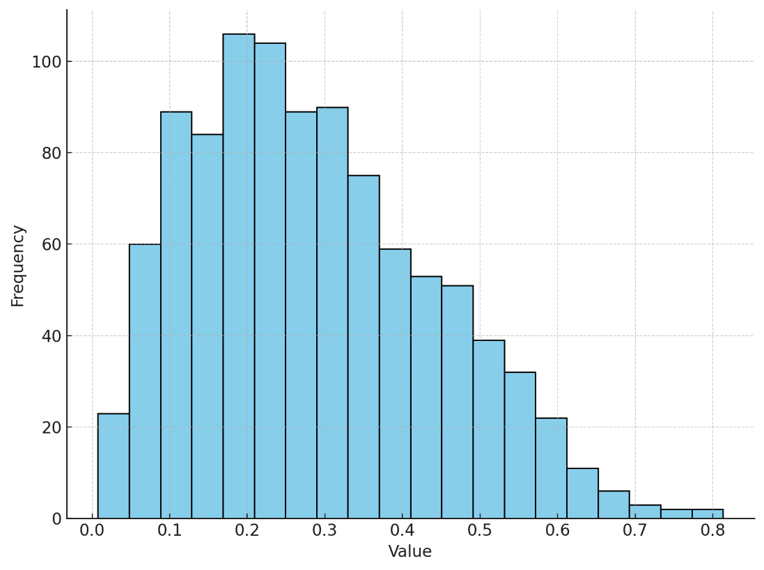
A. Right-Skewed, Mean > Median (1 point)
B. Symmetric, Mean = Median (0 points)
C. Left-Skewed, Mean < Median (0 points)
D. Right-Skewed, Mean < Median (0.5 points)

Question 2 (used in lecture)
Consider the visualization below. Select the option that correctly describes the skew of the distribution as well as the relationship between the mean and the median.
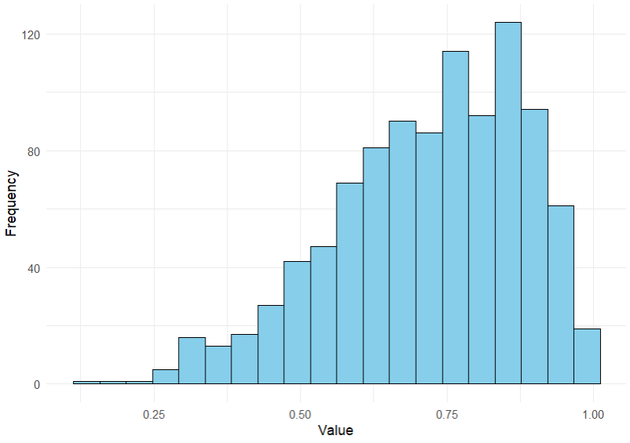
A. Left-Skewed, Mean < Median (1 point)
B. Symmetric, Mean = Median (0 points)
C. Right-Skewed, Mean > Median (0 points)
D. Left-Skewed, Mean > Median (0.5 points)

Question 3 (used in ungraded quiz)
Consider the visualization below. Select the option that correctly describes the skew of the distribution as well as the relationship between the mean and the median.
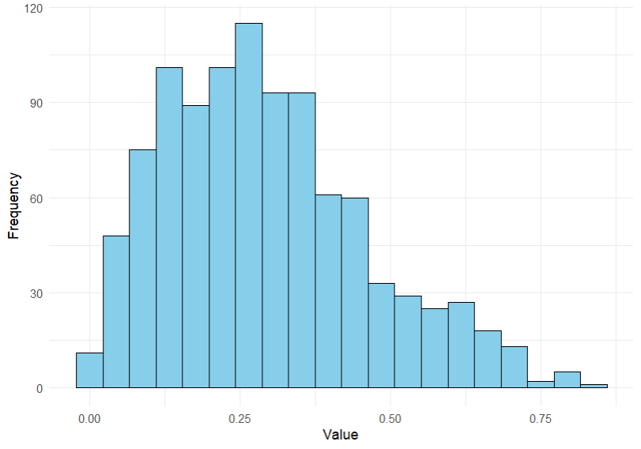
A. Right-Skewed, Mean > Median (1 point)
B. Symmetric, Mean = Median (0 points)
C. Left-Skewed, Mean < Median (0 points)
D. Right-Skewed, Mean < Median (0.5 points)

Question 4 (used in graded quiz)
Consider the visualization below. Select the option that correctly describes the skew of the distribution as well as the relationship between the mean and the median.
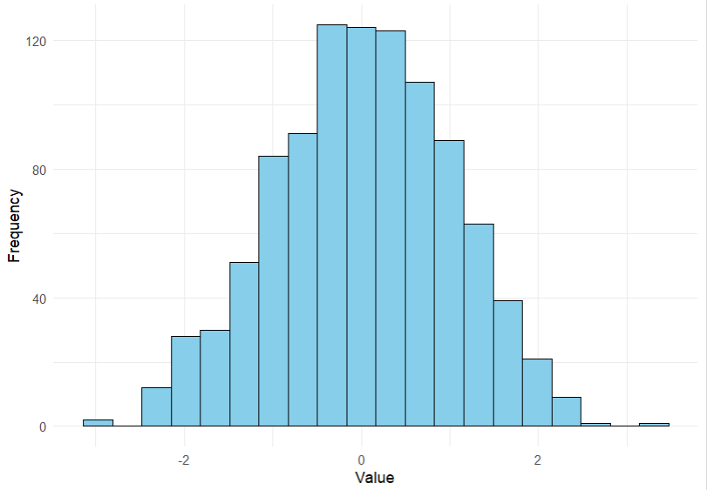
A. Symmetric, Mean = Median (1 point)
B. Left-Skewed, Mean < Median (0 points)
C. Right-Skewed, Mean > Median (0 points)
D. Symmetric, Mean < Median (0.5 points)

Question 5
Consider the visualization below. Select the option that correctly describes the skew of the distribution as well as the relationship between the mean and the median.
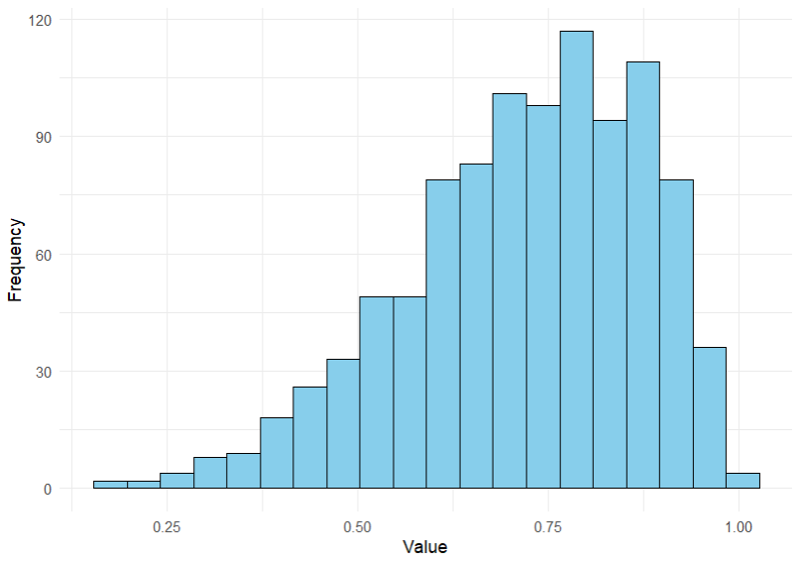
A. Left-Skewed, Mean < Median (1 point)
B. Symmetric, Mean = Median (0 points)
C. Right-Skewed, Mean > Median (0 points)
D. Left-Skewed, Mean > Median (0.5 points)

Question 6
Consider the visualization below. Select the option that correctly describes the skew of the distribution as well as the relationship between the mean and the median.
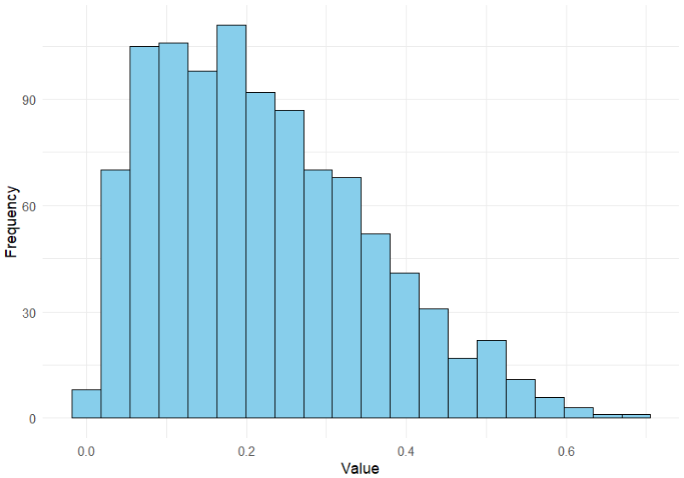
A. Right-Skewed, Mean > Median (1 point)
B. Symmetric, Mean = Median (0 points)
C. Left-Skewed, Mean < Median (0 points)
D. Right-Skewed, Mean < Median (0.5 points)

Question 7
Consider the visualization below. Select the option that correctly describes the skew of the distribution as well as the relationship between the mean and the median.
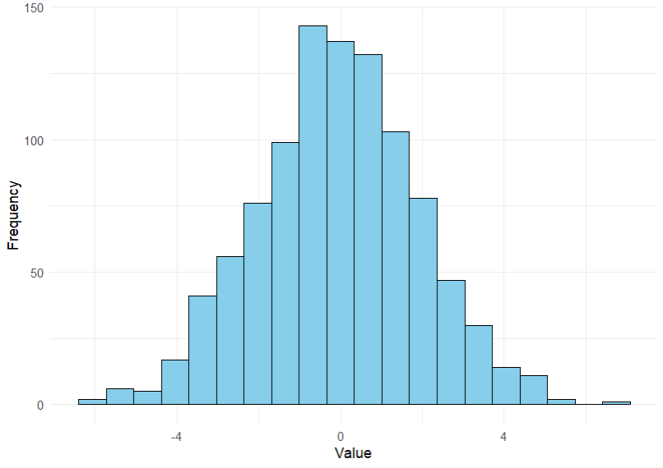
A. Symmetric, Mean = Median (1 point)
B. Left-Skewed, Mean < Median (0 points)
C. Right-Skewed, Mean > Median (0 points)
D. Symmetric, Mean < Median (0.5 points)

Question 8
Consider the visualization below. Select the option that correctly describes the skew of the distribution as well as the relationship between the mean and the median.
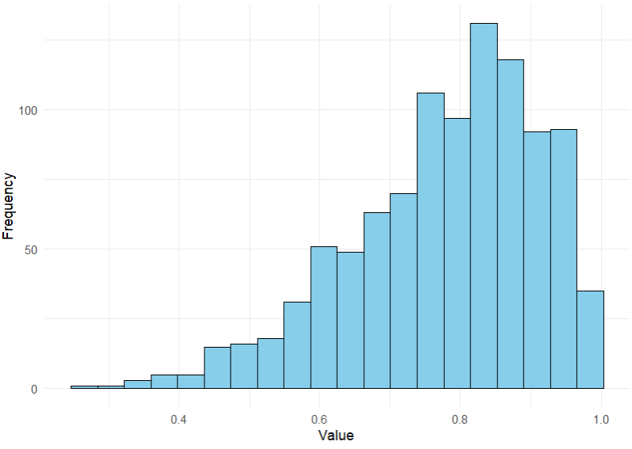
A. Left-Skewed, Mean < Median (1 point)
B. Symmetric, Mean = Median (0 points)
C. Right-Skewed, Mean > Median (0 points)
D. Left-Skewed, Mean > Median (0.5 points)

Question 9
Consider the visualization below. Select the option that correctly describes the skew of the distribution as well as the relationship between the mean and the median.
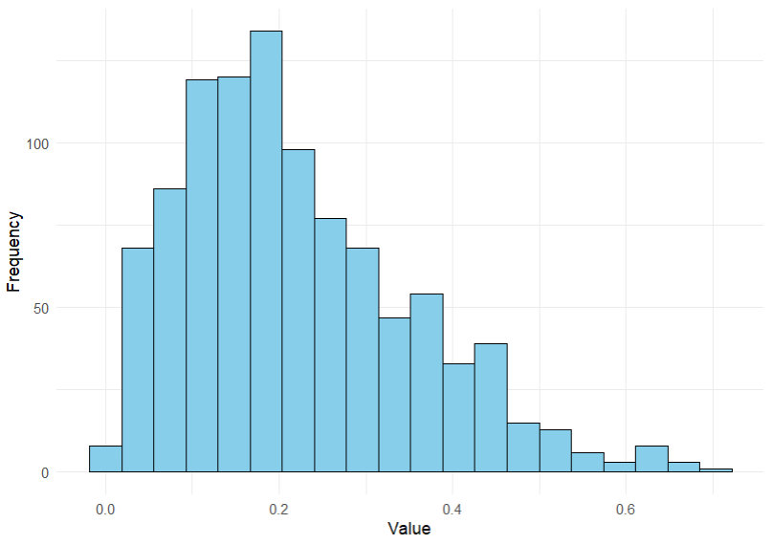
A. Right-Skewed, Mean > Median (1 point)
B. Symmetric, Mean = Median (0 points)
C. Left-Skewed, Mean < Median (0 points)
D. Right-Skewed, Mean < Median (0.5 points)

Question 10
Consider the visualization below. Select the option that correctly describes the skew of the distribution as well as the relationship between the mean and the median.
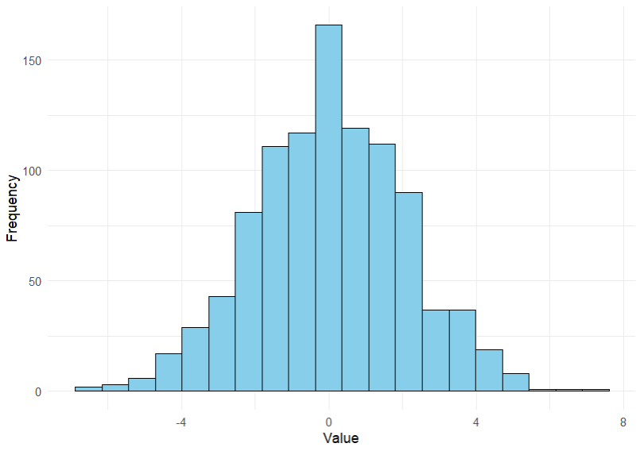
A. Symmetric, Mean = Median (1 point)
B. Left-Skewed, Mean < Median (0 points)
C. Right-Skewed, Mean > Median (0 points)
D. Symmetric, Mean < Median (0.5 points)

Given a visualization, describe the modality of a distribution

Question 1 (used in lecture)
Consider the visualization below. Select the option that correctly describes the modality of the distribution.
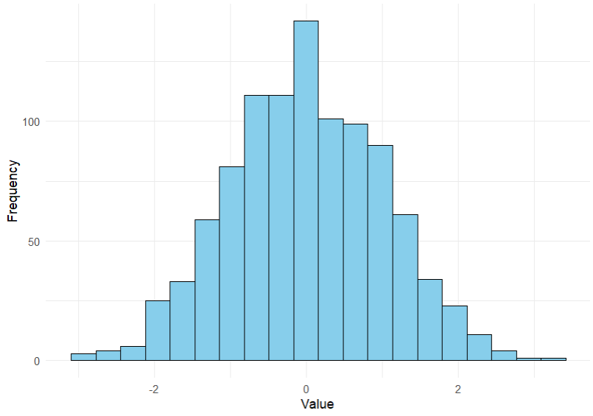
A. Unimodal
B. Bimodal
C. Multimodal (three peaks)
D. Multimodal (four peaks)

Question 2 (used in lecture)
Consider the visualization below. Select the option that correctly describes the modality of the distribution.
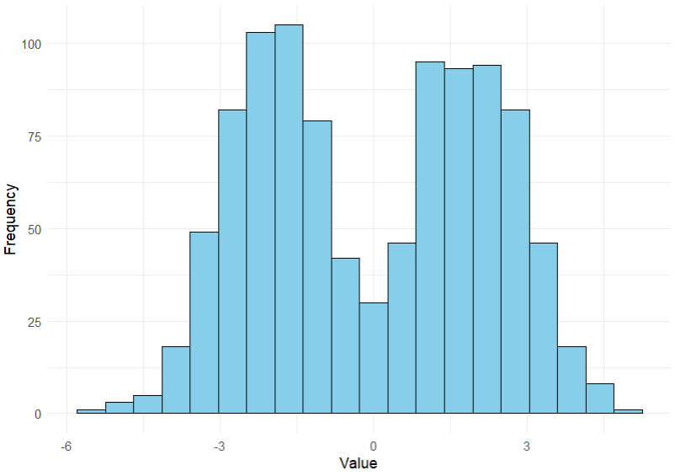
A. Bimodal
B. Unimodal
C. Multimodal (three peaks)
D. Multimodal (four peaks)

Question 3 (used in ungraded quiz)
Consider the visualization below. Select the option that correctly describes the modality of the distribution.
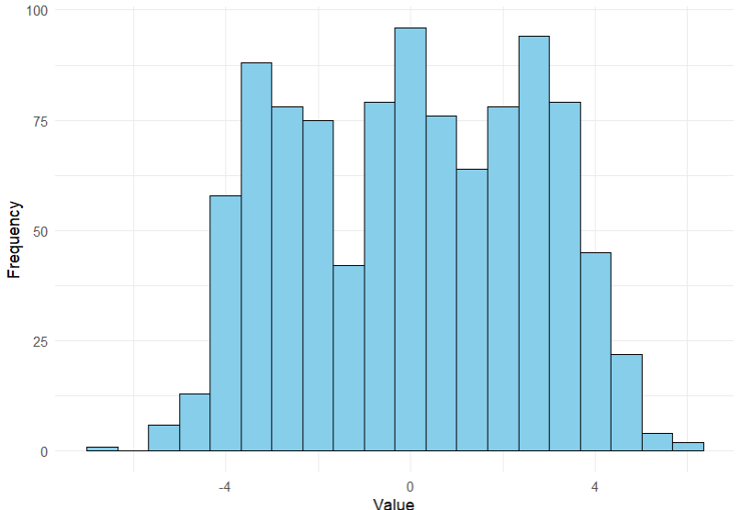
A. Multimodal (three peaks)
B. Unimodal
C. Bimodal
D. Multimodal (four peaks)

Question 4 (used in graded quiz)
Consider the visualization below. Select the option that correctly describes the modality of the distribution.
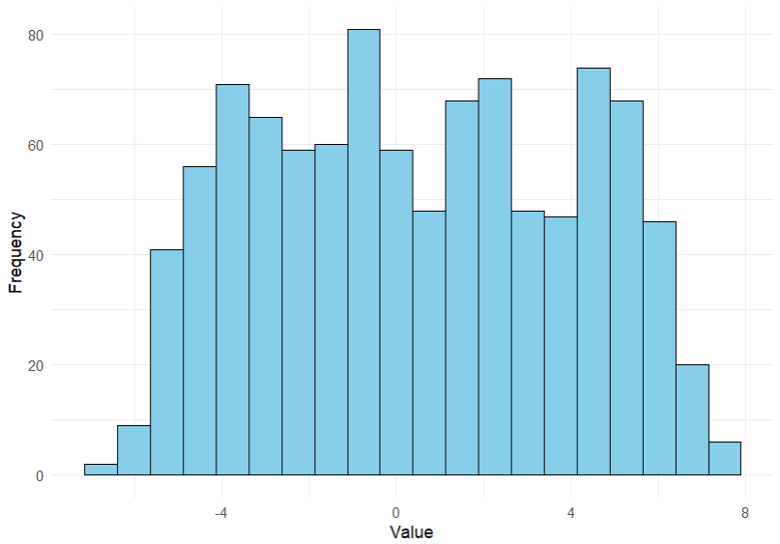
A. Multimodal (four peaks)
B. Unimodal
C. Bimodal
D. Multimodal (three peaks)

Question 5
Consider the visualization below. Select the option that correctly describes the modality of the distribution.
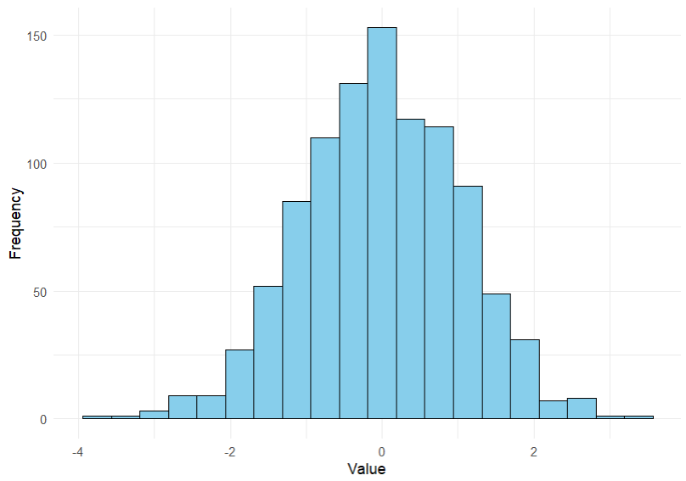
A. Unimodal
B. Bimodal
C. Multimodal (three peaks)
D. Multimodal (four peaks)

Question 6
Consider the visualization below. Select the option that correctly describes the modality of the distribution.
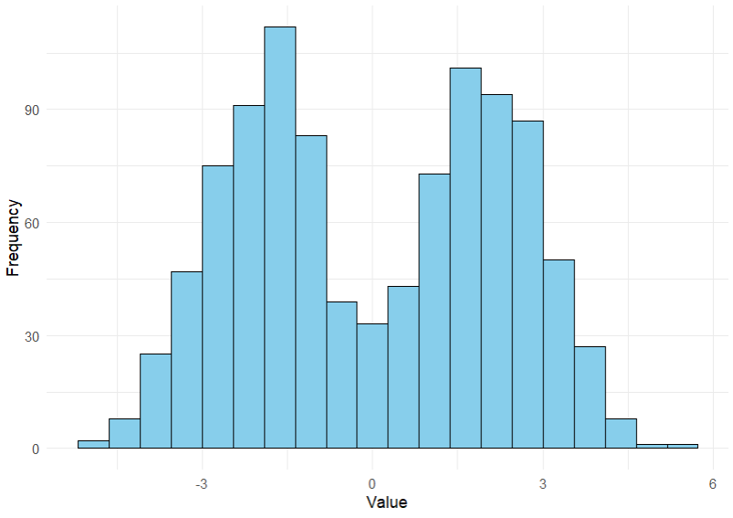
A. Bimodal
B. Unimodal
C. Multimodal (three peaks)
D. Multimodal (four peaks)

Question 7
Consider the visualization below. Select the option that correctly describes the modality of the distribution.
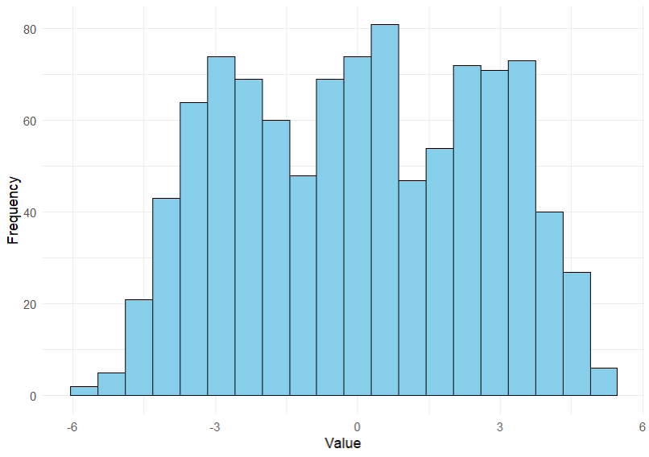
A. Multimodal (three peaks)
B. Unimodal
C. Bimodal
D. Multimodal (four peaks)

Question 8
Consider the visualization below. Select the option that correctly describes the modality of the distribution.
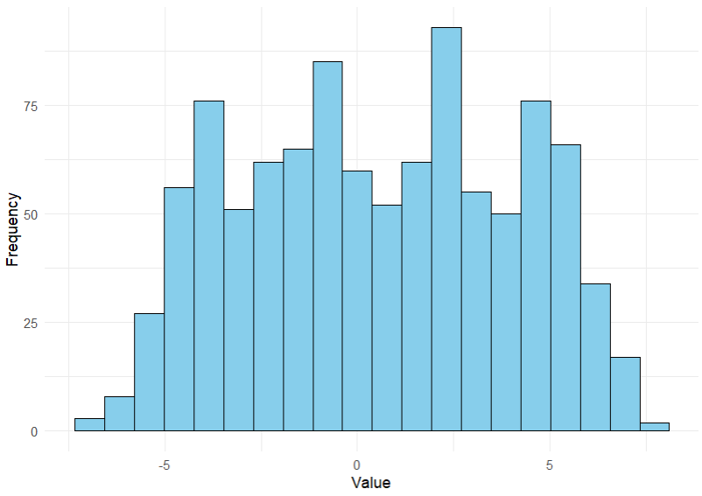
A. Multimodal (four peaks)
B. Unimodal
C. Bimodal
D. Multimodal (three peaks)

Question 9
Consider the visualization below. Select the option that correctly describes the modality of the distribution.
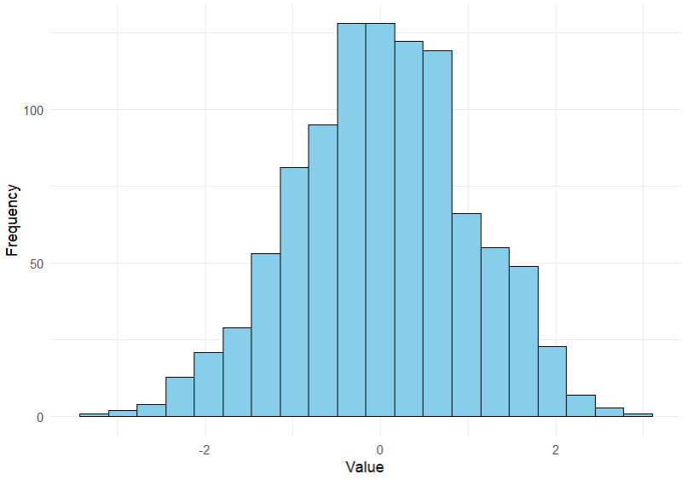
A. Unimodal
B. Bimodal
C. Multimodal (three peaks)
D. Multimodal (four peaks)

Question 10
Consider the visualization below. Select the option that correctly describes the modality of the distribution.
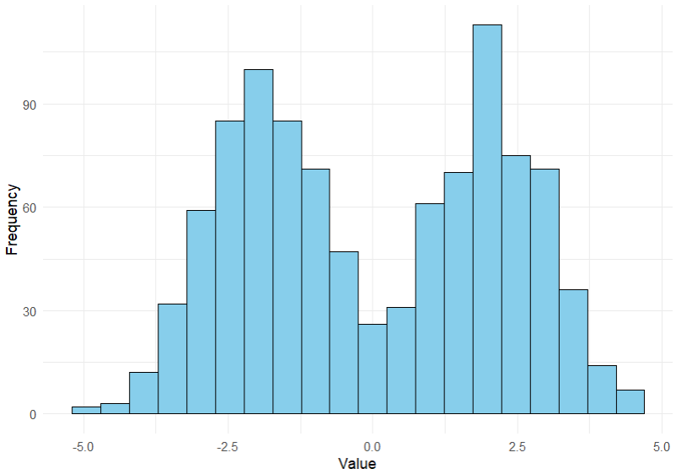
A. Bimodal
B. Unimodal
C. Multimodal (three peaks)
D. Multimodal (four peaks)

Use a definition/description of a visualization tool to determine the visualization tool

Question 1 (used in lecture)
This visualization is used to visualize the distribution of quantitative data when there are a large number of observations, and seeing individual observations or outliers isn’t needed.
A. Histogram
B. Dot chart
C. Pie chart
D. Stem-and-leaf plot

Question 2 (used in lecture)
This visualization uses bars to represent categorical data, where the length of each bar corresponds to the count or percentage of observations in each category.
A. Bar chart
B. Pie chart
C. Histogram
D. Dot chart

Question 3 (used in ungraded quiz)
This visualization shows the distribution of quantitative data while preserving individual data points. It uses stems to represent groups of values and leaves to display individual observations.
A. Stem-and-leaf plot
B. Histogram
C. Box plot
D. Dot chart

Question 4 (used in graded quiz)
This visualization displays quantitative data by grouping values into bins, and it represents each bin's frequency using adjacent bars without gaps.
A. Histogram
B. Bar chart
C. Box plot
D. Pie chart

Question 5
This visualization represents proportions or percentages of a whole, where each category is shown as a slice of a circle.
A. Pie chart
B. Bar chart
C. Box plot
D. Histogram

Question 6
This visualization is used to summarize the distribution of quantitative data, showing the minimum, first quartile, median, third quartile, and maximum values.
A. Box plot
B. Histogram
C. Dot chart
D. Bar chart

Question 7
This visualization displays individual quantitative data points, often in a line or cluster, to highlight patterns or distributions in relatively small datasets.
A. Dot chart
B. Box plot
C. Histogram
D. Pie chart

Question 8
This visualization is commonly used to compare parts of a whole, with data divided into categories represented as proportional slices.
A. Pie chart
B. Bar chart
C. Histogram
D. Dot chart

Question 9
This visualization is effective for displaying and comparing frequencies of categories, with gaps between bars to indicate distinct groups.
A. Bar chart
B. Histogram
C. Box plot
D. Pie chart

Question 10
This visualization provides a quick overview of the spread, center, and potential outliers in a dataset by displaying a five-number summary.
A. Box plot
B. Stem-and-leaf plot
C. Histogram
D. Pie chart

Given a dataset or description of a variable, determine which visualization tool would be most appropriate for visualizing the data

Question 1 (used in lecture)
You have a dataset of the ages of 10 participants in a study: 21, 23, 25, 25, 26, 30, 32, 35, 37, 40. You are interested in seeing the actual numbers of the data.
Which visualization would best display this data?
A. Stem-and-Leaf Plot
B. Box Plot
C. Histogram
D. Dot Chart

Question 2 (used in lecture)
A company has surveyed its employees about their department, and the results are as follows: Sales (45), Marketing (30), HR (15), and IT (25). The data is categorical, and you want to compare the frequency of each department.
Which visualization would best display this data?
A. Bar Chart
B. Histogram
C. Box Plot
D. Dot Chart

Question 3 (used in ungraded quiz)
Here is a small dataset of daily step counts for 10 individuals: 5,000, 5,500, 6,000, 6,500, 7,000, 8,000, 8,500, 9,000, 10,000, 11,000. You want to visualize the distribution of the data without focusing on specific numbers.
Which visualization is most appropriate?
A. Dot Chart
B. Bar Chart
C. Stem-and-Leaf Plot
D. Histogram

Question 4 (used in graded quiz)
You have a small dataset showing the number of books read by 10 individuals: 0, 1, 1, 2, 3, 3, 4, 4, 4, 5. The dataset is small, and you want to see the actual numbers.
Which visualization would best display the data?
A. Stem-and-Leaf Plot
B. Box Plot
C. Histogram
D. Dot Chart

Question 5
You have a large dataset of 500 students' test scores. You want to visualize the distribution of the data and identify any potential outliers.
Which visualization would best display this data?
A. Box Plot
B. Dot Chart
C. Histogram
D. Stem-and-Leaf Plot

Question 6
You are analyzing the favorite color of 8 participants: Blue, Blue, Red, Green, Green, Green, Yellow, Yellow.
Which visualization would best display this categorical data?
A. Bar Chart
B. Dot Chart
C. Histogram
D. Box Plot

Question 7
You are studying the number of hours of sleep per night for 12 individuals: 6, 7, 7, 8, 8, 9, 9, 10, 10, 11, 12, 12. You want to visualize the distribution but focus on the actual data points, but not necessarily their values.
Which visualization would best display this data?
A. Dot Chart
B. Histogram
C. Box Plot
D. Stem-and-Leaf Plot

Question 8
A large dataset shows the number of hours spent studying by 1000 students. You want to see how the data is distributed without focusing on specific individual observations.
Which visualization is most appropriate?
A. Histogram
B. Bar Chart
C. Dot Chart
D. Stem-and-Leaf Plot

Question 9
You have a large dataset of the number of pets owned by 500 individuals. You want to visualize the distribution of the data without focusing on specific data points or identifying outliers.
Which visualization would best display this data?
A. Histogram
B. Box Plot
C. Dot Chart
D. Stem-and-Leaf Plot

Question 10
You have a large dataset showing the salaries (in $1000s) of 800 employees. You want to visualize the distribution of salaries and identify any potential outliers.
Which visualization is most appropriate?
A. Box Plot
B. Dot Chart
C. Histogram
D. Stem-and-Leaf Plot

Week 2 – Counting and Basic Probability

Lecture 4 – Counting

Enumerate the number of ways something can occur using a combination

Question 1 (used in lecture)
You have 10 students in your class, and you need to select 3 students to present a project. How many different ways can you choose 3 students from the 10?
Answer: 120

Question 2 (used in lecture)
From a group of 6 people, you need to choose 3 to form a committee. There are no specific positions in the committee. How many different committees can you form?
Answer: 20

Question 3 (used in ungraded quiz)
You need to select 2 books from a shelf of 5 different books. How many different ways can you make your selection?
Answer: 10

Question 4 (used in graded quiz)
A soccer team has 12 players. The coach needs to choose 5 players for a special task. How many ways can the coach choose the 5 players?
Answer: 792

Question 5
You have 6 different colors of paint, and you want to choose 3 of them to use on your wall. How many ways can you make your selection?
Answer: 20

Question 6
In a class of 15 students, you want to select 4 students to participate in a science fair. How many different ways can you choose 4 students?
Answer: 1365

Question 7
A music festival is offering 6 different performances, and you want to attend 2 performances. How many different ways can you select 2 performances?
Answer: 15

Question 8
A box contains 7 marbles of different colors. You want to select 3 marbles at random. How many ways can you select 3 marbles from the box?
Answer: 35

Question 9
From a deck of 52 playing cards, you want to choose 5 cards. How many different ways can you choose the 5 cards?
Answer: 2598960

Question 10
You have 9 different medals and need to select 3 of them for the top three finishers in a contest. How many different ways can you select 3 medals?
Answer: 84

Enumerate the number of ways something can occur using a permutation

Question 1 (used in lecture)
In a 100-meter race with 8 runners, you want to determine the possible outcomes for who finishes 1st, 2nd, and 3rd. Each position is distinct. How many possible outcomes are there?
Answer: 336

Question 2 (used in lecture)
A committee of 4 members is to be chosen from a group of 8 people. Each member on the committee will hold a distinct position. How many different ways can you arrange the members in the committee?
Answer: 1680

Question 3 (used in ungraded quiz)
You need to select 2 books from a shelf of 5 different books and arrange them in order. How many different ways can you make your selection?
Answer: 20

Question 4 (used in graded quiz)
A soccer team has 12 players. The coach needs to choose 5 players to play five different, unique positions. How many ways can the coach arrange the players in these positions?
Answer: 95040

Question 5
You have 6 different colors of paint, and you want to choose and arrange 3 of them to use on your wall. How many ways can you make your selection?
Answer: 120

Question 6
In a class of 15 students, you want to select and arrange 4 students to participate in a science fair. Each student will be assigned a unique project. How many different ways can students be selected for these projects?
Answer: 32760

Question 7
A music festival is offering 6 different performances, and you want to attend 2 performances in a specific order. How many different ways can you select and arrange 2 performances?
Answer: 30

Question 8
A box contains 7 marbles of different colors. You want to select and arrange 3 marbles at random. How many ways can you select and arrange 3 marbles from the box?
Answer: 210

Question 9
From a deck of 52 playing cards, you want to choose and arrange 5 cards. How many different ways can you choose and arrange the 5 cards?
Answer: 311875200

Question 10
You have 9 different medals and need to select and arrange 3 of them for the top three finishers in a contest. How many different ways can you select and arrange the 3 medals?
Answer: 504

Use fundamental principle of counting to find the number of ways something can be done that involves multiple steps (all steps are explicit)

Question 1 (used in lecture)
A box contains 10 red marbles, 7 blue marbles, and 5 green marbles. How many different ways can you select 3 red marbles and 2 blue marbles?
Answer: 2520

Question 2 (used in lecture)
A deck of cards contains 13 hearts, 13 spades, 13 diamonds, and 13 clubs. How many different ways can you select 2 diamonds and 3 hearts?
Answer: 22308

Question 3 (used in ungraded quiz)
A store has 6 different types of apples, 4 different types of oranges, and 3 different types of bananas. How many different ways can you select 2 apples and 1 orange?
Answer: 60

Question 4 (used in graded quiz)
A bag contains 8 red balls, 6 yellow balls, and 4 green balls. How many different ways can you select 2 red balls and 3 yellow balls?
Answer: 560

Question 5
A team needs to select 2 players from a group of 12 for the starting lineup and 3 players from the remaining 10 to serve as substitutes. How many different ways can this be done?
Answer: 7920

Question 6
A restaurant offers 6 types of appetizers, 5 types of entrees, and 4 types of desserts. How many different ways can you select 2 appetizers and 1 entree?
Answer: 75

Question 7
In a lottery, you need to select 4 white balls and 2 blue balls from a pool of 12 white balls and 8 blue balls. How many different ways can you make this selection?
Answer: 13860

Question 8
A classroom has 15 students, and the teacher wants to assign 4 students to work on one project and 3 students to work on another project. How many different ways can the students be selected?
Answer: 225225

Question 9
A school is conducting a survey of students' favorite subjects. Out of 20 students, 10 prefer math and 10 prefer science. How many different ways can the school select 3 students who prefer math and 2 students who prefer science?
Answer: 5400

Question 10
A basketball coach is selecting players for two different teams. The coach needs to choose 5 players for Team A from a pool of 12 players and 3 players for Team B from the remaining 7 players. How many different ways can this be done?
Answer: 27720

Use fundamental principle of counting to find the number of ways something can be done that involves multiple steps (some steps are implicit)

Question 1 (used in lecture)
A company has 15 employees: 6 engineers, 5 designers, and 4 marketing staff. The company wants to select 6 members for a project: 2 engineers, 1 designer, and the remaining 3 can be chosen from any of the employees. How many different ways can this be done?
Answer: 16500

Question 2 (used in lecture)
A bag contains 10 balls: 4 red, 3 blue, and 3 green. You need to select 5 balls: 2 red, 1 blue, and the remaining 2 can be any color. How many different ways can this be done?
Answer: 378

Question 3 (used in ungraded quiz)
In a deck of 52 playing cards, there are 13 spades, 13 hearts, 13 diamonds, and 13 clubs. You want to draw 5 cards: 2 spades, 2 hearts, and the remaining 1 card can be a diamond or a club. How many different ways can this be done?
Answer: 158184

Question 4 (used in graded quiz)
A sports team has 12 players: 5 forwards, 4 midfielders, and 3 defenders. The coach needs to select 6 players for a match: 3 forwards, 2 midfielders, and the remaining 1 player can be a defender or midfielder. How many different ways can the team be selected?
Answer: 300

Question 5
A bakery has 8 types of bread: 3 white, 2 whole wheat, and 3 rye. You want to buy 5 loaves: 2 white, 1 whole wheat, and the remaining 2 loaves can be any type of bread. How many different ways can this selection be made?
Answer: 60

Question 6
A music festival has 20 bands: 10 rock, 5 pop, and 5 jazz bands. The festival organizer wants to select 6 bands to perform: 3 rock bands, 2 pop bands, and the remaining 1 band can be chosen from any of the three genres. How many different ways can the bands be selected?
Answer: 18000

Question 7
A clothing store has 8 pairs of jeans: 3 black, 3 blue, and 2 gray. You want to select 5 pairs of jeans: 2 black, 2 blue, and the remaining 1 pair can be any color. How many different ways can you make this selection?
Answer: 36

Question 8
You have a deck of 52 playing cards. You need to select 4 cards: 1 spade, 2 hearts, and the remaining 1 card can be any suit. How many different ways can this be done?
Answer: 49686

Question 9
A group of 10 students consists of 4 who play basketball, 3 who play soccer, and 3 who play volleyball. How many different ways can the group select 4 students: 2 basketball players, 1 soccer player, and the remaining 1 student can be chosen from any sport?
Answer: 126

Question 10
A store sells 12 different types of fruit: 5 apples, 4 oranges, and 3 bananas. You want to select 6 fruits for a basket: 2 apples, 2 oranges, and the remaining 2 fruits can be any type of fruit. How many different ways can this be done?
Answer: 1680

Lecture 5 – Probability Basics

Given a description of a random experiment, write out the set corresponding to the sample space for the experiment

Question 1 (used in lecture)
A coin is flipped three times. Write the sample space for this experiment.
A. {HHH, HHT, HTH, HTT, THH, THT, TTH, TTT}
B. {HH, HT, TH, TT}
C. {H, T}
D. {HHH, HHT, HTT, TTT}

Question 2 (used in lecture)
A bag contains three balls numbered 1, 2, and 3. Two balls are drawn with replacement, and their numbers are recorded in order. Write the sample space for this experiment.
A. {(1,1), (1,2), (1,3), (2,1), (2,2), (2,3), (3,1), (3,2), (3,3)}
B. {(1,2), (1,3), (2,3)}
C. {(1,1), (1,2), (1,3), (2,2), (2,3), (3,3)}
D. {1, 2, 3}

Question 3 (used in ungraded quiz)
Two coins are flipped simultaneously, and the outcomes are recorded in order of appearance. Write the sample space for this experiment.
A. {HH, HT, TH, TT}
B. {HH, TT}
C. {H, T}
D. {HH, HT, TH, TT, HT}

Question 4 (used in graded quiz)
A die with four faces numbered 1 through 4 is rolled twice, and the outcomes are recorded in order. Write the sample space for this experiment.
A. {(1,1), (1,2), (1,3), (1,4), (2,1), (2,2), (2,3), (2,4), (3,1), (3,2), (3,3), (3,4), (4,1), (4,2), (4,3), (4,4)}
B. {1, 2, 3, 4}
C. {(1,1), (2,2), (3,3), (4,4)}
D. {(1,1), (1,2), (1,3), (2,1), (2,2), (3,3)}

Question 5
A spinner is divided into four equal sections labeled A, B, C, and D. It is spun twice, and the results are recorded in order. Write the sample space for this experiment.
A. {(A,A), (A,B), (A,C), (A,D), (B,A), (B,B), (B,C), (B,D), (C,A), (C,B), (C,C), (C,D), (D,A), (D,B), (D,C), (D,D)}
B. {A, B, C, D}
C. {A, B, C, D, AA, BB, CC, DD}
D. {A, B, C, D, AB, AC, AD, BC}

Question 6
A coin is flipped, and a spinner divided into three equal sections labeled X, Y, and Z is spun. The outcomes are recorded as the coin result followed by the spinner result. Write the sample space for this experiment.
A. {HX, HY, HZ, TX, TY, TZ}
B. {H, T, X, Y, Z}
C. {HX, HY, HZ, TX, TZ}
D. {HH, TT, XX, YY, ZZ}

Question 7
A bag contains four balls labeled 1, 2, 3, and 4. Two balls are drawn without replacement, and their labels are recorded in order. Write the sample space for this experiment.
A. {(1,2), (1,3), (1,4), (2,1), (2,3), (2,4), (3,1), (3,2), (3,4), (4,1), (4,2), (4,3)}
B. {(1,2), (2,3), (3,4)}
C. {(1,1), (2,2), (3,3), (4,4)}
D. {1, 2, 3, 4}

Question 8
A fair coin is flipped three times, and the number of heads observed is recorded. Write the sample space for this experiment.
A. {0, 1, 2, 3}
B. {H, T}
C. {HHH, HHT, HTH, HTT, THH, THT, TTH, TTT}
D. {0, 1, 2}

Question 9
A jar contains three marbles: one red (R), one blue (B), and one green (G). Two marbles are drawn with replacement, and their colors are recorded in order. Write the sample space for this experiment.
A. {(R,R), (R,B), (R,G), (B,R), (B,B), (B,G), (G,R), (G,B), (G,G)}
B. {R, B, G}
C. {RR, BB, GG}
D. {(R,B), (B,G), (G,R)}

Question 10
Two dice, one with faces numbered 1 through 4 and the other with faces numbered A through D, are rolled, and the outcomes are recorded as ordered pairs (number, letter). Write the sample space for this experiment.
A. {(1,A), (1,B), (1,C), (1,D), (2,A), (2,B), (2,C), (2,D), (3,A), (3,B), (3,C), (3,D), (4,A), (4,B), (4,C), (4,D)}
B. {1, 2, 3, 4, A, B, C, D}
C. {(1,A), (2,B), (3,C), (4,D)}
D. {A, B, C, D}

Compute a classical probability for a given random experiment by identifying elements in the sample space corresponding to the event of interest

Question 1 (used in lecture)
A coin is flipped three times, and the sequence of outcomes is recorded. What is the probability that the first and third flips show the same result?
Answer: 0.5

Question 2 (used in lecture)
A spinner is divided into four equal sections labeled A, B, C, and D. It is spun twice, and the outcomes are recorded in order. What is the probability that the second spin results in a letter that is alphabetically after the letter from the first spin?
Answer: 0.375

Question 3 (used in ungraded quiz)
Two four-sided dice are rolled, and the outcomes are recorded as ordered pairs. What is the probability that the sum of the two rolls is 5?
Answer: 0.25

Question 4 (used in graded quiz)
A bag contains three balls numbered 1, 2, and 3. Two balls are drawn with replacement, and their numbers are recorded in order. What is the probability that the second ball drawn is larger than the first ball drawn?
Answer: 0.3333

Question 5
A coin is flipped once, and a six-sided die is rolled. What is the probability that the coin lands on heads and the die shows a number greater than 4?
Answer: 0.1667

Question 6
Two dice, both with faces numbered 1 through 4, are rolled. What is the probability that both dice show the same number?
Answer: 0.25

Question 7
A bag contains one red ball, one blue ball, and one green ball. Two balls are drawn without replacement, and their colors are recorded in order. What is the probability that one of the balls is red and the other is green?
Answer: 0.3333

Question 8
A coin is flipped three times. What is the probability of getting heads on exactly one of the first two flips and tails on the third flip?
Answer: 0.25

Question 9
A bag contains four cards numbered 1 through 4. A card is drawn, the number is recorded, and the card is returned to the bag. This is repeated twice. What is the probability that the sum of the two drawn numbers is at least 6?
Answer: 0.3125

Question 10
Two spinners, each divided into three equal sections labeled 1, 2, and 3, are spun, and the outcomes are recorded as ordered pairs. What is the probability that the product of the two numbers is a multiple of 3?
Answer: 0.5556

Compute a classical probability for a given random experiment by counting the number of elements in the sample space and event of interest

Question 1 (used in lecture)
You flip a fair coin 10 times, what is the probability that exactly six of them are heads?
Answer: 0.2051

Question 2 (used in lecture)
A committee of 5 is to be selected from a group of 6 men and 9 women. If the selection is made randomly, what is the probability that the committee consists of 3 men and 2 women?
Answer: 0.2398

Question 3 (used in ungraded quiz)
A committee of 5 people is to be selected from a group of 12 people. What is the probability that two specific people, A and B, are both on the committee?
Answer: 0.1515

Question 4 (used in graded quiz)
A deck of 52 cards is shuffled. What is the probability of drawing 5 cards that are all face cards (Jack, Queen, King) from the deck?
Answer: 0.0003

Question 5
A password consists of 3 letters followed by 4 digits. The letters can be any from the alphabet (26 options), and the digits can be any from 0 to 9 (10 options). What is the probability that the password contains exactly 2 vowels (A, E, I, O, U) in the 3 letter positions and the first digit is greater than 5?
Answer: 0.0358

Question 6
A pizza parlor offers 3 types of crust (thin, regular, stuffed), 4 types of sauce (tomato, pesto, white, barbecue), and 5 types of toppings (cheese, pepperoni, mushrooms, onions, peppers). What is the probability of choosing a pizza with exactly 1 topping, a regular crust, and pesto sauce?
Answer: 0.0130

Question 7
A basketball team of 5 players is selected from a group of 10 players, and 2 of the players are point guards. What is the probability that both point guards are included in the team?
Answer: 0.2222

Question 8
A standard 6-sided die is rolled 3 times. What is the probability that the rolls result in exactly two of the rolls showing a 4?
Answer: 0.0694

Question 9
A school club has 12 members. A president and a vice president are to be selected from this group. What is the probability that a specific pair of members, A and B, are selected as president and vice president?
Answer: 0.0152

Question 10
A committee of 4 members is selected from a group of 8 people, and 3 of the people are managers. What is the probability that exactly 2 of the managers are included in the committee?
Answer: 0.4286

Given a description of a random experiment, describe or show how to compute a frequentist probability for an event of interest

Question 1 (used in lecture)
A die is rolled 3 times. What is the probability that the sum of the 3 rolls is greater than 12?
N <- 100000
count <- 0
for (i in 1:N) {
roll1 <- sample(1:6, 1, replace = TRUE)
roll2 <- sample(1:6, 1, replace = TRUE)
roll3 <- sample(1:6, 1, replace = TRUE)
# __________ Fill in Missing Code Here
{
count <- count + 1
}
}
probability <- count / N
Which of the following options would be used to fill in the missing code in order to compute this probability?
A. if (roll1 + roll2 + roll3 > 12)
B. if (roll1 + roll2 + roll3 <= 12)
C. if (roll1 * roll2 * roll3 > 12)
D. if (roll1 + roll2 + roll3 == 12)

Question 2 (used in lecture)
A deck of cards is shuffled, and a card is drawn 5 times with replacement. What is the probability that exactly 3 of the 5 cards drawn are red cards?
N <- 100000
count <- 0
for (i in 1:N) {
red_count <- 0
for (j in 1:5) {
card <- sample(1:52, 1, replace = TRUE)
if (card <= 26) {
red_count <- red_count + 1
}
}
# __________ Fill in Missing Code Here
{
count <- count + 1
}
}
probability <- count / N
Which of the following options would be used to fill in the missing code in order to compute this probability?
A. if (red_count == 3)
B. if (red_count >= 3)
C. if (red_count < 3)
D. if (red_count != 3)

Question 3 (used in ungraded quiz)
A coin is flipped 6 times. What is the probability that at least 4 heads are observed?
N <- 100000
count <- 0
for (i in 1:N) {
heads_count <- 0
for (j in 1:6) {
flip <- sample(0:1, 1, replace = TRUE)
heads_count <- heads_count + flip
}
# __________ Fill in Missing Code Here
{
count <- count + 1
}
}
probability <- count / N
Which of the following options would be used to fill in the missing code in order to compute this probability?
A. if (heads_count >= 4)
B. if (heads_count == 4)
C. if (heads_count < 4)
D. if (heads_count <= 4)

Question 4 (used in graded quiz)
A bag contains 5 red balls and 3 blue balls. Two balls are drawn randomly without replacement. What is the probability that both balls are red?
N <- 100000
count <- 0
for (i in 1:N) {
draw1 <- sample(c("red", "blue"), 1, prob = c(5/8, 3/8))
draw2 <- sample(c("red", "blue"), 1, prob = c(4/7, 3/7))
# __________ Fill in Missing Code Here
{
count <- count + 1
}
}
probability <- count / N
Which of the following options would be used to fill in the missing code in order to compute this probability?
A. if (draw1 == "red" & draw2 == "red")
B. if (draw1 == "red" | draw2 == "red")
C. if (draw1 == "blue" & draw2 == "blue")
D. if (draw1 == "red" & draw2 == "blue")

Question 5
A box contains 3 green marbles, 5 yellow marbles, and 2 red marbles. A marble is drawn, noted, and replaced. This is repeated 4 times. What is the probability that exactly 2 of the marbles drawn are green?
N <- 100000
count <- 0
for (i in 1:N) {
green_count <- 0
for (j in 1:4) {
draw <- sample(c("green", "yellow", "red"), 1, prob = c(3/10, 5/10, 2/10))
# __________ Fill in Missing Code Here
{
green_count <- green_count + 1
}
}
if (green_count == 2) {
count <- count + 1
}
}
probability <- count / N
Which of the following options would be used to fill in the missing code in order to compute this probability?
A. if (draw == "green")
B. if (draw == "yellow")
C. if (draw == "red")
D. if (draw == "green" | draw == "yellow")

Question 6
A die is rolled 4 times. What is the probability that at least one of the rolls shows a 6?
N <- 100000
count <- 0
for (i in 1:N) {
roll_count <- 0
for (j in 1:4) {
roll <- sample(1:6, 1, replace = TRUE)
if (roll == 6) {
roll_count <- roll_count + 1
}
}
# __________ Fill in Missing Code Here
{
count <- count + 1
}
}
probability <- count / N
Which of the following options would be used to fill in the missing code in order to compute this probability?
A. if (roll_count >= 1)
B. if (roll_count == 1)
C. if (roll_count == 0)
D. if (roll_count <= 1)

Question 7
A bag contains 8 blue balls, 6 red balls, and 4 green balls. Three balls are drawn at random without replacement. What is the probability that all three balls are blue?
N <- 100000
count <- 0
for (i in 1:N) {
draw1 <- sample(c("blue", "red", "green"), 1, prob = c(8/18, 6/18, 4/18))
draw2 <- sample(c("blue", "red", "green"), 1, prob = c(7/17, 6/17, 4/17))
draw3 <- sample(c("blue", "red", "green"), 1, prob = c(6/16, 6/16, 4/16))
# __________ Fill in Missing Code Here
{
count <- count + 1
}
}
probability <- count / N
Which of the following options would be used to fill in the missing code in order to compute this probability?
A. if (draw1 == "blue" & draw2 == "blue" & draw3 == "blue")
B. if (draw1 == "blue" & draw2 == "red" & draw3 == "blue")
C. if (draw1 == "green" & draw2 == "blue" & draw3 == "blue")
D. if (draw1 == "red" & draw2 == "blue" & draw3 == "red")

Question 8
A coin is flipped 8 times. What is the probability that exactly 3 heads are observed?
N <- 100000
count <- 0
for (i in 1:N) {
heads_count <- 0
for (j in 1:8) {
flip <- sample(0:1, 1, replace = TRUE)
heads_count <- heads_count + flip
}
# __________ Fill in Missing Code Here
{
count <- count + 1
}
}
probability <- count / N
Which of the following options would be used to fill in the missing code in order to compute this probability?
A. if (heads_count == 3)
B. if (heads_count >= 3)
C. if (heads_count > 3)
D. if (heads_count != 3)

Question 9
A class consists of 10 boys and 12 girls. If 3 students are selected at random without replacement, what is the probability that all 3 students selected are girls?
N <- 100000
count <- 0
for (i in 1:N) {
draw1 <- sample(c("boy", "girl"), 1, prob = c(10/22, 12/22))
draw2 <- sample(c("boy", "girl"), 1, prob = c(9/21, 12/21))
draw3 <- sample(c("boy", "girl"), 1, prob = c(8/20, 12/20))
# __________ Fill in Missing Code Here
{
count <- count + 1
}
}
probability <- count / N
Which of the following options would be used to fill in the missing code in order to compute this probability?
A. if (draw1 == "girl" & draw2 == "girl" & draw3 == "girl")
B. if (draw1 == "girl" & draw2 == "boy" & draw3 == "girl")
C. if (draw1 == "boy" & draw2 == "girl" & draw3 == "girl")
D. if (draw1 == "boy" & draw2 == "boy" & draw3 == "boy")

Question 10
A die is rolled 2 times. What is the probability that the sum of the two rolls is 7?
N <- 100000
count <- 0
for (i in 1:N) {
roll1 <- sample(1:6, 1, replace = TRUE)
roll2 <- sample(1:6, 1, replace = TRUE)
# __________ Fill in Missing Code Here
{
count <- count + 1
}
}
probability <- count / N
Which of the following options would be used to fill in the missing code in order to compute this probability?
A. if (roll1 + roll2 == 7)
B. if (roll1 + roll2 < 7)
C. if (roll1 + roll2 != 7)
D. if (roll1 + roll2 > 7)

Lecture 6 – Axioms of Probability

Use the general law of addition to compute the probability for unions involving two events

Question 1 (used in lecture)
In a deck of 52 playing cards, what is the probability of drawing either a red card (hearts or diamonds) or a king?
Answer: 0.5385

Question 2 (used in lecture)
In a class of 30 students, 18 students are taking math and 12 students are taking physics. If 5 students are taking both math and physics, what is the probability that a randomly selected student is taking either math or physics?
Answer: 0.8333

Question 3 (used in ungraded quiz)
In a standard deck of 52 playing cards, what is the probability of drawing either a spade or a face card (jack, queen, or king)?
Answer: 0.4231

Question 4 (used in graded quiz)
A survey shows that 40% of people like chocolate, 60% like vanilla, and 30% like both. What is the probability that a randomly selected person likes either chocolate or vanilla?
Answer: 0.7

Question 5
A coin is flipped twice. What is the probability of getting at least one head or two tails?
Answer: 1

Question 6
A die is rolled. What is the probability of rolling a number greater than 3 or an even number?
Answer: 0.6667

Question 7
Two cards are drawn at random without replacement from a deck of 52 cards. What is the probability that both cards are red or both cards are queens?
Answer: 0.2489

Question 8
In a box containing 8 red balls, 5 blue balls, and 7 green balls, a ball is selected at random. What is the probability of drawing either a red or a green ball?
Answer: 0.75

Question 9
A bag contains 6 red balls, 4 blue balls, and 2 green balls. If one ball is drawn at random, what is the probability of drawing a red or a green ball?
Answer: 0.6667

Question 10
A standard deck of cards is shuffled and a card is drawn. What is the probability that the card drawn is either a heart or a queen?
Answer: 0.3077

Use the general law of addition to compute the probability for unions involving three events

Question 1 (used in lecture)
In a survey of 500 people, 300 like apples, 200 like oranges, and 150 like bananas. Additionally, 100 people like both apples and oranges, 80 people like both oranges and bananas, and 60 people like both apples and bananas. If 40 people like all three fruits, what is the probability that a randomly selected person likes at least one of the three fruits?
Answer: 0.9

Question 2 (used in lecture)
In a class of 600 students, 400 like chocolate, 350 like vanilla, and 300 like strawberry ice cream. Additionally, 250 students like both chocolate and vanilla, 200 like both vanilla and strawberry, and 150 like both chocolate and strawberry. If 100 students like all three flavors, what is the probability that a randomly selected student likes at least one of the flavors?
Answer: 0.9167

Question 3 (used in ungraded quiz)
In a survey of 1,000 people, 600 like hiking, 500 like biking, and 400 like swimming. Additionally, 300 people like both hiking and biking, 200 like both biking and swimming, and 150 like both hiking and swimming. If 100 people like all three activities, what is the probability that a randomly selected person likes at least one of the activities?
Answer: 0.95

Question 4 (used in graded quiz)
A group of 800 people was surveyed about their preferred drinks. 450 like tea, 350 like coffee, and 300 like juice. Furthermore, 250 people like both tea and coffee, 200 like both coffee and juice, and 150 like both tea and juice. If 100 people like all three drinks, what is the probability that a randomly selected person likes at least one of the drinks?
Answer: 0.75

Question 5
In a survey of 1,200 people, 700 like dogs, 600 like cats, and 500 like birds. Additionally, 350 people like both dogs and cats, 300 like both cats and birds, and 250 like both dogs and birds. If 150 people like all three animals, what is the probability that a randomly selected person likes at least one of the animals?
Answer: 0.875

Question 6
In a survey of 600 students, 250 like soccer, 200 like basketball, and 150 like tennis. Additionally, 100 students like both soccer and basketball, 75 like both basketball and tennis, and 50 like both soccer and tennis. If 30 students like all three sports, what is the probability that a randomly selected student likes at least one of the sports?
Answer: 0.675

Question 7
In a group of 1,000 employees, 700 participate in the wellness program, 600 participate in the fitness program, and 500 participate in the nutrition program. Additionally, 400 employees participate in both the wellness and fitness programs, 350 employees participate in both the fitness and nutrition programs, and 300 employees participate in both the wellness and nutrition programs. If 250 employees participate in all three programs, what is the probability that a randomly selected employee participates in at least one program?
Answer: 1

Question 8
In a survey of 900 people, 500 like horror movies, 400 like action movies, and 300 like comedy movies. Additionally, 200 people like both horror and action movies, 150 like both action and comedy movies, and 100 like both horror and comedy movies. If 50 people like all three types of movies, what is the probability that a randomly selected person likes at least one type of movie?
Answer: 0.8889

Question 9
In a class of 1,000 students, 600 are enrolled in math, 500 are enrolled in science, and 400 are enrolled in history. Additionally, 300 students are enrolled in both math and science, 250 are enrolled in both science and history, and 200 are enrolled in both math and history. If 150 students are enrolled in all three subjects, what is the probability that a randomly selected student is enrolled in at least one of the subjects?
Answer: 0.9

Question 10
In a group of 1,500 people, 900 like rock music, 800 like pop music, and 700 like classical music. Additionally, 600 people like both rock and pop music, 500 like both pop and classical music, and 400 like both rock and classical music. If 300 people like all three genres, what is the probability that a randomly selected person likes at least one genre of music?
Answer: 0.8

Given a scenario, identify in words the complement for an event of interest

Question 1 (used in lecture)
In a deck of 52 cards, let event A be drawing a card that is a heart and event B be drawing a card that is a face card. Which of the following corresponds to the complement of the union of events A and B.
A) Drawing a card that is neither a heart nor a face card
B) Drawing a card that is a heart but not a face card
C) Drawing a card that is a face card but not a heart
D) Drawing a card that is a heart or a diamond but not a face card

Question 2 (used in lecture)
In a random experiment of rolling a fair die multiple times, which of the following corresponds to the complement of the event "rolling at least one 4"?
A) Rolling no 4s
B) Rolling a 4 on the first roll
C) Rolling a 4 on the second roll
D) Rolling a number greater than 4

Question 3 (used in ungraded quiz)
In a random experiment of tossing a fair coin multiple times, which of the following corresponds to the complement of the event "flipping at least one head"?
A) Flipping no heads (i.e., flipping tails on both tosses)
B) Flipping heads on the first toss
C) Flipping heads on the second toss
D) Flipping no tails

Question 4 (used in graded quiz)
In a class of 30 students, let event A be selecting a student who has completed the homework and event B be selecting a student who has passed the exam. Which of the following corresponds to the complement of the union of events A and B?
A) Selecting a student who has completed neither the homework nor passed the exam
B) Selecting a student who has completed both the homework and passed the exam
C) Selecting a student who has not completed the homework but has passed the exam
D) Selecting a student who has completed the homework but has not passed the exam

Question 5
In a lottery with 100 tickets, let event A be selecting a winning ticket and event B be selecting a ticket with a lucky number. Which of the following corresponds to the complement of the union of events A and B?
A) Selecting a ticket that is neither winning nor has a lucky number
B) Selecting a ticket that is winning but does not have a lucky number
C) Selecting a ticket that has a lucky number but is not winning
D) Selecting a non-winning ticket with a lucky number

Question 6
In a random experiment of rolling a fair die, let event A be rolling an even number and event B be rolling a number greater than 4. Which of the following corresponds to the complement of the union of events A and B?
A) Rolling a number that is odd and less than or equal to 4
B) Rolling an odd number
C) Rolling a number that is less than or equal to 4
D) Rolling a number that is neither even nor greater than 4

Question 7
In a random experiment of rolling two fair dice, let event A be rolling a 6 on the first die. Which of the following corresponds to the complement of event A.
A) Not rolling a 6 on the first die
B) Rolling a 6 on the second die
C) Rolling a 6 on both dice
D) Rolling a sum of 7

Question 8
In a random experiment of drawing a card from a standard deck of 52 cards, let event A be drawing a red card and event B be drawing a face card. Which of the following corresponds to the complement of the union of events A and B?
A) Drawing a card that is neither red nor a face card
B) Drawing a red card that is not a face card
C) Drawing a face card that is not red
D) Drawing a card that is not red and not a face card

Question 9
In a random experiment of flipping two coins, let event A be both coins landing heads and event B be at least one coin landing heads. Which of the following corresponds to the complement of the union of events A and B?
A) Both coins landing tails
B) Both coins landing heads
C) One coin landing heads and the other landing tails
D) At least one coin landing tails

Question 10
In a class of 50 students, let event A be selecting a student who is a math major and event B be selecting a student who is a science major. Which of the following corresponds to the complement of the union of events A and B?
A) Selecting a student who is neither a math nor science major
B) Selecting a student who is only a math major
C) Selecting a student who is only a science major
D) Selecting a student who is a math major but not a science major

Given a scenario, compute the probability of interest by first computing the complement of said probability

Question 1 (used in lecture)
You flip a coin 6 times, what is the probability that at least one of the flips is a head?
Answer: 0.9844

Question 2 (used in lecture)
What is the probability of rolling at least one even number in two rolls of a fair six-sided die?
Answer: 0.75

Question 3 (used in ungraded quiz)
What is the probability of flipping at least one head in three flips of a fair coin?
Answer: 0.875

Question 4 (used in graded quiz)
What is the probability of flipping at least one tail in four flips of a fair coin?
Answer: 0.9375

Question 5
What is the probability of drawing at least one red card in two draws from a deck of 52 cards (without replacement)?
Answer: 0.7549

Question 6
What is the probability of drawing at least one face card in two draws from a deck of 52 cards (without replacement)?
Answer: 0.4118

Question 7
What is the probability of flipping at least two heads in five flips of a fair coin?
Answer: 0.8125

Question 8
What is the probability of flipping at least one head in four flips of a fair coin?
Answer: 0.9375

Question 9
What is the probability of rolling at least one number greater than 1 in two rolls of a fair six-sided die?
Answer: 0.9722

Question 10
What is the probability of rolling at least one 6 in three rolls of a fair six-sided die?
Answer: 0.4213

Week 3 – Advanced Probability

Lecture 7 – Conditional Probability and Independence

Given a scenario, use a conditional and a marginal probability to compute a joint probability

Question 1 (used in ungraded quiz)
In a medical study, the probability that a patient has a specific condition is 0.2. Given that a patient has the condition, the probability that they respond positively to a particular treatment is 0.7. What is the probability that a randomly selected patient both has the condition and responds positively to the treatment?
Answer: 0.14

Question 2 (used in graded quiz)
In an online store, the probability that a visitor adds an item to their cart is 0.3. Given that a visitor adds an item to their cart, the probability that they proceed to checkout is 0.5. What is the probability that a randomly selected visitor adds an item to their cart and proceeds to checkout?
Answer: 0.15

Given a scenario, use the joint and marginal probability to compute a conditional probability

Question 1 (used in ungraded quiz)
A fitness club tracks its members' attendance and participation in group classes. The probability that a member attends a group class and uses the gym facilities is 0.4. The probability that a member uses the gym facilities is 0.5. What is the probability that a member attended a group class, given that they used the gym facilities?
Answer: 0.8

Question 2 (used in graded quiz)
A streaming service monitors user activity. The probability that a user watches a new release and gives it a high rating is 0.12. The probability that a user gives a high rating is 0.3. What is the probability that a user watched the new release, given that they gave it a high rating?
Answer: 0.4

Given probabilities involving two events, show whether or not two events are independent

Question 1 (used in ungraded quiz)
An e-commerce company tracks the relationship between making an online purchase and leaving a product review. The probability that a customer makes an online purchase is 0.5. The probability that a customer leaves a product review is 0.3. The probability that a customer both makes an online purchase and leaves a product review is 0.15. Are the events "making an online purchase" and "leaving a product review" independent?
A. Yes, because the product of marginal probabilities equals the joint probability
B. Yes, because the product of marginal probabilities does not equal the joint probability
C. No, because the product of marginal probabilities equals the joint probability
D. No, because the product of marginal probabilities does not equal the joint probability

Question 2 (used in graded quiz)
A study examines the relationship between studying for a test and passing it. The probability that a student studies for the test is 0.6. The probability that a student passes the test is 0.7. The probability that a student both studies and passes the test is 0.4. Are the events "studying for the test" and "passing the test" independent?
A. No, because the product of marginal probabilities does not equal the joint probability
B. No, because the product of marginal probabilities equals the joint probability
C. Yes, because the product of marginal probabilities does not equal the joint probability
D. Yes, because the product of marginal probabilities equals the joint probability

Given a scenario describing two events, compute probabilities to show whether or not the two events are independent

Question 1 (used in ungraded quiz)
Consider an experiment where you toss two fair coins. Are the events "getting at least one head" and "getting a tail on the first toss" independent?
A. No, because the conditional and marginal probabilities are not equal
B. No, because the conditional and marginal probabilities are equal
C. Yes, because the conditional and marginal probabilities are equal
D. Yes, because the conditional and marginal probabilities are not equal

Question 2 (used in graded quiz)
A standard deck of 52 cards is shuffled. Are the events "drawing a heart on the first draw" and "drawing a heart on the second draw" independent if the cards are drawn without replacement?
A. No, because the conditional and marginal probabilities are not equal
B. No, because the conditional and marginal probabilities are equal
C. Yes, because the conditional and marginal probabilities are equal
D. Yes, because the conditional and marginal probabilities are not equal

Lecture 8 – Bayes’ Theorem

Given a scenario, use the law of total probability to compute the probability of an event conditional upon two other possible events

Question 1 (used in ungraded quiz)
Consider an experiment where you roll a die. If the die shows a number less than or equal to 3, you select a letter from the word "STATISTICS," and if the die shows a number greater than 3, you select a letter from the word "PROBABILITY." What is the probability that you select a vowel? Please count Y as a vowel in this case.
Answer: 0.3773

Question 2 (used in graded quiz)
A shipping company uses two delivery trucks, X and Y. Truck X delivers 70% of the packages, and truck Y delivers 30%. Truck X has a 0.95 probability of delivering a package on time, while truck Y has a 0.85 probability. What is the probability that a randomly selected package is delivered on time?
Answer: 0.92

Given a scenario, use the law of total probability to compute the probability of an event conditional upon three other possible events

Question 1 (used in ungraded quiz)
A transportation company has three routes: Route 1, Route 2, and Route 3. Route 1 carries 25% of the passengers, Route 2 carries 35%, and Route 3 carries 40%. The probabilities that passengers from each route arrive on time are 0.95, 0.92, and 0.89, respectively. What is the probability that a randomly selected passenger arrives on time?
Answer: 0.9155

Question 2 (used in graded quiz)
A warehouse has three departments: D1, D2, and D3. Department D1 processes 15% of the orders, D2 processes 45%, and D3 processes 40%. The probabilities that an order from each department is shipped within the promised time are 0.98, 0.94, and 0.90, respectively. What is the probability that a randomly selected order is shipped on time?
Answer: 0.93

Given a scenario, use Bayes’ Theorem to compute the posterior probability of an event for one of two possible events

Question 1 (used in ungraded quiz)
A car factory has three production lines: Line 1 and Line 2. Line 1 produces 80% of the cars, Line 2 produces 20%. The probabilities that a car from each line passes inspection are 0.98 and 0.93 respectively. If a car passes inspection, what is the probability it came from Line 2?
Answer: 0.1918

Question 2 (used in graded quiz)
Consider an experiment where you flip a coin. If the coin is heads, you roll a six-sided die, and if it is tails, you roll a 12-sided die. Someone performs the experiment and tells you they rolled an even number. What is the probability that they flipped a head?
Answer: 0.5

Given a scenario, use Bayes’ Theorem to compute the posterior probability of an event for one of three possible events

Question 1 (used in ungraded quiz)
A company has three stores: Store A, Store B, and Store C. Store A sells 40% of the products, Store B sells 30%, and Store C sells 30%. The probabilities that a product from each store is returned are 0.15, 0.2, and 0.1, respectively. If a randomly selected product is returned, what is the probability it came from Store A?
Answer: 0.4

Question 2 (used in graded quiz)
A hospital has three departments: Department A, Department B, and Department C. Department A treats 50% of the patients, Department B treats 30%, and Department C treats 20%. The probabilities that patients from each department receive a successful treatment are 0.85, 0.9, and 0.75, respectively. If a randomly selected patient had a successful treatment, what is the probability they were treated in Department B?
Answer: 0.3195

Week 4 – Random Variables

Lecture 9 – Random Variables, PMF, PDF, CDF

Given a discrete PMF, find the CDF

Question 1 (used in ungraded quiz)
Let $X$ be the number of heads obtained when tossing a coin twice. The PMF for X is given by:
$$P_{X}\left(x\right)=\frac{\left({2 \atop x}\right)}{4}$$
Which of the following options gives the most correct CDF, $F_{X}(x)$ for $X$?
A. $F_{X}\left(x\right)=\left\{\begin{aligned}0 for x<0 \\ 0.25 for x=0 \\ 0.75 for x= 1 \\ 1 for x≥2\end{aligned}\right.$
B. $F_{X}\left(x\right)=\left\{\begin{aligned}0.25 for x=0 \\ 0.75 for x= 1 \\ 1 for x≥2\end{aligned}\right.$
C. $F_{X}\left(x\right)=\left\{\begin{aligned}0 for x<0 \\ 0.25 for x=0 \\ 0.75 for x= 1\end{aligned}\right.$
D. $F_{X}\left(x\right)=\left\{\begin{aligned}0.25 for x=0 \\ 0.75 for x= 1 \\ 1 for x=2\end{aligned}\right.$

Question 2 (used in graded quiz)
A random variable $X$ represents the outcome of a roll of a four-sided die, where the PMF is given by:
$$P_{X}\left(x\right)=\left\{\begin{aligned}0.1 for x=1 \\ 0.3 for x=2 \\ 0.4 for x=3 \\ 0.2 for x=4 \\ 0 elsewhere\end{aligned}\right.$$
Which of the following options gives the most correct CDF, $F_{X}(x)$ for $X$?
A. $F_{X}\left(x\right)=\left\{\begin{aligned}0 for x<1 \\ 0.1 for x=1 \\ 0.4 for x=2 \\ 0.8 for x=3 \\ 1 for x≥4\end{aligned}\right.$
B. $F_{X}\left(x\right)=\left\{\begin{aligned}0.1 for x=1 \\ 0.4 for x=2 \\ 0.8 for x=3 \\ 1 for x≥4\end{aligned}\right.$
C. $F_{X}\left(x\right)=\left\{\begin{aligned}0 for x<1 \\ 0.1 for x=1 \\ 0.4 for x=2 \\ 0.8 for x=3 \\ 1 for x=4\end{aligned}\right.$
D. $F_{X}\left(x\right)=\left\{\begin{aligned}0.1 for x=1 \\ 0.4 for x=2 \\ 0.8 for x=3 \\ 1 for x=4\end{aligned}\right.$

Given a continuous PDF, find the CDF

Question 1 (used in ungraded quiz)
Let $X$ be a random variable with PDF $f_{X}\left(x\right)=2x$ for $x∈(0, 1)$ and is 0 otherwise. Which of the following options gives the most correct CDF for $X$?
A. $F_{X}\left(x\right)=\left\{\begin{aligned}0 for x≤0 \\ x^{2} for x∈(0, 1) \\ 1 for x≥1\end{aligned}\right.$
B. $F_{X}\left(x\right)=\left\{\begin{aligned}x^{2} for x∈(0, 1) \\ 1 for x≥1\end{aligned}\right.$
C. $F_{X}\left(x\right)=\left\{\begin{aligned}0 for x≤0 \\ x^{2} for x∈(0, 1)\end{aligned}\right.$
D. $F_{X}\left(x\right)=x^{2} for x∈(0, 1)$

Question 2 (used in graded quiz)
Let $X$ be a random variable with PDF $f_{X}\left(x\right)=3e^{-3x}$ for $x∈(0, ∞)$ and is 0 otherwise. Which of the following options gives the most correct CDF for $X$?
A. $F_{X}\left(x\right)=\left\{\begin{aligned}0 for x≤0 \\ 1-e^{-3x} for x∈\left(0, ∞\right)\end{aligned}\right.$
B. $F_{X}\left(x\right)=\left\{\begin{aligned}0 for x≤0 \\ e^{-3x} for x∈\left(0, ∞\right)\end{aligned}\right.$
C. $F_{X}\left(x\right)=\begin{aligned}1-e^{-3x} for x∈\left(0, ∞\right)\end{aligned}$
D. $F_{X}\left(x\right)=e^{-3x} for x∈\left(0, ∞\right)$

Compute a probability using a discrete CDF

Question 1 (used in ungraded quiz)
Let $X$ be a random variable with the following CDF:
$$F_{X}\left(x\right)=\left\{\begin{aligned}0 for x≤0 \\ \frac{\left\lfloor x\right\rfloor \left(\left\lfloor x\right\rfloor +1\right)}{20} for 0<x<4 \\ 1 for x≥4\end{aligned}\right.$$
What is $P(1<X≤3)$?
Answer: 0.5

Question 2 (used in graded quiz)
Let $X$ be a random variable with the following CDF:
$$F_{X}\left(x\right)=\left\{\begin{aligned}0 for x<0 \\ 1-{0.5}^{\left\lfloor x+1\right\rfloor } for x≥0\end{aligned}\right.$$
What is $P(X>1)$?
Answer: 0.25

Compute a probability using a continuous CDF

Question 1 (used in ungraded quiz)
Let $X$ be a random variable with the following CDF:
$$F_{X}\left(x\right)=\left\{\begin{aligned}0 for x<0 \\ 1-e^{-x^{2}} for x≥0\end{aligned}\right.$$
What is $P\left(X>2\right)?$
Answer: 0.0183

Question 2 (used in graded quiz)
Let $X$ be a random variable with the following CDF:
$$F_{X}\left(x\right)=\frac{1}{1+e^{-x}}$$
What is $P\left(-1<X<1\right)?$
Answer: 0.4621

