Blockchain Technology and Smart Contracts for Transformative Energy Trading

Vipina Valsan, P. Sarvan Sri Sai, Koraganji Mukesh, Abbaraju Sree Tharun Raju, Teja Sindukuri

Department of Computer Science and Engineering, Amrita School of Computing, Amrita Vishwa Vidyapeetham, Amritapuri, India.

Department of Electrical and Electronics Engineering, Amrita School of Engineering, Amrita Vishwa Vidyapeetham, Amritapuri, India.

Corresponding Author: deepthi@am.amrita.edu.

Abstract—The trend in renewable energy brings forth the need for safe peer-to-peer energy trading in a microgrid. BCT (Block chain Technology solves it by providiong a secure, tamper-proof ledger that can be used to make transparent and sustainable energy exchange possible. This paper explores how smart contracts can make energy trading more efficient within microgrid users while securely recording all transactions for easy verification. Hence, this architecture designed for these smart contracts will ensure reliable mechanisms such as simultaneous submission of bids, user’s registration, order placement and sorting, and of course, automatic execution of the trading system. The proposed smart contract based energy trading is one that enhances energy efficiency and flexibility while supporting the concept of decentralized control within the grid. BCT directly contributes to SDG 7( Affordable and Clean Energy) as it promotes this technology, especially the percentage of renewable energy in the global energy mix and improving energy efficiency. Additionally, BCT fosters SDG 9 by creating resilient, sustainable infrastructure through technological innovation. Energy trading is further aligned with SDG 7, as decentralized-based trading makes the areas more energy resilient. The detailed analysis of P2P trading scenario, smart contract pseudocode, and the visual-isation after implementation of the smartcontract in solidity aim to navigate real-world implementation of P2P energy markets.

Index Terms—Blockchain technology, Smart contract, Sustain-able energy trading, peer-to-peer.

1. INTRODUCTION

In recent years, the global energy landscape has witnessed a paradigm shift driven by the imperative of sustainability and technological innovation. This transformation is underscored by a pronounced emphasis on harnessing renewable energy sources (RES) [1], [2], such as wind, solar, and hydropower. The main advantage of microgrids is their ability to supply energy locally. They also serve as personal energy backups; when the main power supply experiences a hiccup, microgrids store energy locally and keep your lights on without missing a beat. They are the energy superheroes that store power for a rainy day. When the main grid falters, microgrids use their stored energy to keep things running smoothly [3], [4].

Smart contracts have the benefits, and blockchain tech-nology might just be the dynamic duo we need. Picture blockchain as a super-secure digital ledger, keeping tabs on transactions. Now, meet smart contracts—the digital maestros living on this blockchain. They bring automation, decentral-ization, and rock-solid security. Smart contracts work on the blockchain architecture, which is like a super-secure digital

ledger that records transactions. These contracts are like digital agreements that run on their own. Imagine a self-driving contract that follows specific rules, triggers actions when conditions are met, and handles energy trades automatically. They use computers to process data, verify conditions, and validate contracts. Once recorded, the information is per-manent and transparent. No need for middlemen or system operators; they speed up negotiations between parties. This virtual contract world could create new social setups like decentralized social organizations or self-organizing energy communities. Governments recognize the importance of these smart contracts in unleashing the full power of blockchain technology, making transactions more efficient and secure [5], [6].

1. RESEARCH METHODOLOGY

We’re studying how blockchain technology affects energy trading. We’re starting by asking four main questions.

* Q1:What ways can smart contracts be utilized to promote the adoption of renewable energy sources in the energy market?
* Q2: What are different types of BCT used in energy trading?
* Q3:What are the various aspects of smart contract uti-lization in BCT based energy trading?
* Q4: What are the key challenges of blockchain technol-ogy in energy trading?

The above questions are addressed with the support of key publications from IEEE, Elsevier, and Springer, using databases such as Google Scholar and Scopus [6].

* 1. FINDINGS AND OVERVIEW

1. Addressing Q1:

Smart contracts offer multiple benefits in renewable energy markets: Blockchain technology, essential for environmentally friendly energy trading, started with David Chaum’s vision in 1982. Stuart Haber and W. Scott Stornetta proposed secure timestamp methods in 1991. Satoshi Nakamoto’s 2008 report boosted blockchain, introducing features like hash cache and enabling timestamps without central authorities. In energy trading, blockchain merges with smart contracts and coded agreements, automating tasks like transactions and verification,

4th IEEE International Conference on ICT in Business, Industry and Government – 2024 979-8-3315-1898-1/24/$31.00 © 2024 IEEE

enhancing transparency and efficiency in decentralized markets [6], [7].

* Peer-to-peer energy trading: They enable direct energy trading between consumers and prosumers, fostering the sale of surplus renewable energy and reducing depen-dence on traditional sources [4]. Peer-to-peer (P2P) elec-tricity trading is a business model based on an inter-connected platform that serves as an online marketplace where consumers and producers “meet” to trade electric-ity directly, without the need for an intermediary [7].
* Renewable energy certificates (RECs): Renewable En-ergy Certificates (RECs) are like badges showing clean energy from solar or wind [4]. Each REC equals 1 megawatt-hour of renewable energy. Buying RECs sup-ports clean energy generation. Smart contracts manage REC creation and trade, encouraging more renewable energy use by valuing its environmental benefits [8].
* Green energy tariffs:Smart contracts manage tariffs that financially motivate consumers to use renewable energy, promoting its cost-competitivity. Power consumers, es-pecially in the commercial and industrial sectors, are increasingly choosing renewable energy sources. One op-tion is through a green energy tariff offered by electricity companies, allowing consumers to buy electricity sourced from renewables [8].

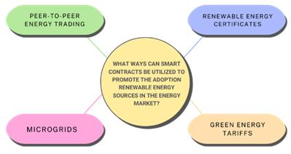

Fig. 1. The Utilization of Smart Contract in Energy markets.

Smart contracts manage microgrids, enabling localized en-ergy distribution powered by renewables, enhancing resilience and sustainability. Used to transport the electricity Smart contracts oversee microgrids, distributing renewable energy lo-cally. They automate energy generation, storage, and distribu-tion, maximizing renewable resource use. Additionally, smart contracts swiftly respond to disruptions, ensuring continuous power during emergencies [9].

B. Addressing Q2:

A developing technology used nowadays in decarbonized energy trading is blockchain. It is classified as distributed ledger technology (DLT). Blockchain technical main into types private and public blockchain [9].

* Public Blockchain: Public blockchain is like an open network where anyone can join, read, write, or be part

of it. Nobody controls it, and it’s decentralized, mean-ing there’s no single boss. Once data is on a public blockchain, it’s safe and can’t be changed. It’s kind of like a public park where everyone can come and play, and once something is there, it stays there for everyone to see. These are some real-time examples for public blockchains: Bitcoin, Ethereum, Monero, Zcash, Dash, Litecoin, Stellar, Steemit, etc [10].

– High Security: It is highly secured with due-to to 51% of mining.

– No Regulations:In this private blockchain, there will not be any regulations in the node. The work should be implemented.

– Full Transparency:It will do all the truncation cor-rectly, and we can see that no truncation is going on.

– Immutable:In this we cannot change the transaction in this.

– Distributed: In this technical, there is no central server it is distributed.

* + Private Blockchain:It is a platform for the decentralized sharing of energy data. It is a blockchain-based energy data analysis platform with a foundation in Australia under the direction of the EWF. It is also a green blockchain-based business, driving the creation of an open, decentralized energy information trading platform [10], [11].

– Full Privacy: It mainly focused on the privacy concerns.

– Distributed: Private blockchain technology is more centralized.

– High Efficiency and Faster Transactions:When you spread out the nodes close by and have fewer of them keeping track of things, the system works faster [11].

1. Addressing Q3:

Blockchain works like a peer-to-peer network where com-puters communicate directly. This setup allows for decentral-ized storage, agreement on data, and better security using cryptography. It removes the middlemen and creates a strong and widely spread systemm [11], [12].

* Transaction: In a transaction, there are two main parts: before the trade happens and when the trade is settled. Before the trade, people talk and agree on things like price and quantity. Then, the actual buying and selling happen when the trade is settled. These two parts are connected because good communication before the trade helps make the settlement go smoothly [12], [13].
* Optimization: In optimization, there are four main types: structural, demand response, buy and sell matching, and security and privacy. Structural optimization improves how well physical structures or systems work. Demand response optimization adjusts energy use based on supply and demand changes. Buy and sell matching optimization

helps match buyers and sellers for smoother transactions. Security and privacy optimization protects data from unauthorized access. These types aim to make systems work better, use energy smarter, and keep information safe [13], [14].

* Evaluation: In evaluation, there are four main types: usability, performance, security, and adoption. Usabil-ity checks how easy something is to use. Performance assesses how well something works and how fast it is. Security looks at how safe and protected something is from hackers or breaches. Adoption examines how widely something is accepted and used by people. These evaluations help understand how effective and reliable something is in real-world use [14].
* Advantages: Blockchain provides numerous benefits for various applications. It ensures security by using cryptog-raphy techniques, enhances efficiency by automating pro-cesses, and promotes decentralization, reducing reliance on centralized authorities. Additionally, blockchain min-imizes transaction dependencies and fosters transparency by recording all transactions on a shared ledger. Its au-tomation capabilities streamline operations and improve overall reliability.

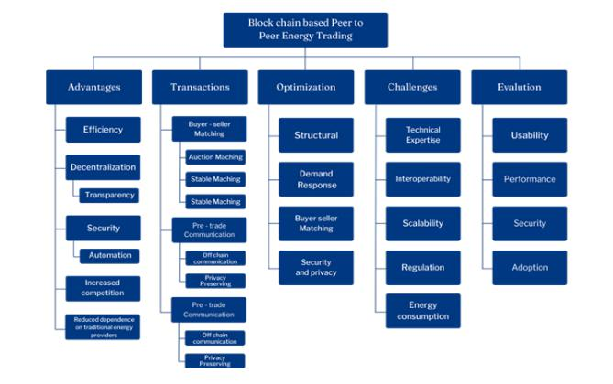

Fig. 2. The Utilization of Smart Contracts in Energy Trading

D. Addressing Q4:

Blockchain-based energy trading has its fair share of hur-dles. Keeping up with changing regulations is tough, and making sure it fits smoothly with the current energy setup isn’t easy either. Then there’s the issue of handling tons of transactions at once—scalability is a big deal. On top of that, keeping data secure and private is a must. And without common standards, it’s like trying to get different systems to speak the same language, which slows everything down [14], [15].

* Regulatory Compliance: Adhering to existing energy regulations and ensuring compliance with evolving reg-ulatory frameworks presents a significant challenge for blockchain-based energy trading platforms.
* Interoperability: Integrating blockchain solutions with existing energy infrastructure and ensuring interoper-ability with diverse systems and devices is a complex challenge that needs to be addressed.
* Scalability: As energy trading involves a high volume of transactions, ensuring the scalability of blockchain networks to handle real-time trading activities is a critical challenge.
* Data Privacy and Security: Protecting sensitive energy-related data and ensuring the security of transactions on blockchain networks are essential challenges, especially in the context of privacy regulations.
* Standardization: The lack of standardized protocols and frameworks for blockchain-based energy trading hinders interoperability and widespread adoption.

IV. SMART CONTRACT FOR P2P ENERGY TRADING

The smart contract model facilitates peer-to-peer (P2P) energy trading between producers (also known as prosumers) and consumers. The goal is to enable individuals to buy and sell energy based on supply and demand without the need for third-party intervention. By utilizing smart contracts on the blockchain, the system ensures easy, reliable, fast, and verifiable transactions[15].

In a solidity-based algorithm tested on the Ethereum plat-form, participants, known as prosumers, first create the user profile. It involves registering unique identifier—typically a blockchain address—and specifying the amount of energy can be offered, usually measured in kilowatt-hours (kWh). Pro-sumers also include e-wallet details for processing payments after completing successful trades. The energy input from the prosumer, as well as price x (which in this case translates to the energy that the prosumer wants to sell per kWh), plays a key role in the process of market clearing process [16].

On the other side, consumers login and provide similar in-formation. They state their address, the energy demand (kWh), and at what rate they bid the energy (Rs/kWh). Consumers also attach e-wallet details for this payment.

A. User Registration and Order Placement:

Here in Fig. 3, It depicts how users register themselves with the smart grid and place their orders. A set of functions, as shown in the smart contract, makes the registration process effective and allows users to place their orders efficiently. These functions ensure that each user is properly authenticated before the transaction is made, and their order details are recorded with precision [16], [17].

B. Owner-Controlled Trade Execution:

Here, in Fig. 4, the contract is managed by a single owner who oversees the entire trading process. This owner has the exclusive right to initiate trade executions by matching user orders, ensuring that no one else can interfere or manipulate the process. This design keeps the system secure and maintains its integrity.

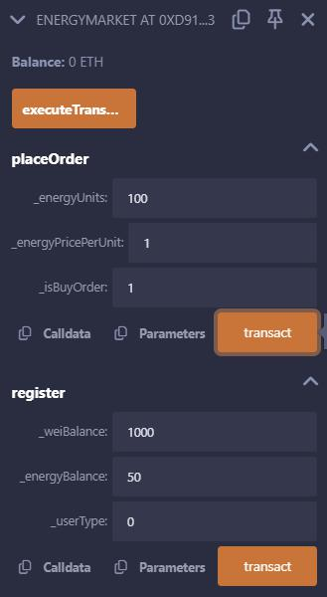

Fig. 3. User Registration

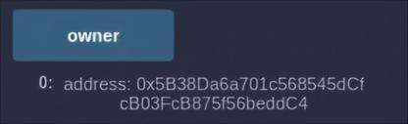

Fig. 4. Owner Address

C. Before and After Transaction Details:

Fig. 5 provides a visual comparison of the user’s status before and after the transaction is completed, highlighting the specific order placed by the user. It displays the number of orders in the contract and how they change after the transaction, enabling users to track the progress and outcome of their orders for complete accountability [17].

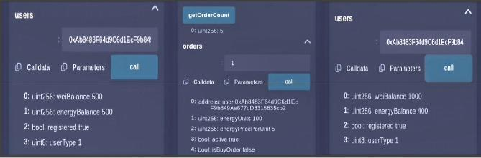

Fig. 5. Visual Comparison Before and After Transaction

D. Process Flow of Energy Transaction in P2P Trading:

The tested prototype of smart contract has the potential to play a key role in a decentralized peer-to-peer (P2P) energy trading marketplace where every consumer or energy producer would be able to buy or sell energy without the need for intermediaries. The use of Solidity smart contracts will allow

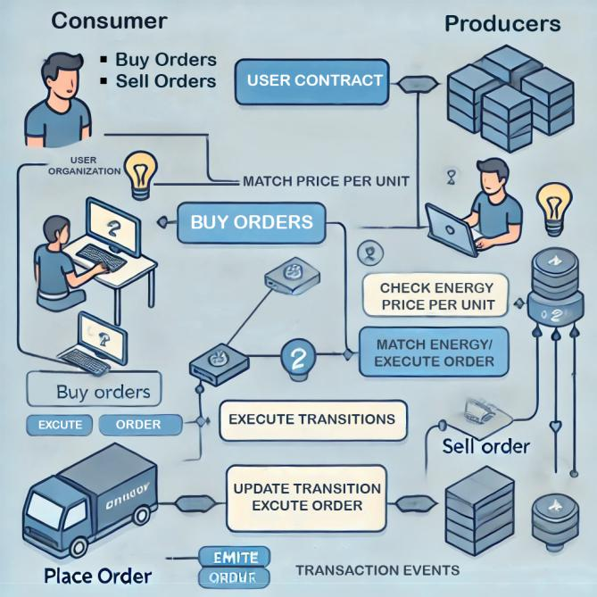

Fig. 6. Energy Transaction Process Flow Diagram

the platform to put energy trading on autopilot while making the processes transparent, secure, and low cost. Fig. 6The system depicts a truly decentralized energy market where individuals are connected through smart contracts. Consumers place buy and sell orders, while producers monitor energy prices to find a match. The system operates through several

stages, including price matching, execution of transactions, and updating the order status.

1. Flowchart of the energy transaction implemented in smart contract:

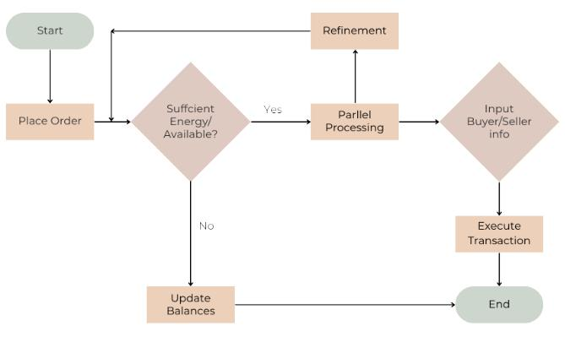

Fig. 7. Energy Transaction Flow

Fig. 7 illustrates a flowchart for peer-to-peer (P2P) energy trading scenarios. It begins with the “Place Order” operation, wherein participants place their orders for buying or selling. In the subsequent stage, a check is done to see if the energy needed to satisfy the order is available. If the response is “yes,” the system adjusts the figures and completes the cycle. If the response is “no,” the process divides into two branches, one dealing with pricing the order, another dealing with buying/selling the order, and completing the transaction at the end. Each stage is assigned a specific color for ease of understanding, with separate colors indicating different outcomes and tasks in the trading system [17].

* 1. FUTURE SCOPE

1. Tokenisation of Energy Units:

A Non-Fungible Token, or NFT, is a unique digital asset that represents ownership or the uniqueness of certain data, built on blockchain technology. NFTs are different from bitcoin or Ethereum, or any other fungible crypto assets, which can be easily swapped for one another. Each is unique and cannot be exchanged on a one-to-one basis. NFTs have become the new normal for creating digital representation and ownership in the form of art, music, videos, or even a building. However, the application of NFT extends further than collecting digital items and has wide-ranging potential.

With each kilowatt hour of energy created comes an NFT. Here’s an example: the energy generator or transformer creat-ing one kilowatt hour of electricity using sunlight from panels or wind from turbines might be represented by a digital token created on a blockchain.

This NFT has many advantages in that it can testify to the amount of energy produced, the kind, and quantity. The token may also give further information like when and where the energy was produced, carbon emissions involved, and the type of energy.

Fig. 8. Energy Tokenization Process

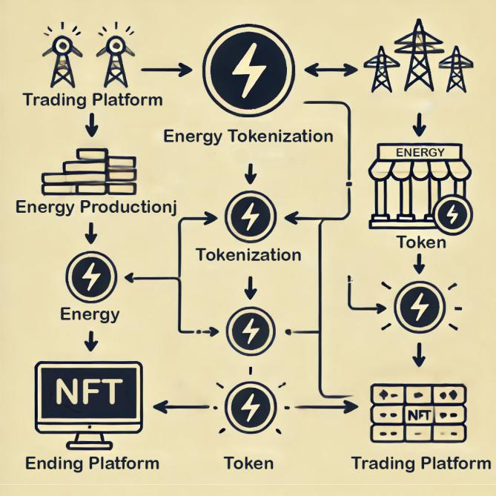

Fig. 8Energy tokenization would involve taking the energy produced in some form of energy production and converting it into digital tokens that can be traded on numerous platforms. For instance, even the energy tokens could be converted into NFTs, thereby making possible the management and trading of more than what is available on all platforms.

After having been tokenized, consumers, businesses, and even energy brokers can buy, sell or even trade energy NFTs. For example, one whose location would have excess green energy would sell those NFTs representing that energy to another person whose location would consume it. That trans-action would then naturally be conducted on a blockchain, rendering it automatic, transparent, and secure. In this manner, the buying and selling or even transfer of ownership are all managed through smart contracts that eliminate all middlemen [18].

B. Machine Learning Integration:

A blockchain is a decentralized data structure with the prin-ciples of a distributed database. Global information resources are considered to be of open access in this network and, therefore, are used to increase the volumes of transactions, the algorithm execution speed, order-filling rates, and all other characteristics. For each parameter, it is possible to be exact, but it is possible to learn through the use of some machine learning data fit for the parameters.

This will provide advantages to not only those particular entities but also will enable the overall health of the blockchain ecosystem to be strengthened. In the future, the interconnec-tion between blockchain technology and machine learning will play a very important role in transforming the techniques and

measures handling big data, securing data, and transacting, thereby furthering the level of globalization and increasing efficiency within the smart grids [18].

VI. CONCLUSION

The paper dives deep into smart contracts within the energy sector, offering insights into their current status and future prospects. It covers the advantages and hurdles of using smart contracts, explores new market strategies and software needs, and stresses the necessity for ongoing research and advancement. Security concerns, implementation challenges, and the ecological and financial ramifications of expanding smart contract usage in digital energy systems are highlighted. Ultimately, the paper urges ongoing exploration and creativity to harness smart contracts for efficient power network manage-ment and to enable decentralized, adaptable energy systems in the years ahead.

VII. ACKNOWLEDGMENT

The authors express their heartfelt appreciation to Shri. (Dr.) Mata Amritanandamayi Devi (AMMA) for her guidance and Amrita Vishwa Vidyapeetham for providing the platform for this research.

REFERENCES

1. R. Tonelli, A. Bracciali, and H. Rocha, ”Results of Blockchain-Oriented Software Engineering 2024 Workshop: Speculations on Blockchain for Energy Communities Management,” 2024 IEEE International Confer-ence on Software Analysis, Evolution and Reengineering, 2024, pp. 1-5.
2. J. Singh, S. Rani, and P. Kumar, ”Blockchain and Smart Contracts: Evolution, Challenges, and Future Directions,” 2024 International Con-ference on Knowledge Engineering and Communication Systems, 2024, pp. 1-5.
3. X. Zhang, X. Feng, Z. Jiang, Q. Gong, and Y. Wang, ”A blockchain-enabled framework for reverse supply chain management of power batteries,” Journal of Clean Production, 2023.
4. T. Anderson and C. Brown, ”Blockchain-Based Smart Contracts: Al-gorithmic Approaches to Enhance Efficiency and Security,” Journal of Computer and System Sciences, vol. 109, pp. 1-20, 2023. DOI: 10.1016/j.jcss.2023.02.003.
5. Y. K. Chau, C. Yuen, and Y. Liu, ”Blockchain for Decentralized Peer-to-Peer Energy Trading,” IEEE Access, 2020.
6. A. Smith, B. Johnson, and C. Lee, ”Blockchain-Based Management of Renewable Energy Certificates: A Case Study,” IEEE Transactions on Sustainable Energy, 2021.
7. X. Zhang, Y. Wang, and Z. Chen, ”Smart Contract-Enabled Green En-ergy Tariffs: Promoting Renewable Energy Adoption in Power Markets,” IEEE Transactions on Power Systems, 2020.
8. A. Patel, B. Gupta, and C. Wang, ”Smart Contract-Managed Microgrids for Resilient and Sustainable Energy Distribution,” IEEE Transactions on Smart Grid, 2021.
9. D. Yaga, P. Mell, N. Roby, and K. Scarfone, ”Blockchain technology overview,” US National Institute of Standards and Technology, 2018.
10. M. Andoni, V. Robu, D. Flynn, S. Abram, D. Geach, D. Jenkins, P. McCallum, and A. Peacock, ”Blockchain technology in the energy sector: A systematic review of challenges and opportunities,” 2019.
11. J. Lee, S. Gupta, and M. Zhang, ”A Comprehensive Analysis of Proof of Stake (PoS) Consensus Mechanisms in Blockchain Networks,” IEEE Transactions on Emerging Topics in Computing, 2021.
12. V. Valsan, L. Varsha, M. Deeksha, S. Ankith, and K. P. Kanakasabapathy, ”Blockchain based smart energy trading in a sustainable community: A Comparative Technological Analysis,” 2020.
13. Y. Yuan and F.-Y. Wang, ”Towards blockchain-based intelligent trans-portation systems,” in 2016 IEEE 19th International Conference on Intelligent Transportation Systems (ITSC), pp. 2663–2668.
14. P. Wongthongtham, D. Marrable, B. Abu-Salih, X. Liu, and G. Morri-son, ”Blockchain-enabled peer-to-peer energy trading,” Computers and Electrical Engineering, vol. 94, no. 107299, 2021.
15. Bhavana, G.B., Anand, R., Ramprabhakar, J. et al. Applications of blockchain technology in peer-to-peer energy markets and green hy-drogen supply chains: a topical review. Sci Rep 14, 21954 (2024). https://doi.org/10.1038/s41598-024-72642-2.
16. V. Valsan, K. P, M. V. Ramesh, L. Varsha, M. Deeksha and S. Ankith, ”Blockchain based Smart Energy Trading in a Sustainable Community: A Comparative Technological Analysis,” 2023 6th In-ternational Conference on Contemporary Computing and Informat-ics (IC3I), Gautam Buddha Nagar, India, 2023, pp. 561-567, doi: 10.1109/IC3I59117.2023.10397779.
17. V. Valsan, K. KK, D. N. S, A. Ajithkumar and A. Sasikumar, ”Securing Sustainable Energy Trading: An RSA-Encrypted IoT Solution for Smart Meter Data Transmission,” 2024 International Conference on Compu-tational Intelligence and Computing Applications (ICCICA), Samalkha, India, 2024, pp. 187-192, doi: 10.1109/ICCICA60014.2024.10584897
18. Kayikci, S,Khoshgoftaar, T. M. (Year). Blockchain meets machine learning: A survey. Journal Name, Volume(Issue), Page Range. Depart-ment of Electrical Engineering and Computer Science, Florida Atlantic University, Boca Raton, FL 33431, USA.