**Harnessing Blockchain Technology and Smart Contracts for Transformative Energy Trading**

1P. Sarvan Sri Sai, 1Koraganji Mukesh, 1Teja Sindukuri, 1Abbaraju Sree Tharun Raju, 1Vipina Valsan.

1Department of Computer Science and Engineering,

Amrita School of Computing, Amrita Vishwa Vidyapeetham, Amritapuri, India

1Department of Electrical and Electronics Engineering,

Amrita School of Engineering, Amrita Vishwa Vidyapeetham, Amritapuri, India

#Corresponding Author: deepthi@am.amrita.edu

**Abstract:** The rise of renewable energy has led to the growing need for trustworthy peer-to-peer energy trading within microgrids. Blockchain technology (BCT) addresses this challenge by providing a secure, tamper-proof ledger that ensures transparent and sustainable energy exchanges. This paper examines how smart contracts can facilitate efficient energy trading among microgrid users, with all transactions being securely recorded and easily verifiable. The architecture of these smart contracts creates a reliable framework for trading energy, integrating mechanisms like simultaneous bid submissions, user registration, order placement and sorting, and automatic transaction execution. This system not only promotes energy efficiency and flexibility but also supports decentralized control within the grid.

By enabling transparent and decentralized energy trading, this technology directly contributes to SDG 7: Affordable and Clean Energy**, particularly in increasing the share of renewable energy in the global energy mix and improving energy efficiency. Additionally, it supports SDG 9 by fostering resilient and sustainable infrastructure through technological innovation. Furthermore, the decentralized nature of energy trading aligns with SDG 11 helping create more energy-resilient urban areas. The detailed analysis, pseudocode, and open-source code provided in this paper aim to guide real-world implementation and offer suggestions for future improvements in energy and flexibility trading.

**Keywords:** Blockchain technology, microgrid, sustainable energy trading, Hyperledger fabric, peer-to-peer**.**

**1. Introduction**

In recent years, the global energy landscape has witnessed a paradigm shift driven by the imperative of sustainability and technological innovation. This transformation is underscored by a pronounced emphasis on harnessing renewable energy sources (RES) [1-3], such as wind, solar, and hydro power. The main advantage of microgrids is their ability to supply energy locally. They also serve as personal energy backups; when the main power supply experiences a hiccup, microgrids store energy locally and keep your lights on without missing a beat. They are the energy superheroes that store power for a rainy day. When the main grid falters, microgrids use their stored energy to keep things running smoothly. [3,4]

Smart contracts the benefits and blockchain technology might just be the dynamic duo we need. Picture blockchain as a super-secure digital ledger, keeping tabs on transactions. Now, meet smart contracts – the digital maestros living on this blockchain. They bring automation, decentralization, and rock-solid security. Smart contracts work on the blockchain architecture, which is like a super-secure digital ledger that records transactions. These contracts are like digital agreements that run on their own. Imagine a self-driving contract that follows specific rules, triggers actions when conditions are met, and handles energy trades automatically. They use computers to process data, verify conditions, and validate contracts. Once recorded, the information is permanent and transparent. No need for middlemen or system operators; they speed up negotiations between parties. This virtual contract world could create new social setups like decentralized social organizations or self-organizing energy communities. Governments recognize the importance of these smart contracts in unleashing the full power of blockchain technology, making transactions more efficient and secure.[2,4]

# 2.Research Methodology

We're studying how blockchain technology affects energy trading. We're starting by asking four main questions. We're looking at important articles, conferences, and journals, sorting them based on what they're trying to find out. We're using Google Scholar and Scopus to find the main articles, mostly from Elsevier, IEEE, and Springer. We're also checking other places like ScienceDirect. We're refining our questions as we learn more.[5]

* 2.1.RQ1: What ways can smart contracts be utilized to promote the adoption renewable energy sources in the energy market?
* 2.2.RQ2: What are the technical characteristics of blockchain technology?
* 2.3.RQ3: What are the blockchain based peer to peer energy Trading?
* 2.4.RQ4: What are the key challenges and future scope of Blockchain Technology in energy trading?

# 3.Findings and Overview

# *3.1Addressing RQ1:* What ways can smart contracts be utilized to promote the adoption of renewable energy sources in the energy market?

Blockchain technology, essential for environmentally-friendly energy trading, started with David Chaum's vision in 1982. Stuart Haber and W. Scott Stornetta proposed secure timestamp methods in 1991. Satoshi Nakamoto's 2008 report boosted blockchain, introducing features like Hash cache, enabling timestamps without central authorities. In energy trading, blockchain merges with smart contracts, coded agreements automating tasks like transactions and verification, enhancing transparency and efficiency in decentralized markets.[3,5]

***3.1.1Peer-to-peer energy trading:*** They enable direct energy trading between consumers and prosumers, fostering the sale of surplus renewable energy and reducing dependence on traditional sources [4]. Peer-to-peer (P2P) electricity trading is a. business model, based on an interconnected platform, that serves as an online marketplace where consumers and producers “meet” to trade electricity directly, without the need for an intermediary.[7]

***3.1.2 Renewable energy certificates****:* Renewable Energy Certificates (RECs) are like badges showing clean energy from solar or wind[4]. Each REC equals 1 megawatt-hour of renewable energy. Buying RECs supports clean energy generation. Smart contracts manage REC creation and trade, encouraging more renewable energy use by valuing its environmental benefits.[8]

***3.1.3 Green energy tariffs****:* Smart contracts manage tariffs that financially motivate consumers to use renewable energy, promoting its cost-competitiveness. Power consumers, especially in the commercial and industrial sector, are increasingly choosing renewable energy sources. One option is through a green energy tariff, offered by electricity companies, allowing consumers to buy electricity sourced from renewables.[9]

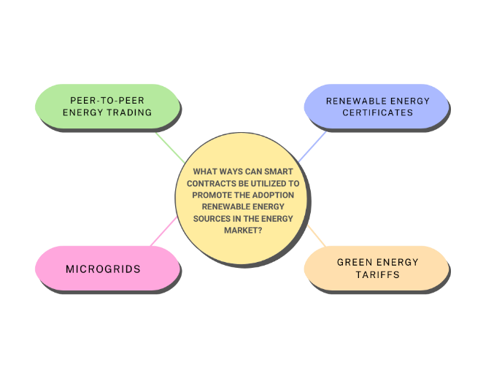

Fig.1. The Utilization of Smart Contract

**Microgrids**: Smart contracts manage microgrids, enabling localized energy distribution powered by renewables, enhancing resilience and sustainability Used to transport the electricity Smart contracts oversee microgrids, distributing renewable energy locally. They automate energy generation, storage, and distribution, maximizing renewable resource use. Additionally, smart contracts swiftly respond to disruptions, ensuring continuous power during emergencies.[10]

***3.2Addressing RQ2:*** What are the technical characteristics of blockchain technology?

A developing technology used nowadays in decarbonized energy trading is blockchain. It is classified as distributed ledger technology (DLT). Blockchain technical main into types private and public blockchain.[13]

***3.2.1. Public Blockchain:*** Public Blockchain is like an open network where anyone can join, read, write, or be part of it. Nobody controls it, and it's decentralized, meaning there's no single boss. Once data is on a public blockchain, it's safe and can't be changed. It's kind of like a public park where everyone can come and play, and once something is there, it stays there for everyone to see. This are some real-time example for public blockchain Bitcoin, Ethereum, Monero, Zcash, Dash, Litecoin, Stellar, Steemit etc.[8]

**Features of Public Blockchain:**

1**.High Security** - It is highly secured with due-to to 51% of mining.

2.**No Regulations** - In this private blockchain they will not be any regulations in the node. The work should implement.

3.**Full Transparency** - it is will do the all the truncation correctly we can see the any not truncation is going on.

4.**Immutable** - In this we cannot change the transaction in this.

5.**Distributed** - In this technical they are no central server.it distributed.

***3.2.3Private Blockchain:*** It is a platform for the decentralized sharing of energy data. It is a blockchain based energy data analysis platform with a foundation in Australia under the direction of the EWF. It is also a green blockchain based business, driving the creation of an open decentralized energy information trading platform.[16]

**Features of Private Blockchain:**

**1.Full Privacy:** It mainly focused on the privacy concerns.

**2. Distributed:** Private blockchain technology is more centralized.

**3.High Efficiency and Faster Transactions:** When you spread out the nodes close by and have fewer of them keeping track of things, the system works faster.[12]

***3.2.3: Proof of Work (PoW)***

Proof of Work (PoW), Proof of Stake in Proof of Work (PoW) consensus, is used to maintain the bitcoin. Miners compete to solve a tough cryptographic puzzle (find the hash value to Nonce; this will be creating the hash value), like finding a specific code's hash, to earn the right to add the next block to the chain. This process, often called "mining," is a bit like a race to crack a code. Miners, the participants in this race, receive some of the native cryptocurrency as a reward for their successful efforts [12].

***3.2.4: Proof of Stack(PoS)***

Permissioned blockchains require participants to have permission to perform transactions and add information to the blockchain. In PoA, a set of approved validators are granted the authority to validate transactions, ensuring a controlled and secure network. Authority nodes undergo a selection process, disclose their identity, and adhere[11]

***3.3 Addressing RQ3: What are the various processes involved in blockchain based energy trading?***

Blockchain works like a peer-to-peer network where computers communicate directly. This setup allows for decentralized storage, agreement on data, and better security using cryptography. It removes the middlemen and creates a strong and widely spread system.[5,6]

**3.3.1 Transaction:** In a transaction, there are two main parts: before the trade happens and when the trade is settled. Before the trade, people talk and agree on things like price and quantity. Then, the actual buying and selling happen when the trade is settled. These two parts are connected because good communication before the trade helps make the settlement go smoothly[6,17].

**3.3.2 Optimization:** In optimization, there are four main types: structural, demand response, buy and sell matching, and security and privacy. Structural optimization improves how well physical structures or systems work. Demand response optimization adjusts energy use based on supply and demand changes. Buy and sell matching optimization helps match buyers and sellers for smoother transactions. Security and privacy optimization protects data from unauthorized access. These types aim to make systems work better, use energy smarter, and keep information safe [4,18].

**3.3.3 Evaluation:** In evaluation, there are four main types: usability, performance, security, and adoption. Usability checks how easy something is to use. Performance assesses how well something works and how fast it is. Security looks at how safe and protected something is from hackers or breaches. Adoption examines how widely something is accepted and used by people. These evaluations help understand how effective and reliable something is in real-world use.

**3.3.4 Advantages:** Blockchain provides numerous benefits for various applications. It ensures security by using cryptographic techniques, enhances efficiency by automating processes, and promotes decentralization, reducing reliance on centralized authorities. Additionally, blockchain minimizes transaction dependencies and fosters transparency by recording all transactions on a shared ledger. Its automation capabilities streamline operations and improve overall reliability.

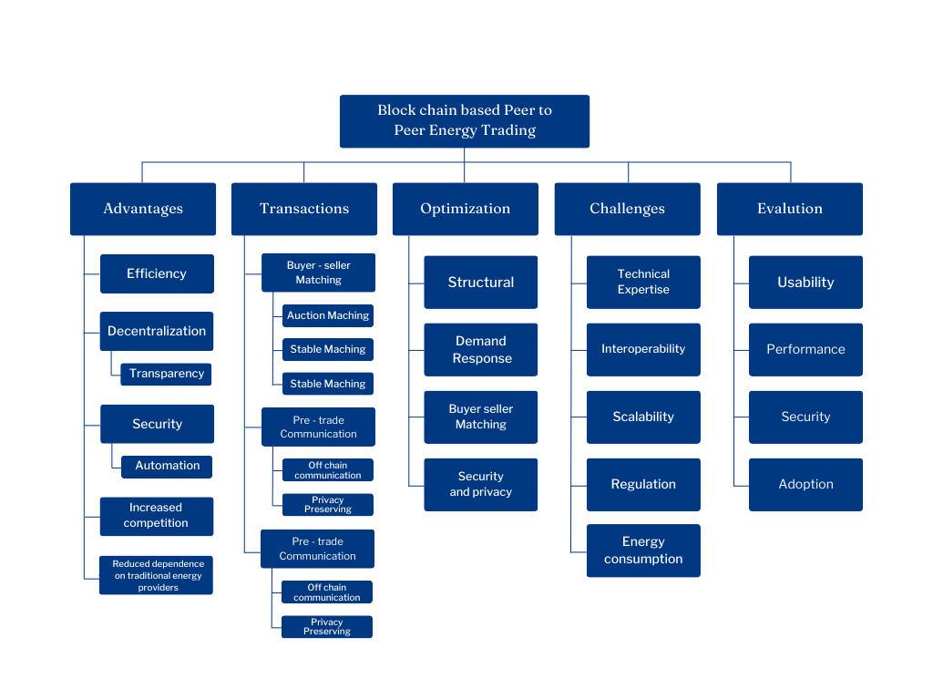

Fig.2. Block Based Peer to Peer Energy Trading

***3.42Addressing RQ4****:* What are the key challenges and future scope of Blockchain Technology in energy trading?

The key challenges and future scope of Blockchain in energy trading are as follows:

***3.4.1:* Challenges:**

1.Regulatory Compliance: Adhering to existing energy regulations and ensuring compliance with evolving regulatory frameworks presents a significant challenge for blockchain-based energy trading platforms.

2.Interoperability: Integrating blockchain solutions with existing energy infrastructure and ensuring interoperability with diverse systems and devices is a complex challenge that needs to be addressed.

3.Scalability: As energy trading involves a high volume of transactions, ensuring the scalability of blockchain networks to handle real-time trading activities is a critical challenge.

4.Data Privacy and Security: Protecting sensitive energy-related data and ensuring the security of transactions on blockchain networks are essential challenges, especially in the context of privacy regulations.

5.Standardization: The lack of standardized protocols and frameworks for blockchain-based energy trading hinders interoperability and widespread adoption.

***3.4.2:* Future Scope:**

1.Decentralized Energy Markets: In the future, we will use blockchain to build decentralized energy markets, allowing people to trade energy directly with each other and better integrate renewable energy at a local level.

2.Transactive Energy: Our project will include systems where energy trading happens automatically, based on set rules. This will make energy trading faster and more efficient, while also helping to meet energy demand more effectively.

3.Smart Contracts for Automation: We'll use smart contracts to automate the entire energy trading process, so transactions happen on their own without the need for middlemen, making everything quicker and simpler.

4.Renewable Energy Integration: In the future, we'll focus on better integrating renewable energy into the system. Blockchain will make trading and using renewable energy smoother and more efficient.

5.Grid Flexibility and Resilience: Our project will help make energy grids more flexible and resilient by introducing a bidding system for real-time energy trading. This will help balance supply and demand and keep the grid stable.

6.User-Friendly Interface: We also plan to add a user-friendly interface (GUI) to the project, making it easy for anyone to use the platform for energy trading, making it more accessible to everyday users.

**4.Algorithm:**

This smart contract supports the P2P energy trading between producers and consumers also known as prosumers and consumers respectively. The idea is to make it possible for people to buy and sell energy on the basis of supply and demand, without third party intervention by using smart contracts over the blockchain for easy, reliable, fast, and verifiable transactions. For further information, you can refer to the following GitHub repository: [GitHub Code](https://github.com/darthvader9092/Smart-Contarcts-for-Energy-Grids.git)

In this structure, the participants called prosumers firstly create their profile, which may involve the registration of their unique identifier, usually one of the addresses on the blockchain, and describe the energy which they can make available (typically stated in kilowatt–hours or kWh). They also provide e-wallet information for making payments after a successful deal in their trades. The energy input from the prosumer, as well as price x (which in this case translates to, the energy that the prosumer wants to sell- per kWh), plays a key role in the process of matching them with energy consumers.

On the other side, consumers login and provide similar information. They state their address, how much energy they want (energy demand), and what rate they respect for the energy (kWh). Consumers also attach e-wallet details for this payment.

4.1 User Registration and Order Placement

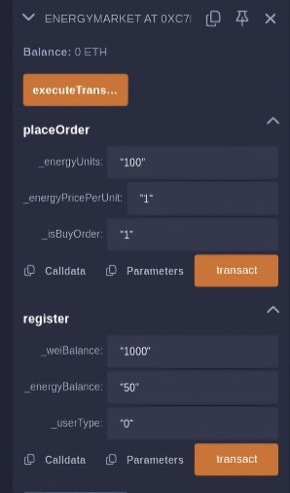

Fig.3: User Registration

Here in this Fig.3 depicts how users will register themselves with the smart grid and place their orders. A set of functions, as shown in the smart contract, makes the registration process effective and allows users to place their orders efficiently. These functions ensure that each user is properly authenticated before the transaction is made and their order details are recorded with precision.

4.2 Owner-Controlled Trade Execution

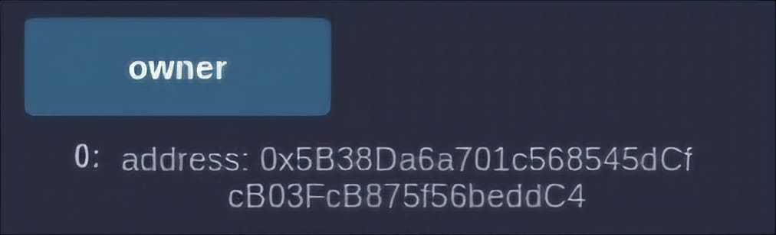

Fig.4: Owner Address

Here, In Fig.4 contract is controlled by one owner who is responsible for the overall control and the operation of the trade process. Only the owner has the right to initiate the executing of the trades by matching the orders of the users in such a way that no other person can trigger or manipulate the trade to keep the entire system intact.

4.3 Before and After Transaction Details

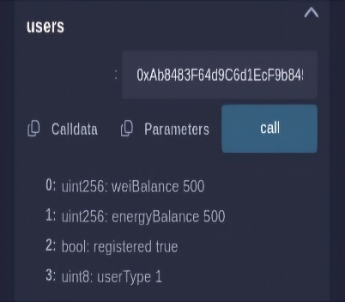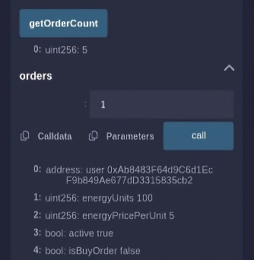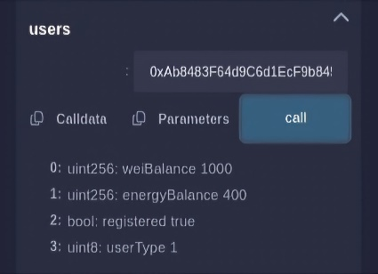

Fig.5: Visual Comparison

Fig.5 provides a visual comparison between the user's state before and after the transaction is completed. It highlights, for example, the specific order the user has placed, showing the number of orders in a contract and how they change post-transaction. This will allow the users to track the progress and outcomes of their orders for full accountability.

4.4 Flowchart representing the flow of contract in system:

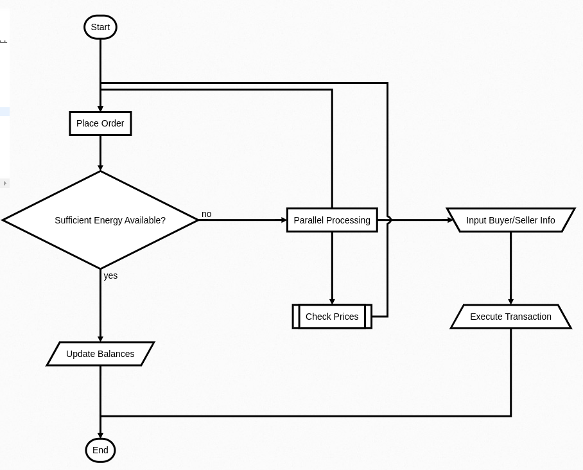

Fig.6: Working of system.

Fig.6 The illustration below shows a flowchart for peer-to-peer (P2P) energy trading activities. It begins with the “Place Order” operation wherein participants place their orders for buying or selling. In the subsequent stage, a check is done to see if the energy needed to satisfy the order is actually on hand. In the event that the response is “Yes,” the system changes the figures and completes the cycle. In the case of a “No” response, the process divides into two branches, one dealing with pricing the order, another dealing with buying/selling the order, and completing the transaction at the end. Each stage of carrying out the process is assigned a certain color for ease of understanding, and there are separate colors with different meaning for the outcomes and tasks that occupy the trading system.

**4.Conclusion:**

The review paper dives deep into smart contracts within the energy sector, offering insights into their current status and future prospects. It covers the advantages and hurdles of using smart contracts, explores new market strategies and software needs, and stresses the necessity for ongoing research and advancement. Security concerns, implementation challenges, and the ecological and financial ramifications of expanding smart contract usage in digital energy systems are highlighted. Ultimately, the paper urges ongoing exploration and creativity to harness smart contracts for efficient power network management and to enable decentralized, adaptable energy systems in the years ahead.

**5. Acknowledgement**

The authors express their heartfelt appreciation to Shri. (Dr.) Mata Amritanandamayi Devi (AMMA), a globally acclaimed humanitarian leader and their esteemed Chancellor, for her exceptional guidance and encouragement. They also acknowledge with gratitude Amrita Vishwa Vidyapeetham for offering them the platform to conduct this research.

**6. References**

[1] R. Tonelli, A. Bracciali and H. Rocha, "Results of Blockchain-Oriented Software Engineering 2024 Workshop: Speculations on Blockchain for Energy Communities management," 2024 IEEE International Conference on Software Analysis, Evolution and Reengineering - Companion (SANER-C), Rovaniemi, Finland, 2024, pp. 1-5, doi: 10.1109/SANER-C62648.2024.00005. keywords: {Blockchain;Energy Communities;Smart Contracts;Smart Grids;Topic Analysis},

[2] J. Singh, S. Rani and P. Kumar, "Blockchain and Smart Contracts: Evolution, Challenges, and Future Directions," 2024 International Conference on Knowledge Engineering and Communication Systems (ICKECS), Chikkaballapur, India, 2024, pp. 1-5, doi: 10.1109/ICKECS61492.2024.10616652. keywords: {Surveys;Energy consumption;Technological innovation;Proof of stake;Uncertainty;Scalability;Smart contracts;Blockchain;Smart Contracts;Decentralization;Cryptocurrency;Digital Transformation},

[3] X. Zhang, X. Feng, Z. Jiang, Q. Gong, Y. Wang, A blockchain-enabled framework for reverse supply chain management of power batteries, J. Clean. Prod. 415 (2023) 137823.

[4 Anderson, T., & Brown, C. (2023). "Blockchain-Based Smart Contracts: Algorithmic Approaches to Enhance Efficiency and Security." Journal of Computer and System Sciences, 109, 1-20. DOI: 10.1016/j.jcss.2023.02.003

[5] Anderson, T., & Brown, C. (2023). "Blockchain-Based Smart Contracts: Algorithmic Approaches to Enhance Efficiency and Security." Journal of Computer and System Sciences, 109, 1-20. DOI: 10.1016/j.jcss.2023.02.003

[6] Y. K. Chau, C. Yuen, and Y. Liu Blockchain for Decentralized Peer-to-Peer Energy Trading IEEE Access, 2020.

[7] A. Smith, B. Johnson, C. Lee Blockchain-Based Management of Renewable Energy Certificates: A Case Study IEEE Transactions on Sustainable Energy, 2021.

[8] X. Zhang, Y. Wang, Z. Chen Smart Contract-Enabled Green Energy Tariffs2: Promoting Renewable Energy Adoption in Power Markets IEEE Transactions on Power Systems, 2020.

[9] A. Patel, B. Gupta, C. Wang Smart Contract-Managed Microgrids for Resilient and Sustainable Energy Distribution IEEE Transactions on Smart Grid, 2021.

[10] Yaga D, Mell P, Roby N, Scarfone K. Blockchain technology overview. US

National Institute of Standards and Technology,2018.

[11] M. Andoni, V. Robu, D. Flynn, S. Abram, D. Geach, D. Jenkins, P. McCallum, A. Peacock, Blockchain technology in the energy sector: A systematic review of challenges and opportunities,2019.

[12] J. Lee, S. Gupta, M. Zhang A Comprehensive Analysis of Proof of Stake (PoS) Consensus Mechanisms in Blockchain Networks IEEE Transactions on Emerging Topics in Computing, 2021.

[13] Vipina Valsan, Lokavarapu Varsha, Mucharla Deeksha, Suravarapu Ankith, Kanakasabapathy P Blockchain based smart energy trading in a sustainable community: A Comparative Technological Analysis

[14] Y.Yuan, F.-Y. Wang, Towards blockchain-based intelligent transportation systems, in: 2016 IEEE 19th international conference on intelligent transportation systems (ITSC), IEEE, 2016, pp. 2663–2668.

[15] P. Wongthongtham, D. Marrable, B. Abu-Salih, X. Liu, G. Morrison, Blockchain-enabled peer-to-peer energy trading, Computers Electrical Engineering 94 (2021) 107299.