DOORI

A PROJECT REPORT

Submitted by

Vardaan Vishnu (19BCE10063)
Prantik Bhattacharjee(19BCE10222)
Shikhar Vashishta (19BCE10025)
Prashant Chauhan (19BCE10280)

in partial fulfillment for the award of the degree
of

BACHELOR OF TECHNOLOGY

in

COMPUTER SCIENCE AND ENGINEERING


SCHOOL OF COMPUTING SCIENCE AND ENGINEERING
VIT BHOPAL UNIVERSITY
KOTHRIKALAN, SEHORE
MADHYA PRADESH - 466114

Apr 2021

VIT BHOPAL UNIVERSITY,KOTHRIKALAN, SEHORE
MADHYA PRADESH – 466114

BONAFIDE CERTIFICATE

Certified that this project report titled Doori is the Bonafide work of Vardaan Vishnu (19BCE10063), Prantik Bhattacharjee (19BCE10222), Shikhar Vashishtha (19BCE10025), Prashant Chauhan(19BCE10280) who carried out the project work under my supervision. Certified further that to the best of my knowledge the work reported here does not form part of any other project / research work on the basis of which a degree or award was conferred on an earlier occasion on this or any other candidate.

PROGRAM CHAIR PROJECT GUIDE
Dr. M Ashwin, Program Chair Dr Abha Trivedi,
School of Computer Science and Engineering School of Computer Science and Engineering
VIT BHOPAL UNIVERSITY VIT BHOPAL UNIVERSITY

The Project Exhibition II Examination is held on 30 April 2021

ACKNOWLEDGEMENT

First and foremost, we would like to thank the Lord Almighty for His presence and immense blessings throughout the project work.
We wish to express our heartfelt gratitude to Dr. Manas Kumar Mishra, Head of the Department, School of Computer Science & Engineering for much of his valuable support encouragement in carrying out this work.
We would like to thank our internal guide Dr. Abha Trivedi, for continually guiding and actively participating in our project, giving valuable suggestions to complete the project work.
We would like to thank all the technical and teaching staff of the School of Computer Science & Engineering, who extended directly or indirectly all support.
Last, but not the least, we are deeply indebted to our parents who have been the greatest support while we worked day and night for the project to make it a success.

ABSTRACT

In the current Covid-19 situation, safety measures taken by the governments around the world have failed in front of Covid-19, due to lack of social distancing practice. Newer variants of the virus have emerged that are equivalent or more dangerous than the previous one. Thus, it becomes a monumental challenge to tackle the issue of social distancing in an overly populated country like India. Doori aims to combine Computer Vision to create a real-time social distance monitoring software so that administrators can use them to locate breach of bio-bubbles. It uses OpenCV library and YOLO v3 for real-time human detection.
The various features we wish to add to our application are:
- Doori aims to combine Computer Vision to create a real-time social distance monitoring software.
- It would be able to scan for environments in real-time for breach of bio-bubbles. The parameters will be flexible, so that the administrators can use them at their own behest.
- It utilizes OpenCV library and YOLO v3(You only look once) for real-time object detection to detect humans.

TABLE OF CONTENTS

CHAPTER NO. | TITLE | PAGE NO.
 | Abstract | 3
1 | INTRODUCTION  Introduction  1.2 Existing work, limitations  1.3 Proposed work for project  1.4 Novelty of Project | 6  .  .  .
2 | PROJECT LITERATURE REVIEW  2.1 Real Time Usage of Project  2.2 Real World Hardware and Software Requirements | 7
3 | WORK DONE  3.1 Module Work Flow  3.2 Overall System Architecture  3.3 Module Description  3.4 Implementation and Coding (Images) | 8  9  9  9,10,11

INTRODUCTION

  - PROJECT INTRODUCTION: -

In the current Covid-19 situation, it is very important to maintain social distancing in public places. The safety measures taken by the governments around the world have failed in front of the deadly first wave of Covid-19, due to lack of social distancing practice. Newer variants of the virus have emerged that are equivalent or more dangerous than the previous one. Thus, it becomes a monumental challenge to tackle the issue of social distancing in an overly populated country like India. Hence, we come forward with our project, Doori, a social distancing tracker, based on Computer Vision. Our project’s main objective is to help authorities implement Social distancing in public places & offices.
  - EXISTING WORK, LIMITATIONS: -
Social distancing trackers are useful in ensuring proper W.H.O. guidelines on COVID-19. But software lacks the integration of a mask detector in them. Both of these features are not integrated in a single package, since they have different requirements and physical limitations.

  - PROPOSED WORK FOR PROJECT: -

The various features we wish to add to our application are:
- Doori aims to combine Computer Vision to create a real-time social distance monitoring software.
- It would be able to scan for environments in real-time for breach of bio-bubbles. The parameters will be flexible, so that the administrators can use them at their own behest.
- It utilizes OpenCV library and YOLO v3(You only look once) for real-time object detection to detect humans.

  - NOVELTY OF PROJECT
- The Idea for this project arises from ‘OpenCV documentation’ which stated an API that could create human detection along with distancing.
- Novelty or Originality of concept remains the essence of this project
- We will try to make our project as Original & Innovative as possible by constantly adding our own innovative ideas

PROJECT LITERATURE REVIEW

(2.1) REAL TIME USAGE: -
Various daily life tasks have been automated with the help of computer vision (branch of AI). How our app can be used in real time scenario:
- The algorithm can be used to analyze social distancing in a public area and carry out necessary actions to better deal with the pandemic.
- Automating the task will lead to effective actions taken in a short time hence equipping us better to deal with the situation.

(2.2) REAL WORLD HARDWARE AND SOFTWARE REQUIREMENTS: -
Hardware Requirements-
- Camera
- 24x7 running System for seamless tracking and to run python script
Software Requirements-
- Python 3.5.2
- OpenCV2 4.2.0
- NumPy 1.14.5
- For human detection: YOLOv3.weights, YOLOv3.cfg files

WORK DONE

(3.1) MODULE WORK FLOW: -
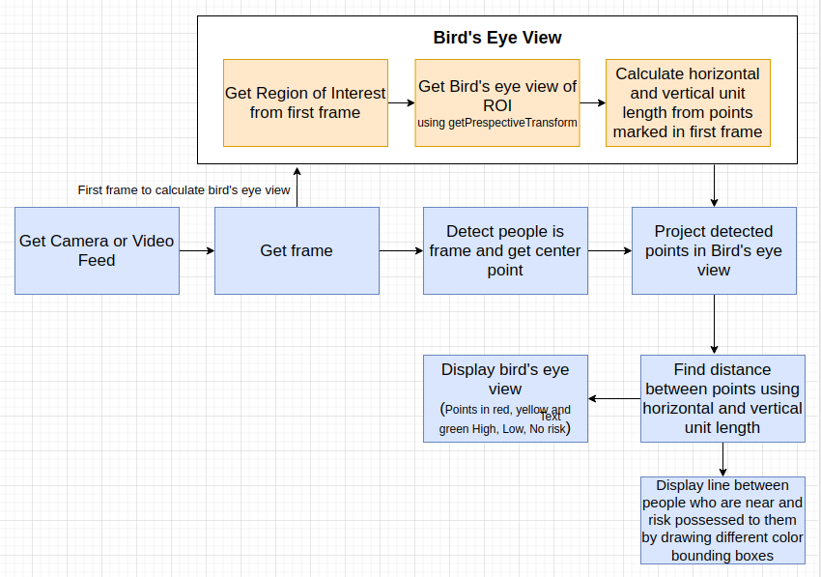
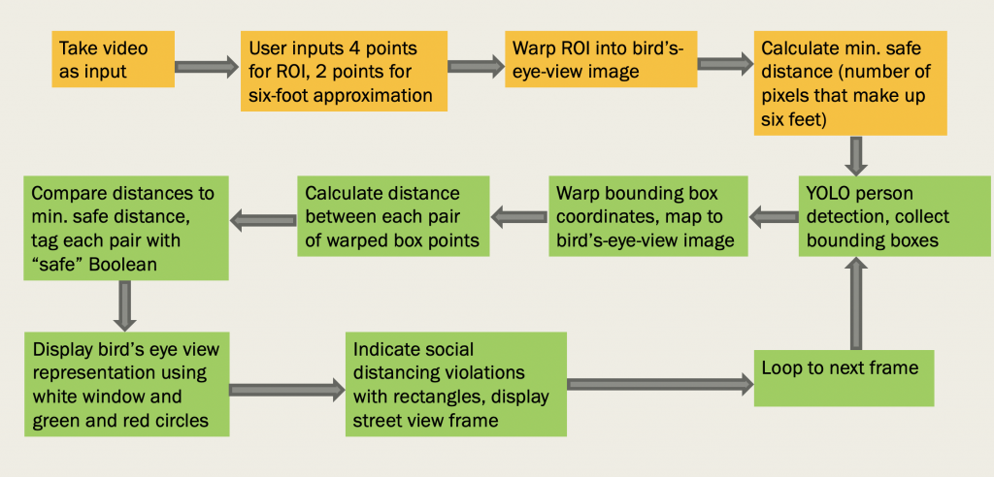

(3.2) OVERALL SYSTEM ARCHITECTURE: -
- Apply object detection to detect all people (and only people) in a given image/frame.
- Compute the pairwise distances between all detected people.
- Based on these distances, check to see if any two people are less than N pixels apart.
- Loop the entire process for all consequent frames.

(3.3) MODULE DESCRIPTION: -
- A wide-angle lens camera captures more objects but fewer details.
- A standard/medium camera is best to capture something specific or highly detailed. If you need to capture fewer objects but in a greater detail, a narrow-angle camera lens is a better choice.
- Thus, wide-angle camera is not suitable for object detection.
- Lenses covering a viewing angle of 60 to 25 degrees are considered best in this scenario.

(3.4) IMPLEMENTATION & CODING (IMAGES): -
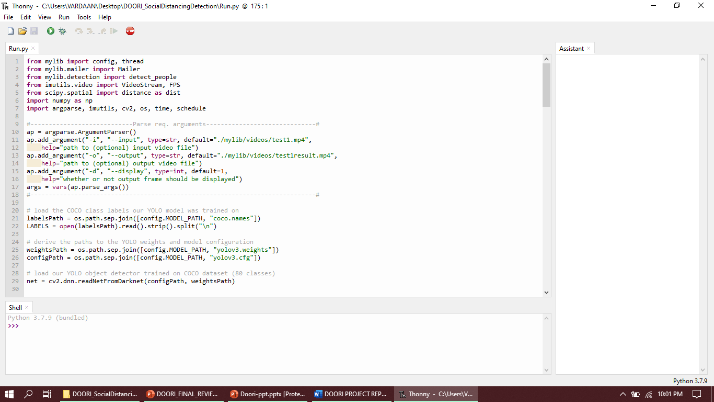

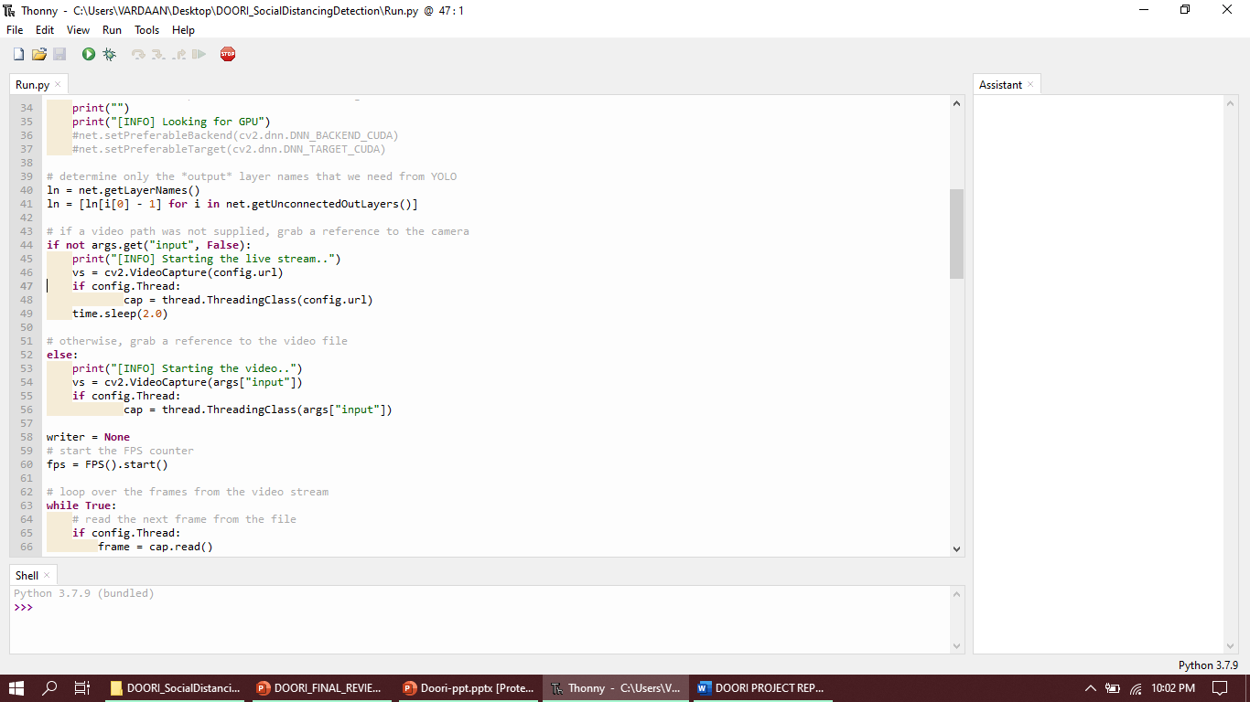

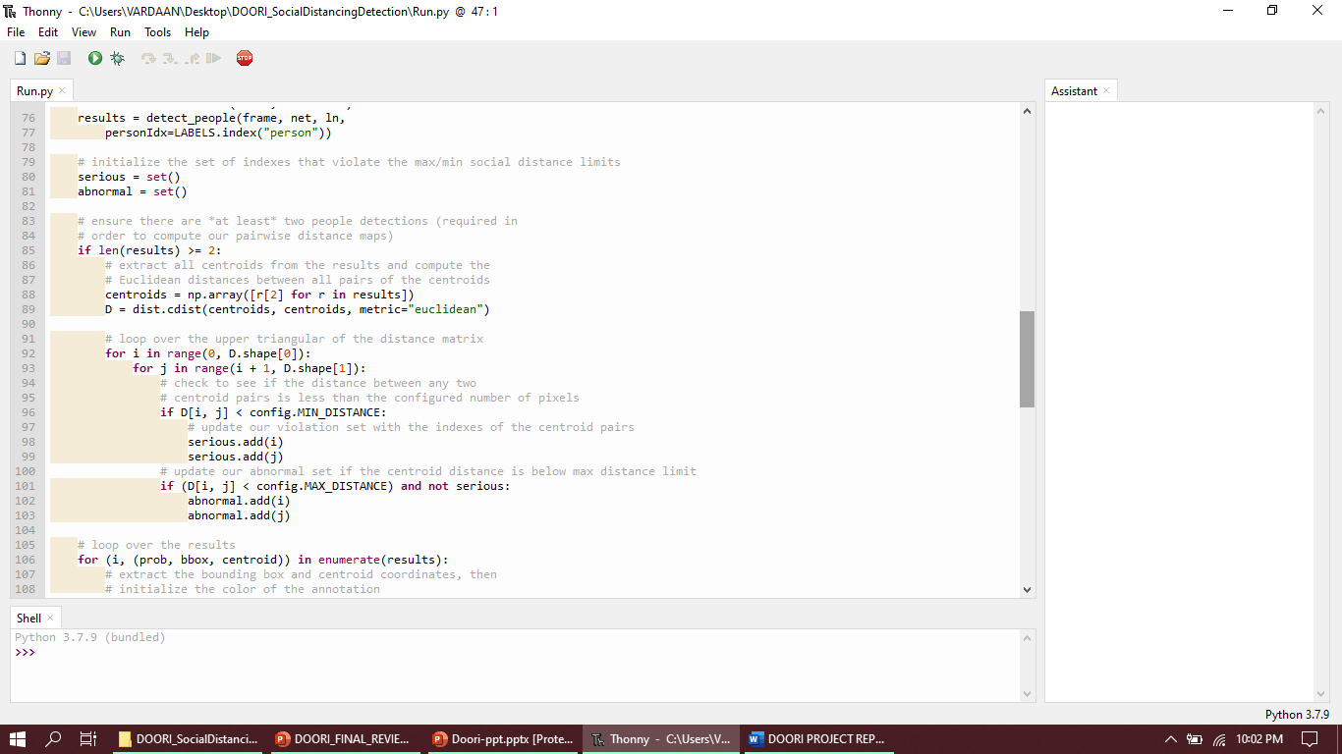

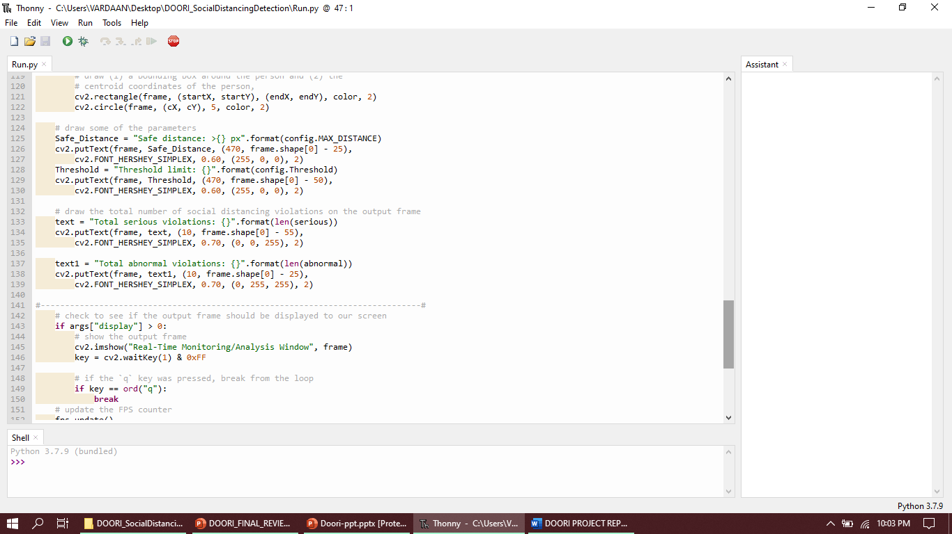

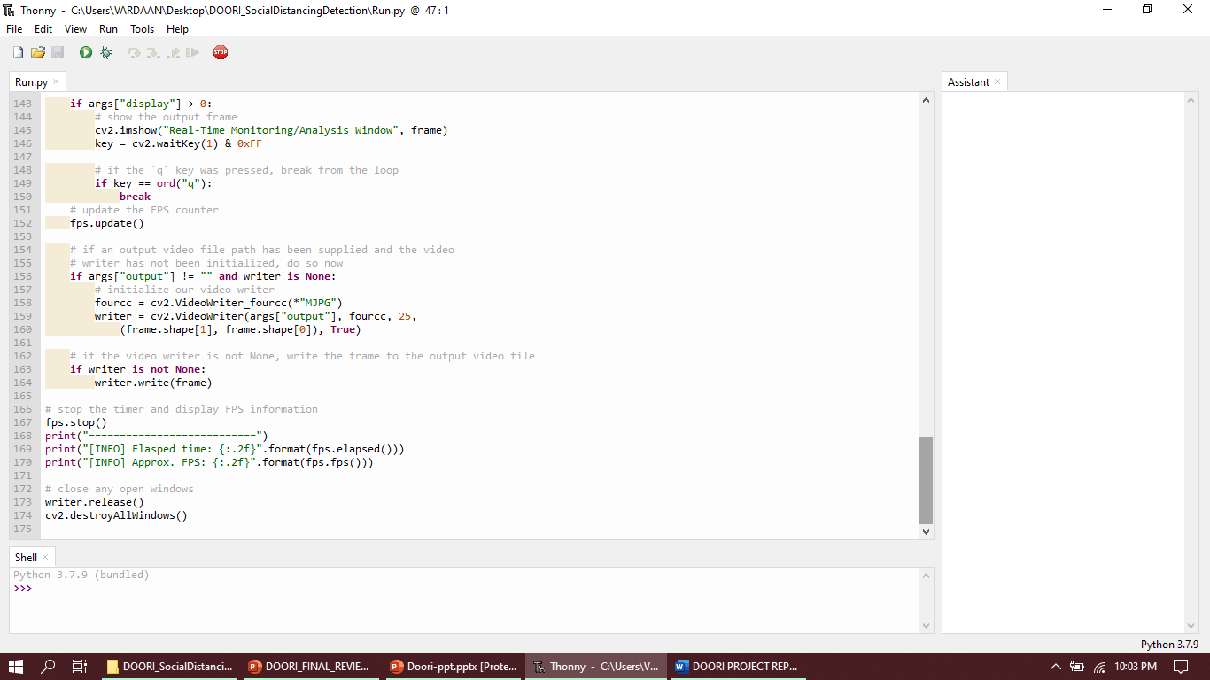

CONCLUSION

Thus, we can conclude here that Doori Social distancing tracker is functional and till now has 0 error to it. It uses OpenCV, CNN, ML, AI and the team has tried to code the application modules in such a way that Doori helps as well as reaches out to more and more people/organizations.

REFERENCES
- Opencv documentation
- www.darknet.com
- www.google.com

