CSC 868.01 – Spring 2013
Advanced Object Oriented Software Design and Development
Prof. Levine

POST 1

Group 1, Team 2
February 11, 2013

Group members (Team 2 members in italics)

Robert (Bob) Bierman
Victor Woeltjen
Jason Lum
Steven Gimeno
Ying Kit Ng (Kent)
Bianca Uy
Kay Choi
1. Output

The following illustrates an execution of the POST 1 program for the given example product catalog and transaction test file.

Input files:

Product catalog (products.txt) | Transactions file (transactions.txt)
A000 Hamburger meat (lb) 0005.99  A001 American cheese (lb) 0002.49  A002 Hamburger sauce(gal) 0001.99  A003 Hamburger bun(dozen) 0001.29  XBHH Paper towels (dozen) 0004.99 | Sam  A000 3  A001  CASH $50.0  John  A002 10  CREDIT 1234123412341234  Wilfred  A001 3  CHECK $100.0

Program output:

Transaction log (log.txt); also written to console:
STORE NAME
123 Address St.

Sam 2013-02-11 08:00:11
American cheese (lb) 1 @ $2.49 $2.49
Hamburger meat (lb) 3 @ $5.99 $17.97
------
Total: $20.46
Amount Tendered: $50.00
Amount Returned: $29.54

STORE NAME
123 Address St.

John 2013-02-11 08:00:11
Hamburger sauce(gal) 10 @ $1.99 $19.90
------
Total: $19.90
Paid by Credit Card 1234123412341234

STORE NAME
123 Address St.

Wilfred 2013-02-11 08:00:11
American cheese (lb) 3 @ $2.49 $7.47
------
Total: $7.47
Paid by check

2. UML Specifications

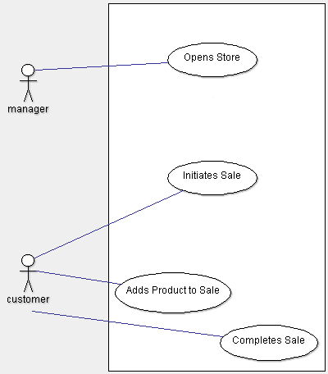Figure 1: Use Case Overview

Use case # | 1
Use case name | Store opens
Summary | The manager starts systems and opens the store.
Dependency
Actor | Manager
Precondition | Store is closed.
Description | - Manager starts “store” software (server)  - Catalog is loaded.  - Manager starts one or more POSTs.  - Each POST connects to the “store” (server)
Alternative
Postcondition | Store is ready to record transactions. POSTs wait for sales to be initiated.
Manager
Store
POST
Cashier
Starts store
Loads
catalog
Data
storage
Starts POSTs
Connects
to store
Awaits new
transaction
Use case # | 2
Use case name | Sale initiation.
Summary | A customer approaches the POS to initiate a sale.
Dependency | Store opens
Actor | Customer
Precondition | The store is open, and no sale is currently in progress.
Description | - The customer identifies him- or herself to the cashier / POST.
Alternative
Postcondition | POST is ready to continue the sale (by adding products, accepting payment, or abandoning the sale); sale initially includes no products and no amount due.

Customer
Store
POST
Cashier
Data
storage
Identifies
self
Enters
name
Awaits item
entry
Use case # | 3
Use case name | Product addition.
Summary | A customer adds some quantity of product to a sale in progress.
Dependency | Sale initiation
Actor | Customer
Precondition | A sale is currently in progress.
Description | - The customer presents the UPC for the product desired, followed by the quantity of product.  - System records the quantity of item as well as the new total amount due as part of the sale in progress.
Alternative | No quantity specified.  - Quantity is assumed to be 1.  Invalid UPC.  - Warning is issued to the POST that the requested UPC is not recognized.  - Sale remains in progress, but no changes are made to the products involved or amount due.
Postcondition | Sale remains in progress.

Customer
Store
POST
Cashier
Data
storage
Presents
Item/UPC
Enters UPC
& quantity
Awaits item
entry or
payment
Specifies
quantity
Use case # | 4
Use case name | Sale completion.
Summary | Customer issues payment for the products involved in the current sale.
Dependency | Sale initiation; one or more product addition.
Actor | Customer.
Precondition | A sale is currently in progress.
Description | - The customer indicates their preferred payment type.  - If cash, the amount of cash is then indicated.  - If credit, credit card information is then given.  - If check, the check amount is assumed to match amount due.
Alternative | No items have been added to sale.  - Sale is abandoned. No transaction is recorded. POST returns to waiting state (no sale in progress).  Cash payment amount is less than amount due.  - Sale remains open. Amount due is reduced by the amount of cash paid.
Postcondition | Transaction representing the sale is reported to store server and recorded in sales log. A receipt is issued listing all details from the transaction. The sale is closed and the POST returns to its waiting state (no sale in progress).
Customer
Store
POST
Cashier
Data
storage
Presents
Payment
Submits
transaction
Records
transaction
Enters
payment info
Confirms
Prints receipt
Gives receipt
Awaits new
transaction

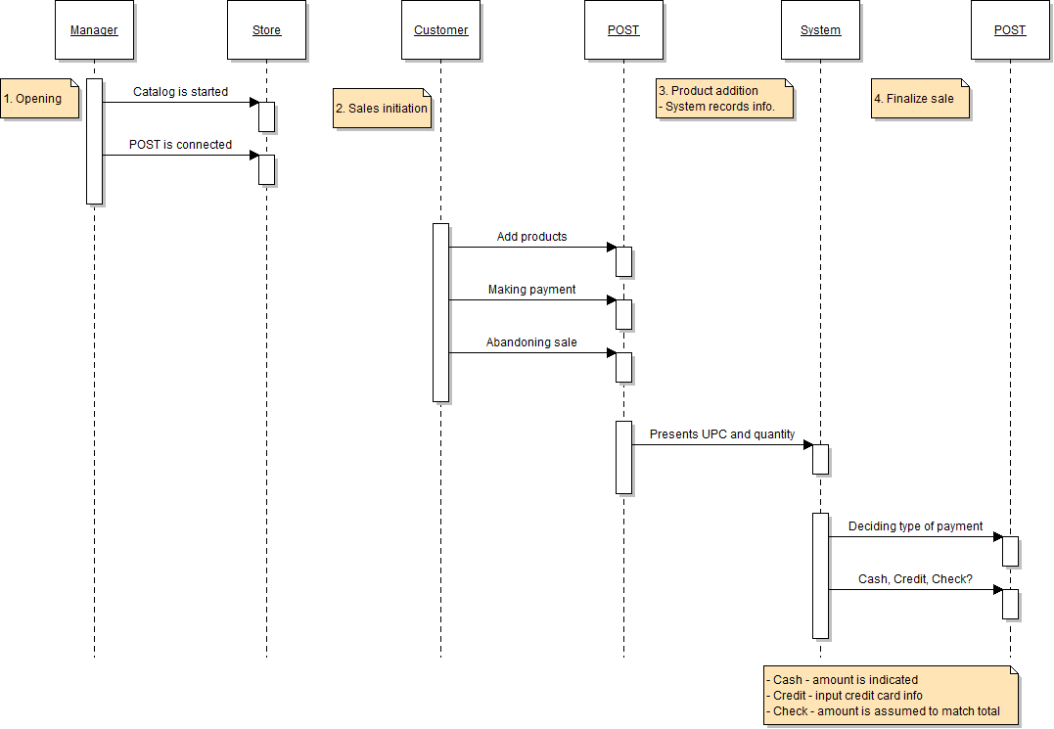Figure 2: Sequence Diagram (summary)
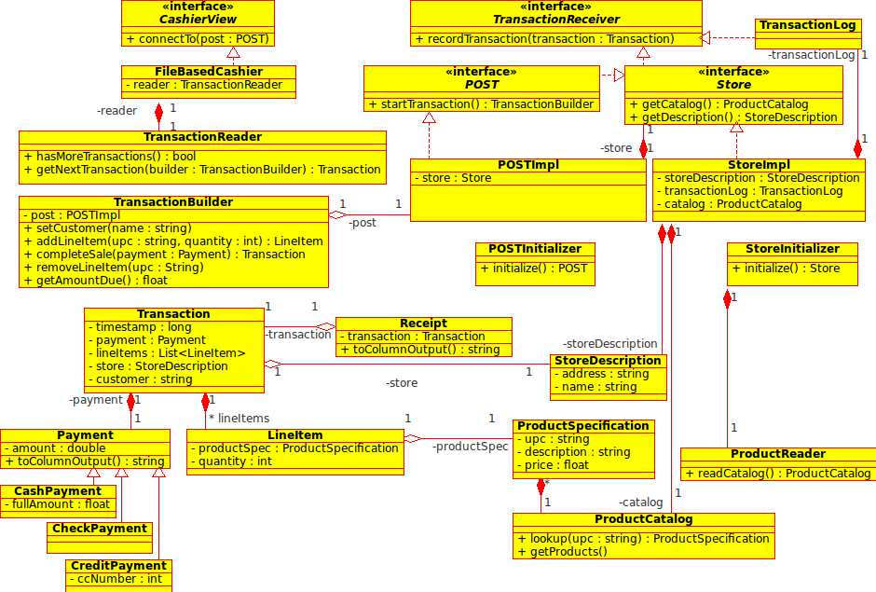Figure 3: Class Diagram
3. Source code

//BEGIN Source code for post/client/view/FileBasedCashier.java

package post.client.view;

import java.io.File;
import java.io.FileReader;
import java.io.IOException;
import post.client.controller.POST;
import post.model.Receipt;
import post.model.Transaction;

/**
* A file-based cashier simulates the cashier's activity by reading
* transactions from a file and issuing them back to the POST.
*
* @author woeltjen
*/
public class FileBasedCashier implements CashierView {
private static final String DEFAULT_TRANSACTIONS = "transaction.txt";
private TransactionReader reader;

/**
* Create a new "Cashier" that reads from a file. This no-argument form
* will read from the default file name, "transaction.txt"
* @throws IOException
*/
public FileBasedCashier() throws IOException {
this(new File(DEFAULT_TRANSACTIONS));
}

/**
* Create a new "Cashier" that reads from a specified file"
* @param f the file containing formatted transaction information
* @throws IOException
*/
public FileBasedCashier(File f) throws IOException {
this(new TransactionReader(new FileReader(f)));
}

/**
* Create a new "Cashier" that reads transactions from the
* specified TransactionReader
* @param reader the source for reading transactions
*/
public FileBasedCashier(TransactionReader reader) {
this.reader = reader;
}

/**
* Connect this CashierView to a POST. For file-based cashier, this
* will initiate reading from the transaction file via the transaction
* reader, and delivering results back to the POST.
* @param post the POST we are connected to
*/
public void connectTo(POST post) {
while (reader.hasMoreTransactions()) {
Transaction t = reader.getNextTransaction(post.startTransaction());
Receipt r = post.recordTransaction(t);
System.out.println(r.toColumnOutput() + "\n");
}
}
}

//END Source code for post/client/view/FileBasedCashier.java

//BEGIN Source code for post/client/view/CashierView.java

package post.client.view;

import post.client.controller.POST;

/**
* A CashierView is an object that can be connected to a POST, and will
* typically issue transactions to it.
* @author woeltjen
*/
public interface CashierView {
/**
* Connect this cashier's view to the specified POST. This will allow the
* view to begin issuing transactions to the POST.
* @param post
*/
public void connectTo(POST post);
}

//END Source code for post/client/view/CashierView.java

//BEGIN Source code for post/client/view/TransactionReader.java

package post.client.view;

import java.io.BufferedReader;
import java.io.IOException;
import java.io.Reader;
import java.util.ArrayList;
import java.util.List;
import post.client.controller.TransactionBuilder;
import post.model.*;

/**
* Class TransactionReader
*/
public class TransactionReader {

private BufferedReader reader;
private List<String> nextBlock;

//
// Constructors
//
public TransactionReader(Reader r) {
reader = new BufferedReader(r);
prepareBlock();
}

/**
* @return boolean
*/
public boolean hasMoreTransactions() {
return !nextBlock.isEmpty() && nextBlock.size() > 2;
}

/**
* @return Transaction
* @param builder
*/
public Transaction getNextTransaction(TransactionBuilder builder) {
builder.setCustomer(nextBlock.get(0).trim());
for (int i = 1; i < nextBlock.size() - 1; i++) {
String lineItem = nextBlock.get(i);
String upc = lineItem.substring(0, 4);
int quantity = 1;
if (lineItem.length() > 10) { // ...contains explicit quantity
quantity = Integer.parseInt(lineItem.substring(10));
}
builder.addLineItem(upc, quantity);
}
Payment p = parsePayment(
nextBlock.get(nextBlock.size()-1), builder.getAmountDue());
prepareBlock();
return builder.completeSale(p);
}

private Payment parsePayment(String line, float amountDue) {

int x = 1;

do{
try{
if (line.startsWith("CASH")) {
float amount = Float.parseFloat(line.substring(line.indexOf('$') + 1));
return new CashPayment(amount, amountDue);
} else if (line.startsWith("CREDIT")) {
long ccNumber = Long.parseLong(line.substring(line.indexOf(' ') + 1));
return new CreditPayment(amountDue, ccNumber);
} else if (line.startsWith("CHECK")) {
return new CheckPayment(amountDue);
}
}

catch(Exception e){
System.out.println("Error: Specify payment type.");
}
}while(x==1);

return null;
}

private void prepareBlock() {
nextBlock = new ArrayList<String>();
String nextLine;
try {
while ((nextLine = reader.readLine()) != null) {
if (nextLine.trim().isEmpty()) return; // Stop after newline
nextBlock.add(nextLine);
}
} catch (IOException ioe) {
}
}
}

//END Source code for post/client/view/TransactionReader.java

//BEGIN Source code for post/client/controller/POST.java

package post.client.controller;

import post.server.controller.Store;

/**
* A Point of Sale Terminal. Acts as a Store, but additionally allows
* transactions to be initiated.
* @author woeltjen
*/
public interface POST extends Store {
/**
* Initiate a new transaction. The returned TransactionBuilder object
* may be used by POST's users to create submittable Transaction objects;
* this is favored over Views constructing their own transaction, as it
* allows the POST to inject its own logic during the transaction cycle
* (for instance, to validate UPCs)
* @return TransactionBuilder
*/
public TransactionBuilder startTransaction( );
}

//END Source code for post/client/controller/POST.java

//BEGIN Source code for post/client/controller/POSTImpl.java

package post.client.controller;

import post.model.ProductCatalog;
import post.model.Receipt;
import post.model.StoreDescription;
import post.model.Transaction;
import post.server.controller.Store;

/**
* Class POSTImpl implements the POST interface to instantiate
* @author Kay Choi
*/
public class POSTImpl implements POST {
private Store store;

/**
* Class constructor.
* @param store the Store that the POSTImpl belongs to
*/
public POSTImpl(Store store) {
this.store = store;
}

/**
* @return Receipt
* @param transaction
*/
@Override
public Receipt recordTransaction(Transaction transaction) {
return store.recordTransaction(transaction);
}

/**
* @return ProductCatalog
*/
@Override
public ProductCatalog getCatalog() {
return store.getCatalog();
}

/**
* @return TransactionBuilder
*/
@Override
public TransactionBuilder startTransaction() {
return new TransactionBuilder(this, System.currentTimeMillis());
}

@Override
public StoreDescription getDescription() {
return store.getDescription();
}
}

//END Source code for post/client/controller/POSTImpl.java

//BEGIN Source code for post/client/controller/POSTInitializer.java

package post.client.controller;

import post.server.controller.Store;

/**
*
* @author Kay Choi
*/
public class POSTInitializer {
private Store store;

/**
* Class constructor.
* @param store
*/
public POSTInitializer(Store store) {
this.store = store;
}

/**
*
* @return POSTImpl
*/
public POST initialize() {
return new POSTImpl(store);
}
}

//END Source code for post/client/controller/POSTInitializer.java

//BEGIN Source code for post/client/controller/TransactionBuilder.java

package post.client.controller;

import java.util.HashMap;
import post.model.Payment;
import post.model.ProductSpecification;
import post.model.Transaction;

/**
* Class TransactionBuilder collects transaction data from a customer and uses
* it to build a Transaction object.
* @author Kay Choi
*/
public class TransactionBuilder {

private HashMap<String, Integer> items;
private final long time;
private final POST post;
private float amountDue;
private String customer;

/**
* Create a new transaction builder. The specified POST is used for
* validation when needed (for instance, confirming valid UPCs)
*
* Note that the timestamp is in milliseconds since the UNIX epoch
* (January 1, 1970 00:00:00 GMT)
*
* @param parent the POST used for validation
* @param timestamp the time (in ms since UNIX epoch)
*/
public TransactionBuilder(POST parent, long timestamp) {
items = new HashMap<String, Integer>();
time = timestamp;
amountDue = 0f;
post = parent;
}

/**
* Set the name of the customer involved in this transaction.
* @param name the name of the customer
*/
public void setCustomer(String name) {
customer = name;
}

/**
* Adds a new item to the transaction. The UPC of the item is stored, along
* with the quantity. The subtotal is also updated.
* @return true if the UPC was valid
* @param upc the UPC of the item being purchased
* @param quantity the number of items being purchased
*/
public boolean addLineItem(String upc, int quantity) {
ProductSpecification product = post.getCatalog().lookup(upc);

if(product != null){
if(items.get(upc) != null) { //UPC previously entered
int num = items.get(upc);
items.put(upc, num + quantity);
} else {
items.put(upc, quantity);
}

amountDue += quantity * product.getPrice();
return true;
} else
return false;
}

/**
* Removes an item from the transaction.
* @param upc the UPC of the item
*/
public void removeLineItem(String upc) {
items.remove(upc);
}

/**
* Issue payment to complete a transaction. This will return a full
* Transaction object; note that this transaction is not necessarily
* recorded to the originating POST.
* @return Transaction an object representing the processed transaction, if
* the payment amount is sufficient
* @param payment the specific payment for this transaction
*/
public Transaction completeSale(Payment payment) {
if(payment.getAmount() >= amountDue)
return new Transaction(customer, time, payment, items, post);
else
return null;
}

/**
* Get the current amount due (total price of all items)
* @return float the current subtotal
*/
public float getAmountDue() {
return amountDue;
}
}

//END Source code for post/client/controller/TransactionBuilder.java

//BEGIN Source code for post/server/controller/TransactionReceiver.java

package post.server.controller;

import post.model.Receipt;
import post.model.Transaction;

/**
* A TransactionReceiver is simply eligible to record transactions. It will
* also provide Receipt objects to confirm that the transaction has been
* recorded.
*
* @author woeltjen
*/
public interface TransactionReceiver {

/**
* Record the specified transaction. Note that this method is responsible
* for issuing a Receipt object (this may be null in cases where errors
* have occurred.)
* @return Receipt a receipt for the transaction
* @param transaction the transaction to record
*/
public Receipt recordTransaction(Transaction transaction);
}

//END Source code for post/server/controller/TransactionReceiver.java

//BEGIN Source code for post/server/controller/StoreInitializer.java

package post.server.controller;

import java.io.File;
import java.io.FileReader;
import post.model.ProductCatalog;
import post.model.ProductReader;
import post.model.StoreDescription;

/**
* The StoreInitializer is responsible for setting up the Store.
*
* During launch, the StoreInitializer is responsible for generating the
* Store object that will be used for future interactions. This may include
* initializing a product catalog and connecting to the transaction log.
*
* @author woeltjen
*/
public class StoreInitializer {
private static final String DEFAULT_STORE_NAME = "STORE NAME";
private static final String DEFAULT_ADDRESS = "123 Address St.";

private static final String DEFAULT_LOG_NAME = "log.txt";
private static final String DEFAULT_CATALOG_NAME = "products.txt";

private String logName;
private String productFileName;

public StoreInitializer() {
this(DEFAULT_LOG_NAME, DEFAULT_CATALOG_NAME);
}

public StoreInitializer(String logName, String productFileName) {
this.logName = logName;
this.productFileName = productFileName;
}

/**
* Create and set up new Store, connected to the appropriate log files and
* product catalog.
* @return
*/
public Store initialize() {
try {
StoreDescription desc =
new StoreDescription(DEFAULT_STORE_NAME, DEFAULT_ADDRESS);
TransactionLog log = new TransactionLog(new File(logName));
ProductCatalog catalog =
new ProductReader(new FileReader(productFileName))
.readCatalog();
return new StoreImpl(desc, log, catalog);
} catch (Exception e) {
// TODO: How to log this?
return null;
}
}

// public static void main(String[] args) {
// // Test method
// Store s = new StoreInitializer().initialize();
// System.out.println(s.getDescription().getName());
// System.out.println(s.getCatalog().getProducts().size());
// }
}

//END Source code for post/server/controller/StoreInitializer.java

//BEGIN Source code for post/server/controller/TransactionLog.java

package post.server.controller;

import java.io.File;
import java.io.FileWriter;
import java.io.IOException;
import java.io.Writer;
import post.model.Receipt;
import post.model.Transaction;

/**
* Logs transaction information to a file.
* @author woeltjen
*/
public class TransactionLog implements TransactionReceiver {
private Writer log;

/**
* Create a new transaction log. Transaction information will be recorded
* to the specified file.
* @param f
* @throws IOException
*/
public TransactionLog(File f) throws IOException {
this(new FileWriter(f, true));
}

/**
* Create a new transation log. Transaction information will be written
* to the specified stream.
* @param w
*/
public TransactionLog(Writer w) {
log = w;
}

@Override
public Receipt recordTransaction(Transaction transaction) {
try {
Receipt r = new Receipt(transaction);
log.write(r.toColumnOutput() + "\n");
log.flush();
return r;
} catch (Exception e) {
// TODO: How to handle write errors? Return receipt anyway?
return null;
}
}

// public static void main(String[] args) {
// // Test method
// try {
// TransactionLog log =
// new TransactionLog(new OutputStreamWriter(System.out));
// final Store store = new StoreImpl(new StoreDescription("T1", "T2"), log, null);
// Transaction t = new Transaction(null, System.currentTimeMillis(), null, null, store) {
//
// @Override
// public String getCustomer() {
// return "Test customer";
// }
//
// @Override
// public List<LineItem> getLineItems() {
// return super.getLineItems();
// }
//
// @Override
// public Payment getPayment() {
// return new CreditPayment(14.99f, 1234);
// }
//
// @Override
// public StoreDescription getStore() {
// return super.getStore();
// }
//
// @Override
// public long getTimestamp() {
// return super.getTimestamp();
// }
// };
// log.recordTransaction(t);
// } catch (Exception e) {
// e.printStackTrace();
// }
// }
}

//END Source code for post/server/controller/TransactionLog.java

//BEGIN Source code for post/server/controller/StoreImpl.java

package post.server.controller;

import post.model.ProductCatalog;
import post.model.Receipt;
import post.model.StoreDescription;
import post.model.Transaction;

/**
* Provides a general implementation of a store.
*
* This simply connects the Store's interface to a specific group of relevant
* objects provided during the constructor call.
*
* @author woeltjen
*/
public class StoreImpl implements TransactionReceiver, Store {
private StoreDescription storeDescription;
private TransactionLog transactionLog;
private ProductCatalog catalog;

/**
* Create a new store.
* @param storeDescription a description of the store
* @param transactionLog the transaction log the store should write to
* @param catalog a catalog of products available through the store.
*/
public StoreImpl(StoreDescription storeDescription, TransactionLog transactionLog, ProductCatalog catalog) {
this.storeDescription = storeDescription;
this.transactionLog = transactionLog;
this.catalog = catalog;
}

@Override
public StoreDescription getDescription() {
return storeDescription;
}

@Override
public ProductCatalog getCatalog() {
return catalog;
}

@Override
public Receipt recordTransaction(Transaction transaction) {
return transactionLog.recordTransaction(transaction);
}
}

//END Source code for post/server/controller/StoreImpl.java

//BEGIN Source code for post/server/controller/Store.java

package post.server.controller;

import post.model.ProductCatalog;
import post.model.StoreDescription;

/**
* Represents a Store. In addition to receiving transactions, a store also
* provides information about itself (description, product catalog).
*/
public interface Store extends TransactionReceiver {

/**
* Get a description of this store
* @return
*/
public StoreDescription getDescription();

/**
* Get a catalog of products available through this store.
* @return ProductCatalog
*/
public ProductCatalog getCatalog();
}

//END Source code for post/server/controller/Store.java

//BEGIN Source code for post/POST1Main.java

package post;

import post.client.controller.POST;
import post.client.controller.POSTInitializer;
import post.client.view.CashierView;
import post.client.view.FileBasedCashier;
import post.server.controller.Store;
import post.server.controller.StoreInitializer;

/**
* Main point of entry for POST1. Creates a Store and a POST with default
* values, then connects a file-based cashier to the POST.
* @author woeltjen
*/
public class POST1Main {
public static void main (String[] args) {
Store store = new StoreInitializer().initialize();
POST post = new POSTInitializer(store).initialize();

try {
CashierView view = new FileBasedCashier();
view.connectTo(post);
} catch (Exception e) {
e.printStackTrace();
}
}
}

//END Source code for post/POST1Main.java

//BEGIN Source code for post/model/ProductReader.java

package post.model;

import java.io.BufferedReader;
import java.io.FileReader;
import java.io.IOException;
import java.io.Reader;
import java.util.ArrayList;
import java.util.List;

/**
* Reads in a product catalog from a text stream.
*
* @author woeltjen
*/
public class ProductReader {
private Reader reader;

/**
* Create a new ProductReader. This will look at the supplied Reader
* object in order to find product information.
* @param r
*/
public ProductReader(Reader r) {
this.reader = r;
}

/**
* Read in the product catalog. This produces a ProductCatalog containing
* ProductSpecifications, which can be used to look up products by UPC
* and so forth.
* @return ProductCatalog
*/
public ProductCatalog readCatalog() throws IOException {
BufferedReader r = new BufferedReader(reader);
List<ProductSpecification> products =
new ArrayList<ProductSpecification>();

String nextLine;
while ( (nextLine = r.readLine()) != null) {
String upc = nextLine.substring(0, 4);
String desc = nextLine.substring(9, 29);
float price = Float.parseFloat(nextLine.substring(34));
products.add(new ProductSpecification(upc, desc, price));
}

return new ProductCatalog(products);
}

// public static void main (String[] args) {
// // Test ProductReader
// Reader r;
//
// try {
// r = new FileReader("products.txt");
// ProductCatalog cat = new ProductReader(r).readCatalog();
// System.out.println(cat.lookup("XBHH").getDescription());
// } catch (Exception e) {
// e.printStackTrace();
// }
// }
}

//END Source code for post/model/ProductReader.java

//BEGIN Source code for post/model/CheckPayment.java

package post.model;

/**
* Represents payment made by check.
* @author woeltjen
*/
public class CheckPayment extends Payment {
public CheckPayment(float amount) {
super(amount);
}

@Override
public String toColumnOutput() {
return "Paid by check";
}
}

//END Source code for post/model/CheckPayment.java

//BEGIN Source code for post/model/LineItem.java

package post.model;

/**
* A LineItem describes the purchase of a specific product, at a specific
* quantity.
*
* @author woeltjen
*/
public class LineItem {
private ProductSpecification productSpec;
private int quantity;

/**
* Create a new line item. This includes both the product purchased, and the
* quantity purchased.
*
* @param productSpec
* @param quantity
*/
public LineItem(ProductSpecification productSpec, int quantity) {
this.productSpec = productSpec;
this.quantity = quantity;
}

/**
* Get the product involved in this line item.
*
* @return the specification for the product purchased.
*/
public ProductSpecification getProductSpec() {
return productSpec;
}

/**
* Get the quantity of the item purchased.
*
* @return the quantity of the item purchased
*/
public int getQuantity() {
return quantity;
}
}

//END Source code for post/model/LineItem.java

//BEGIN Source code for post/model/CashPayment.java

package post.model;

/**
* A CashPayment represents payment given by cash, which should equal or
* exceed the amount due.
* @auther woeltjen
*/
public class CashPayment extends Payment {
private float fullAmount;

/**
* Create a new cash payment. This includes both the amount offered
* by the customer, and the amount due (the change received is implicitly
* the difference between the two.)
* @param tendered
* @param due
*/
public CashPayment(float tendered, float due) {
super(due);
fullAmount = tendered;
}

@Override
public String toColumnOutput() {
return "Amount Tendered: " + formatPrice(fullAmount) + "\n"
+ "Amount Returned: " + formatPrice(fullAmount - getAmount());

}

private String formatPrice(float price) {
return String.format("$%.2f", price);
}
}

//END Source code for post/model/CashPayment.java

//BEGIN Source code for post/model/StoreDescription.java

package post.model;

/**
* Provides a basic description of a specific store.
* @author woeltjen
*/
public class StoreDescription {
private String address;
private String name;

/**
* Create a new description for a store.
* @param name the name of the store
* @param address the store's address
*/
public StoreDescription(String name, String address) {
this.address = address;
this.name = name;
}

/**
* Get the store's address
*
* @return the store's address
*/
public String getAddress() {
return address;
}

/**
* Get the store's name
*
* @return the store's name
*/
public String getName() {
return name;
}
}

//END Source code for post/model/StoreDescription.java

//BEGIN Source code for post/model/ProductSpecification.java

package post.model;

/**
* Describes relevant information about a specific product in inventory.
* @author woeltjen
*/
public class ProductSpecification {
private String upc;
private String description;
private float price;

/**
* Create a new product specification
* @param upc the products 4-digit locator
* @param description a text description of the product
* @param price the products price, in dollars
*/
public ProductSpecification(String upc, String description, float price) {
this.upc = upc;
this.description = description;
this.price = price;
}

/**
* Get the product's UPC code
*
* @return the value of upc
*/
public String getUpc() {
return upc;
}

/**
* Get a short human-readable description of the product
*
* @return the value of description
*/
public String getDescription() {
return description;
}

/**
* Get the price of the product
*
* @return the value of price
*/
public float getPrice() {
return price;
}
}

//END Source code for post/model/ProductSpecification.java

//BEGIN Source code for post/model/Transaction.java

package post.model;

import java.util.ArrayList;
import java.util.List;
import java.util.Map;
import java.util.Map.Entry;
import post.server.controller.Store;

/**
* Represents a completed sale
* @author woeltjen
*/
public class Transaction {

private String customer;
private long timestamp;
private Payment payment;
private List<LineItem> lineItems;
private StoreDescription store;

/**
* Create a new transaction object to describe a sale.
* @param customer the name of the customer
* @param timestamp the time of the sale (ms since UNIX epoch)
* @param payment the payment issued by the customer
* @param lineItems the products purchased (UPC/quantity pairs)
* @param store the store from which these objects were purchased
*/
public Transaction(String customer, long timestamp, Payment payment,
Map<String, Integer> lineItems, Store store) {
this.customer = customer;
this.timestamp = timestamp;
this.payment = payment;
this.store = store.getDescription();
this.lineItems = new ArrayList<LineItem>();

for (Entry<String, Integer> entry : lineItems.entrySet()) {
this.lineItems.add(new LineItem(store.getCatalog().lookup(entry.getKey()), entry.getValue()));
}
}

/**
* Get the time of purchase. This is in milliseconds since the UNIX epoch
* (January 1, 1970 00:00:00)
* @return the time at which the sale occurred
*/
public long getTimestamp() {
return timestamp;
}

/**
* Get the payment issued for this sale
* @return the payment
*/
public Payment getPayment() {
return payment;
}

/**
* Get all LineItems for this purchase. Each line item represents an
* individual product purchased at some quantity.
* @return the items purchased
*/
public List<LineItem> getLineItems() {
return lineItems;
}

/**
* Get a description of the store where the sale was made.
* @return the store description
*/
public StoreDescription getStore() {
return store;
}

/**
* Get the name of the customer involved in the sale
* @return
*/
public String getCustomer() {
return customer;
}
}

//END Source code for post/model/Transaction.java

//BEGIN Source code for post/model/Payment.java

package post.model;

/**
* A Payment represents monetary value exchanged for products.
*
* Payment is an abstract class. Specific payment forms are represented as
* subclasses.
*/
public abstract class Payment {

private float amount;

/**
* Create a payment for the specified amount due.
*
* @param amount
*/
public Payment(float amount) {
this.amount = amount;
}

/**
* Get the amount paid.
*
* @return the amount paid
*/
public float getAmount() {
return amount;
}

/**
* Describe this payment in a manner appropriate for display on a
* receipt or in a transaction log.
* @return
*/
public abstract String toColumnOutput();
}

//END Source code for post/model/Payment.java

//BEGIN Source code for post/model/CreditPayment.java

package post.model;

/**
* Represents payment made by credit card.
* @author woeltjen
*/
public class CreditPayment extends Payment {
private long ccNumber;

/**
* Create a new object representing a payment of
* the specified amount, using the specified credit card number.
* @param amount
* @param ccNumber
*/
public CreditPayment(float amount, long ccNumber) {
super(amount);
this.ccNumber = ccNumber;
}

/**
* Get the value of ccNumber
*
* @return the value of ccNumber
*/
public long getCcNumber() {
return ccNumber;
}

@Override
public String toColumnOutput() {
return "Paid by Credit Card " + ccNumber;
}
}

//END Source code for post/model/CreditPayment.java

//BEGIN Source code for post/model/ProductCatalog.java

package post.model;

import java.util.*;

/**
* A catalog of all available products within the store. Useful for identifying
* products by UPC, or for getting a full listing of products available.
* @author woeltjen
*/
public class ProductCatalog {
private Map<String, ProductSpecification> productMap =
new HashMap<String, ProductSpecification>();

/**
* Create a new product catalog for the specified group of products.
* @param products the products available
*/
public ProductCatalog(Collection<ProductSpecification> products) {
for (ProductSpecification p : products) {
productMap.put(p.getUpc(), p);
}
}

/**
* Look up a product by its UPC. Note that the return value may be
* null if there is no product with the specified UPC in this catalog.
* @return ProductSpecification
* @param upc
*/
public ProductSpecification lookup(String upc) {
return productMap.get(upc);
}

/**
* Get a list of all products available in this catalog.
* @return List<ProductSpecification>
*/
public List<ProductSpecification> getProducts() {
List<ProductSpecification> copy = new ArrayList<ProductSpecification>();
copy.addAll(productMap.values());
return copy;
}
}

//END Source code for post/model/ProductCatalog.java

//BEGIN Source code for post/model/Receipt.java

package post.model;

import java.text.DateFormat;
import java.text.SimpleDateFormat;
import java.util.Calendar;
import java.util.GregorianCalendar;

/**
* Create a receipt for the specified transaction. This is primarily to
* provide formatted text output for the transaction.
*
* @author woeltjen
*/
public class Receipt {
private static final DateFormat DATE_FORMAT =
new SimpleDateFormat("yyyy-MM-dd hh:mm:ss");

private Transaction transaction;

/**
* Create a new receipt for the specified transaction.
* @param t
*/
public Receipt(Transaction t) {
transaction = t;
}

/**
* Get a formatted text representation of the transaction described by
* this receipt.
* @return String
*/
public String toColumnOutput() {
Calendar cal = new GregorianCalendar();
cal.setTimeInMillis(transaction.getTimestamp());

String output = "";
output += transaction.getStore().getName() + "\n";
output += transaction.getStore().getAddress() + "\n";
output += "\n";
output += transaction.getCustomer() + "\t";
output += DATE_FORMAT.format(cal.getTime()) + "\n";

for (LineItem item : transaction.getLineItems()) {
float itemPrice = item.getProductSpec().getPrice();
float totalPrice = item.getQuantity() * itemPrice;
output += item.getProductSpec().getDescription() + "\t";
output += item.getQuantity() + " @ ";
output += formatPrice(itemPrice) + "\t";
output += formatPrice(totalPrice) + "\n";
}

output += "------\n";
output += "Total: " + formatPrice(transaction.getPayment().getAmount());
output += "\n";
output += transaction.getPayment().toColumnOutput();

return output;
}

private String formatPrice(float price) {
return String.format("$%.2f", price);
}
}

//END Source code for post/model/Receipt.java

