CSC 868.01 – Spring 2013
Advanced Object Oriented Software Design and Development
Prof. Levine

DSS1 Interpreter
(4/8 Milestone)

Group 1
April 8, 2013

Group members

Robert (Bob) Bierman
Victor Woeltjen
Jason Lum
Steven Gimeno
Ying Kit Ng (Kent)
Bianca Uy
Kay Choi
Overview

This document describes the integration of the DSS1 Interpreter component into an OpenMRS module.

The following major components were introduced to the OpenMRS BasicModule in order to expose this initial DSS1 interpreter functionality:
- Administration page extension: Add links to upload or create DSS programs on the Administration page. Implemented by subclassing AdministrationSectionExt, and declaring the extension in config.xml.
Java class:
org.openmrs.module.basicmodule.extension.html.AdminDSS
- Controllers: Handle user requests to create DSS1 programs (DSSController, mapped to module/basicmodule/dssLink.form) and upload DSS1 programs (DSSUploadController, mapped to module/basicmodule/dssUpload.form). These save and execute uploaded user files, and display the appropriate forms to do so.
Java classes:
org.openmrs.module.basicmodule.web.controller.DSSController
org.openmrs.module.basicmodule.web.controller.DSSUploadController
- Views: Displayed as forms to receive user input, and connect this input to relevant controllers.
Java server pages:
webapp/dssForm.jsp
webapp/dssUploadForm.jsp
- Interpreter component: The full compiler & interpreter for DSS1 programs, as implemented in the 4/1 milestone. The full sources were copied into the module's package structure, in order to simplify interactions between OpenMRS, the DSS1 module, and interpreter components.
Java packages:
org.openmrs.module.basicmodule.dsscompiler.ast
org.openmrs.module.basicmodule.dsscompiler.compiler
org.openmrs.module.basicmodule.dsscompiler.lexer
org.openmrs.module.basicmodule.dsscompiler.parser
org.openmrs.module.basicmodule.dsscompiler.visitor
org.openmrs.module.basicmodule.dsscompiler.interpreter
org.openmrs.module.basicmodule.dsscompiler.interpreter.intrinsics
org.openmrs.module.basicmodule.dsscompiler.interpreter.node
org.openmrs.module.basicmodule.dsscompiler.interpreter.value

Note that, as this is an intermediate milestone, some temporary names are in use (“basicmodule”, for example.) Unused files from both BasicModule and from developing the Interpreter also exist within the accompanying sources.

Sequence Diagram
Client Server
Server
Filesystem
Client
Filesystem
Browser
DSSUpload
Controller
DSSProgram
Parser
Interpreter
Server
Console
Visits “Upload” link
Show Upload Page
Upload file
Select file
Save file
Create DSSProgram object
compileAndExecute()
Create Parser
Open source file
Read file data
execute()
Return AST
Create Interpreter
interpret(AST)
Print alerts
Return on completion
Return on completion
Show Upload Page
Screen shots

The following screen shots illustrate the execution of a DSS program via the OpenMRS web interface.
First, links to upload or create a DSS program appear in the lower-right:
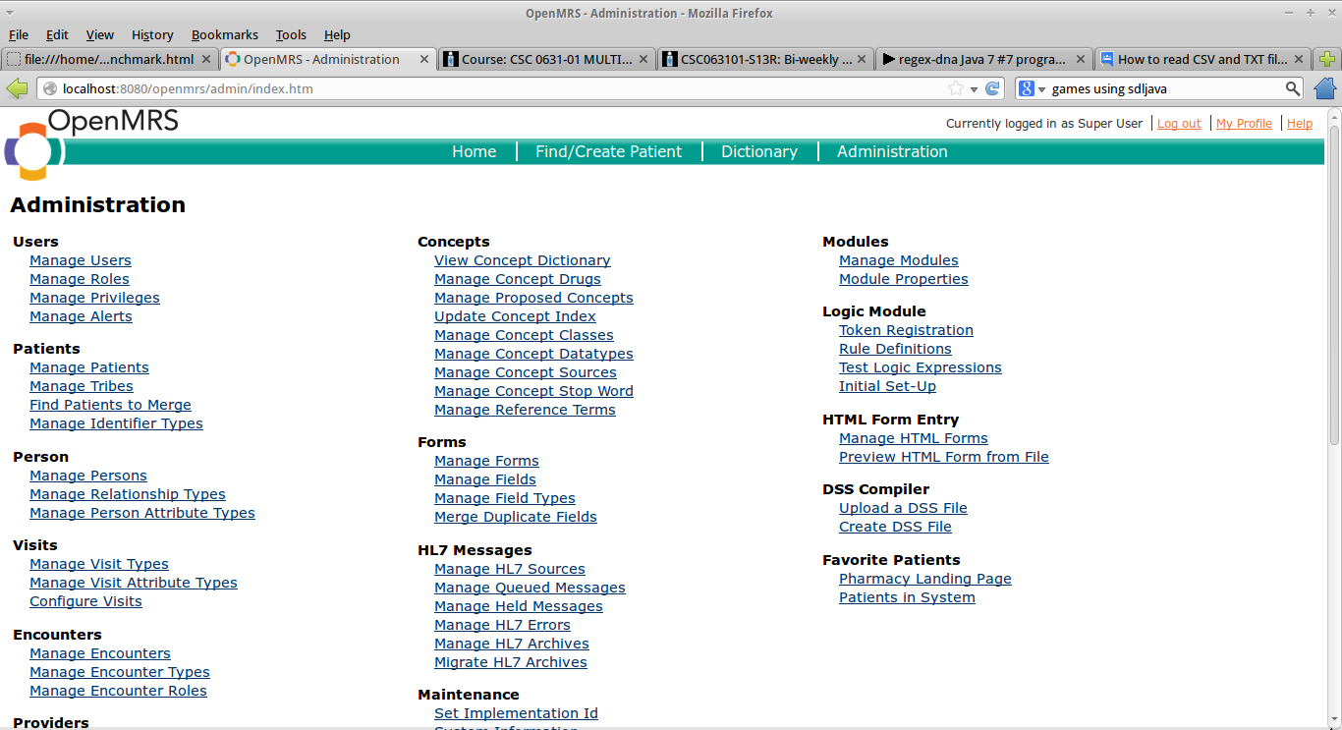

Clicking “Upload a DSS File” opens the DSS Upload page. (Note: “Create DSS File” is not fully tested, and will not be demonstrated for this milestone.)
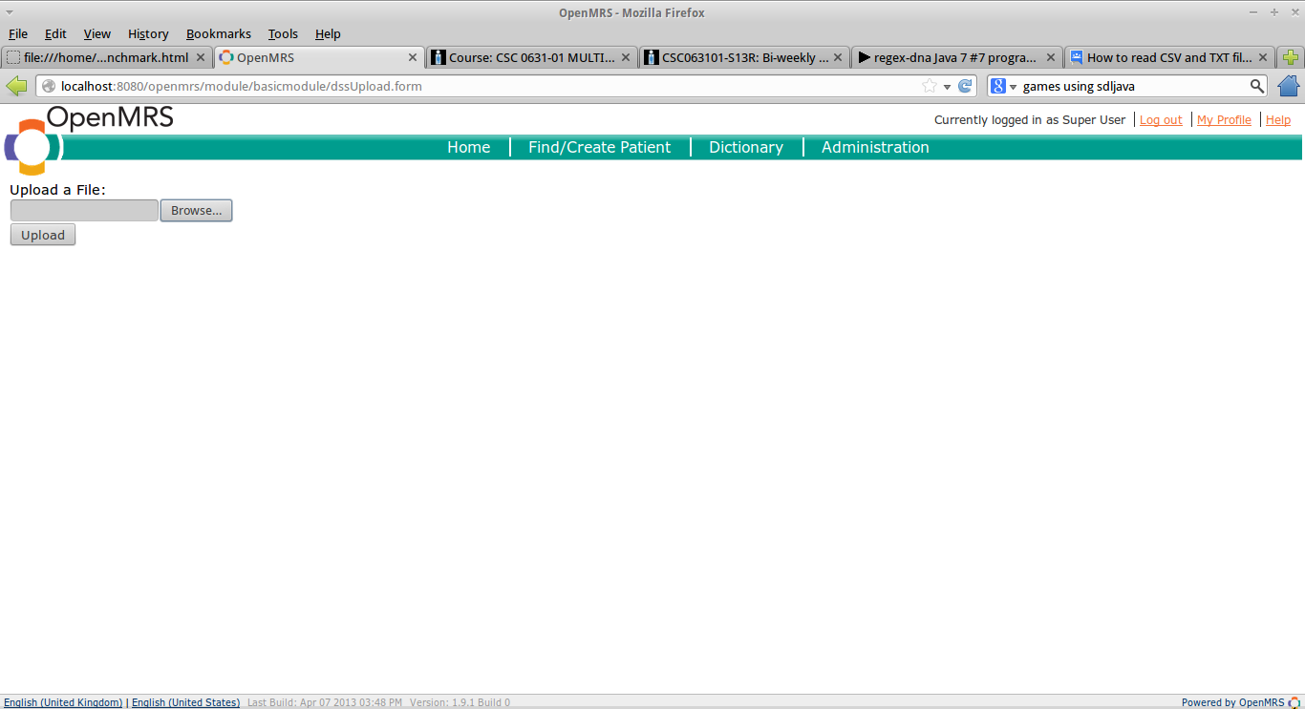
Clicking “Browse” prompts the user with their browser's standard file chooser.
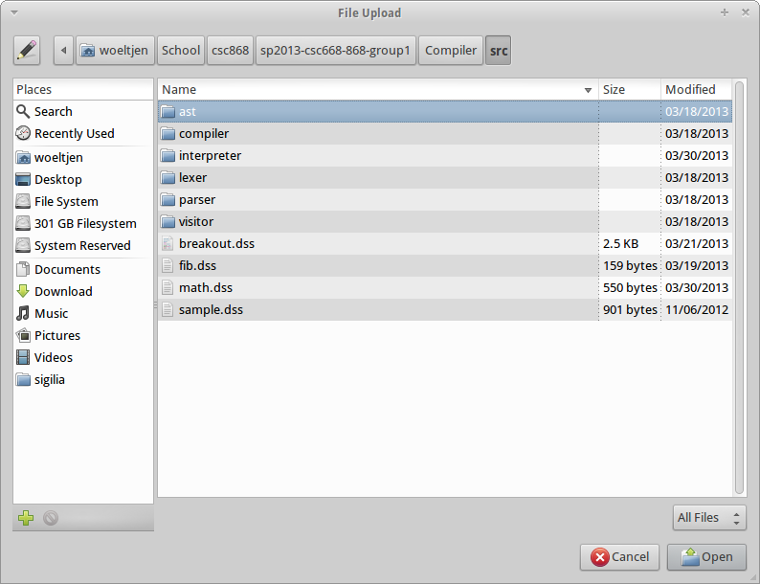

The user may then complete the action with the “Upload” button.
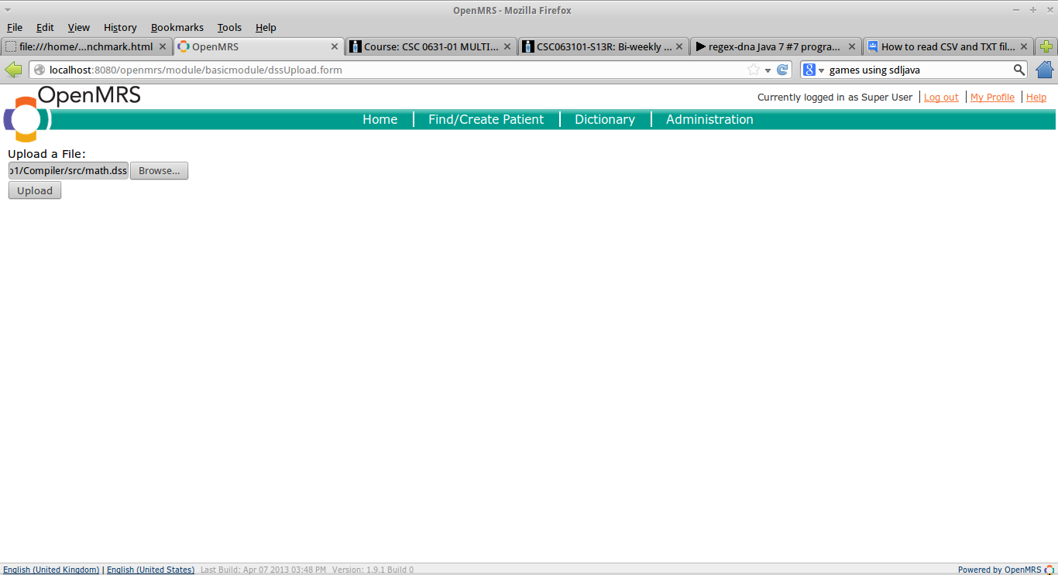
Note that, in this example, the user chooses the file “math.dss”, which contains the following DSS source code:

program
// FIBONACCI SEQUENCE
function fib(x) {
if x<2 then {
return x
}
return fib(x-2) + fib(x-1)
}

function newInstance(obj) {
return new obj
}

// MAIN BLOCK
{
alert(44.5)
alert(true)
alert(true & false)
alert(true | false)

alert("hello")

alert(0)
alert(55 + 22)
alert(55 + 22.5)

alert("Temperature is " + 98.6)

o := Object(x,y)
o.x := 10
o.y := "Words"

alert(o)
alert(newInstance(o))

alert (44 < 44.1)

alert (2 ** 2)
alert (16 ** 0.5)
}

When the user clicks upload, the browser simply returns to the “Upload a DSS File” screen. However, program output is printed to the server's console, as evidenced in this screenshot of NetBeans (from which the server was being run in this example):

