CSC 868.01 – Spring 2013
Advanced Object Oriented Software Design and Development
Prof. Levine

OpenMRS – Initial Milestone
Screenshots

Group 1
March 19, 2013

Group members

Robert (Bob) Bierman
Victor Woeltjen
Jason Lum
Steven Gimeno
Ying Kit Ng (Kent)
Bianca Uy
Kay Choi

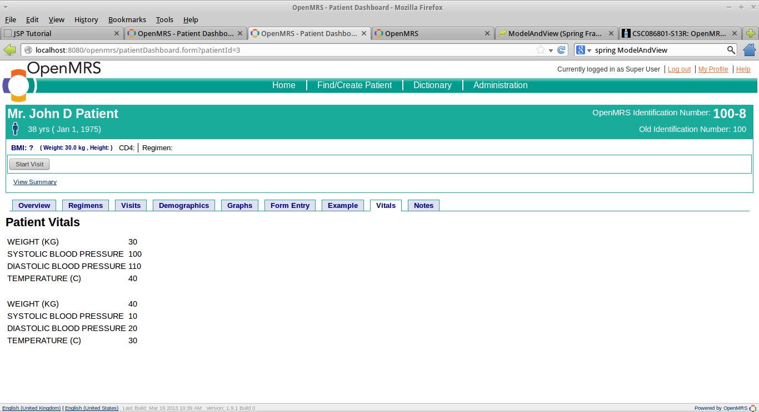
Vitals tab

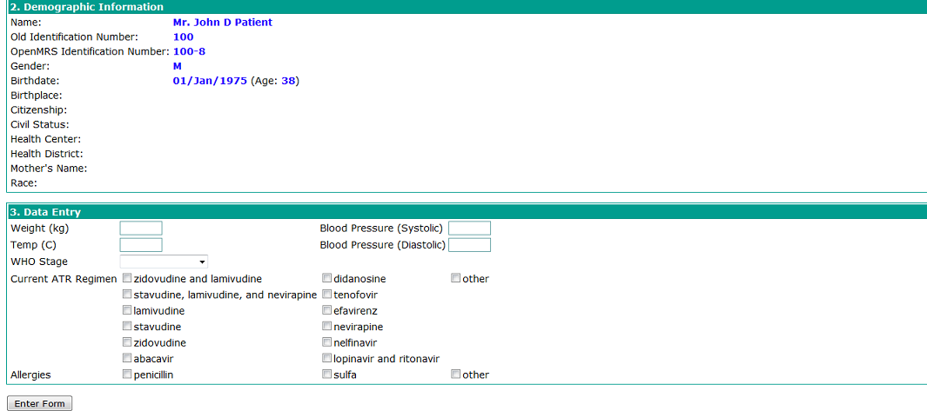
Vitals Entry Form

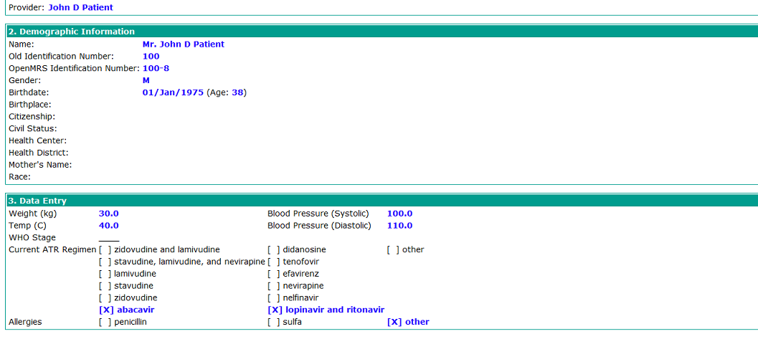
Vitals Entry Form (after submission)
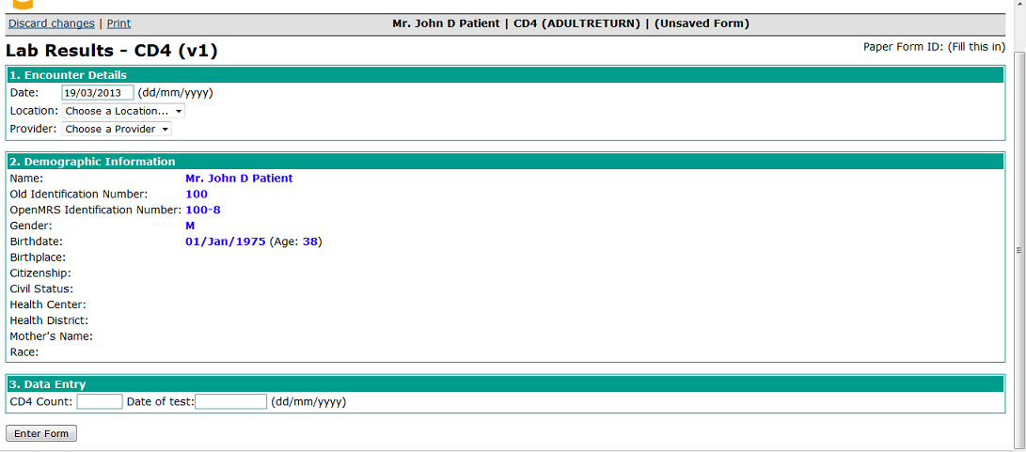
CD4 Lab Results Form

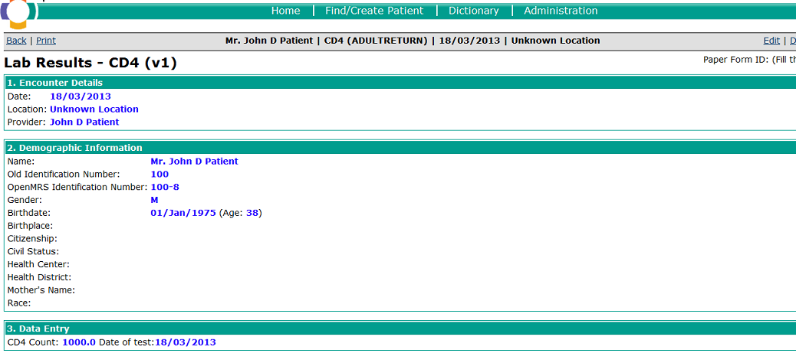
CD4 Lab Results Form (after submission)
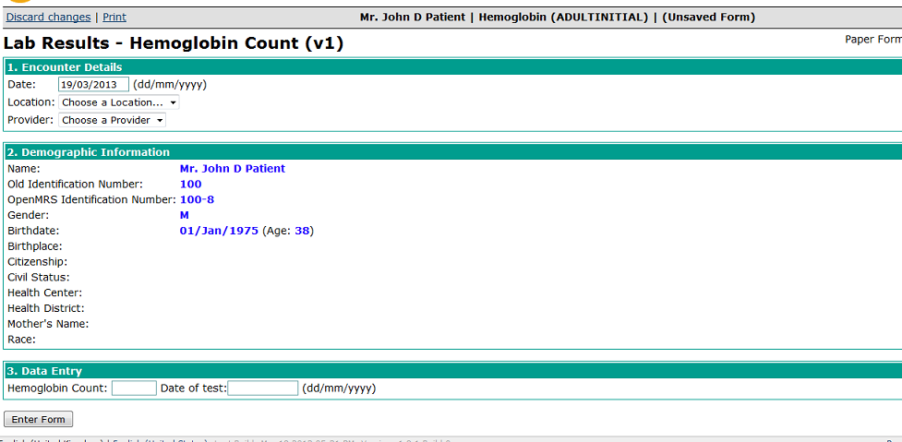
Hemoglobin Lab Results Form

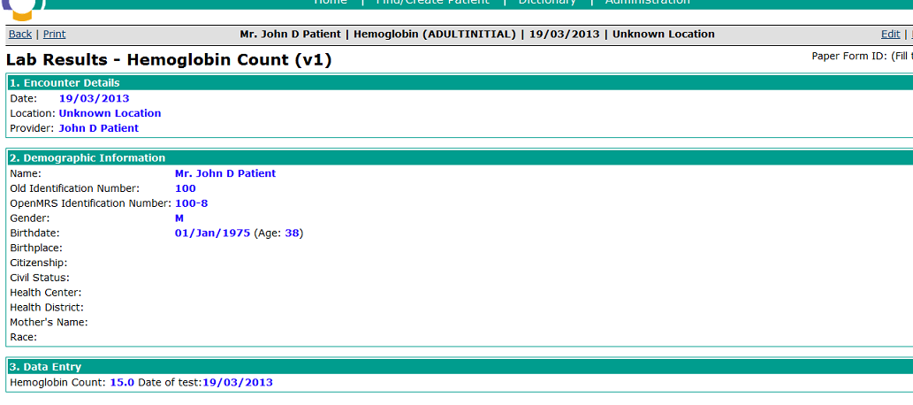
Hemoglobin Lab Results Form (after submission)

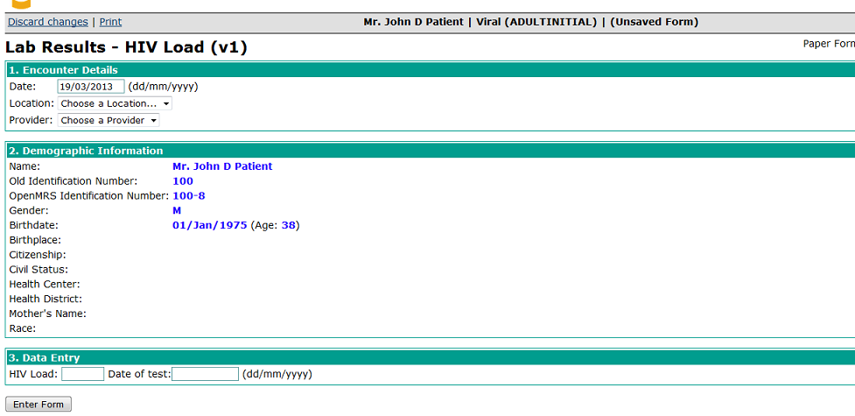
Viral Load Lab Results Form

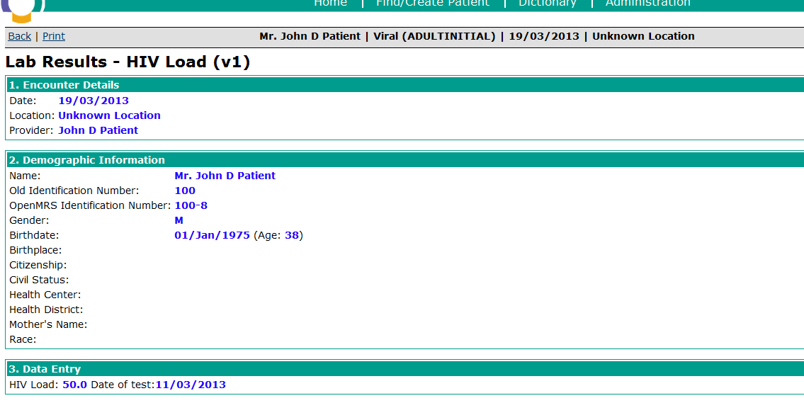

Viral Load Lab Results Form (after submission)
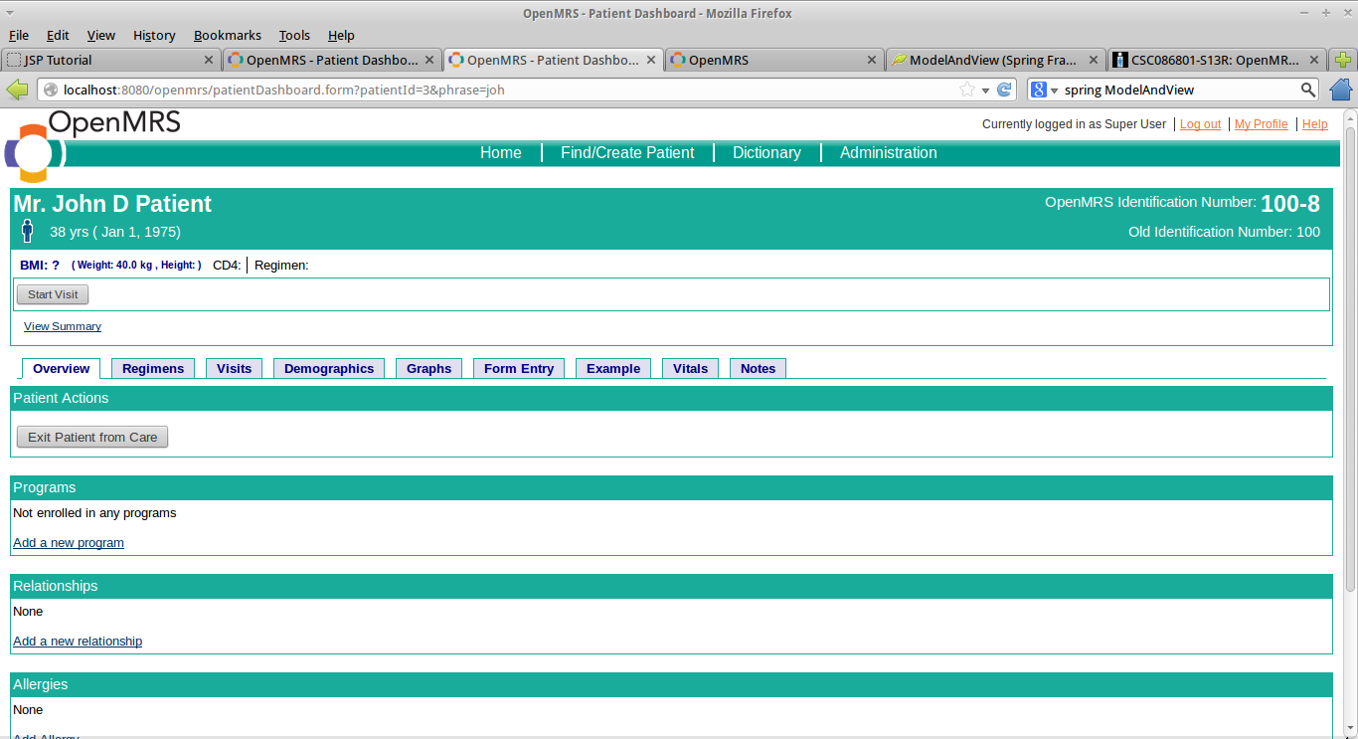

Patient Summary Link (“View Summary”)

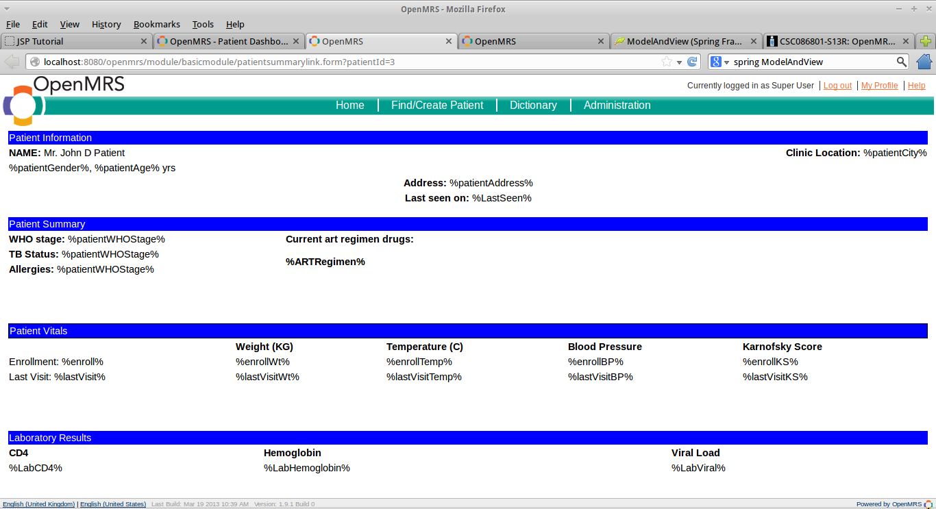
Patient Summary

