FastX - BusTicketBooking

Actor: Passenger

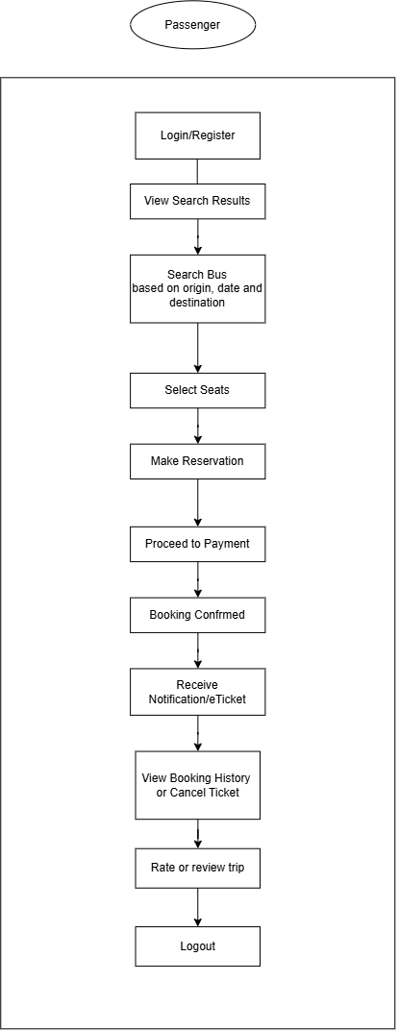
Actor: Bus Operator
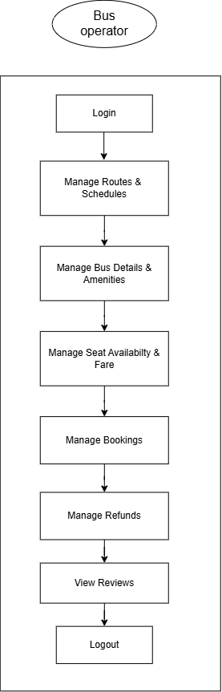

Actor: Administrator

