Project Overview
Project Title: Level-Up Fitness Tracker Website
Team: 5 members (CS)
Team members: Li jiayang ，Dario Muñoz ，Johnkerby ，Khang ， Peter
1.1 Purpose
This system helps users plan training, record workouts, view data trends, and maintain consistency
1.2 Target Users
- FIU Students
- Fitness Beginners
- People who need to plan their training
1.3 Key Features
- Dashboard
- Workout logging
- Calendar
- Exercise statistics and progress tracking
- Personalization section
- Navigation/menu system
- Gamification (levels, rankings, leaderboard
2. System Requirements
2.1 Functional Requirements
- FR-01 User can create an account and log in
- FR-02 User can add a workout session
- FR-03 User can view workout history
- FR-04 User can schedule workouts in a calendar
- FR-05 User can view statistics (weekly/monthly)
- FR-06 User can customize personal settings (personalization section)
- FR-07 The system provides a dashboard showing user stats and levels
- FR-08 The system includes a navigation menu for accessing all features
2.2 Non-Functional Requirements
- NFR-01 The UI should load within 2 seconds on average
- NFR-02 Data must persist across sessions (DB or localStorage)
- NFR-03 System should be responsive (mobile-friendly)
- NFR-04 The system should be easy to maintain and extend (modular design)

3. System Architecture
The system employs client-server architecture and incorporates elements of event-driven design: user interactions (such as adding a workout plan, completing a task, or updating progress) trigger events that update user data and gamified features, such as levels, statistics, and progress indicators. This approach supports the gamification features of the application by allowing the system to dynamically respond to user actions.
3.1 Technology Stack（tba)
- Frontend: HTML, CSS, JavaScript (developed using Visual Studio Code)
- Backend: Java (planned for implementation)
- Database: MySQL (planned)
- Development Tools: Visual Studio Code (code editor)

3.2 Architecture Overview
The system is structured into three main components:
- Frontend:
Provides user interaction, displays dashboard, calendar, and workout features.
- Backend:
Handles business logic, processes user requests, and manages data communication.
- Database:
Stores user data, workout logs, calendar events, and statistics.
3.3 Data Flow
- The user interacts with the frontend (e.g., adds a workout).
- The frontend sends a request to the backend API.
- The backend processes the request and stores/retrieves data from the database.
- The backend returns the response to the frontend.
- The frontend updates the UI accordingly.
4. UI Design
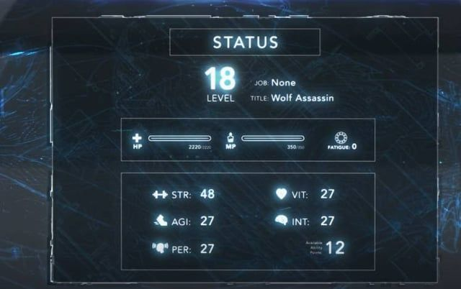

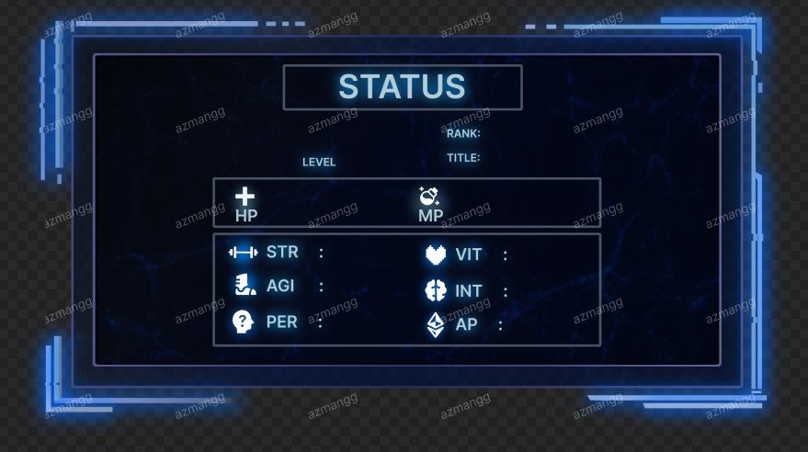

5. Team Roles & Responsibilities
5.1 Sprint Responsibilities (for now)
- Petar Dosev is responsible for creating the GitHub repository and adding all team members as collaborators
- Dario Muñoz is responsible for creating the Dashboard page (initial HTML version)
- Li Jiayang is responsible for finalizing the design prototype for the project
- Khang Tran is responsible for creating the Calendar page

6. Project Development Plan and Progress
The development of the Level-Up Fitness Tracker follows an iterative Agile/Scrum approach. The team plans features based on sprint discussions and gradually implements them over time.
6.1 Initial Planning (Early Sprint)
In the initial sprint, the team focused on basic setup and UI design. The following tasks were planned:
- Creating the GitHub repository and setting up the development environment
- Designing the basic UI structure and layout
- Creating simple HTML pages with styling
- Deciding the overall design theme (gamified “Status Panel” style)
At this stage, the goal was to establish a working prototype and define the direction of the project.
6.2 Intermediate Planning (Sprint Refinement)
In later sprint planning meetings, more structured features were proposed and prioritized:
- Calendar with checklist functionality
- Workout log and statistics page
- Personalization section
- Navigation/menu system
- System documentation and architecture design
The team also estimated sprint velocity (around 20–31 story points) and assigned responsibilities to each member.
6.3 Current Implementation Progress
So far, the following components have been planned or partially implemented:
- Basic HTML pages with styling
- Initial dashboard layout
- UI design concept (RPG-style status panel)
- Project structure and feature breakdown
Additional features such as workout logging, calendar scheduling, and statistics visualization are currently under development.
6.4 Future Work
The next development steps include:
- Implementing backend services using Java
- Connecting the frontend with the database
- Completing workout tracking and statistics features
- Enhancing the gamification system (levels, leaderboard, etc.)
- Improving UI/UX with animations and transitions

