Computer Communications and Networks (COMN)
2020/21, Semester 2

Assignment 2 Results Sheet

Forename and Surname: | Liu Rongxing
Matriculation Number: | s1810054

Question 1 – Number of retransmissions and throughput with different retransmission timeout values with stop-and-wait protocol. For each value of retransmission timeout, run the experiments for 5 times and write down average number of retransmissions and average throughput.

Retransmission timeout (ms) | Average number of  re-transmissions | Average throughput  (Kilobytes per second)
5 | 1271.4 | 69.65
10 | 683.4 | 60.76
15 | 114 | 60.93
20 | 96.3 | 58.85
25 | 99.2 | 51.04
30 | 104.6 | 51.97
40 | 104.8 | 46.62
50 | 97.6 | 43.6
75 | 109 | 39.95
100 | 110.8 | 30.34

Question 2 – Discuss the impact of retransmission timeout value on the number of retransmissions and throughput. Indicate the optimal timeout value from a communication efficiency viewpoint (i.e., the timeout that minimizes the number of retransmissions while ensuring a high throughput).

When the timeout is changed from 5ms to 15ms, the number of retransmissions drops quickly. Then the number of retransmissions fluctuates, with no apparent change. Overall, the average throughput decreases gradually as the timeout increases. This is because the round-trip propagation delay is already 10ms. If the timeout is set to 10ms or below, the probability of timeout is very large (even without packet loss). Hence, there will be many unnecessary retransmissions. When the timeout value is 15ms and above, there will be enough time for sender to receive acknowledgement (if the packet is not lost). The number of retransmissions is much lesser. From the table, the optimal timeout value is 20ms.

Question 3 – Experimentation with Go-Back-N. For each value of window size, run the experiments for 5 times and write down average throughput.

 | Average throughput (Kilobytes per second)
Window Size | Delay = 5ms | Delay = 25ms | Delay = 100ms
1 | 53.17 | 12.34 | 3.95
2 | 68.92 | 19.94 | 6.2
4 | 108.91 | 27.46 | 9.67
8 | 127.59 | 35.67 | 12.35
16 | 124.94 | 44.88 | 15.45
32 | 135.76 | 47.27 | 13.94
64 | 91.77 | 53.27 | 16.64
128 | 59.86 | 49.89 | 17.82
256 | 46.81 | 39.59 | 19.68

Create a graph as shown below using the results from the above table:
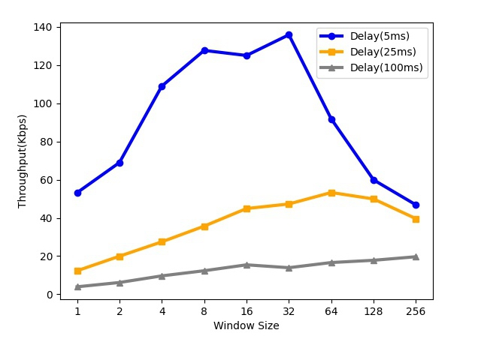

Question 4 – Discuss your results from Question 3.

When the delay is 5ms, initially the throughput increases as window size increases, then it reaches the peak when window size=32, after that the throughput decreases as window size increases. The reason for this trend is that initially as the window size increases, sender can send more packets in advance and receiver will also receive all the packets earlier. Hence, the throughput will increase. However, when the window size becomes large enough, receiver cannot process too many packets on time, which will cause a lot of timeouts and consequently a lot of retransmissions. The throughput will become lower. For the other two cases, the timeout is larger, which gives receiver more time to process, and the drawbacks of large window size becomes small.

Based on Question 2, the optimal timeout value when delay=5ms is 20ms. I noticed that 20ms is 10ms more than the round-trip delay (which is 2*5ms=10ms). The extra 10ms could be due to the time needed for receiver to write the data. Hence, for the cases with 25ms and 100ms delay, I set the timeout value to be 10ms plus the round-trip timeout. This means that for transmission delay=25ms, I used 60ms as the timeout and for transmission delay=100ms, I used 210ms as the timeout.

When the delay is 25ms, the throughput also increases first, reaching the peak when window size=64 and then decreases as window size increases.
When the delay is 100ms, the throughput generally increases as window size increases despite a small drop when window size changes from 16 to 32.

For all values of window sizes, the throughput is lower when the transmission delay is higher.

Question 5 – Experimentation with Selective Repeat. For each value of window size, run the experiments for 5 times and write down average throughput.

 | Average throughput (Kilobytes per second)
Window Size | Delay = 25ms
1 | 14.38
2 | 26.85
4 | 47.13
8 | 84.02
16 | 134.25
32 | 215.78

Question 6 - Compare the throughput obtained when using “Selective Repeat” with the corresponding results you got from the “Go Back N” experiment and explain the reasons behind any differences.

Under the same network conditions (bandwidth, packet loss rate, propagation delay), “Selective Repeat” achieves a much higher throughput than “Go Back N”. When the window size is 32, the throughput of SR is even higher than GBN with only 5ms propagation delay. The results of throughput for SR might be lower than the expected level, especially when the window size is large. This is because sometimes the receiver will receive all the packets and end yet the sender is still waiting for the acknowledgement of some packets (two-army problem). To address this issue, I set a timeout value of 0.5 second for the sender such that if it has not received any messages for 0.5 second, it will know that receiver has ended and hence end itself. As a result, an extra of 0.5 second is spent. This will cause the value of throughput to be lower than expected. When the window size is large, the time taken for transmission is only 3-4 seconds, and 0.5 second is not insignificant compared to 3-4 seconds. Hence, the throughput will drop by approximately 30-40.

SR is more efficient than GBN both on both the sender as well as the receiver side.

On the sender side, in the event of a timeout, GBN retransmits all the packets within the window while SR only retransmits those whose acknowledgement has not been received. At any time, SR is expecting acknowledgement of all unacknowledged packets within the window, while GBN is only expecting the acknowledgement of the base. Hence, sender can process the acknowledgements more efficiently and end faster.

On the receiver side, GBN is only expecting the packet with consecutive sequence number while SR buffers those packets with non-consecutive sequence numbers. In this way, receiver will write into the new file faster and finish faster.

Question 7 – Experimentation with iperf. For each value of window size, run the experiments for 5 times and write down average throughput.

 | Average throughput (Kilobytes per second)
Window Size (KB) | Delay = 25ms
1 | 12.17
2 | 22.83
4 | 27.85
8 | 63.05
16 | 83.18
32 | 92.13

Question 8 - Compare the throughput obtained when using “Selective Repeat” and “Go Back N” with the corresponding results you got from the iperf experiment and explain the reasons behind any differences.

The throughput obtained using iperf is faster than that using GBN but slower than that using SR.

TCP is more efficient than GBN (especially in large window size) in terms of retransmissions, because in the event of a timeout, GBN retransmits all the packets within the window while TCP only retransmits the oldest unacknowledged one.

Generally, TCP performs similarly to SR, but at the same time, TCP is responsible for error checking, flow control, congestion control and so on. All these functionalities take time to achieve. In addition, TCP requires 3-way handshake before starting to transfer. As a result, the throughput of using TCP is slower than SR.

