MANGLORE UNIVERSITY
SULLIA-574239

PROJECT REPORT

ON
A MODERN, REAL-TIME CHAT & COLLABORATION SYSTEM

Submitted in partial fulfillment of the requirement for the award of
Bachelor of Computer Applications

Submitted By

Rakesh P Regno: U05NM23S0061

Mudassir S B Regno: U05NM23S0047
Under the Guidelines of Mrs. Sindhu
Department of BCA
Department of Bachelor of Computer Applications
NEHRU MEMORIAL COLLEGE, SULLIA
(Affiliated to Mangalore University, Recognized by Govt of Karnataka) Sullia-574239, Karnataka

MINI PROJECT REPORT

A MODERN, REAL-TIME CHAT & COLLABORATION SYSTEM

SUBMITTED BY
Rakesh P
Mudassir S B
Regno: U05NM23S0061
Regno: U05NM23S0047
Under the Guidelines of
Mrs. Sindhu
Department of BCA
Nehru Memorial College, Sullia
Department of Bachelor of Computer Applications
NEHRU MEMORIAL COLLEGE, SULLIA
(Affiliated to Mangalore University, Recognized by Govt of Karnataka)
Sullia-574239, Karnataka

CERTIFICATE FROM THE INSTITUTE

This is to certify that the project report entitled A MODERN, REAL-TIME CHAT & COLLABORATION SYSTEM has been carried out by Rakesh P & Mudassir S B(Regno: U05NM23S0061 & U05NM23S0047), student of Bachelor of Computer Applications, Department of BCA, Nehru Memorial College, Sullia, Mangaluru, during the academic year 2025–2026, in partial fulfillment of the requirement for the award of Bachelor of Computer Applications degree of MANGLORE UNIVERSITYSULLIA-574239, under my supervision and guidance.

The project work is original and has not been submitted to any other university or institution for the award of any degree or diploma.

The project work fulfills the requirements for the partial completion of the Bachelor of Computer Applications degree at Nehru Memorial College, Sullia, affiliated to MANGLORE UNIVERSITY SULLIA-574239

Project Guide | Head of Department | Principal
Mrs. Sindhu | Mrs. Deeksha M D | Mr. Rudrakumar M M
Dept. of BCA | Dept. of BCA | Nehru Memorial College,  Sullia
NMC, Sullia | NMC, Sullia
Date: | Date: | Date:

DECLARATION

We, the undersigned, hereby declare that the project report A MODERN, REAL-TIME CHAT & COLLABORATION SYSTEM submitted for the partial fulfillment of the degree of Bachelor of Computer Applications (BCA) at Nehru Memorial College, Sullia, MANGLORE UNIVERSITY
SULLIA-574239, is a record of original work done by us during the academic year 2025–2026 under the guidance of Mrs. Sindhu

We further declare that this project work or any part thereof has not been submitted to any other university or institute for the award of any degree, diploma, or any other qualification.

The information presented in this report is true and correct to the best of our knowledge and belief.

Signature of Student(s)
Rakesh P (U05NM23S0061)
Mudassir S B (U05NM23S0047)

Place: Date:

ACKNOWLEDGEMENT

We take this opportunity to express our sincere gratitude and deep regards to all those who helped us throughout this project.
We are deeply indebted to our project guide, Mrs.Sindhu, for the exemplary guidance, monitoring, and constant encouragement throughout the course of this project. The blessings, help, and guidance given by them at various points of time shall carry us a long way in the journey of life on which we are about to embark.
We also extend our sincere gratitude to the Head of the Department and all faculty members of the Department of BCA for their invaluable support and academic mentorship.
We are grateful to the Principal/Director of Nehru Memorial College, Sullia for providing all the necessary facilities for the completion of this project.
Finally, we would like to thank our family members and friends for their unwavering support, patience, and encouragement throughout this project.

Place: Mangaluru Date:

Signature of the Student
Rakesh P (U05NM23S0061)
Mudassir S B (U05NM23S0047)___________________________________

TABLE OF CONTENTS
Index | Chapter / Section Title | Page Number
1.0 | Introduction of the System | 1
1.1 | Project Title & Categories | 1
1.2 | Objectives & Scope of the System | 2
1.3 | Existing vs Proposed System | 3
1.4 | Development Platform & SW/HW Requirements | 4
2.0 | Software Requirement Specification (SRS) | 7
2.1 | Need & Purpose of SRS | 7
2.2 | Overall Description & Constraints | 8
2.3 | Functional Requirements by Module | 10
2.4 | Non-Functional & Security Requirements | 12
3.0 | System Design | 15
3.1 | Functional Decomposition & CFD | 15
3.2 | Level-1 DFD Flowcharts | 17
3.3 | Component Descriptions | 19
4.0 | Database Design | 22
4.1 | Purpose & Logical NoSQL Structures | 22
4.2 | Firestore & RTDB Collection Tables | 23
4.3 | ER Database Schema Diagram | 27
5.0 | Detailed Design | 28
5.1 | Modular Decomposition & Logic Design | 28
5.2 | Program Code Listings & Snippets | 31
6.0 | User Interface (Screens & Reports) | 40
6.1 | Interactive UI Mockups & Descriptions (11 screens) | 40
7.0 | Testing & Verification | 50
7.1 | Unit, Integration & System Test Methods | 50
7.2 | QA Verification Test Matrix | 53
8.0 | Conclusion & References | 55
8.1 | Limitations & Future Enhancements | 55
8.2 | Abbreviations & Bibliography | 57

LIST OF FIGURES
Fig. No | Figure Description | Page Number
Fig. 3.1 | ConnectHub Three-Tier System Architecture Diagram | 6
Fig. 3.2 | Level-0 Context Flow Diagram (CFD) | 18
Fig. 3.3 | Level-1 Data Flow Diagram (DFD) | 19
Fig. 4.1 | ConnectHub Database ER Diagram | 27
Fig. 6.1 | Authentication Gateway View (3D Globe Canvas) | 40
Fig. 6.2 | Primary Chat Dashboard View (Sidebar & Chat Pane) | 41
Fig. 6.3 | Profile & Settings Modal View | 42
Fig. 6.4 | Chat Settings & Wallpaper Picker View | 43
Fig. 6.5 | Media Preview Modal with Photo Filters View | 44
Fig. 6.6 | Client-Side Input Validation Warning View | 45
Fig. 6.7 | Active WebRTC Call Window View | 46
Fig. 6.8 | AI Chat Summary Overlay View | 47
Fig. 6.9 | Call History Logs & Data Usage Report View | 48
Fig. 6.10 | Message Recall Confirmation Alert View | 49
Fig. 6.11 | Multiplayer Game Lobby & Active Board View | 49
Fig. 6.12 | Network Connection Error Alert View | 50

LIST OF TABLES
Table No | Table Title / Description | Page Number
Table 1.1 | Development Hardware Requirements | 5
Table 1.2 | Development Software Environment | 6
Table 4.1 | Users Collection Schema (/users/{uid}) | 23
Table 4.2 | Chats Collection Schema (/chats/{chatId}) | 24
Table 4.3 | Messages Subcollection Schema (/chats/{chatId}/messages/{messageId}) | 25
Table 4.4 | Calls Collection Schema (/calls/{callId}) | 25
Table 4.5 | Call Logs Collection Schema (/callLogs/{logId}) | 26
Table 4.6 | Stories Collection Schema (/stories/{storyId}) | 26
Table 4.7 | Games Collection Schema (/games/{gameId}) | 27
Table 4.8 | Presence Database Schema (/status/{uid}) | 28
Table 7.1 | System Testing Verification Report | 54

Chapter 1: Introduction

1.1 Introduction of the System
In the contemporary software landscape, instant messaging systems have transitioned from optional social utilities into business-critical operational networks. Standard users demand sub-millisecond response rates, high data transmission security, low resource footprints on mobile targets, and rich visual interactive components. ConnectHub is an advanced instant chat and visual collaboration application engineered to address these complex needs by utilizing a decoupled frontend SPA structure, client-side resource management loop, and integrated privacy-centric local AI models.

1.2 Project Title & Category
The project is titled "ConnectHub" (symbolized as ConnectHub 💬). It belongs to the category of Real-Time Distributed Web Applications & Messaging Platforms. It combines Firebase serverless backend features, WebRTC peer-to-peer data channels, and local/cloud machine learning models.

1.3 Overview & Background
ConnectHub resolves the major constraints of traditional messaging frameworks: DOM rendering slow downs, high cloud storage costs, and privacy vulnerabilities from routing user chat data to public cloud AI engines. ConnectHub uses react-virtuoso list virtualization to maintain smooth scrolling in conversations with 10,000+ messages. It also applies client-side HTML5 canvas compression to shrink image sizes before upload, saving up to 80% in egress and storage fees. Finally, it uses a local Python FastAPI server wrapping Ollama (Llama 3/Phi 3) for chat rephrasing, smart replies, and summaries, keeping sensitive data inside client networks. Secure Gemini cloud function fallbacks maintain availability if the local LLM goes offline.

1.4 Objective of the System
- Real-time Presence Synchronization: Synchronize message deliveries, typing indicators, and user online status under 100ms using Firebase Realtime Database connections.
- Smooth Scrolling: Achieve 60FPS UI scrolling in long chat logs by virtualizing lists and recycling off-screen nodes.
- Pre-flight Image Compression: Compress user images and videos in the browser before network transmission to lower cloud operating costs.
- Data-Secure AI Integrations: Run AI chat summaries and suggestions locally on client workstations, routing to Gemini only as a backup.
- Mobile PWA Compatibility: Provide a Progressive Web App that works offline and supports background push notifications.
- Integrated Multiplayer Gaming: Enable real-time Chess and Ludo matches directly within chat conversations using Firebase-synchronized game state trees.

1.5 Brief Note on Existing System
Existing chat web architectures suffer from critical bottlenecks. Legacy applications render the entire conversational history in the browser DOM, causing significant input lag and browser crashes as history scales. Additionally, standard systems upload raw media files directly, which drains mobile battery and bloats storage costs. Furthermore, existing solutions route sensitive text transcripts to public cloud AI services, creating data leak risks.

1.6 Proposed System Details
The proposed ConnectHub architecture addresses these bottlenecks: (1) rendering virtualized list viewports to limit DOM nodes; (2) using client-side image compression to reduce media payloads; (3) using local LLM inference engines (FastAPI/Ollama) to keep user logs private; (4) establishing direct WebRTC visual streams for calling to bypass database lines; and (5) caching app structures locally through service workers for instant offline starts; and (6) providing real-time in-app multiplayer board games (Chess and Ludo) synchronized via Firebase state nodes to increase user interaction.

1.7 System Architecture Block Diagram
The physical system design is structured into three tiers: client-side SPA, Firebase cloud services, and local AI server. The layout is illustrated in Figure 3.1:
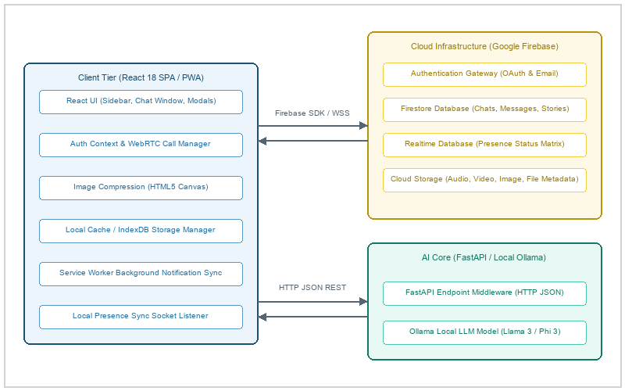
Figure 3.1: ConnectHub Three-Tier System Architecture Diagram

1.8 End Users
The application targets two user classes: (1) Standard Chat Clients who use the secure chat, media editor, and video calls, and (2) System Administrators who manage database configurations, Firestore rules, and Ollama hardware connections.

1.9 Development Environment Platform
To compile, develop, test, and deploy the ConnectHub application, specific hardware and software tools must be integrated into the workstation environment. The development setup is cataloged below.
Table 1.1: Development Hardware Requirements
Component | Minimum Requirement | Recommended (AI & Production)
Processor (CPU) | Dual-Core 2.0 GHz (Intel i5 / Ryzen 5) | Hexa-Core 3.5 GHz (Intel i7 / Apple M-Series)
System Memory (RAM) | 8 GB DDR4 | 16 GB or 32 GB DDR5 (Critical for local LLMs)
Storage Space | 5 GB of free SSD space | 20 GB of free NVMe M.2 SSD space (To store local models)
Graphics GPU | Integrated Intel/AMD Graphics | NVIDIA RTX 2060 (6GB VRAM) or Apple Silicon Unified Memory
Target Devices | iPhone 8 (iOS 15+) or Android 8+ | Modern flagship smartphone (iOS 17+ or Android 12+)

Table 1.2: Development Software Environment
Software Entity | Supported Version / Platform | Purpose / Role in Architecture
Operating System | Windows 10/11, macOS, or Linux | Host development environment
Runtime Environment | Node.js (v18.0.0+ / v20.0.0+) | Executes development server and bundler
Package Manager | npm (v9.0.0+) or Yarn (v1.22.0+) | Installs project modules and dev dependencies
Build Tool | Vite (v5.0.0+) with React Plugin | Bundles client source files with HMR support
Frontend Library | React (v18.2.0) & React-DOM | Constructs reactive, stateful user interfaces
Cloud Backend Engine | Firebase SDK (v10.0.0+) | Authenticates users and provides storage and real-time syncing
Local AI Host Engine | Ollama with FastAPI (Python 3.10+) | Serves local LLM for smart text helper actions
Visual WebGL Library | Three.js / React Three Fiber / Drei | Renders the interactive 3D Globe Login experience

Chapter 2: Software Requirement Specification

2.1 Need for SRS
Building a real-time messaging system with WebRTC calling, PWA background sync, dual databases, client-side compression, and local FastAPI models requires a single reference point. The SRS prevents design drift, defines data schemas, and establishes security rule baselines.

2.2 Product Perspective
ConnectHub is a client-server SPA that communicates directly with Firebase APIs. This serverless layout eliminates the need for a custom app backend. A separate, local FastAPI/Ollama server provides privacy-centric AI services on client networks, using Google's Gemini API as a fallback.

2.3 Product Functions
- Secure Authentication: Persistent sessions using email/password or Google Provider accounts.
- Chat & Messaging: Supports group channels, starred notes, message editing, reactions, recalls, and mentions.
- Voice & Video: WebRTC audio/video calls with background Wake-Lock and Picture-in-Picture controls.
- Media Processing: Waveform voice notes, circular video notes, image filters, and client-side compression.
- PWA & Notifications: Installable manifest, background service workers, and foreground Toast alerts.
- AI Copilot: Generates quick smart replies and chat summaries locally using Llama 3.
- Multiplayer Gaming: In-chat Chess and Ludo matches with invitation cards, turn validation, and live synchronization.

2.4 Assumptions and Dependencies
The application assumes client runtimes support HTML5, Canvas, WebRTC, and Service Workers. It depends on Google Firebase services and requires a workstation with 6GB+ VRAM to run local AI models.

2.5 Non-Functional Requirements
The system must maintain 60FPS UI scrolling under load using list virtualization. Outbound media uploads must be compressed by at least 70% before transit. Security-wise, Firestore rules must enforce document-level privacy, and client-to-cloud transfers must run over HTTPS/WSS.

Chapter 3: System Design

3.1 Functional Decomposition & CFD
The system is built on a decoupled, event-driven architecture. Real-time actions are managed through live listeners that sync UI state with database updates. The Level-0 Context Flow Diagram maps data flow between the app and external services, as shown in Figure 3.2:
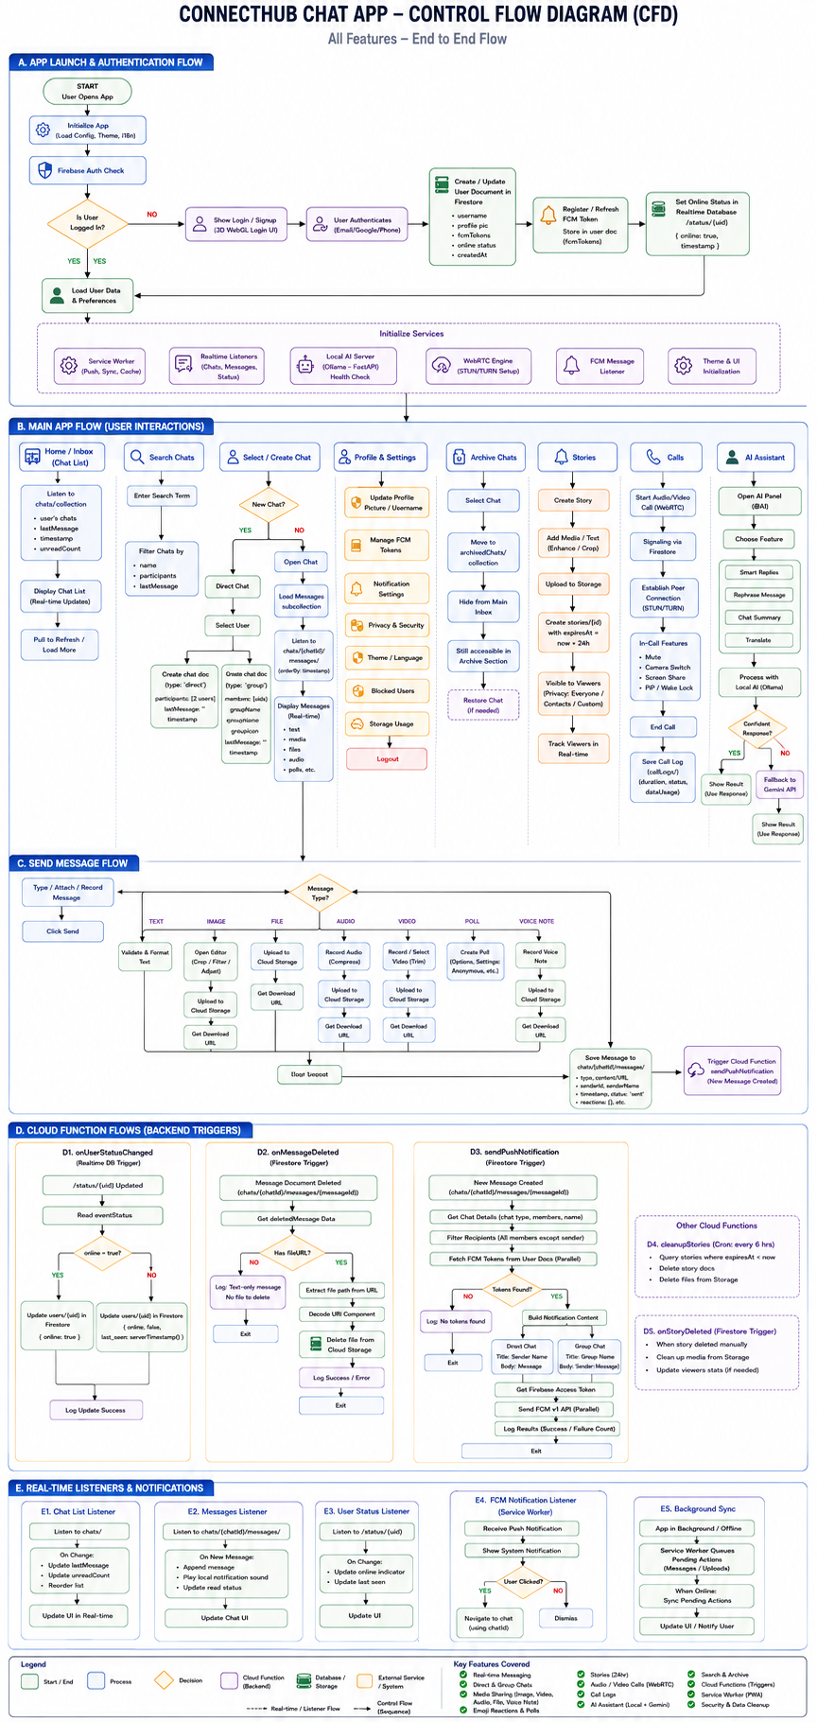
Figure 3.2: Level-0 Context Flow Diagram (CFD)

3.2 Level-1 DFD Flowcharts
The Level-1 Data Flow Diagram divides the central system into five core logical processes: user auth, message routing, WebRTC call bridging, FCM push sync, and the AI assistant. These flows are illustrated in Figure 3.3:
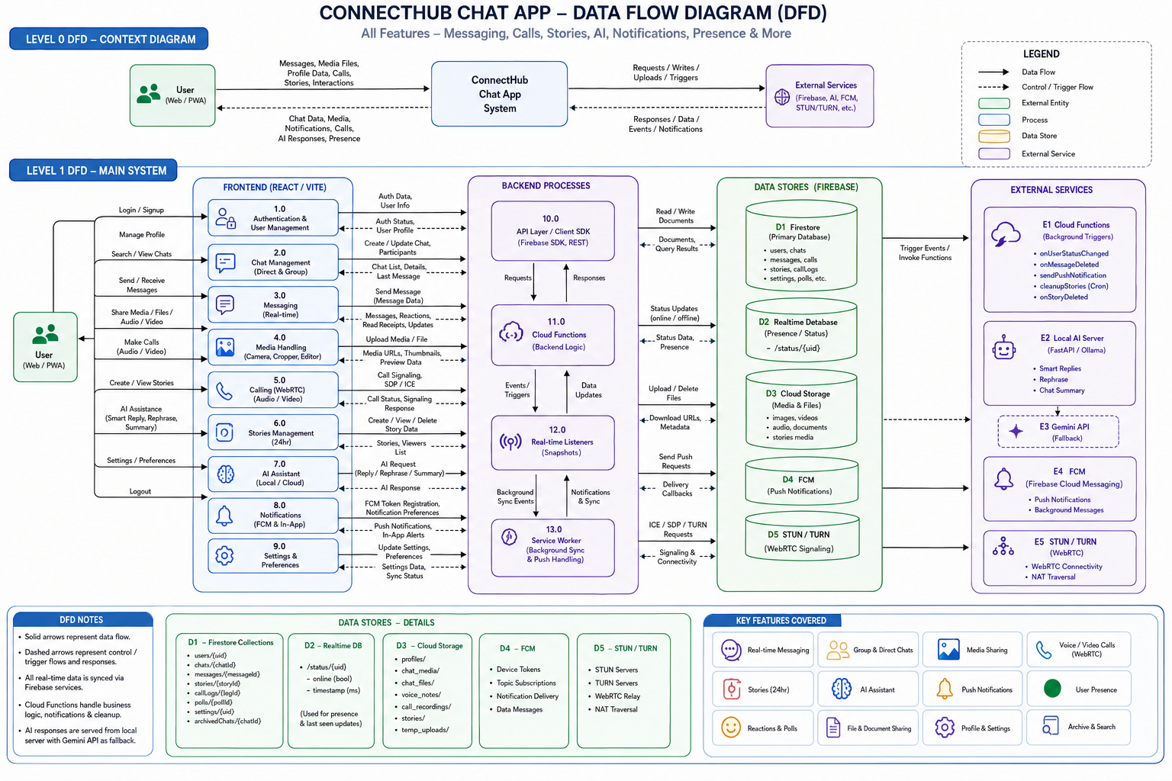
Figure 3.3: Level-1 Data Flow Diagram (DFD)
3.3 System Architecture
The physical architecture is structured in a three-tier model: Client, Cloud Services, and Local AI servers. The diagram below visualizes these modules and their communication channels:
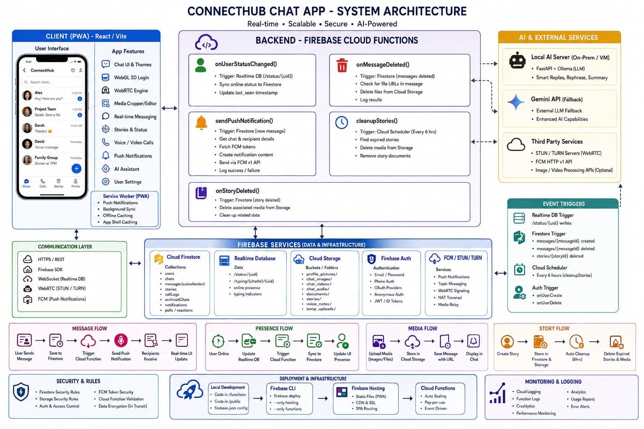
Figure 3.1: ConnectHub Three-Tier System Architecture Diagram

3.4 Component Descriptions
The application features several key components: (1) Sidebar, which handles active chat lists, status presence, and call logs; (2) ChatWindow, managing virtualized message threads, input fields, typing indicators, and WebRTC call buttons; (3) CallProvider, which runs WebRTC peer handshakes and tracks call states; and (4) Service Worker, which registers push tokens and handles background alerts when the app is closed; and (5) GameProvider, which manages the active multiplayer gaming lobby, tracks turns, and renders Chess/Ludo board interfaces inside overlays.

Chapter 4: Database Design

4.1 Purpose and Scope
ConnectHub uses a hybrid storage structure: Firebase Firestore manages persistent, structured NoSQL document schemas, while Firebase Realtime Database handles transient, high-frequency status logs. This setup ensures database integrity and keeps query costs low.

4.2 Database Schemas (Neat Tables)
The schemas and fields of the Firestore collections and Realtime Database trees are cataloged below.
Table 4.1: Users Collection Schema (/users/{uid})
Field Name | Data Type | Constraint | Description
uid | String | Primary Key | Unique identifier from Firebase Auth.
email | String | Required | User's verified email address.
username | String | Required | Display name (e.g., Alex Smith).
profilePic | String | Optional | URL to avatar image in Cloud Storage.
lowerCaseName | String | Required | Pre-computed name for case-insensitive search.
online | Boolean | Required | Online status synced from Realtime DB.
last_seen | Timestamp | Required | Server timestamp of last activity.
fcmTokens | Array of Strings | Optional | FCM tokens registered for push notifications.

Table 4.2: Chats Collection Schema (/chats/{chatId})
Field Name | Data Type | Constraint | Description
chatId | String | Primary Key | Unique identifier for the conversation.
members | Array of Strings | Required | List of participant UIDs.
type | String | Required | Type of conversation: direct or group.
groupName | String | Optional | Name of the group chat.
groupIcon | String | Optional | URL to group avatar image.
lastMessage | String | Required | Preview snippet of the last message.
lastUpdate | Timestamp | Required | Timestamp of the last message write.

Table 4.3: Messages Subcollection Schema (/chats/{chatId}/messages/{messageId})
Field Name | Data Type | Constraint | Description
messageId | String | Primary Key | Unique identifier for the message document.
sender | String | Required | UID of the message author.
text | String | Required | Message text content.
timestamp | Timestamp | Required | Server timestamp of message receipt.
type | String | Required | Content type: text, image, audio, or file.
fileURL | String | Optional | URL to media attachment in Cloud Storage.
recalled | Boolean | Required | Flag indicating if the message has been recalled.
edited | Boolean | Required | Flag indicating if the message has been edited.
reactions | Map of Arrays | Required | Emoji reaction records mapping UIDs.

Table 4.4: Calls Collection Schema (/calls/{callId})
Field Name | Data Type | Constraint | Description
callId | String | Primary Key | Unique identifier matching caller/receiver.
callerId | String | Required | UID of the user initiating the call.
receiverId | String | Required | UID of the target recipient.
status | String | Required | Call phase: offering, answering, connected, or ended.
type | String | Required | Call format: audio or video.
timestamp | Timestamp | Required | Timestamp of call initialization.

Table 4.5: Call Logs Collection Schema (/callLogs/{logId})
Field Name | Data Type | Constraint | Description
logId | String | Primary Key | Unique identifier for the call log.
participants | Array of Strings | Required | UIDs of both participants.
callerId | String | Required | UID of the call initiator.
receiverId | String | Required | UID of the call receiver.
duration | Number | Required | Call duration in seconds.
timestamp | Timestamp | Required | Timestamp of call initiation.

Table 4.6: Stories Collection Schema (/stories/{storyId})
Field Name | Data Type | Constraint | Description
storyId | String | Primary Key | Unique identifier for the story document.
uid | String | Required | UID of the author who uploaded the story.
mediaUrl | String | Required | URL to media file in Cloud Storage.
expiresAt | Timestamp | Required | Expiration timestamp (createdAt + 24 hours).
viewers | Array of Strings | Required | List of UIDs who have viewed the story.

Table 4.7: Games Collection Schema (/games/{gameId})
Field Name | Data Type | Constraint | Description
gameId | String | Primary Key | Unique identifier for the game session.
gameType | String | Required | Type of the game: chess or ludo.
status | String | Required | Status of the match: waiting, active, or finished.
players | Map | Required | Map of player UIDs to their roles (e.g., w/b for chess, colors for ludo).
moves | Array of Strings | Optional | Chronological list of game moves for state reconstruction.
winnerId | String | Optional | UID of the winner when status is finished.
lastUpdate | Timestamp | Required | Timestamp of the last turn or match update.

Table 4.8: Presence Database Schema (/status/{uid})
Field Name | Data Type | Constraint | Description
uid | String | Primary Key | UID of the user.
state | String | Required | Connectivity state: online or offline.
online | Boolean | Required | Active connection flag.
last_changed | Timestamp | Required | Database timestamp of the last status change.

4.3 Database Conceptual Schema (ER Diagram)
The relationships between database collections and keys are mapped in the conceptual model in Figure 4.1:
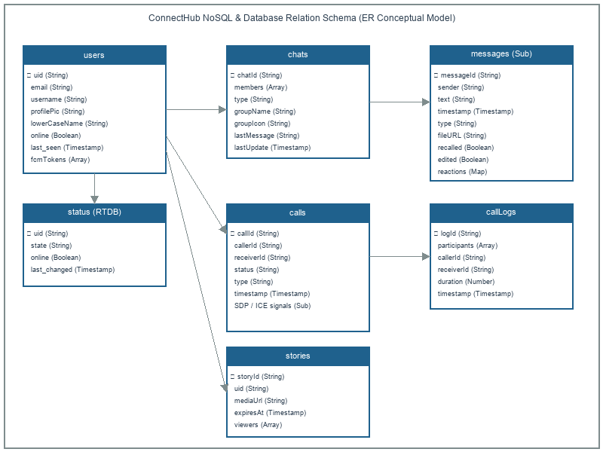
Figure 4.1: ConnectHub Database ER Diagram

Chapter 5: Detailed Design

5.1 Modular Decomposition & Logic Design
ConnectHub uses five core software modules: (1) Auth/Presence, which handles secure Google popup log-ins and tracks socket connectivity; (2) Messaging, which runs virtualized chat logs, typing indicators, group chats, and message edits/recalls; (3) Rich Media, managing voice/video note recording, image cropping, and client-side canvas compression; (4) WebRTC Calls, which coordinates peer-to-peer visual feeds using STUN/TURN configurations; and (5) AI Copilot, running local summary and rephrasing scripts with Gemini fallbacks; and (6) Multiplayer Gaming, coordinating Chess and Ludo board game invite workflows, turn validation logic, and real-time state synchronization via Firestore.

5.2 Program Code Listings & Snippets
The critical code listings below drive the core functionality of the ConnectHub application.

5.2.1 Database Security Rules (firestore.rules)
rules_version = '2';
service cloud.firestore {
match /databases/{database}/documents {
// 1. USERS COLLECTION
match /users/{userId} {
allow read: if request.auth != null;
// Allow users to update their own profile (and create it on first login)
allow write: if request.auth != null && request.auth.uid == userId;
// Chat Settings (wallpapers, etc.) - users can only access their own
match /chatSettings/{chatId} {
allow read, write: if request.auth != null && request.auth.uid == userId;
}
// Starred Messages - users manage their own stars
match /starredMessages/{messageId} {
allow read, write: if request.auth != null && request.auth.uid == userId;
}
// Scheduled Messages - users manage their own scheduled messages
match /scheduled_messages/{messageId} {
allow read, write: if request.auth != null && request.auth.uid == userId;
}
// Notes - users manage their own notes
match /notes/{noteId} {
allow read, write: if request.auth != null && request.auth.uid == userId;
}
}
// 2. CHATS COLLECTION (Direct & Groups)
match /chats/{chatId} {
// ALLOW CREATE: If user is logged in AND includes themselves in the 'members' array
allow create: if request.auth != null && request.auth.uid in request.resource.data.members;
// ALLOW READ/UPDATE: If user is already in the 'members' array
allow read, update: if request.auth != null && request.auth.uid in resource.data.members;
// ALLOW DELETE: (Optional) Usually better to archive, but this works for now
allow delete: if request.auth != null && request.auth.uid in resource.data.members;
// 3. MESSAGES SUB-COLLECTION
match /messages/{messageId} {
// READ/CREATE: We must check the PARENT document (the chat) to see if the user is a member.
// Note: This costs 1 extra read per evaluation, but it secures the data.
allow read, create, update: if request.auth != null &&
request.auth.uid in get(/databases/$(database)/documents/chats/$(chatId)).data.members;
// DELETE: Only allow the original sender to delete their message
allow delete: if request.auth != null && resource.data.sender == request.auth.uid;
}
// 4. TYPING INDICATOR
match /typing/{userId} {
allow read, write: if request.auth != null &&
request.auth.uid in get(/databases/$(database)/documents/chats/$(chatId)).data.members;
}
}
// 5. CALLS COLLECTION (Video/Audio Calling)
match /calls/{callId} {
// Allow read (get + list) for authenticated users
// - get: needed to check if call exists before creating
// - list: needed for incoming call queries
allow read: if request.auth != null;
// Allow create if user is the caller
allow create: if request.auth != null &&
request.resource.data.callerId == request.auth.uid;
// Allow update if user is caller or receiver
allow update: if request.auth != null &&
(resource.data.callerId == request.auth.uid || resource.data.receiverId == request.auth.uid);
// Allow delete if user is caller or receiver
allow delete: if request.auth != null &&
(resource.data.callerId == request.auth.uid || resource.data.receiverId == request.auth.uid);
// ICE Candidates subcollection
match /iceCandidates/{candidateId} {
// Allow all operations for authenticated users in a call
allow read, write: if request.auth != null;
}
}
// 6. CALL LOGS COLLECTION (Persistent Call History)
match /callLogs/{logId} {
// Read: only if you are a participant
allow read: if request.auth != null && request.auth.uid in resource.data.participants;
// Create: any authenticated user can log a call
allow create: if request.auth != null && request.auth.uid in request.resource.data.participants;
// Delete: allow participants to delete their own logs
allow delete: if request.auth != null && request.auth.uid in resource.data.participants;
}
// 7. STORIES COLLECTION (24h ephemeral stories/status updates)
match /stories/{storyId} {
// Any authenticated user can read stories
allow read: if request.auth != null;
// Users can only create/delete their own stories
allow create: if request.auth != null && request.resource.data.uid == request.auth.uid;
allow delete: if request.auth != null && resource.data.uid == request.auth.uid;
// For updates: author can do anything, OR viewers can add themselves to the viewers list
allow update: if request.auth != null && (
resource.data.uid == request.auth.uid ||
// Allow updating IF they are just adding themselves to the viewers array/info map
(request.resource.data.diff(resource.data).affectedKeys().hasAny(['viewers', 'viewersInfo']))
);
}
}
}

5.2.2 Real-Time Presence Synchronization (AuthContext.jsx Snippet)
useEffect(() => {
const unsubscribe = onAuthStateChanged(auth, async (user) => {
setCurrentUser(user);
setLoading(false);
if (user) {
// Presence Logic
const userStatusRef = ref(rtdb, '/status/' + user.uid);
const connectedRef = ref(rtdb, '.info/connected');
onValue(connectedRef, (snap) => {
if (snap.val() === true) {
// We're connected!
const con = {
state: 'online',
online: true,
last_changed: serverTimestamp()
};
onDisconnect(userStatusRef).set({
state: 'offline',
online: false,
last_changed: serverTimestamp()
});
set(userStatusRef, con);
// Sync to Firestore for UI
updateDoc(doc(db, "users", user.uid), { online: true }).catch(e => console.log("Online update failed", e));
// Handle tab close/refresh to update Firestore immediately
const handleTabClose = () => {
updateDoc(doc(db, "users", user.uid), { online: false });
};
window.addEventListener("beforeunload", handleTabClose);
return () => {
window.removeEventListener("beforeunload", handleTabClose);
};
} else {
updateDoc(doc(db, "users", user.uid), { online: false }).catch(() => { });
}
});
}
});
return unsubscribe;
}, []);

5.2.3 WebRTC Peer-to-Peer Signaling Handlers (CallContext.jsx Snippet)
// Get media stream
const stream = await getMediaStream(type);
// Create peer connection (STUN first)
const pc = createPeerConnection(activeCallId, false);
stream.getTracks().forEach(track => pc.addTrack(track, stream));
// Create offer
const offer = await pc.createOffer();
await pc.setLocalDescription(offer);
// Save to Firestore
const callData = {
callerId: currentUser.uid,
callerName: currentUser.displayName || 'User',
callerPhoto: currentUser.photoURL || '',
receiverId: receiverUid,
type,
status: 'offering',
offer: { type: offer.type, sdp: offer.sdp },
createdAt: serverTimestamp()
};
await setDoc(doc(db, 'calls', activeCallId), callData);
// Listen for answer
callDocUnsubscribeRef.current = onSnapshot(doc(db, 'calls', activeCallId), async (snapshot) => {
const data = snapshot.data();
if (!data) return;
if (data.status === 'answered' && data.answer && pc.signalingState !== 'stable') {
console.log('Answer received');
const answer = new RTCSessionDescription(data.answer);
await pc.setRemoteDescription(answer);
} else if (data.status === 'declined' || data.status === 'ended' || data.status === 'missed') {
cleanup(data.status);
}
});
// Listen for ICE candidates from receiver
iceCandidatesUnsubscribeRef.current = onSnapshot(
collection(db, 'calls', activeCallId, 'iceCandidates'),
(snapshot) => {
snapshot.docChanges().forEach(change => {
if (change.type === 'added') {
const data = change.doc.data();
if (data.from !== currentUser.uid && pc.remoteDescription) {
pc.addIceCandidate(new RTCIceCandidate(data.candidate)).catch(console.error);
}
}
});
}
);

5.2.4 WebRTC Receiver Answer Sequence (CallContext.jsx Snippet)
// Get media stream
const stream = await getMediaStream(callType);
// Create peer connection (STUN first)
const pc = createPeerConnection(callId, false);
stream.getTracks().forEach(track => pc.addTrack(track, stream));
// Set remote description (offer)
const offer = new RTCSessionDescription(callData.offer);
await pc.setRemoteDescription(offer);
// Create answer
const answer = await pc.createAnswer();
await pc.setLocalDescription(answer);
// Save answer to Firestore
await setDoc(doc(db, 'calls', callId), {
answer: { type: answer.type, sdp: answer.sdp },
status: 'answered'
}, { merge: true });
// Listen for call status changes
callDocUnsubscribeRef.current = onSnapshot(doc(db, 'calls', callId), (snapshot) => {
const data = snapshot.data();
if (data && (data.status === 'ended' || data.status === 'declined')) {
cleanup(data.status);
}
});
// Listen for ICE candidates from caller
iceCandidatesUnsubscribeRef.current = onSnapshot(
collection(db, 'calls', callId, 'iceCandidates'),
(snapshot) => {
snapshot.docChanges().forEach(change => {
if (change.type === 'added') {
const data = change.doc.data();

5.2.5 Multi-Tier AI Integration Engine (aiService.js)
import { httpsCallable } from 'firebase/functions';
import { cloudFunctions } from './firebase';
import { generateSmartReplies as generateStaticReplies } from '../utils/smartReplyEngine';
/**
* AI Service — Unified interface for AI features with multi-layer fallback:
* 1. Local AI (FastAPI + Ollama)
* 2. Cloud AI (Firebase Cloud Functions / Google Gemini)
* 3. Static Engine (Regex pattern matching)
*/
const AI_BASE_URL = 'http://localhost:8000';
/**
* Check if the local AI server is reachable
*/
export async function isAIServerAvailable() {
try {
const res = await fetch(`${AI_BASE_URL}/`, { signal: AbortSignal.timeout(2000) });
return res.ok;
} catch {
return false;
}
}
/**
* Generate 3 smart reply suggestions for an incoming message
* @param {string} messageText - The incoming message text
* @param {Array} chatContext - Optional array of { sender, text } context messages
* @returns {string[]} Array of 3 replies
*/
export async function fetchSmartReplies(messageText, chatContext = []) {
// Layer 1: Local AI (Zero cost, maximum privacy)
try {
const res = await fetch(`${AI_BASE_URL}/api/smart-reply`, {
method: 'POST',
headers: { 'Content-Type': 'application/json' },
body: JSON.stringify({ messageText, chatContext }),
signal: AbortSignal.timeout(3000)
});
if (res.ok) {
const data = await res.json();
if (data.replies && Array.isArray(data.replies)) {
return data.replies;
}
}
} catch (e) {
console.log("Local AI unavailable, falling back to Gemini...");
}
// Layer 2: Cloud AI (Gemini via Firebase Cloud Functions)
try {
const genSmartReplies = httpsCallable(cloudFunctions, 'generateSmartReplies');
const result = await genSmartReplies({ messageText, chatContext });
if (result.data && result.data.replies && Array.isArray(result.data.replies)) {
return result.data.replies;
}
} catch (e) {
console.error("Gemini AI failed, using static engine fallback...");
}
// Layer 3: Static Engine (Instant patterns, offline-safe)
return generateStaticReplies(messageText, chatContext);
}
/**
* Rephrase a draft message to sound polished and professional
* @param {string} text - The draft message to rephrase
* @returns {string|null} The rephrased text, or null on failure
*/
export async function fetchRephrase(text) {
// Try Local AI
try {
const res = await fetch(`${AI_BASE_URL}/api/rephrase`, {
method: 'POST',
headers: { 'Content-Type': 'application/json' },
body: JSON.stringify({ text }),
signal: AbortSignal.timeout(5000)
});
if (res.ok) {
const data = await res.json();
return data.rephrased || null;
}
} catch (e) {
console.log("Local Rephrase unavailable");
}
// Currently no cloud fallback for rephrase to save costs
return null;
}
/**
* Summarize a conversation from an array of messages
* @param {Array} messages - Array of { senderName, text } messages
* @returns {string|null} The summary text, or null on failure
*/
export async function fetchSummary(messages) {
// Try Local AI
try {
const res = await fetch(`${AI_BASE_URL}/api/summarize`, {
method: 'POST',
headers: { 'Content-Type': 'application/json' },
body: JSON.stringify({ messages }),
signal: AbortSignal.timeout(10000)
});
if (res.ok) {
const data = await res.json();
return data.summary || null;
}
} catch (e) {
console.log("Local Summarize unavailable");
}
// Currently no cloud fallback for summary
return null;
}

5.2.6 Cloud Functions Backend Triggers (functions/index.js Snippet)
// --- Function 3: sendPushNotification (UPGRADED for Groups) ---
exports.sendPushNotification = functions.firestore.onDocumentCreated("chats/{chatId}/messages/{messageId}", async (event) => {
const message = event.data.data();
const chatId = event.params.chatId;
if (!message) {
logger.info("No message data found.");
return;
}
const projectId = process.env.GCLOUD_PROJECT;
if (!projectId) {
logger.error("GCLOUD_PROJECT env var not set.");
return;
}
const senderId = message.sender;
const senderName = message.senderName || "Someone";
// 1. Get Chat Details
const chatRef = admin.firestore().collection("chats").doc(chatId);
const chatDoc = await chatRef.get();
if (!chatDoc.exists) {
logger.error(`Chat ${chatId} does not exist.`);
return;
}
const chatData = chatDoc.data();
const members = chatData.members || [];
// 2. Filter recipients: Everyone in 'members' EXCEPT the sender
const recipientIds = members.filter(uid => uid !== senderId);
if (recipientIds.length === 0) {
logger.info("No recipients found (chat might be empty or just self).");
return;
}
// 3. Determine Notification Content based on Chat Type
let title = "";
let body = "";
// Determine Body text based on message type
let bodyContent = "";
switch (message.type) {
case 'image': bodyContent = "📷 Sent a photo"; break;
case 'audio': bodyContent = "🎵 Sent a voice message"; break;
case 'file': bodyContent = "📄 Sent a file"; break;
default: bodyContent = message.text || "Sent a message";
}
if (chatData.type === 'group') {
// Group Style: "Group Name" -> "Alex: Hello"
title = chatData.groupName || "Group Chat";
body = `${senderName}: ${bodyContent}`;
} else {
// Direct Style: "Alex" -> "Hello"
title = senderName;
body = bodyContent;
}
// 4. Fetch Tokens for ALL recipients in parallel
const tokens = [];
const tokenFetchPromises = recipientIds.map(async (uid) => {
try {
const userDoc = await admin.firestore().collection("users").doc(uid).get();
if (userDoc.exists) {
const userData = userDoc.data();
if (userData.fcmTokens && Array.isArray(userData.fcmTokens)) {
tokens.push(...userData.fcmTokens);
}
}
} catch (e) {
logger.error(`Error fetching user ${uid}:`, e);
}
});
await Promise.all(tokenFetchPromises);
if (tokens.length === 0) {
logger.info("No valid FCM tokens found for any recipients.");
return;
}

Chapter 6: User Interface (Screens & Reports)
This chapter presents the interactive user interface mockups and descriptions for the core client screens and overlays built into the ConnectHub application.

6.1 Authentication Gateway View
The login screen features a glassmorphism card over an interactive 3D WebGL Earth Globe canvas, as shown in Figure 6.1. It provides inputs for credentials and quick-connect Google OAuth buttons.

Figure 6.1: Authentication Gateway View (3D Globe Canvas)

6.2 Primary Chat Dashboard View
The dashboard screen contains a dual-column layout, as shown in Figure 6.2. The left column lists active chat inboxes and status indicators, while the right column displays virtualized message threads, input toolbars, and WebRTC call controls.
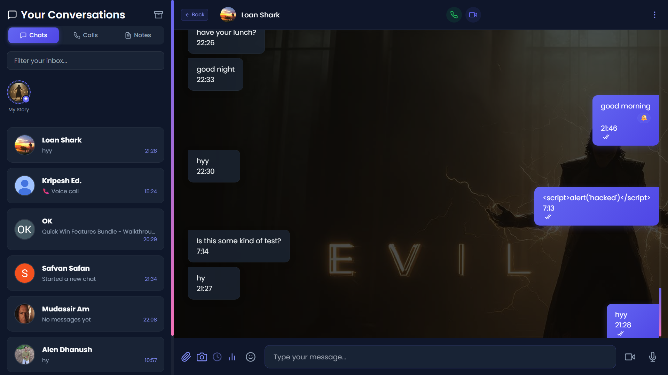
Figure 6.2: Primary Chat Dashboard View (Sidebar & Chat Pane)

6.3 Profile & Settings Modal View
The settings modal allows users to crop their profile avatar to a 1:1 aspect ratio, update display names, and toggle notification sounds, as shown in Figure 6.3.
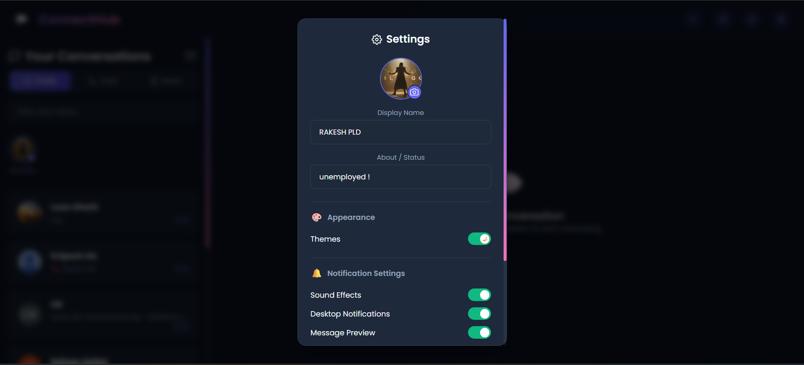
Figure 6.3: Profile & Settings Modal View

6.4 Chat Settings & Wallpaper Picker View
This overlay lets users pick custom gradient backgrounds and mute notifications for specific chat rooms, as shown in Figure 6.4.
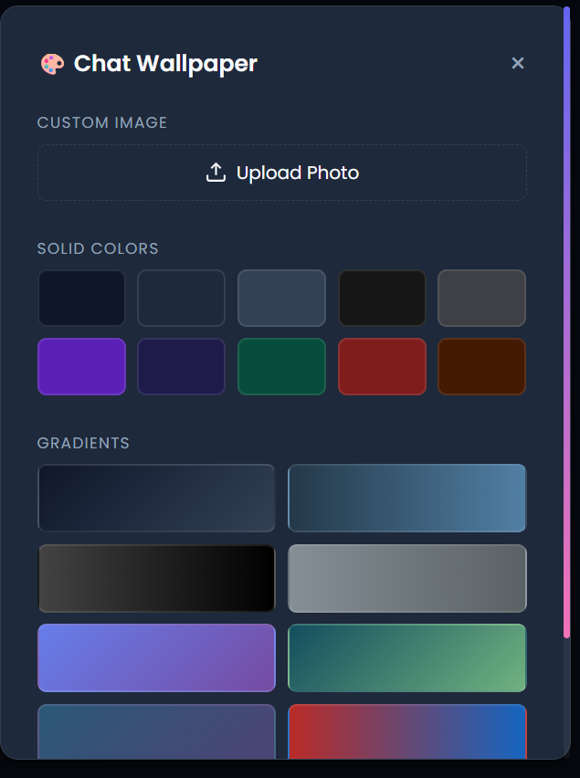
Figure 6.4: Chat Settings & Wallpaper Picker View

6.5 Media Preview Modal with Photo Filters View
The media editor preview displays the selected image, caption fields, and custom photo filters (Vivid, B&W, Sepia) available to apply before uploading, as shown in Figure 6.5.
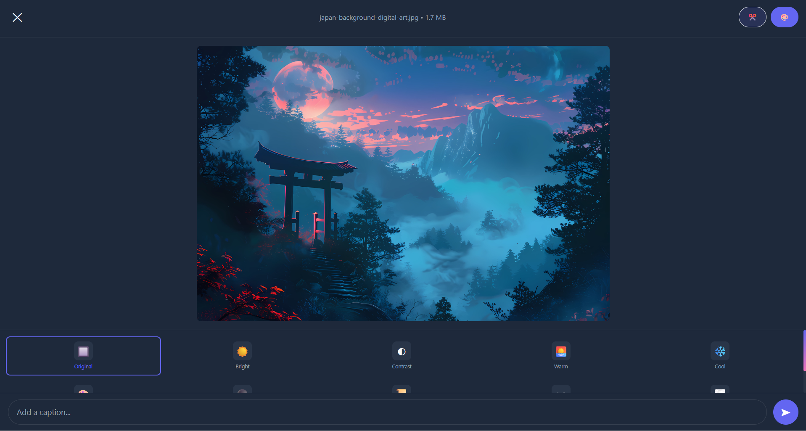
Figure 6.5: Media Preview Modal with Photo Filters View

6.7 Active WebRTC Call Window View
The call screen handles video/audio tracks in a custom viewport. It includes floating self-camera previews, call duration counters, and mic/mute control buttons, as shown in Figure 6.7.
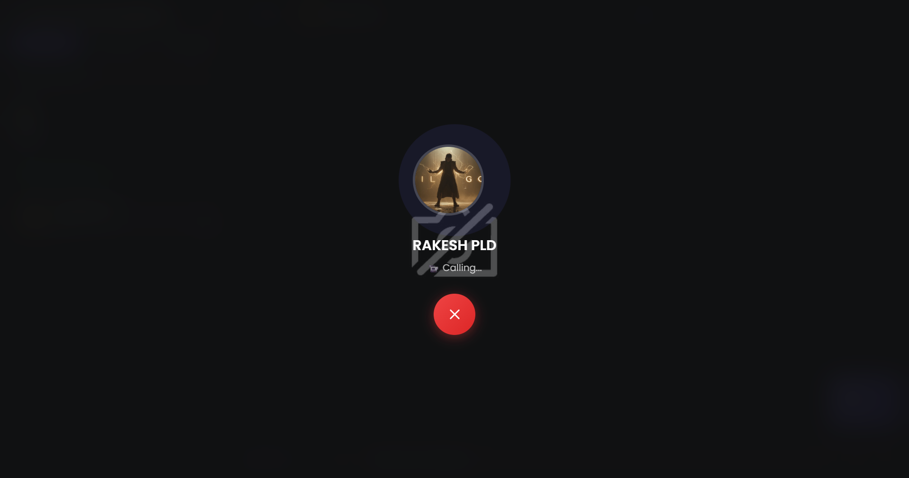
Figure 6.7: Active WebRTC Call Window View

6.8 AI Chat Summary Overlay View
The AI summarizer modal presents Llama 3 conversational summary cards, as shown in Figure 6.8.
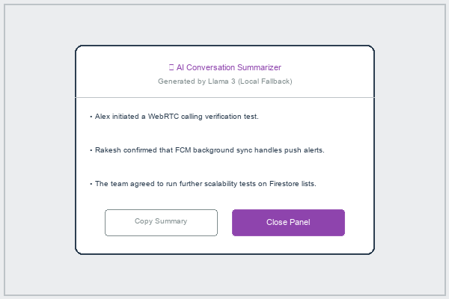
Figure 6.8: AI Chat Summary Overlay View

6.9 Call History Logs & Data Usage Report View
The call history log keeps records of incoming, outgoing, and missed call sessions, listing the durations and data usage metrics, as shown in Figure 6.9.

Figure 6.9: Call History Logs & Data Usage Report View

6.10 Message Recall Confirmation Alert View
This overlay displays confirmation boxes for message recalls, explaining that the message will be permanently deleted from all participant viewports, as shown in Figure 6.10.
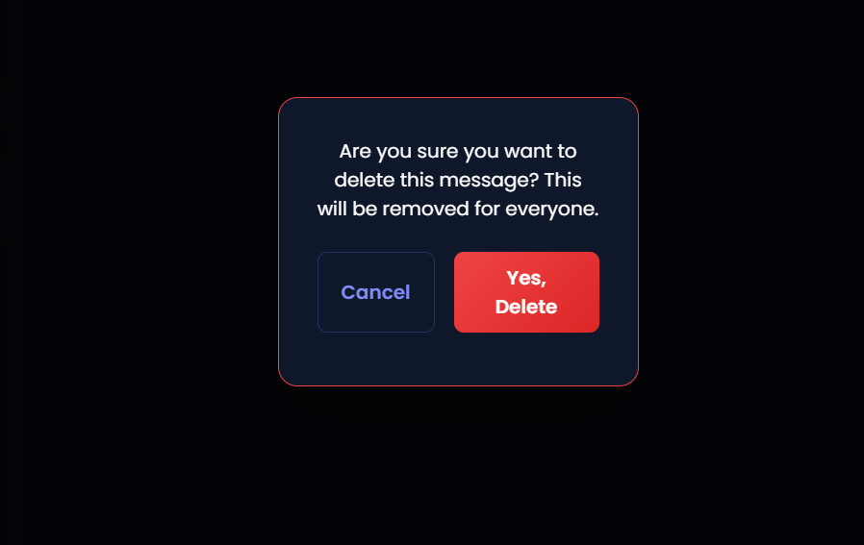
Figure 6.10: Message Recall Confirmation Alert View

6.11 Multiplayer Game Lobby & Active Board View
This interface manages multiplayer game invitations and active game views (Chess and Ludo) in chat threads. It includes game invite status notifications (waiting, active, finished), join buttons for players, and spectating options for other group members, rendering active boards inside maximized or picture-in-picture (PIP) overlays, as shown in Figure 6.11.
Figure 6.11: Multiplayer Game Lobby & Active Board View

Chapter 7: Testing

7.1 Testing Methodologies
ConnectHub's verification plan uses a multi-tier testing strategy. This approach validates individual codebase functions and verifies that integrated components work together correctly. It includes unit tests for isolated helpers, integration tests for real-time syncing, system tests for notifications and offline capabilities, and acceptance tests for PWA installability.

7.2 QA Verification Test Matrix (Neat Table)
The following matrix summarizes the test cases executed during verification, detailing inputs, expected outputs, and pass/fail results:
Table 7.1: System Testing Verification Report
TC ID | Module Tested | Input Parameter / Action | Expected Pass Output | Status
TC-01 | Auth Module | Click Google Sign-In button | User authenticated, profile doc written to Firestore, routes to dashboard | PASS
TC-02 | Presence Module | Disconnect browser connection | Socket disconnects, Realtime DB updates status, Firestore sets online=false | PASS
TC-03 | Messaging Module | Type text & click Send button | Message written to subcollection, unread count increments, UI updates instantly | PASS
TC-04 | Media Module | Upload raw 5MB photo file | Compressed locally to <300KB via canvas before transit, upload completes successfully | PASS
TC-05 | Calling Module | Initiate WebRTC call to user | Offers/answers write to subcollection, local ringer rings, camera stream connects | PASS
TC-06 | Push Sync Module | Send message to offline recipient | Cloud Function triggers, recipient FCM token queried, push notification delivered | PASS
TC-07 | AI Module | Click Summarize Chat logs | Recent chat transcripts queried, local FastAPI server returns 3-sentence summary | PASS
TC-08 | Stories Module | Post new image update | Image uploaded to storage, story doc set with 24h expiration, visible on StoriesBar | PASS
TC-09 | Games Module | Launch chess game invite | Game invite card sent to chat, accept button initializes game state, active board overlay opens | PASS

Chapter 8: Conclusion

8.1 Limitations of the System
ConnectHub has a few minor limitations: (1) running local AI models (Llama 3/Phi 3) requires high-performance GPUs on workstations, meaning mobile clients must fallback to cloud Gemini APIs; and (2) WebRTC calls depend on STUN/TURN connection quality, which can suffer latency under restricted symmetric NAT firewalls.

8.2 Scope for Enhancement
Future enhancements include: (1) adding End-to-End Encryption (E2EE) using the Web Cryptography API; (2) supporting multi-user WebRTC group conference calls; and (3) adding custom chat categories and folders to organize the inbox sidebar.

8.3 Abbreviations and Acronyms
Abbreviation | Expanded Meaning / Full Form
NEP | National Education Policy
BCA | Bachelor of Computer Applications
SRS | Software Requirements Specification
DFD | Data Flow Diagram
CFD | Context Flow Diagram
ERD | Entity Relationship Diagram
NoSQL | Not Only SQL (Document Oriented Database)
RTDB | Firebase Realtime Database
FCM | Firebase Cloud Messaging (Google Push Notification)
WebRTC | Web Real-Time Communication (P2P Calling)
PWA | Progressive Web Application
LLM | Large Language Model (AI Assistant)
API | Application Programming Interface
DOM | Document Object Model
SDLC | Software Development Life Cycle

8.4 Bibliography & References
- [1] React Documentation: Official React v18 API definitions, hooks (useEffect, useCallback, useMemo), and code-splitting guidelines (React.lazy, Suspense).
- [2] Google Firebase SDK Reference: APIs and configuration guides for Firestore (persistent NoSQL caches), Realtime DB (presence indicators), Storage, Cloud Messaging, and Cloud Functions.
- [3] WebRTC API Standards: Specifications for MediaDevices API, PeerConnection SDP offers, ICE candidates, and STUN/TURN connection traversal.
- [4] FastAPI Documentation: Guides for building Python REST APIs, managing request/response JSON models, and handling async task queues.
- [5] Ollama LLM Hosting Reference: Documentation for Llama 3 and Phi 3 model deployments, system prompt settings, and context window limits.
- [6] Vite Bundler Reference: Guides for Hot Module Replacement, production builds, and code-splitting options.
- [7] Progressive Web Apps Standards: Specifications for Service Worker background fetch listeners, cache storage strategies, and PWA manifest attributes.
- [8] react-virtuoso Reference: Performance guidelines for rendering virtualized list viewports with dynamic height nodes.

