MiniProject Title: GHAYS RTW

Authors: DARVIN PASIGNA

# Project Overview

GHAYS RTW is a sole proprietorship where the products are curtains, RTW’s, wedding dresses and bedsheets and other related products. As we all know that the competition of this kind of business is very tough. Because we can find it anywhere in our place, especially during pandemic, there were a lot of businesses like this were put up, even not in the market or in the mall. We can even find it along the road that we didn’t expect to find it. Mostly we have the same products and sometimes they have lower price than ours.

## Statement of the Problem

1. How to increase the sale?

2. How to dispose the products are not fast moving to avoid late in the trend.

3. Where to advertise the product?

## Project Solution

1. To address the problem, we will create and website to improve the sales and expand the market of the products.

2. The products will be well presented with nice photos and videos. The products will be opened to many, not only the for locals but also will be opened to all internet users nationwide.

# System Features

The system features include sign-up and login, user personal information, change password and email, a cart, a product page, and contact us.

## Sign up and Log in module

User sign up with their email address as their login username, upload an ID, and create a password, and then they will receive email confirmation. After confirmation, they can login to the website to purchase products. Customer Personal Information

## Personal Information

Users can view and edit basic information such as the full name, address, email address, contact numbers.

## Product Page

Customers could browse the dashboard for the products. They can also search for an item of their type such as dress, blouse, shorts and long pants, trousers, crop tops and under wears, curtains, bedsheets and pillow cases and wedding clothes.

## Cart

Then they can add their chosen items to shopping carts for their future checkout. So, to buy it, they just tick the items in the carts at the maximum of 20 items per checkout and click the checkout button. And for the payment, they can use the COD (Cash on Delivery) or payment first through GCASH or bank deposit

## Contact Us Module

Provides guidance for existing customers and offers an overview of your brand for new visitors. The user can send an email or phone call to the admin.

# Limitations

# Theme, Fonts, logo, Technology

**Theme:**

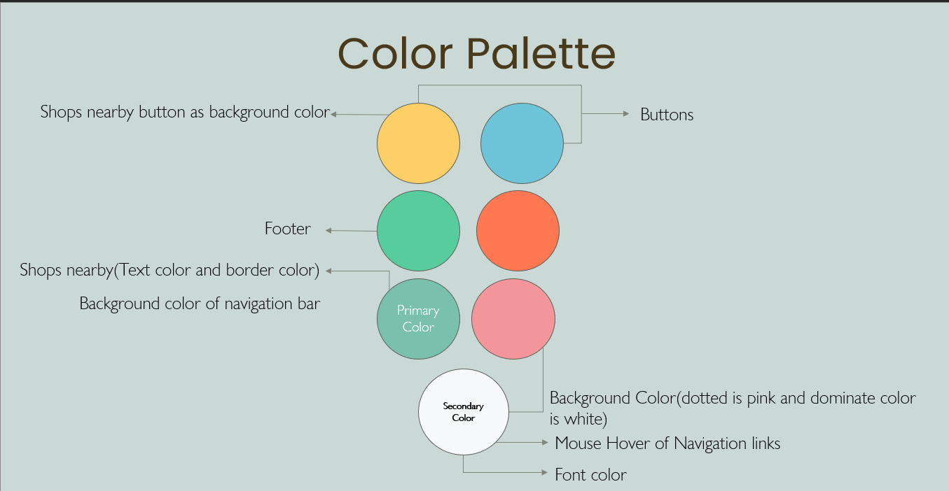

**LOGO & FONTS:** We concept our logo to be in text format, so that it can easily read and memorize. We also choose Poppins, to be modern and clean look.



**TECHNOLOGY:** We choose this different technology, to speed up our works, and to be appealing to most users.

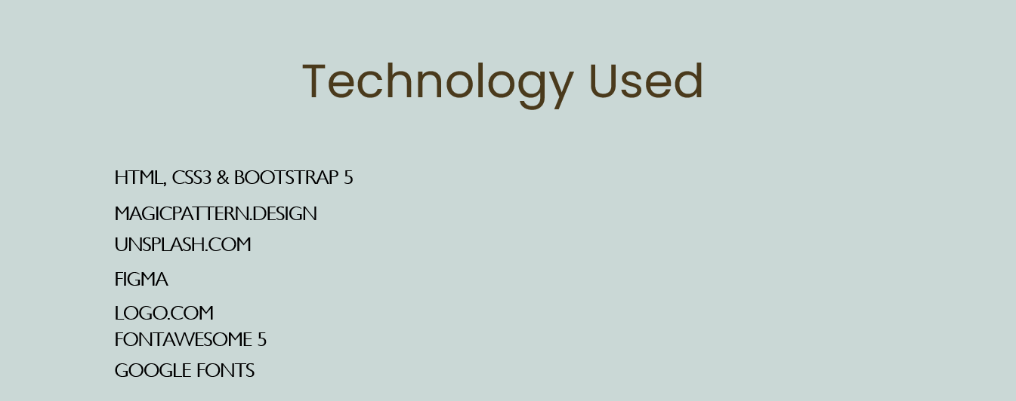

# Site Map

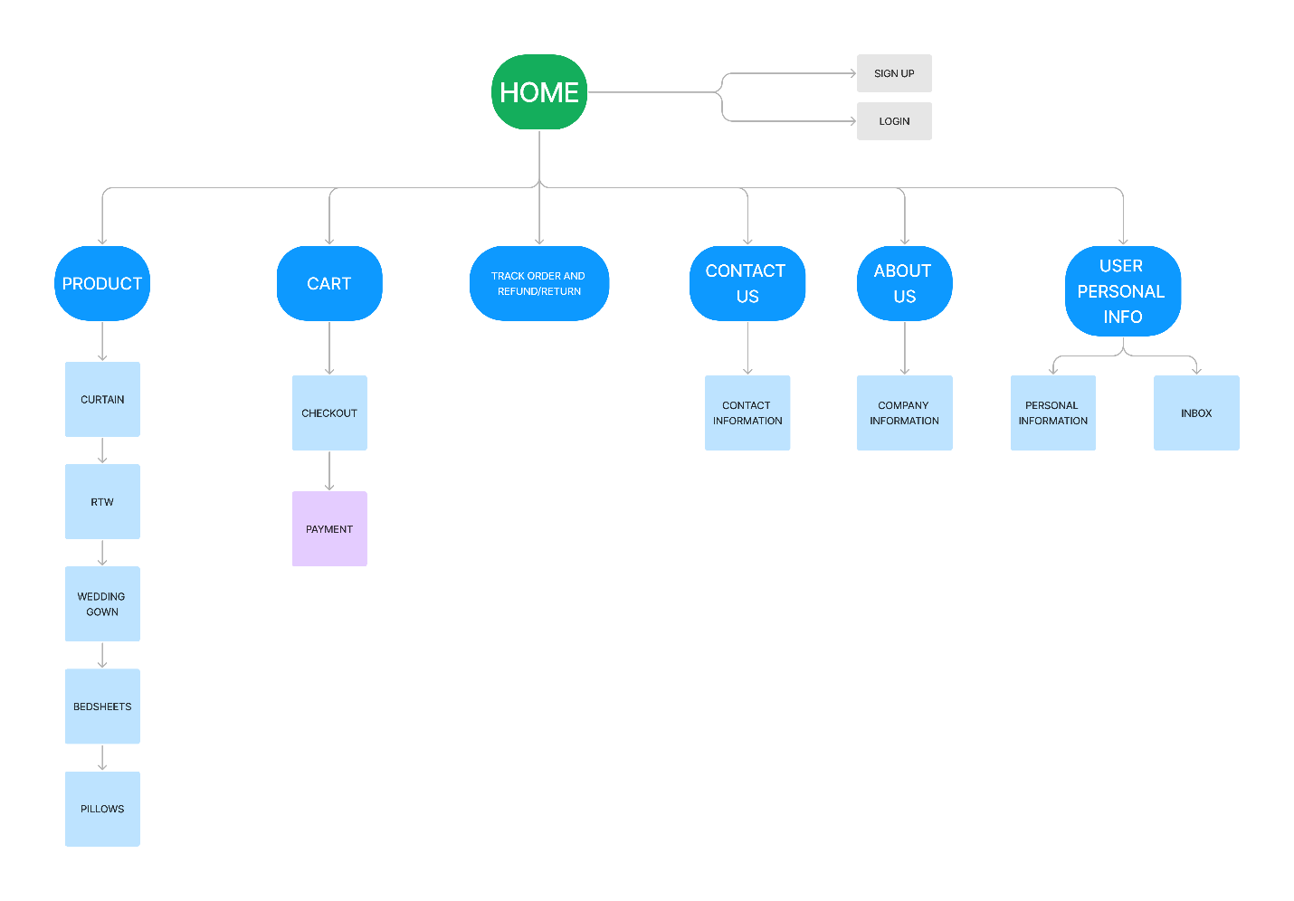

# Mockup/Wireframe

# Web App URL: