DARWIN-EU PX-CY-Z: Tables and Figures

Table 1. Baseline population characteristics.
Variable name | Variable level | Estimate name | Sex
Variable name | Variable level | Estimate name | overall | Male | Female
Number records | – | N | 2,564 | 1,262 | 1,302
Number subjects | – | N | 2,564 | 1,262 | 1,302
Age | – | Median [Q25 – Q75] | 46 [36 – 56] | 46 [37 – 56] | 45 [36 – 55]
Age | – | Mean (SD) | 47.54 (14.81) | 47.57 (14.40) | 47.52 (15.21)
Age | – | Range | 21 to 99 | 21 to 98 | 21 to 99
Days in cohort | – | Median [Q25 – Q75] | 3,654 [3,654 – 3,654] | 3,654 [3,654 – 3,654] | 3,654 [3,654 – 3,654]
Days in cohort | – | Mean (SD) | 3,594.61 (332.90) | 3,587.20 (341.22) | 3,601.79 (324.60)
Days in cohort | – | Range | 17 to 3,654 | 449 to 3,654 | 17 to 3,654
Prior observation | – | Median [Q25 – Q75] | 16,834 [13,477 – 20,588] | 16,932 [13,636 – 20,634] | 16,734 [13,320 – 20,410]
Prior observation | – | Mean (SD) | 17,545.28 (5,406.72) | 17,555.07 (5,255.26) | 17,535.78 (5,551.58)
Prior observation | – | Range | 7,729 to 36,260 | 7,729 to 36,115 | 7,929 to 36,260
Future observation | – | Median [Q25 – Q75] | 4,010 [3,891 – 4,117] | 4,005 [3,878 – 4,116] | 4,018 [3,900 – 4,118]
Future observation | – | Mean (SD) | 3,924.53 (418.47) | 3,910.98 (430.96) | 3,937.65 (405.74)
Future observation | – | Range | 16 to 4,201 | 448 to 4,201 | 16 to 4,199
Cohort start date | – | Median [Q25 – Q75] | 2008-01-01 [2008-01-01 – 2008-01-01] | 2008-01-01 [2008-01-01 – 2008-01-01] | 2008-01-01 [2008-01-01 – 2008-01-01]
Cohort start date | – | Range | 2008-01-01 to 2008-01-01 | 2008-01-01 to 2008-01-01 | 2008-01-01 to 2008-01-01
Cohort end date | – | Median [Q25 – Q75] | 2018-01-01 [2018-01-01 – 2018-01-01] | 2018-01-01 [2018-01-01 – 2018-01-01] | 2018-01-01 [2018-01-01 – 2018-01-01]
Cohort end date | – | Range | 2008-01-17 to 2018-01-01 | 2009-03-24 to 2018-01-01 | 2008-01-17 to 2018-01-01
Comedications | Opioids | N (%) | 49 (1.91%) | 22 (1.74%) | 27 (2.07%)
Comedications | Antidiabetes | N (%) | 26 (1.01%) | 15 (1.19%) | 11 (0.84%)
Comorbidities | Asthma | N (%) | 1,234 (48.13%) | 611 (48.42%) | 623 (47.85%)
Comorbidities | Depression | N (%) | 2,531 (98.71%) | 1,246 (98.73%) | 1,285 (98.69%)
Comorbidities | HIV | N (%) | 475 (18.53%) | 230 (18.23%) | 245 (18.82%)
HIV: Human Immunodeficiency Virus.

Figure 1. Number of records in cohorts.
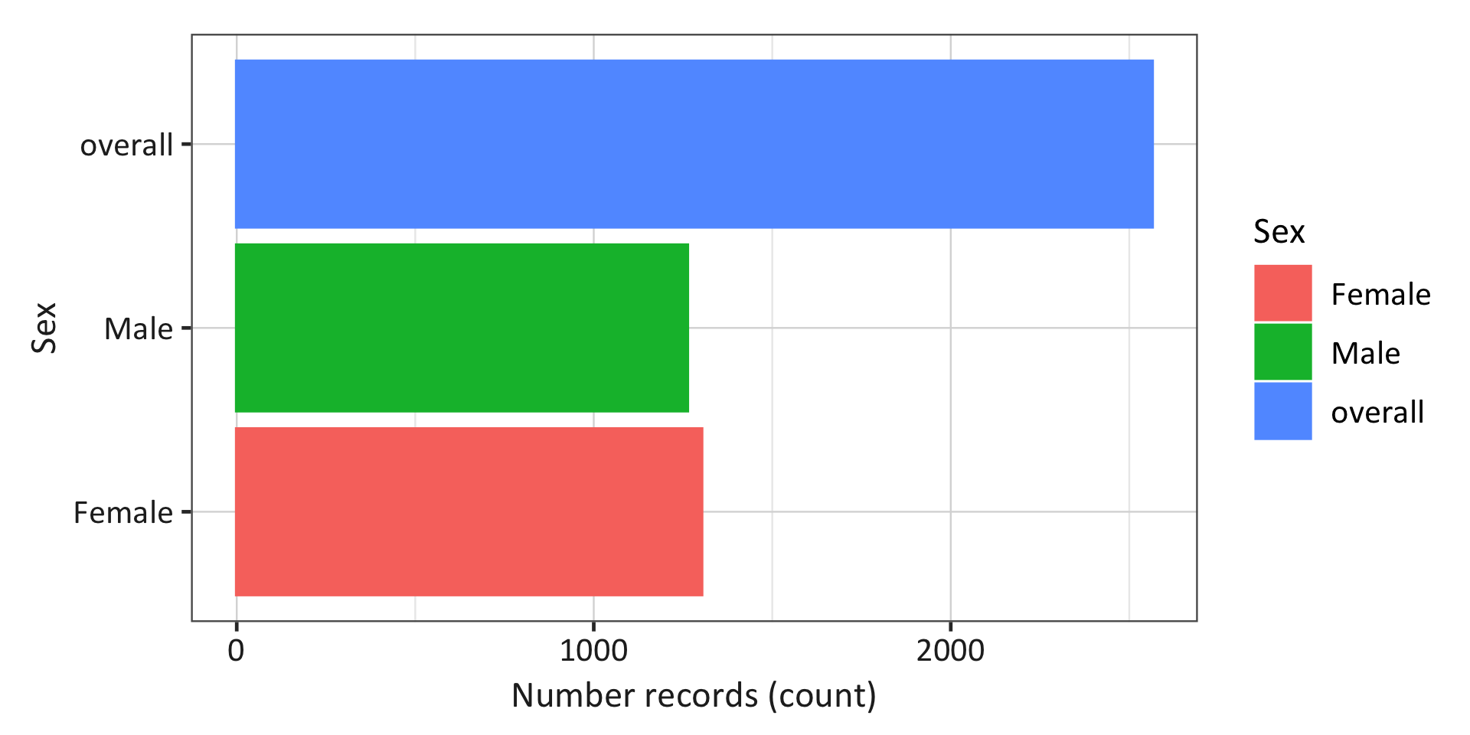

Figure 2. Incidence over time statified by sex.
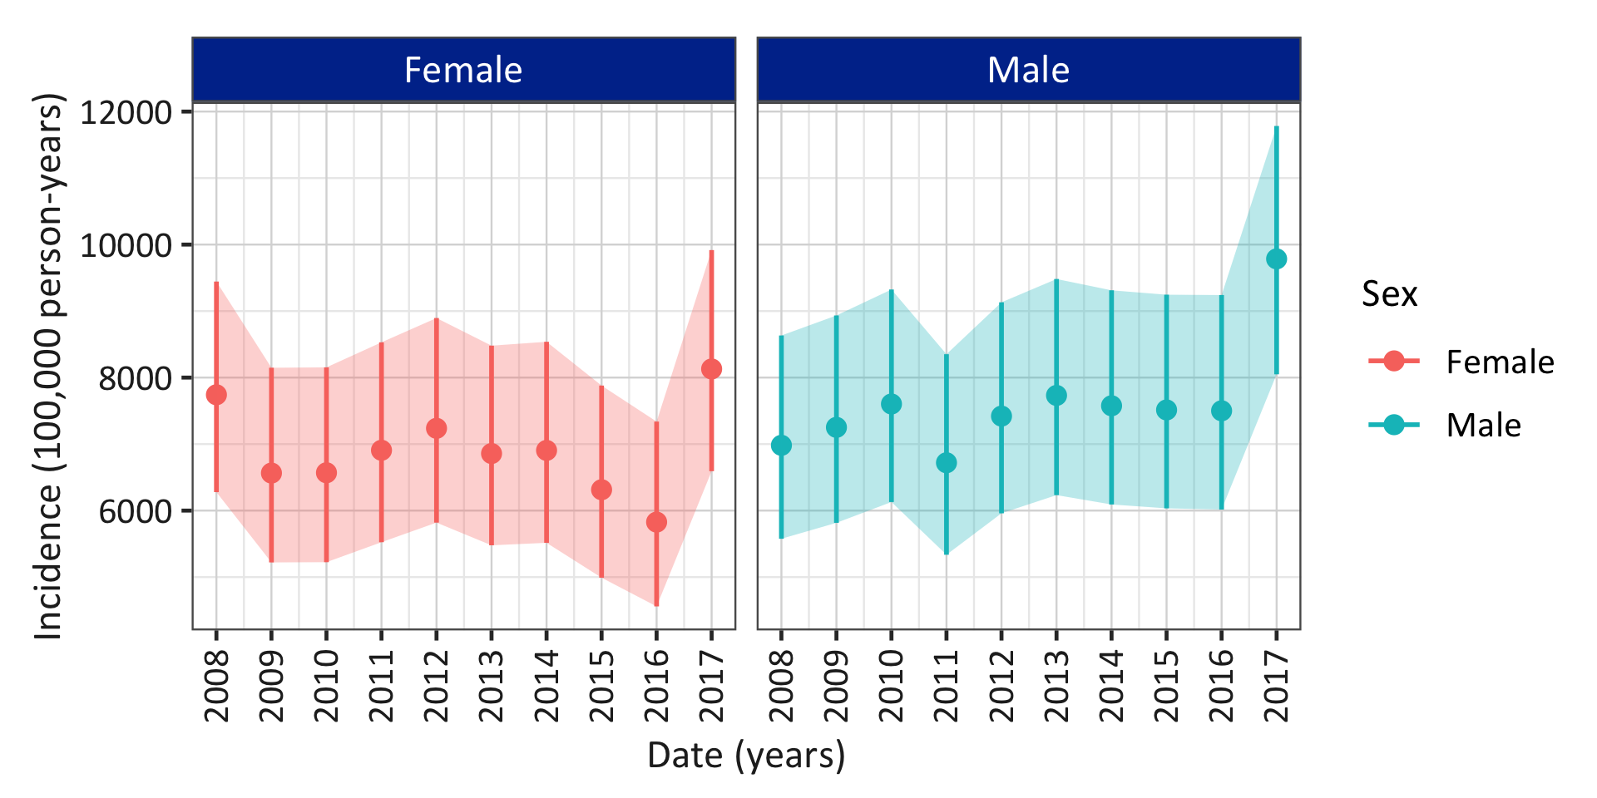

Table 2. Measurement value change after intervention.
Variable | Estimate | Sex
Variable | Estimate | Overall | Male | Female
Value before | Median [Q25 – Q75] | 60.00 [55.00 – 77.25] | 65.00 [61.00 – 80.00] | 53.00 [48.00 – 59.00]
Value before | Range | 24.00 to 117.00] | 30.00 to 120.00] | 20.00 to 100.00]
Value after | Median [Q25 – Q75] | 58.00 [55.00 – 72.00] | 66.00 [62.00 – 79.00] | 50.00 [47.00 – 60.00]
Value after | Range | 22.00 to 108.00] | 33.00 to 117.00] | 19.00 to 100.00]
Change in value | Median [Q25 – Q75] | -2.00 [0.00 – -5.25] | 1.00 [1.00 – -1.00] | -3.00 [-1.00 – 1.00]
Change in value | Range | -2.00 to -9.00] | 3.00 to -3.00] | -1.00 to 0.00]

Figure 3. Measurement value change after intervention.
