DARWIN-EU PX-CY-Z: Tables and Figures

**Table 1:** Baseline population characteristics.

| **Variable name** | **Variable level** | **Estimate name** | **Sex** | | |
| --- | --- | --- | --- | --- | --- |
| **overall** | **Male** | **Female** |
| Number records | - | N | 695 | 367 | 328 |
| Number subjects | - | N | 695 | 367 | 328 |
| Age | - | Median [Q25 - Q75] | 48 [27 - 70] | 48 [26 - 70] | 48 [30 - 69] |
|  |  | Mean (SD) | 48.18 (23.70) | 47.71 (24.38) | 48.71 (22.94) |
|  |  | Range | 8 to 89 | 8 to 89 | 8 to 87 |
| Days in cohort | - | Median [Q25 - Q75] | 1,363 [626 - 2,384] | 1,372 [612 - 2,430] | 1,345 [672 - 2,314] |
|  |  | Mean (SD) | 1,539.52 (1,037.62) | 1,542.46 (1,069.29) | 1,536.23 (1,002.61) |
|  |  | Range | 3 to 3,654 | 20 to 3,654 | 3 to 3,654 |
| Prior observation | - | Median [Q25 - Q75] | 899 [180 - 1,824] | 822 [180 - 1,756] | 954 [180 - 1,999] |
|  |  | Mean (SD) | 1,175.99 (1,048.06) | 1,119.05 (1,000.68) | 1,239.70 (1,096.68) |
|  |  | Range | 180 to 4,226 | 180 to 4,029 | 180 to 4,226 |
| Future observation | - | Median [Q25 - Q75] | 1,362 [626 - 2,383] | 1,371 [611 - 2,428] | 1,344 [672 - 2,314] |
|  |  | Mean (SD) | 1,574.23 (1,098.10) | 1,584.04 (1,139.58) | 1,563.25 (1,051.37) |
|  |  | Range | 2 to 4,092 | 19 to 4,092 | 2 to 3,811 |
| Cohort start date | - | Median [Q25 - Q75] | 2008-01-01 [2008-01-01 - 2008-07-14] | 2008-01-01 [2008-01-01 - 2008-05-23] | 2008-01-01 [2008-01-01 - 2008-08-13] |
|  |  | Range | 2008-01-01 to 2010-06-24 | 2008-01-01 to 2010-06-24 | 2008-01-01 to 2010-06-22 |
| Cohort end date | - | Median [Q25 - Q75] | 2012-02-11 [2010-03-06 - 2015-01-20] | 2012-02-06 [2010-01-19 - 2015-03-22] | 2012-03-20 [2010-04-08 - 2015-01-16] |
|  |  | Range | 2008-01-03 to 2018-01-01 | 2008-01-20 to 2018-01-01 | 2008-01-03 to 2018-01-01 |
| Comedications | Opioids | N (%) | 51 (7.34%) | 28 (7.63%) | 23 (7.01%) |
|  | Antidiabetes | N (%) | 29 (4.17%) | 18 (4.90%) | 11 (3.35%) |
| Comorbidities | Asthma | N (%) | 39 (5.61%) | 24 (6.54%) | 15 (4.57%) |
|  | Depression | N (%) | 95 (13.67%) | 52 (14.17%) | 43 (13.11%) |
|  | HIV | N (%) | 22 (3.17%) | 12 (3.27%) | 10 (3.05%) |

HIV: Human Immunodeficiency Virus.

**Figure 1:** Number of records in cohorts.

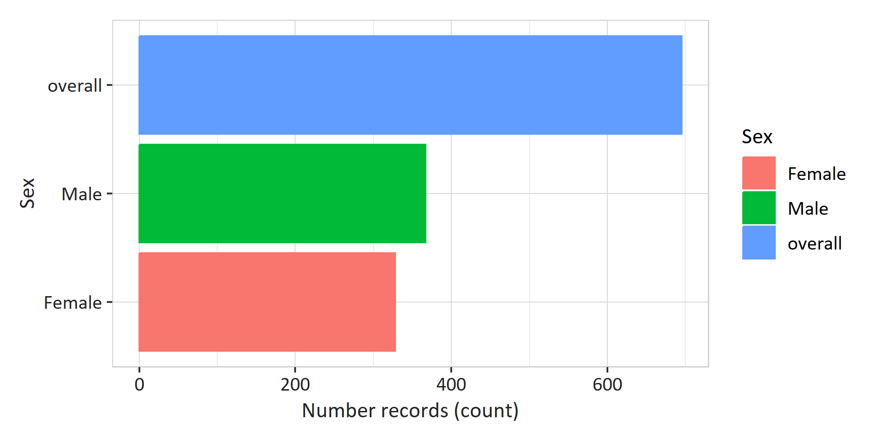

**Figure 2:** Incidence over time statified by sex.

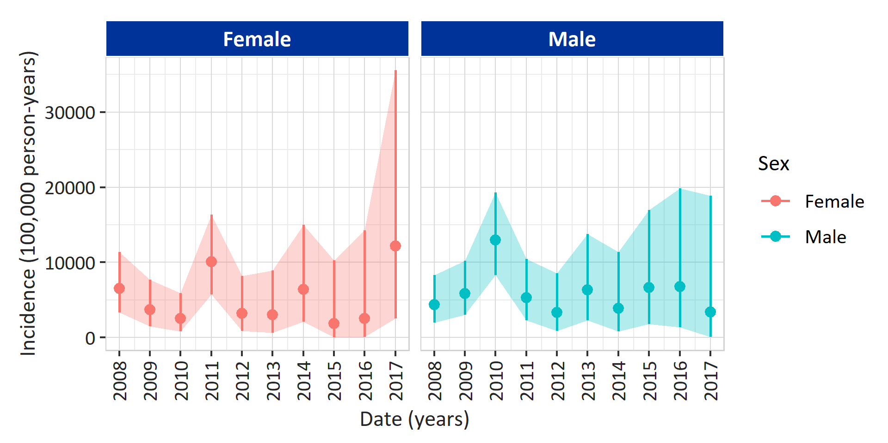

**Table 2:** Measurement value change after intervention.

| **Variable** | **Estimate** | **Sex** | | |
| --- | --- | --- | --- | --- |
| **Overall** | **Male** | **Female** |
| Value before | Median [Q25- Q75] | 60.00 [55.00, 77.25] | 65.00 [61.00, 80.00] | 53.00 [48.00, 59.00] |
|  | Range | 24.00 to 117.00] | 30.00 to 120.00] | 20.00 to 100.00] |
| Value after | Median [Q25- Q75] | 58.00 [55.00, 72.00] | 66.00 [62.00, 79.00] | 50.00 [47.00, 60.00] |
|  | Range | 22.00 to 108.00] | 33.00 to 117.00] | 19.00 to 100.00] |
| Change in value | Median [Q25- Q75] | -2.00 [0.00, -5.25] | 1.00 [1.00, -1.00] | -3.00 [-1.00, 1.00] |
|  | Range | -2.00 to -9.00] | 3.00 to -3.00] | -1.00 to 0.00] |

**Figure 3:** Measurement value change after intervention.

