Operating System (01CE1401)

Lab Manual 24-25

**Name: Vadgama Harsh D.**

**ER No.: 92410103123**

**Class: 4 EC5**

|  |  |  |  |
| --- | --- | --- | --- |
| **Lab** | **Program** | **Signature** | **Marks** |
| 1. | Demonstrate different commands of Linux (minimum 15 commands) |  |  |
| 2. | a) Write a shell script with basic commands like echo and read  b) Write a shell script to display addition of given two numbers |  |  |
| 3. | Write a shell script to display multiplication table of given number |  |  |
| 4. | Write a shell script to generate marksheet of a student. Take 3 subjects, calculate and display total marks, percentage and Class obtained by the student. |  |  |
| 5. | Write a shell script to check entered string is palindrome or not. |  |  |
| 6. | Write a shell script to find factorial of given number n. |  |  |
| 7. | Write a shell script which will accept a number b and display whether it is prime numbers or not. |  |  |
| 8. | Write a shell script which will generate first n Fibonacci numbers like: 1, 1, 2, 3, 5, 13, … |  |  |
| 9. | Write a menu driven shell script which will print the following menu and execute the given task.  a. Display calendar of current month  b. Display today’s date and time  c. Display usernames those are currently logged in the system  d. Display your name at given x, y position  e. Display your terminal number |  |  |
| 10. | Write a shell script to concatenate two strings |  |  |
| 11. | Write a shell script to read n numbers as command arguments and sort them in descending order. |  |  |
| 12. | Write a program using function, which convert each word in a given text into capital. |  |  |
| 13. | Write a shell script to display all Executable Files, Directories And Zero sized files from current directory |  |  |
| 14. | Write a Shell programming using filters (including grep, egrep, fgrep) |  |  |

Practical 1 : Demonstrate different commands of Linux (min. 15 commands).

Size : Times New Roman 14 (bold)

1. **ls**: Lists the files and directories in the current directory.
2. **cd**: Changes the current directory to a specified one.
3. **mkdir**: Creates a new directory with the given name.
4. **touch**: Creates an empty file or updates the timestamp of an existing file.
5. **cat**: Displays the contents of a file or concatenates files.

**ss1.png**

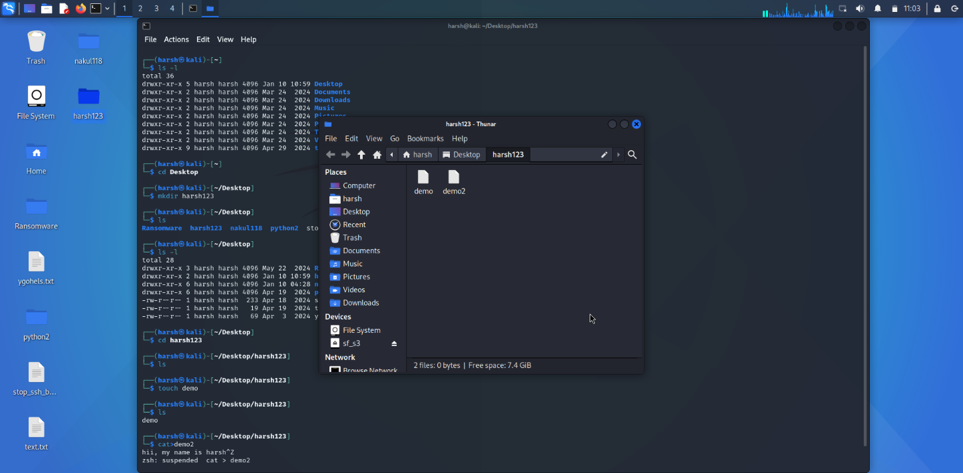

1. **ping**: Sends ICMP packets to check the connectivity to a network host.
2. **pwd**: Prints the current working directory path.
3. **ls -la**: Lists all files and directories, including hidden ones, in long format.

**ss2.png**

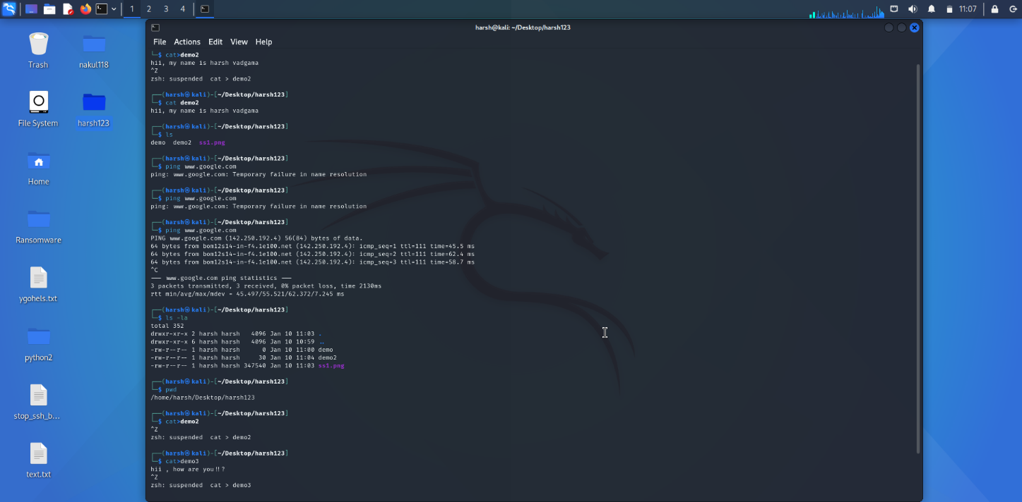

1. **cp**: Copies files or directories to a specified location.
2. **mv**: Moves or renames files or directories.

**ss3.png**

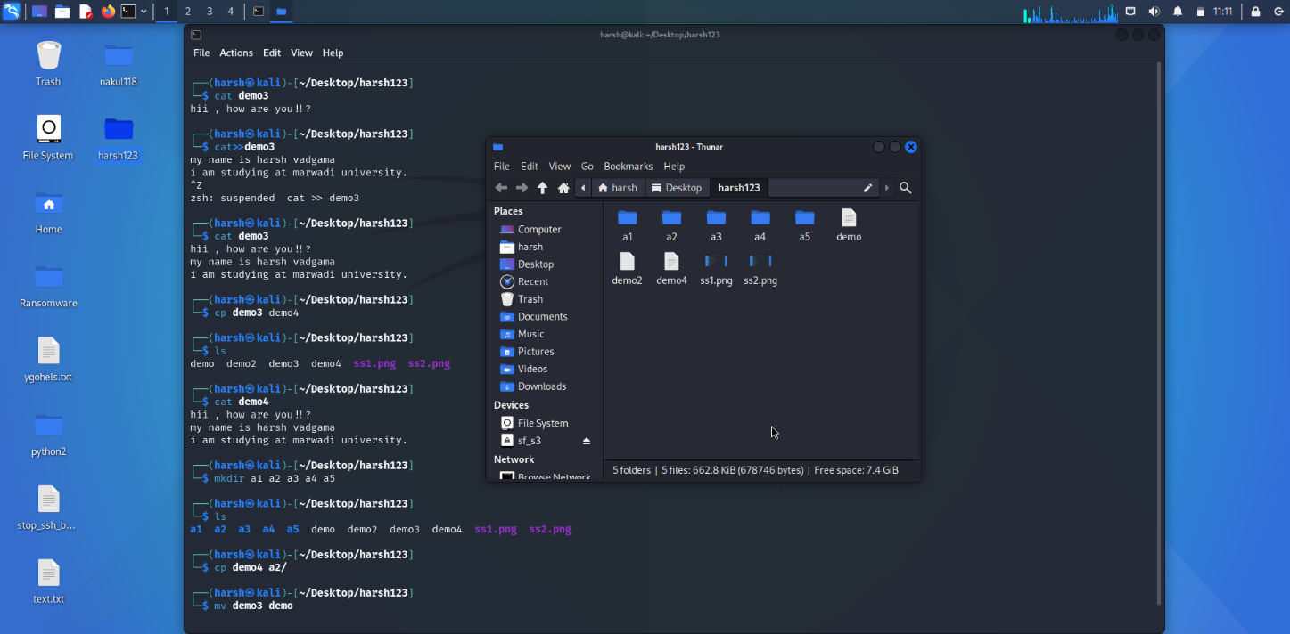

1. **rmdir**: Deletes an empty directory.
2. **hostname**: Displays or sets the system's hostname.
3. **zip**: Creates a compressed archive of files and directories in .zip format. Example: zip archive.zip file1 file2.
4. **unzip**: Extracts files from a .zip archive. Example: unzip archive.zip.
5. **sudo apt-get**: Installs, updates, or removes software packages on Debian-based systems.

**ss4.png**

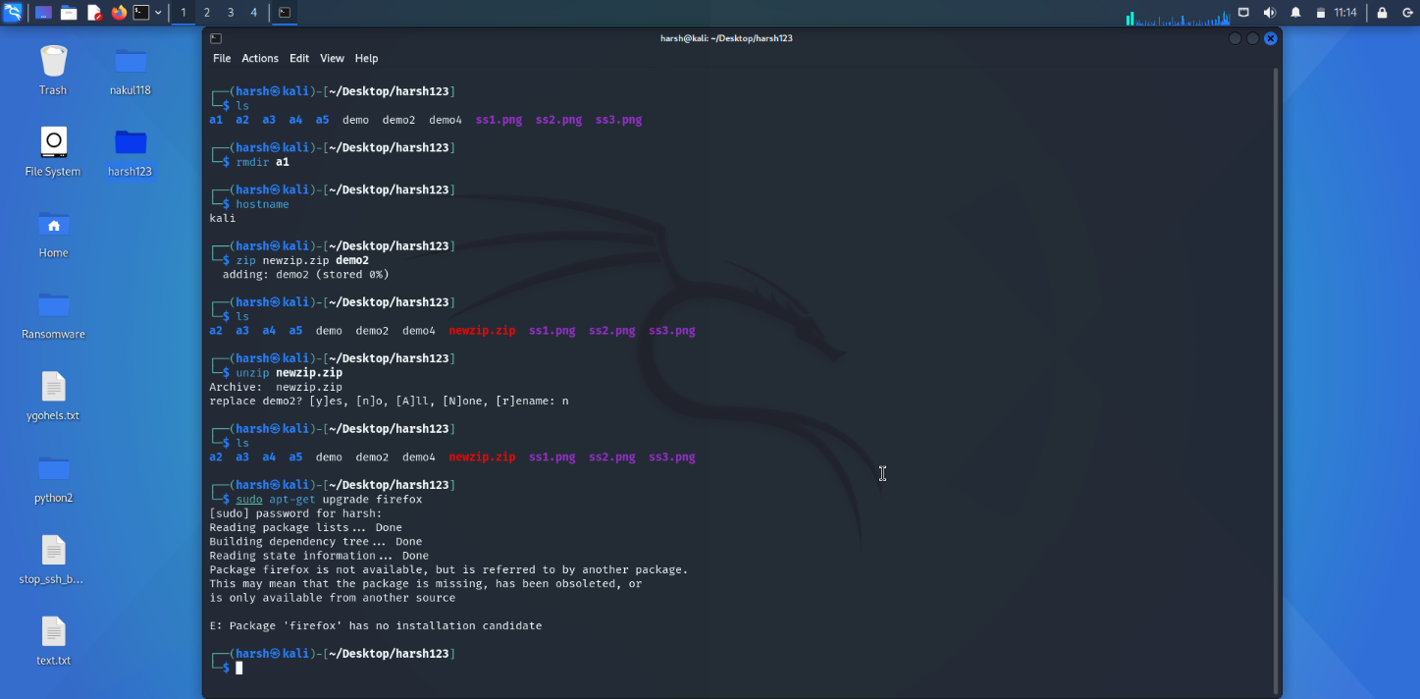

1. **passwd**: Changes the password of a user account.
2. **chmod**: Modifies file or directory permissions.

**ss5.png**

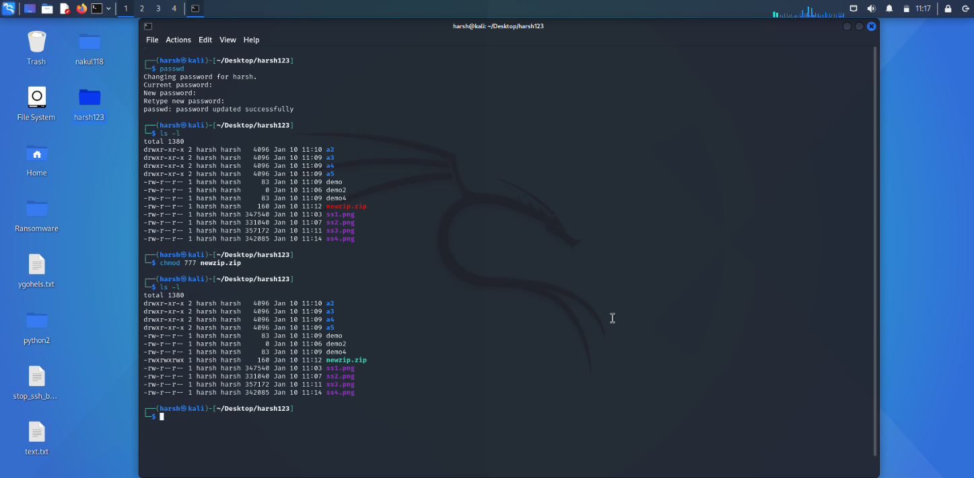

1. **su root**: Switches to the root user account (requires the root password).

**ss6.png**

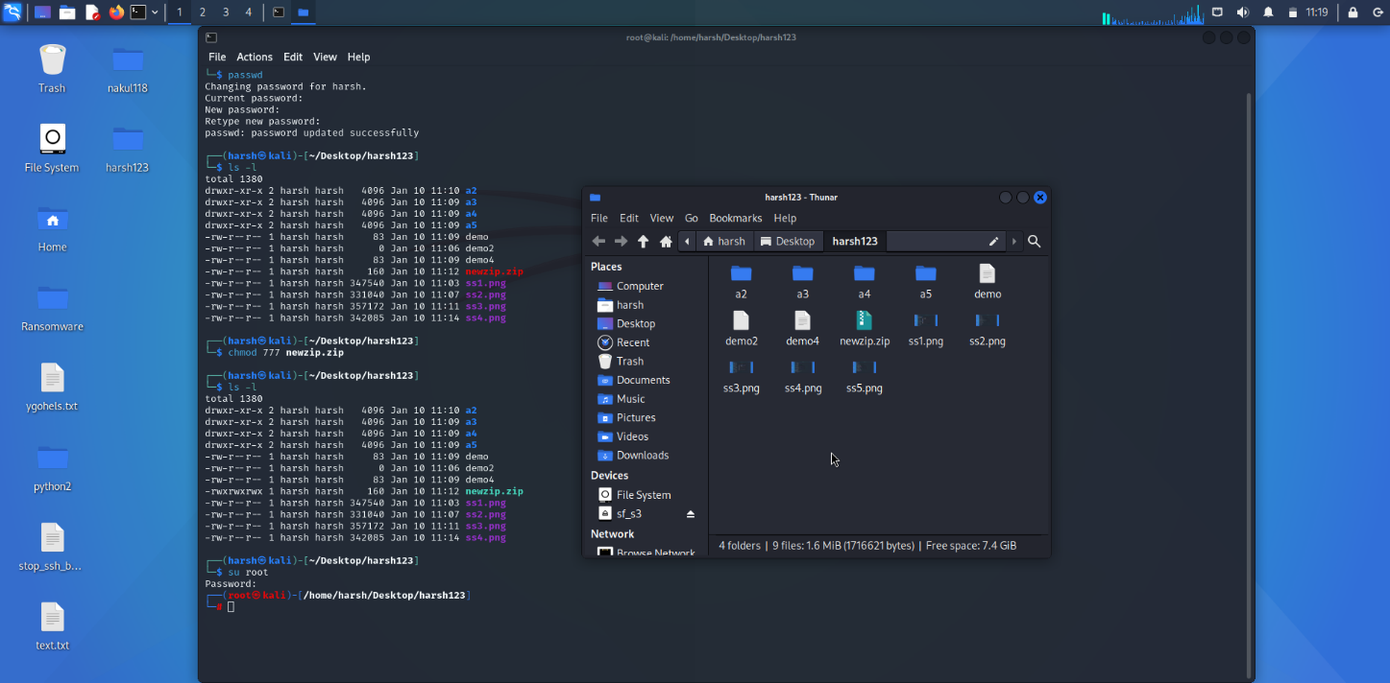

Practical 2 :

a)

echo "enter you name "

read name

echo "hello $name welcome to shell script"

Output :

enter you name

harsh

hello harsh welcome to shell script

pr2a.png

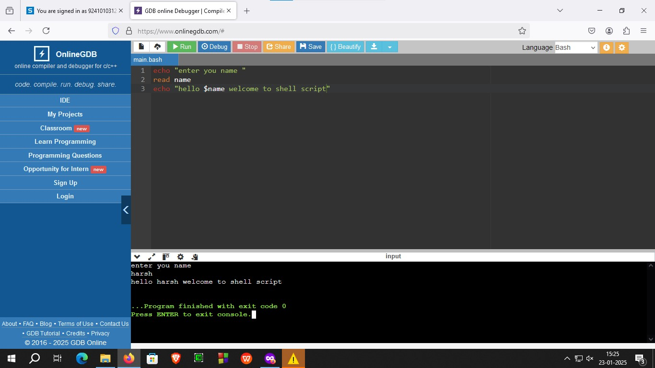

**b)**

echo "my name is harsh vadgama"

echo "my enrollment number is 92410103123"

echo "my class is EC5-C"

echo "enter number 1 : "

read no1

echo "enter number 2 : "

read no2

sum=$((no1+no2))

echo "result: $sum"

Output:

my enrollment number is 92410103123

my class is EC5-C

enter number 1 :

12

enter number 2 :

12

result: 24

pr2b.png

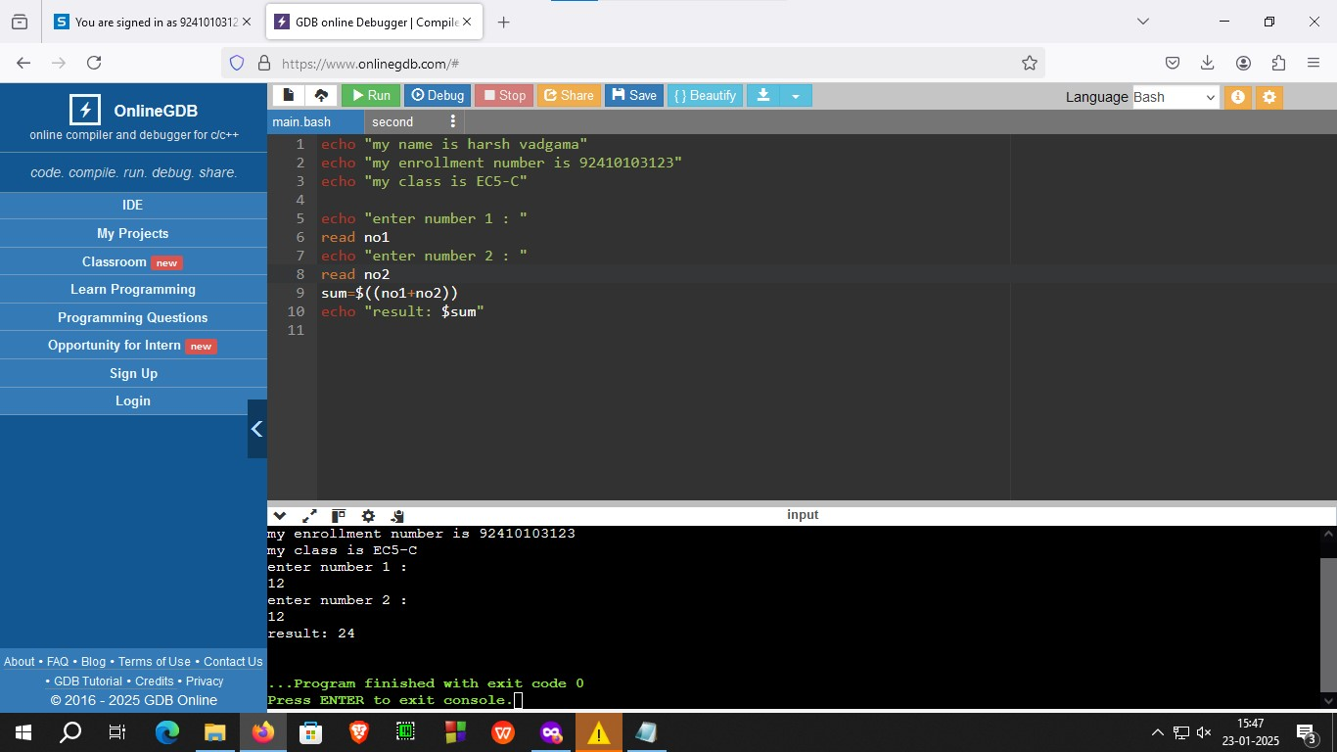

Practical 3 :

echo "My name is Harsh Vadgama"

echo "My enrollment number is 92410103123"

echo "My class is EC5-C"

echo "Enter a number to display its multiplication table:"

read n

if ! [[ "$n" =~ ^[0-9]+$ ]]; then

echo "Invalid input!!"

exit 1

fi

echo "Multiplication table for $n:"

for ((i = 1; i <= 10; i++)); do

echo "$n x $i = $((n * i))"

done

Output:

My name is Harsh Vadgama

My enrollment number is 92410103123

My class is EC5-C

Enter a number to display its multiplication table:

5

Multiplication table for 5:

5 x 1 = 5

5 x 2 = 10

5 x 3 = 15

5 x 4 = 20

5 x 5 = 25

5 x 6 = 30

5 x 7 = 35

5 x 8 = 40

5 x 9 = 45

5 x 10 = 50

pr3.png

