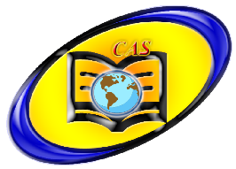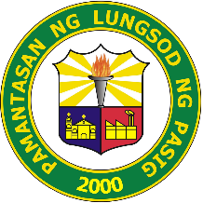**PAMANTASAN NG LUNGSOD NG PASIG**

**College of Arts and Sciences**

**MISSION**

College of Arts and Sciences (CAS) commits itself to create a relevant, supportive and collaborative academic environment that helps mold and nurture PLPians with the university's core values and prepares them to face the challenges of the 21st century.

**VISION**

We envision PLPians to be excellent in both academic and non-academic endeavors towards value-oriented and responsible Pasigueños.

**OBJECTIVES**

* To equip students with the basic skills and perspectives and advanced knowledge in their chosen vocation.
* To Provide Specialized courses that serve the baccalaureate degree program of the college and its coordinating colleges.
* To provide students value-oriented and community based global education; educate them for responsible participation in the community and in the country.
* To encourage scientific attitude and research culture that facilitates research development, innovations and procedures in various disciplines.