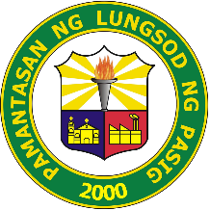**PAMANTASAN NG LUNGSOD NG PASIG**

**College of Business and Accountancy**

**MISSION**

To promote holistic well-being of its endeavors through the relevant and sustainable programs that adroitly addressing the needs of the students. The student council must engage the university stakeholders to the society to endow knowledge and skills that must resort to heightening students’ commitment to the country and to realization of the students’ potential. To represent the interest of the entire student body and should protect and defend the students’ rights.

**VISION**

A world class Supreme Student Council envisions itself to create harmonious relationships among its endeavors; To ensure and enhance the collaboration and communication in internal and external exchange in order to build an atmosphere of unity; To propagate cognizance of the state of the university that will stand as resource of development and transformation; And to be an agent of stable and progressive country.