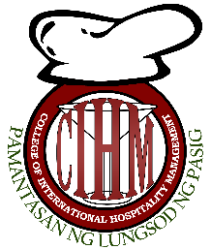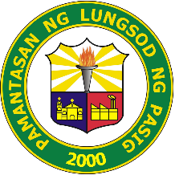**PAMANTASAN NG LUNGSOD NG PASIG**

**College of International Hospitality Management**

**MISSION**

To produce God-fearing, competent, educated and well-disciplined future Professionals of the Hospitality Industry through the collaborative efforts of stakeholders concerned by providing competency based learning and industry training.

**VISION**

A vessel of sturdy institution that will develop competitive, socially responsible professionals in a globally competitive environment of a fast changing Hospitality Industry through academic, social and moral foundation of learning that could help build a strong community and a greater nation.