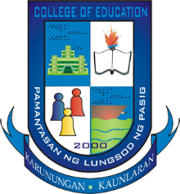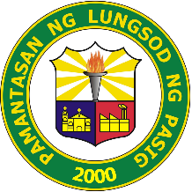**PAMANTASAN NG LUNGSOD NG PASIG**

**College of Education**

**MISSION**

To prepare future teachers who are imbued with the ideals, aspirations and traditions of Philippine life and sufficiently equipped with pedagogical knowledge and skill to be globally competitive through relevant education and research, provisions for the mastery of general education subjects, integration of theory and practice, intensification of professional subjects, provision for community exposure and total immersion in practice teaching.

**VISION**

The Pamantasan ng Lungsod ng Pasig College of Education envisions itself to be truly educative and value oriented community dedicated to teaching, research and community service to the future teachers who are academically competent, responsible, changing society and the challenges of global competitiveness.