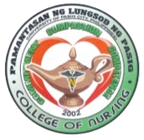**PAMANTASAN NG LUNGSOD NG PASIG**

**College of International Hospitality Management**

**MISSION**

To develop globally competitive Professional Nurses who can integrate within themselves the essential foundations of the scientific, cultural, religious and liberal perspectives of the nursing profession, show evidence of committed leadership in the health situation of the local community where they live, and continue to grow personally and professionally in graduate study and research.

**VISION**

Pamantasan ng Lungsod ng Pasig College of Nursing envisions to be a leading center of excellence and developmentin nursing education among local Colleges and Universities.