1. I want you to provide me with the Python program and I will run it myself by changing the search criteria below, and I want the program to genrete CSV file
2. I want to search on People in seach from twitter for any one who has a specific word in his twitter name

Example (الكابتن)

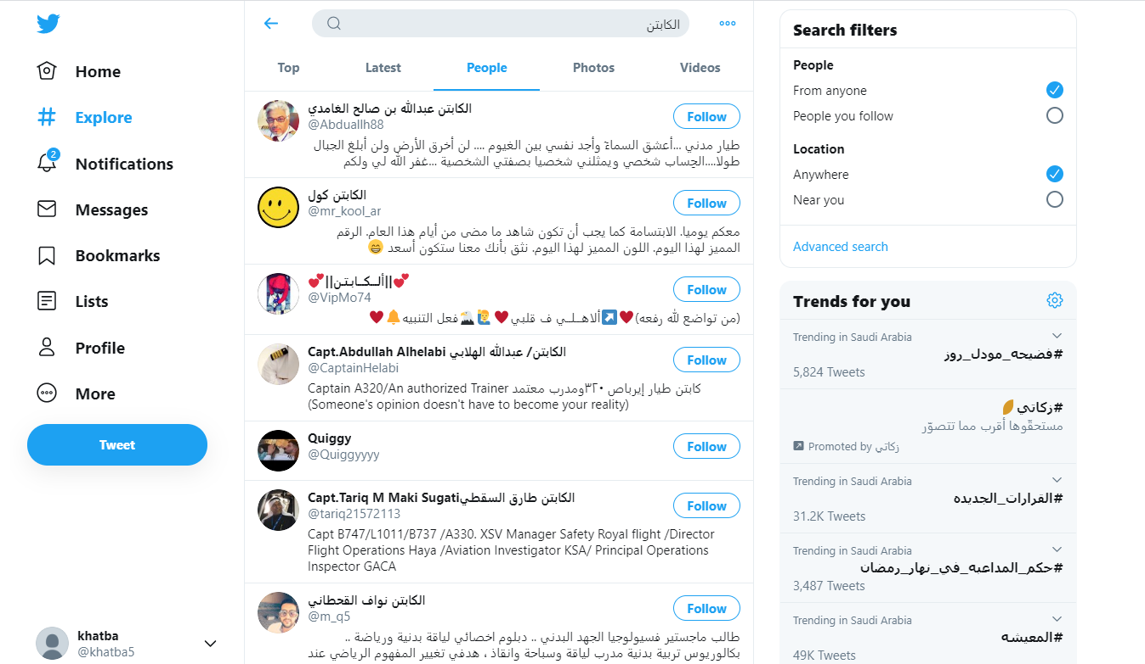

1. Then to go to each and every user and click on his page and extract three things:
2. Screenname
3. Username (which is always @text)
4. Bio text (including any html tags)

