Executive Linear Regression Report
Sales Drivers - Aplazaloh Campaign
Analysis level: supervisor - day - campaign

Main finding
Sales are mainly explained by effective talk time. The final model indicates that each additional hour of TALK_TIME_HOURS is associated with +4.75 expected sales, while each additional hour of ACW_HOURS is associated with -4.06 expected sales. The simple model preserves almost the same explanatory power as the full model, making it the most actionable version for management.

Final model | Adjusted R² | AIC | BIC
Simple time model | 0.937160 | 252.790783 | 258.644514
Conclusion: using only two variables, the model explains approximately 93.7% of the observed variation in sales.

1. What was analyzed
The analysis started from an operational dataset with 6,138 records. To avoid duplication and create a management-ready analytical unit, the information was first consolidated at advisor-day level and then at supervisor-day-campaign level. The final modeling dataset contained 52 observations, where each row represented the aggregated performance of one supervisor on one date and campaign.
Stage | Analytical unit | Rows
Original dataset | Operational record | 6,138
Advisor-day dataset | DATE + DNI + SUPERVISOR + CAMPAIGN | 698
Supervisor-day dataset | DATE + SUPERVISOR + CAMPAIGN | 52
The target variable was Q_VENTAS, translated here as SALES_QUANTITY. The explanatory variables were grouped into three families: operational volume, operational time usage, and efficiency/productivity. The objective was not to build the most complex model, but to identify which factor most clearly explained sales variation during the observed period.

2. How the finding was obtained
Alternative models were compared to identify which block of variables explained sales better. The evidence shows that the time-based model outperformed the volume model and the efficiency model. After that, a full time model was compared against a simplified two-variable model.
Model | Variables | R² | Adjusted R² | Interpretation
Full time model | 7 | 0.946136 | 0.937566 | Highest fit, more variables
Simple time model | 2 | 0.939624 | 0.937160 | Recommended final model
Efficiency model | 13 | 0.916257 | 0.887608 | Useful, less efficient
Volume model | 5 | 0.840356 | 0.823004 | Lower explanatory power
The simple model was selected because it maintains almost the same adjusted R-squared as the full model while achieving lower AIC and BIC values. This means it explains nearly the same sales variation with less complexity. For management use, that is a practical advantage: the message is clearer and the recommendation is easier to act on.
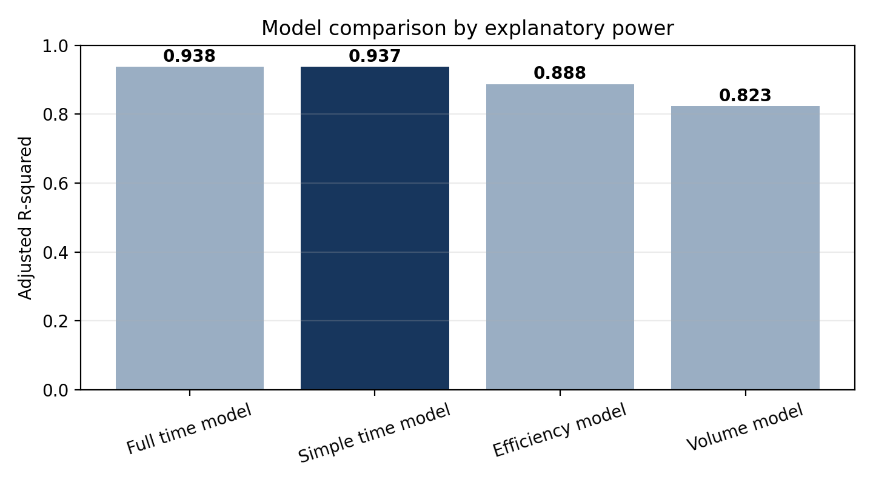
Chart 1. The time-based model has the strongest explanatory power. The simple model preserves almost the same adjusted R-squared as the full version.

3. Main finding: talk time is the dominant driver
The standardized impact ranking allows variables to be compared on the same scale. This ranking shows that TALK_TIME_HOURS is, by a wide margin, the variable with the strongest relative impact within the time-based model. In practical terms, changes in talk time are more strongly associated with changes in sales than changes in the other evaluated variables.
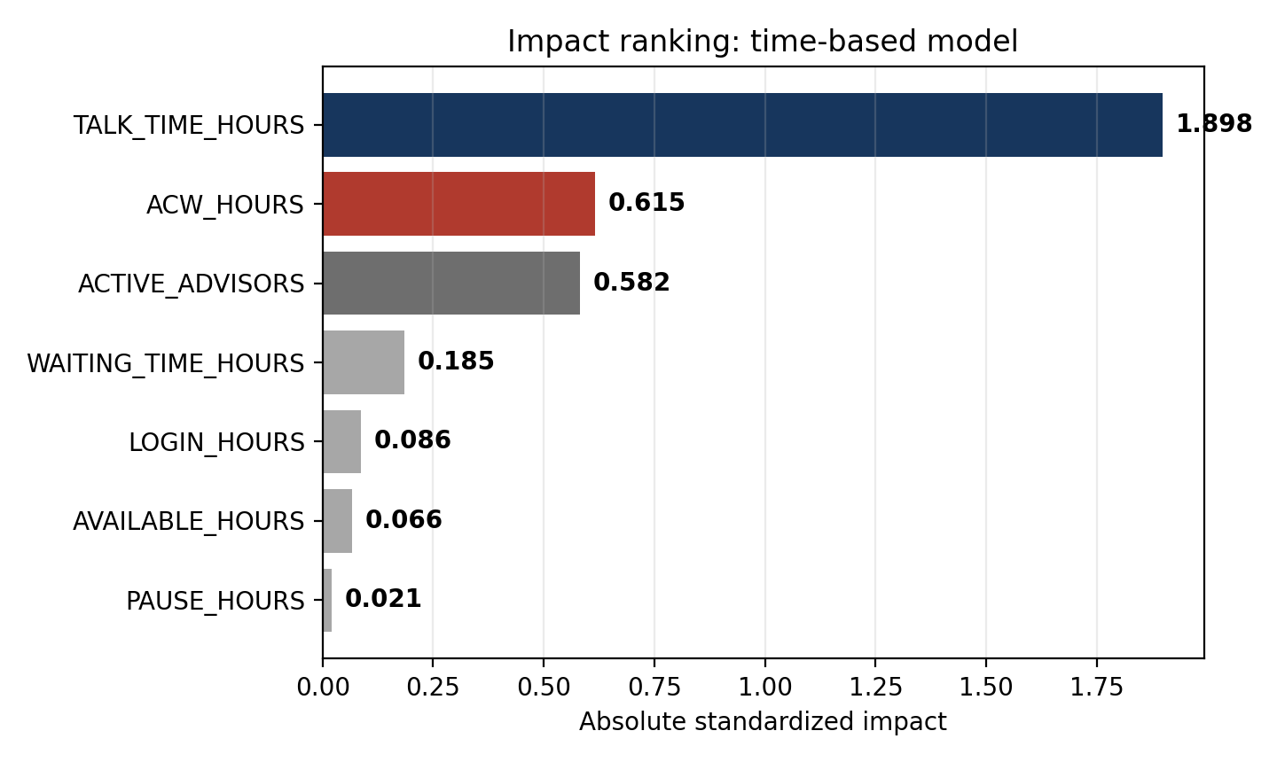
Chart 2. TALK_TIME_HOURS has the highest standardized impact. ACW_HOURS is the second relevant variable, but with a negative effect.
The business interpretation is direct: sales are not mainly explained by being logged in, pause time, waiting time, or availability. They are explained by effective commercial conversation time. Talk time acts as the strongest indicator of productive sales activity.
Operational conclusion
The team sells more when the workday is converted into effective customer conversations. Login time alone is not enough; the critical resource is productive talk time.

4. Final model equation
The final model uses two variables: TALK_TIME_HOURS and ACW_HOURS. Its mathematical form comes from multiple linear regression. It is an extension of the simple straight-line equation y = mx + b, but with two explanatory variables instead of one.
SALES_QUANTITY = -0.329279 + 4.749583*TALK_TIME_HOURS - 4.062390*ACW_HOURS
Parameter interpretation:
Parameter | Value | What it represents | Business reading
Intercept | -0.329279 | Mathematical baseline of the model | Limited standalone operational interpretation
b1 | 4.749583 | Coefficient of TALK_TIME_HOURS | Each additional talk hour is associated with +4.75 expected sales
b2 | -4.062390 | Coefficient of ACW_HOURS | Each additional ACW hour is associated with -4.06 expected sales
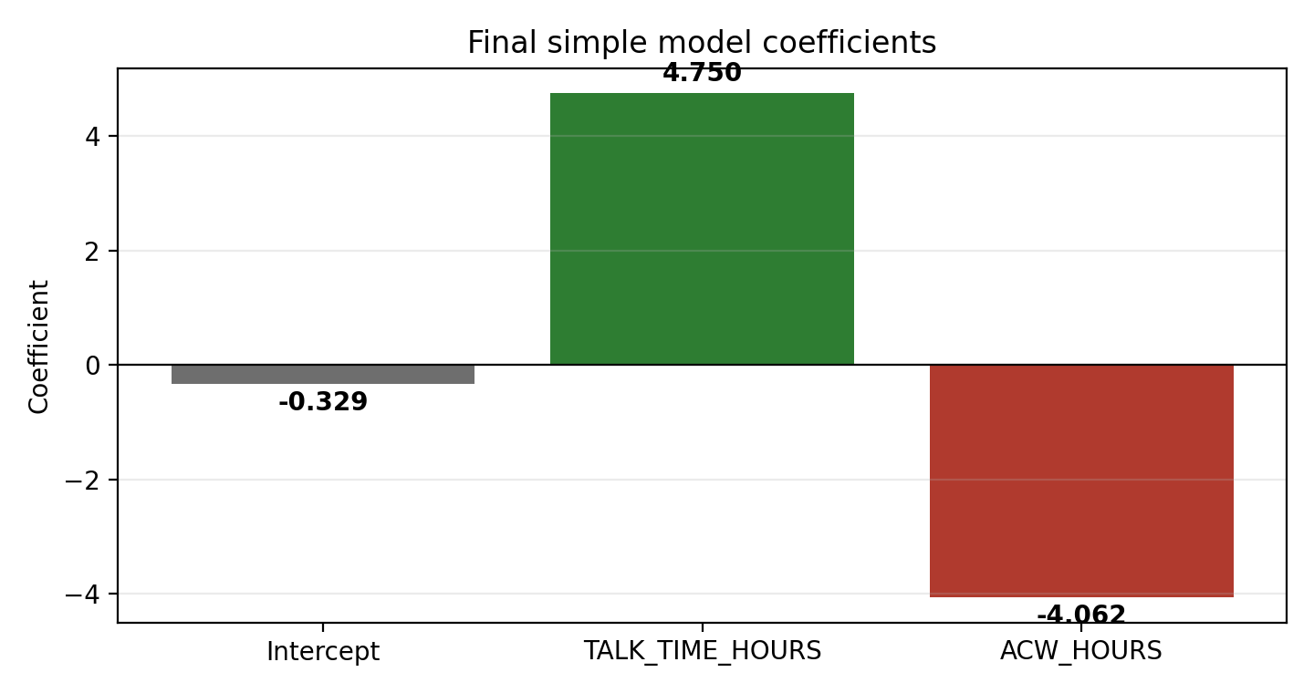
Chart 3. The final model coefficients quantify the expected effect of one additional hour in each variable.

5. Applied example using the equation
Assume a supervisor-day with 10 talk hours and 1.5 ACW hours. Using the final equation:
Step | Calculation
Input values | TALK_TIME_HOURS = 10; ACW_HOURS = 1.5
Substitution | SALES_QUANTITY = -0.329279 + 4.749583*(10) - 4.062390*(1.5)
Result | SALES_QUANTITY = 41.07 estimated sales
If talk time increases by 1 hour | 41.07 + 4.75 = 45.82 estimated sales
If ACW increases by 1 hour | 41.07 - 4.06 = 37.01 estimated sales
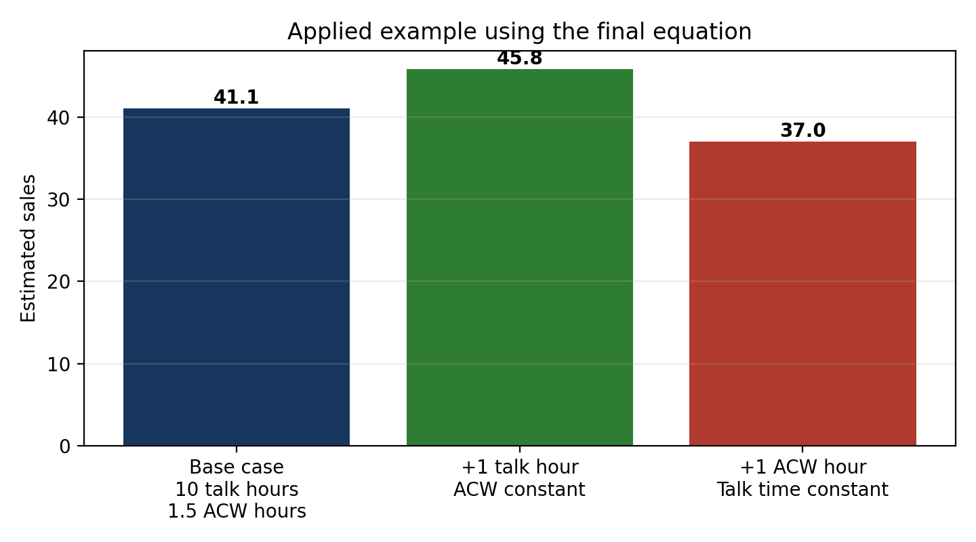
Chart 4. Simulation using the final equation: one additional talk hour increases expected sales; one additional ACW hour reduces expected sales.

6. What this means for management
- The main operational objective should be to maximize effective talk time, not only connection time or raw call activity. The model shows that talk time concentrates the strongest signal associated with sales.
- ACW should be managed as an operational friction. It should not be eliminated when required for proper closing or registration, but it should be controlled when it consumes commercial capacity unnecessarily.
- The simple model is suitable for management because it turns the analysis into a clear rule: more effective conversation time increases expected sales; more post-call administrative time reduces them.

7. Final conclusions
- The selected final model is the simple time model, composed of TALK_TIME_HOURS and ACW_HOURS.
- The model explains approximately 93.7% of the observed variation in SALES_QUANTITY at supervisor-day-campaign level.
- TALK_TIME_HOURS is the main positive driver: each additional talk hour is associated with +4.75 expected sales.
- ACW_HOURS is the main operational friction identified: each additional ACW hour is associated with -4.06 expected sales.
- The management recommendation is to prioritize productive talk time and reduce unnecessary ACW without compromising the quality of commercial registration.
Final executive message
Sales are mainly explained by the ability to turn the workday into effective customer conversations. Talk time is the visible sales engine; ACW is the operational friction that must be controlled.

