- STUDENT–TEACHER–SUBJECT–CODE:
AIM
To write a Prolog program to create a database containing Student, Teacher, Subject, and Subject Code and retrieve the required information using queries.
OBJECTIVE
- To create a Prolog database using facts.
- To store student, teacher, subject, and code details.
- To retrieve information using Prolog queries.
- To understand database searching in Prolog.
ALGORITHM
- Start.
- Define the predicate student_teacher(Student, Teacher, Subject, Code).
- Store student, teacher, subject, and code details as facts.
- Enter a query to search the database.
- Match the given information with the stored facts.
- Display the matching result.
- Stop.
FLOWCHART:
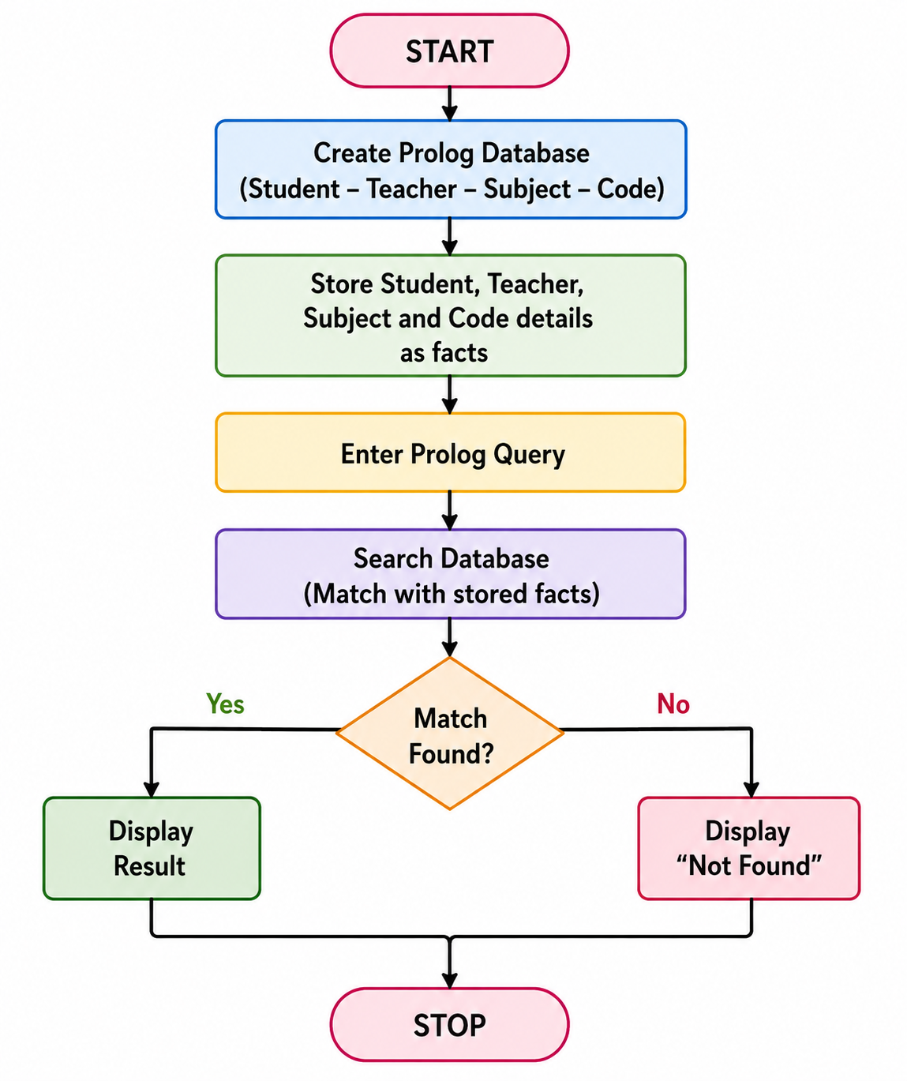

CODE:
student_teacher(bhavya, ramesh, ai, cs101).
student_teacher(rahul, priya, dbms, cs102).
student_teacher(anitha, kumar, os, cs103).
student_teacher(akash, ramesh, dsa, cs104).
student_teacher(priya, kumar, java, cs105).
OUTPUT:
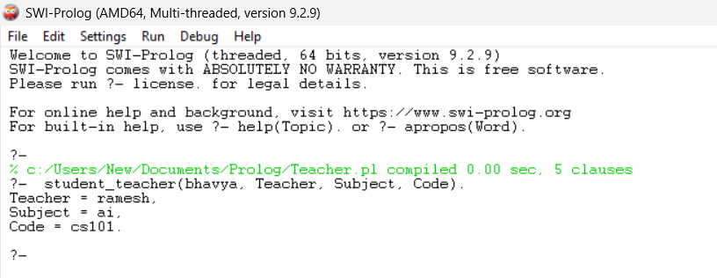
RESULT:
Thus, the Prolog program for the Student–Teacher–Subject–Code database was successfully implemented, and the required information was retrieved using Prolog queries.

