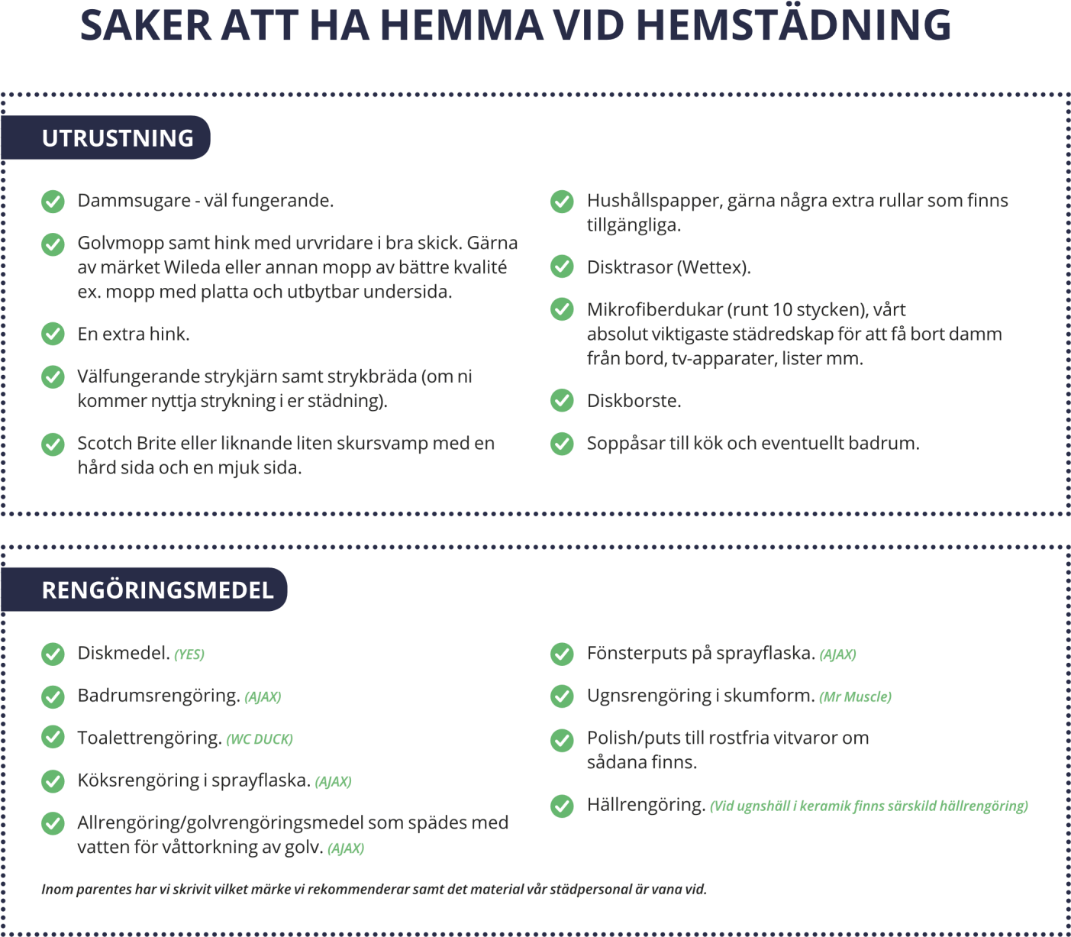



INCA STÄD

Karlslundsgatan 30, 151 63, Södertälje

[www.incastad.hol.e](http://www.incastad.hol.es/)

info@incastad.hol.es



[s](http://www.incastad.hol.es/)

