A New Polkadot Product Capability: Your Phone as the Backend
An app distributed by a blockchain. A smartphone providing verifiable computation. A smart contract acting as the judge.
A small game called Rainbow demonstrates how the three pieces work together.
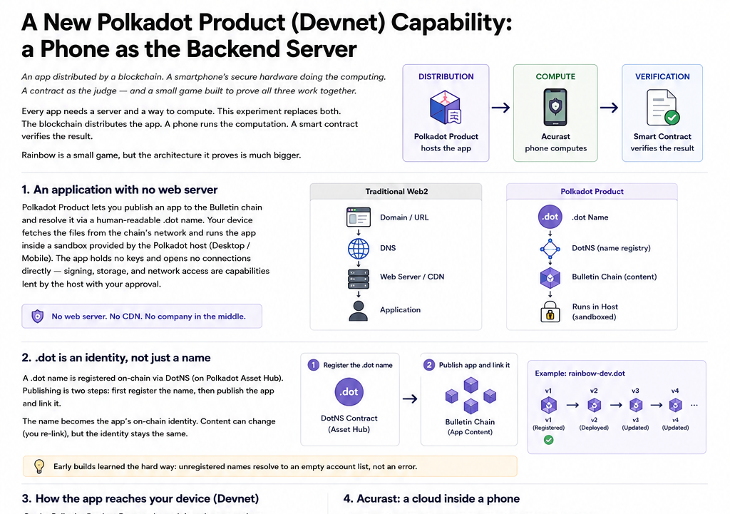
Figure 1 — The architecture in one view: distribution, computation, and verification.

The idea
Every application needs somewhere to live and somewhere to compute.
Traditionally, that means servers: a company hosts the application, operates the infrastructure, and performs the computation. Users trust that infrastructure because there has rarely been another practical option.
Two pieces of infrastructure change that model:
- Polkadot Product lets applications be published to and distributed from a blockchain rather than a conventional web server.
- Acurast provides decentralized compute using smartphones, with secure hardware and attestation allowing computation to be verified.
The blockchain distributes the application. A phone performs the computation. A smart contract verifies the result.
Rainbow is a small demonstration of that architecture.

1. An application with no web server
A Polkadot Product is an application whose files are published onto the Bulletin chain and resolved through a human-readable .dot name.
Instead of:
Domain → DNS → Web server → Application
the path becomes:
.dot name → DotNS → content hash → Bulletin chain → application
The user's device retrieves the application from the chain's network and executes it inside a sandbox. There is no conventional web server or CDN serving the application.

The host is part of the security model
Products do not operate as unrestricted web pages. The application itself does not hold wallet keys or establish direct blockchain connections. Instead, those capabilities are provided by the host application — Polkadot Desktop or the mobile Polkadot applications — and exposed according to the user's permissions.
Product requests capabilities. Host controls capabilities. User approves them.
Signing, storage, notifications, camera access and networking can therefore be treated as explicit capabilities rather than privileges automatically granted to the application.

2. .dot is an identity, not just a name
A .dot name is registered through DotNS, which operates through a smart contract on Polkadot's Asset Hub.
Publishing a Product happens in two stages:
- Register the .dot name.
- Publish the application and associate its content with that name.
For example: rainbow-dev.dot
The name remains the application's on-chain identity while its content can be updated by linking it to a new published version.
The registered name also participates in the application's account identity. The host derives an account for the Product and user combination, which is useful for applications such as leaderboards.

3. The Polkadot Product Devnet
The Polkadot Product Devnet provides the components required to test the complete publishing flow: a name registry, a Bulletin chain for application content, an Asset Hub for contracts, and development resources.
The important property is that the entire path is real. A name resolves to real content, the content is retrieved from the chain, the host loads it, and the application interacts with contracts.
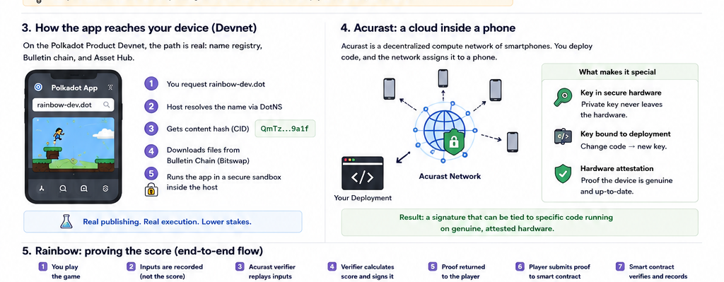
Figure 2 — From .dot resolution and chain-hosted content to an Acurast processor.
One practical lesson from development is that the Devnet environment is its own ecosystem. Its Bulletin chain is separate from other environments such as Paseo. Pointing a Product at the wrong chain may not produce an obvious error; the expected content simply will not be there.
Real publishing and real execution, without production stakes.

4. The browser is part of the infrastructure
If there is no web server, what opens the application? The answer is the Polkadot host.
Polkadot Desktop and the mobile applications can be understood as specialized browsers for blockchain-hosted applications.
Traditional web | Polkadot Product
URL | .dot name
DNS | DotNS
Web server/CDN | Bulletin chain
Browser | Polkadot host
Website permissions | Product capabilities
Wallet integration | Host-controlled signing

5. A cloud inside a phone
Removing the application server solves only half of the problem. A browser is still an untrusted environment: the user controls the device running it and therefore cannot be expected to honestly report the result of a computation performed locally.
Acurast is a decentralized compute network in which smartphones act as compute processors. A deployment can specify code and execution requirements, and the network can assign that workload to a participating device.
The crucial property is that the computation can produce verifiable evidence of what ran.
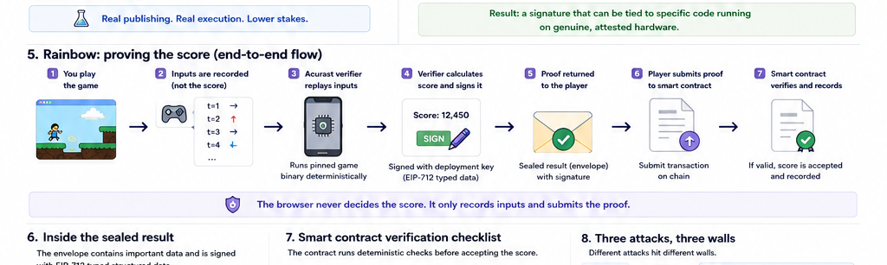
Figure 3 — Rainbow's end-to-end flow: play → record inputs → replay → sign → submit → verify.

6. Why the phone can be trusted
Acurast's architecture combines three security mechanisms.
The key is generated inside secure hardware. The processor's secure hardware generates a signing key internally. The private key does not need to be exposed to the application, the network operator, or the device owner.
The key is bound to the deployment. A deployment's key pair is associated with the code being executed. Change the deployment code and the associated identity changes.
The hardware can be attested. The device provides an attestation chain establishing that it is running on genuine supported hardware and software. This is remote attestation.
A valid result signature can be tied to specific code executing on genuine attested hardware.

7. Rainbow: a game designed to prove the architecture
Rainbow is deliberately simple. You play a platformer, finish a run, and receive a score.
The interesting part is that the browser does not determine the score. Instead, the browser records the player's actions and sends those inputs to an Acurast verifier. The verifier runs the game again.
The browser never decides the score. It only records inputs and submits the proof.

8. Making the game deterministic
The approach depends on one critical property: the same inputs must always produce the same output.
Rainbow uses fixed-point arithmetic to avoid cross-environment floating-point differences. The team tested the compiled module across multiple execution environments and compared the simulation tick by tick across many seeds.
That allows the browser to be treated as an untrusted client.

9. The browser never sends a score
- The input log is sent to the Acurast verifier.
- The verifier loads the pinned game binary.
- The verifier replays the inputs.
- The verifier calculates the score independently.
- The result is signed by the deployment's key.
- The signed result is returned to the client.
- The client submits the proof to the leaderboard contract.
The client can therefore lie about what score it achieved, but that lie is irrelevant. The contract never needs to trust the client's score.

10. Pinning the exact rules
The leaderboard contract stores a Keccak-256 fingerprint of the expected game binary. The verifier fingerprints the binary it actually loads. The fingerprints must match.
Did the player provide legitimate inputs? The verifier replays them. Did the verifier use the correct game? The binary fingerprints must match.

11. The sealed result
The verifier gives the result back to the player as a signed envelope. It contains information such as player identity, game identity, session, score, rules fingerprint, and expiration time.
The verifier signs the complete structure using EIP-712 typed structured data. The signature is bound to the intended contract and chain, preventing the proof from simply being replayed somewhere else.
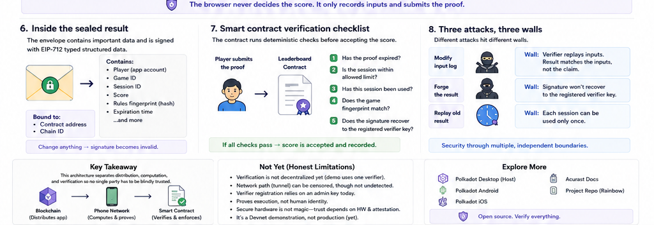
Figure 4 — The sealed result and the contract's verification boundaries.

12. The contract becomes the judge
When the wallet submits the proof, the leaderboard contract checks the result:
- Has the proof expired?
- Is the session within the allowed limit?
- Has this session already been used?
- Does the game fingerprint match?
- Does the signature recover to the registered verifier key?
If the checks pass, the contract accepts the score.

13. Three attacks, three different walls
Modify the input log. The verifier replays the modified inputs, so the resulting score is the score those inputs actually produce.
Forge the result. The contract verifies the signature. A forged signature does not recover to the registered verifier key.
Replay an old result. Each session can be consumed only once, so submitting the same proof again fails.

14. Why not zero-knowledge proofs?
Zero-knowledge proofs could, in principle, provide another way to prove that a computation was performed correctly. But proving a complex, continuously running game execution in zero knowledge can be computationally expensive.
Replaying the same deterministic computation inside attested hardware is considerably more practical for this type of workload.
Use secure hardware to execute and attest the computation, then use cryptographic signatures and a smart contract to verify the result.

15. The game is only the demonstration
Remove the platformer and the architecture remains.
A client records an activity. An independently operated phone deterministically re-executes it. Secure hardware ties the execution to the expected code. The result is signed. A smart contract verifies the signature.
The same pattern could apply to sensor readings, verifiable random draws, examination results, model inference, or other workloads where the client should not be trusted to report the result.

16. What has actually been demonstrated?
Polkadot Product — Decentralized application distribution.
Acurast — Decentralized, attestable computation.
Smart contract — Public verification and deterministic enforcement.
Blockchain-hosted application → untrusted client activity → attested smartphone computation → cryptographic proof → on-chain verification

17. What this does not prove yet
- Verification is not yet decentralized: the current demonstration uses a single verifier selected by the development team.
- The network path can still censor: a tunnel operator could delay or block communication, although it cannot silently modify an authenticated result.
- Verifier registration has an administrative trust point: the current contract uses an owner account to determine accepted verifier keys.
- It proves execution, not player identity: bots, automation and multiple accounts remain outside the demonstrated security model.
- Secure hardware is not magic: the trust model ultimately depends on the security of the underlying hardware, firmware and attestation infrastructure.
- It is still a Devnet proof-of-concept rather than a production deployment.

18. The bigger picture
The most interesting part of this experiment is not that a game can have a tamper-resistant leaderboard. It is that the traditional application stack can be split across decentralized infrastructure.
Blockchain distributes the application. The user device provides the interface. Acurast performs verifiable computation. The smart contract enforces the rules.
The result is a system in which distribution, computation and verification can each have independent trust boundaries.

19. Where to look next
Everything in the demonstration should ultimately be verifiable from the implementation, deployment records and supporting documentation.
Project repository: TODO: repo URL
Product host implementations include Polkadot Desktop, Polkadot Android, and Polkadot iOS.

References
1. Sabt, Achemlal, Bouabdallah — Trusted Execution Environment: What It Is, and What It Is Not, IEEE TrustCom 2015.
2. Killer, De Carli, Brun, Charlé, Godenzi, Wehrli — Acurast: Decentralized Serverless Cloud, arXiv:2503.15654 (v2, Jan 2026).
3. Acurast pallet documentation — submitAttestation / attestation certificate chains.
4. Coker, Guttman, Loscocco et al. — Principles of Remote Attestation, International Journal of Information Security, 2011.
5. Ménétrey et al. — Attestation Mechanisms for Trusted Execution Environments Demystified, DAIS 2022.
6. Bethea, Cochran, Reiter — Server-side Verification of Client Behavior in Online Games, NDSS 2010.
7. Park, Ahmad, Lee — BlackMirror: Preventing Wallhacks in 3D Online FPS Games, ACM CCS 2020.
8. EIP-712 — Typed structured data hashing and signing.
9. Johnson, Menezes, Vanstone — The Elliptic Curve Digital Signature Algorithm (ECDSA), IJIS 2001.
10. Certicom Research — SEC 2: Recommended Elliptic Curve Domain Parameters, 2010.
11. Walfish, Blumberg — Verifying computations without reexecuting them, Communications of the ACM, 2015.
12. Ben-Sasson, Chiesa, Tromer, Virza — Succinct Non-Interactive Zero Knowledge for a von Neumann Architecture, USENIX Security 2014.
13. Cerdeira, Santos, Fonseca, Pinto — SoK: Understanding the Prevailing Security Vulnerabilities in TrustZone-assisted TEE Systems, IEEE S&P 2020.
Additional background: Schneier & Kelsey on tamper-evident audit logs; Crosby & Wallach on tamper-evident logging; Android Key Attestation documentation; Acurast documentation.

