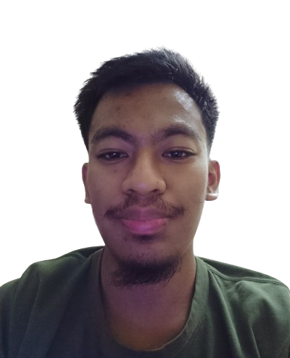
DARWISH BIN MAT ZAIN
17610 Kuala Balah, Kelantan
(+60)1154185178 | darwish.matzain1@gmail.com
LinkedIn | Github | Portfolio
I am a Bachelor of Computer Science student with a minor in Software Engineering at Universiti Malaysia Pahang Al-Sultan Abdullah (UMPSA), seeking an internship from 9 March 2026 to 21 August 2026. I aim to apply my technical skills, contribute effectively to team projects, and gain hands-on experience in a professional development environment. Highly motivated to learn, collaborate, and deliver value while supporting the success of projects.Computer Science (Software Engineering) undergraduate with hands-on experience in full-stack web development and desktop applications. Built and deployed community-focused web platforms and productivity tools using PHP, JavaScript, and Python. Seeking an internship (Mar–Aug 2026) to contribute to real-world software projects while strengthening professional development skills
PROJECTS
Jeli Tourism Website – Full-Stack Web Application (PHP,JS,HTML,MySQL)
- Designed and developed an end-to-end community tourism platform to centralize local attractions, articles and announcements for Jeli district.
- Implemented server-side logic, database interactions and dynamic front-end features without framework, focusing on clarity and maintainability.
- Deployed and maintained a live production site at https://jeli.com.my

Recluse Board – Multipurpose Desktop Dashboard (Python,Qt6)
- Developed a modular desktop dashboard integrating productivity tools such as a Pomodoro timer, audio player and real-time widgets.
- Designed UI components with Qt6 and structured application logic for extensibility.
- Focused on usability and performance for daily personal workflow optimisation.

UMPSA Auto Login – Browser Extension (Forked & Enhanced)
- Enhanced an existing Chrome extension to improve automated login flows for UMPSA-related websites.
- Refactored logic and adjusted permission handling to improve usability and reliability.
- Gained experience working with browser APIs and existing code bases.
WORK
Perbadanan Kemajuan Iktisad Negeri Kelantan (Internship)

TECHNICAL SKILLS AND LANGUAGES
Programming & Development
- Python (proficient)
- PHP, JavaScript, HTML (full-stack project experience)

Frameworks & Platforms
- Qt6 (Python desktop applications)
- Unity, Godot (basic / academic projects)

Tools & Environment
- Git & GitHub
- Linux (Debian), Windows
- ARM SBCs (Orange Pi 3 LTS)

Languages
- Basic familiarity with multiple languages
(Japanese, Mandarin, Arabic, Korean, Spanish)
EXTRACURRICULAR EXPERIENCES
PEKA 5 UMP 2021/22
- Multimedia Committee Member
- Committee of Karnival Mega Residen Pelajar

Enactus UMP Club 2020/21
- Multimedia Executive Committee
- NEX:US The Link to Social Impact
organised by Enactus UNM (Quarter Final)
EDUCATION
Universiti Malaysia Pahang Al-Sultan Abdullah (UMPSA) | Pekan, Pahang
Bachelor Degree of Computer Science (Software Engineering) with Honours | 2026 (Expected)

Kolej Matrikulasi Kelantan | Pasir Puteh, Kelantan
Matriculation Certification - Life Science (2.86) | 2019

