1. List of all employees and their current compensation due, grouped by their category, and sorted by highest salary.

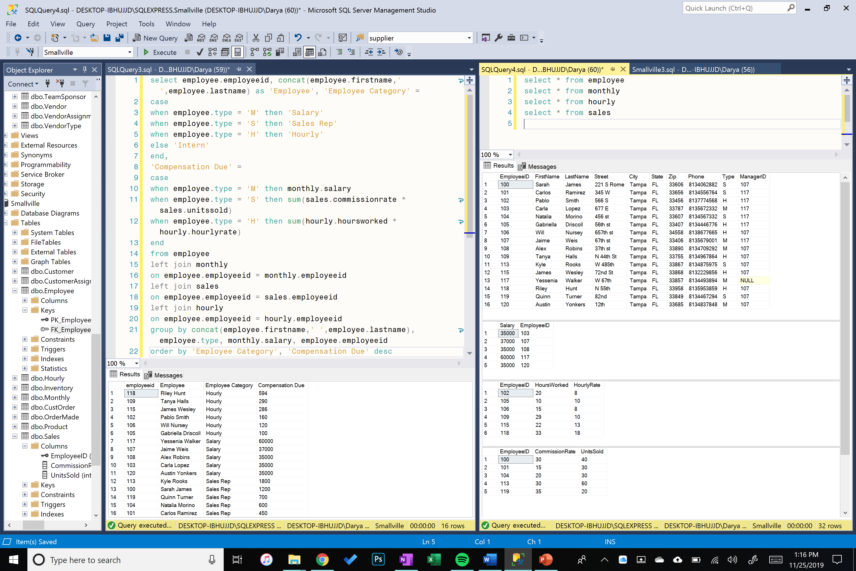

1. List of all customer orders, the customer’s full name (use concat operator), and sales rep credited with the order, grouped by sales rep and sorted by highest sales in number of units.

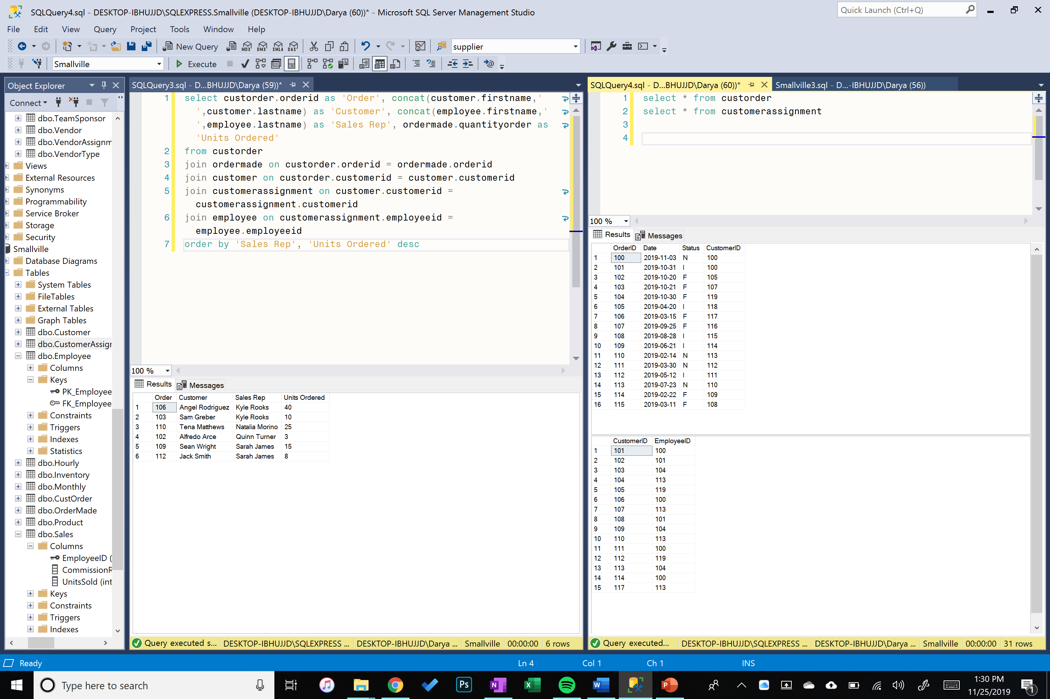

1. List of all Sales Reps with their total number of orders sold, total number of units sold, highest, lowest, and average dollar value generated, grouped by Sales Rep, sorted by highest to lowest orders, units, and sales dollar value.

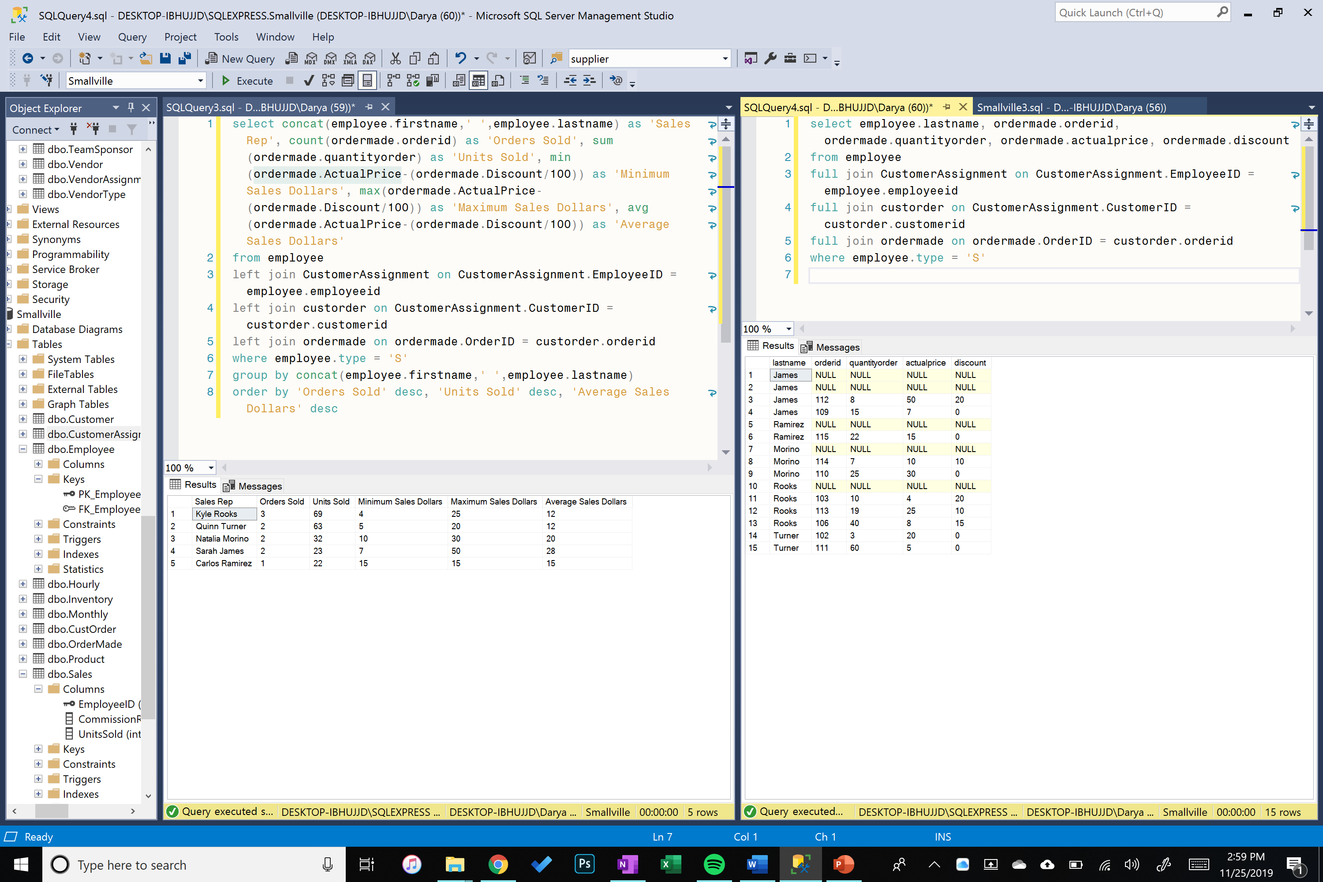

1. Result set reporting most and least popular product sold, with their total units and dollar value generated.

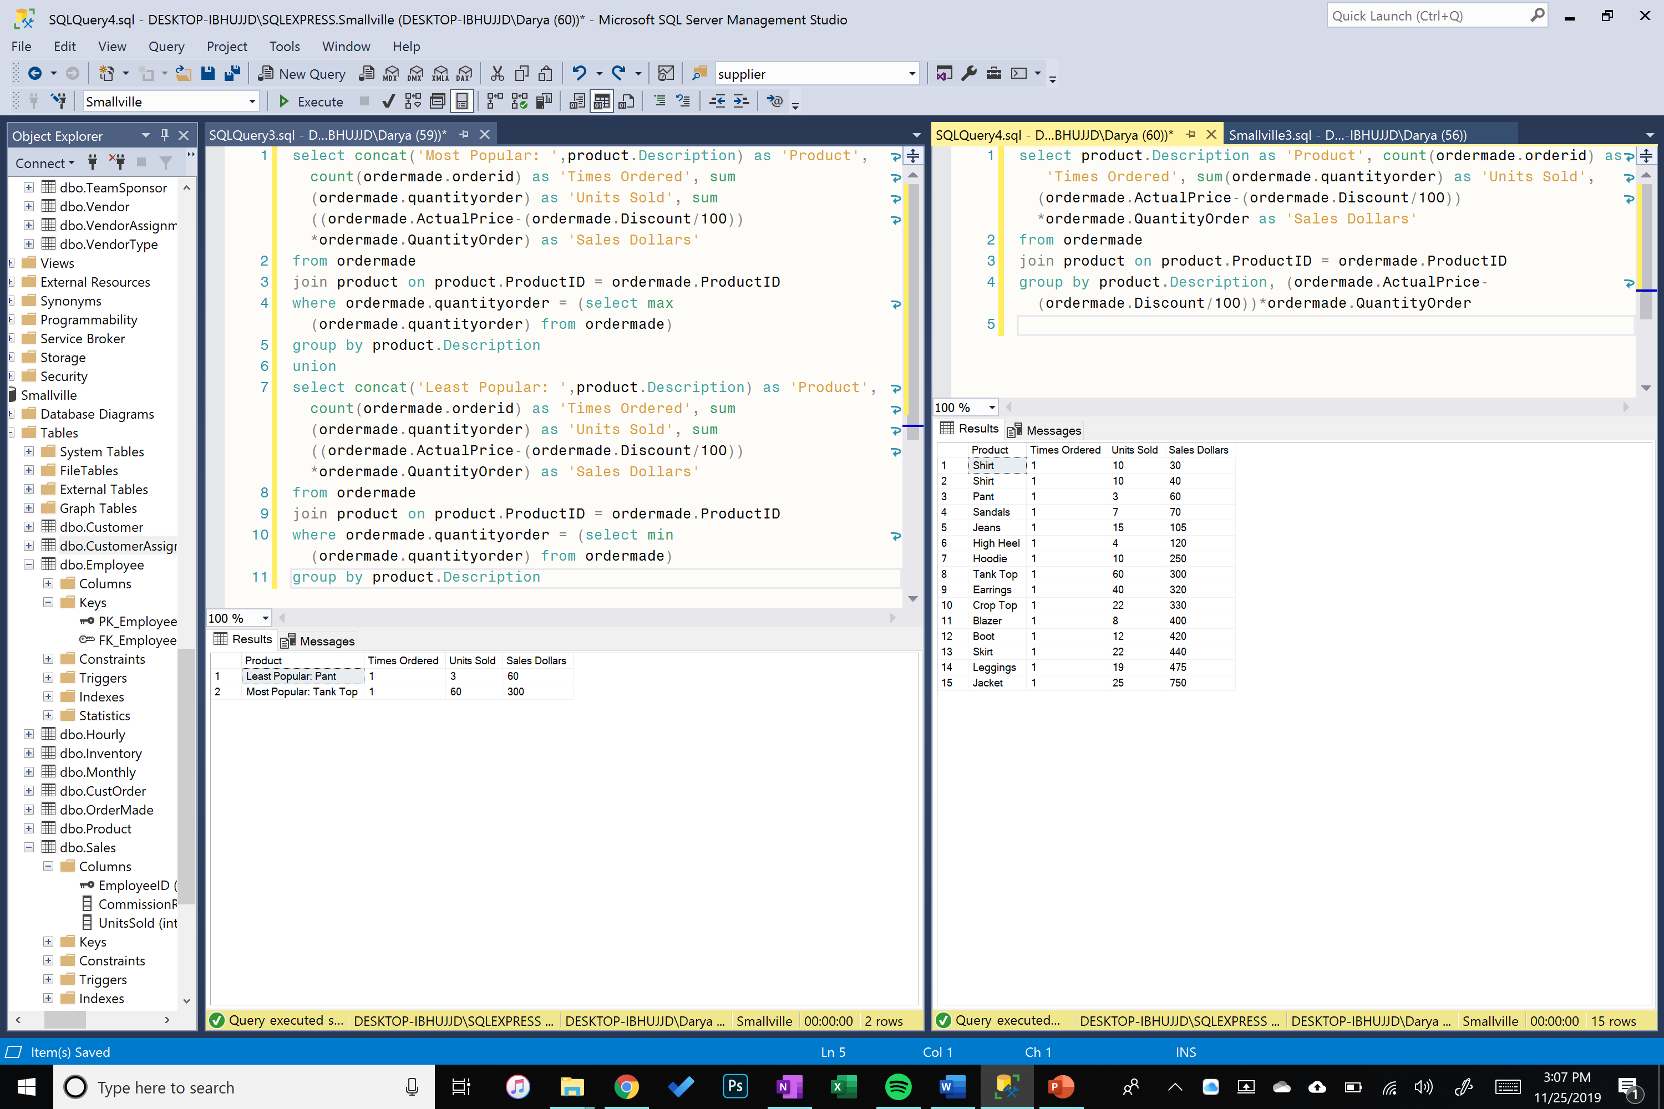

1. Result set listing all customers by last name, all the products they have ordered and total dollars spent; grouped by customer, sorted by highest dollar value.

