1. League needs a current season status listing all players, goals scored, minutes played, and penalties assessed for each, grouped by teams. Players must be listed by full name using concat operator. Teams must be listed by team name. List should be sorted by team, player, goals.

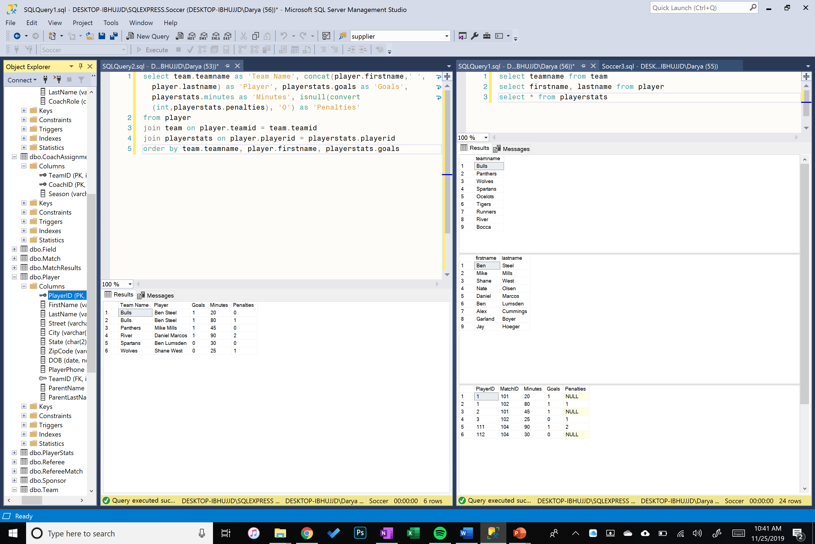

1. League needs a report listing all matches played so far this season. The list needs to include the teams playing in each match, the host field and goals scored by each team.

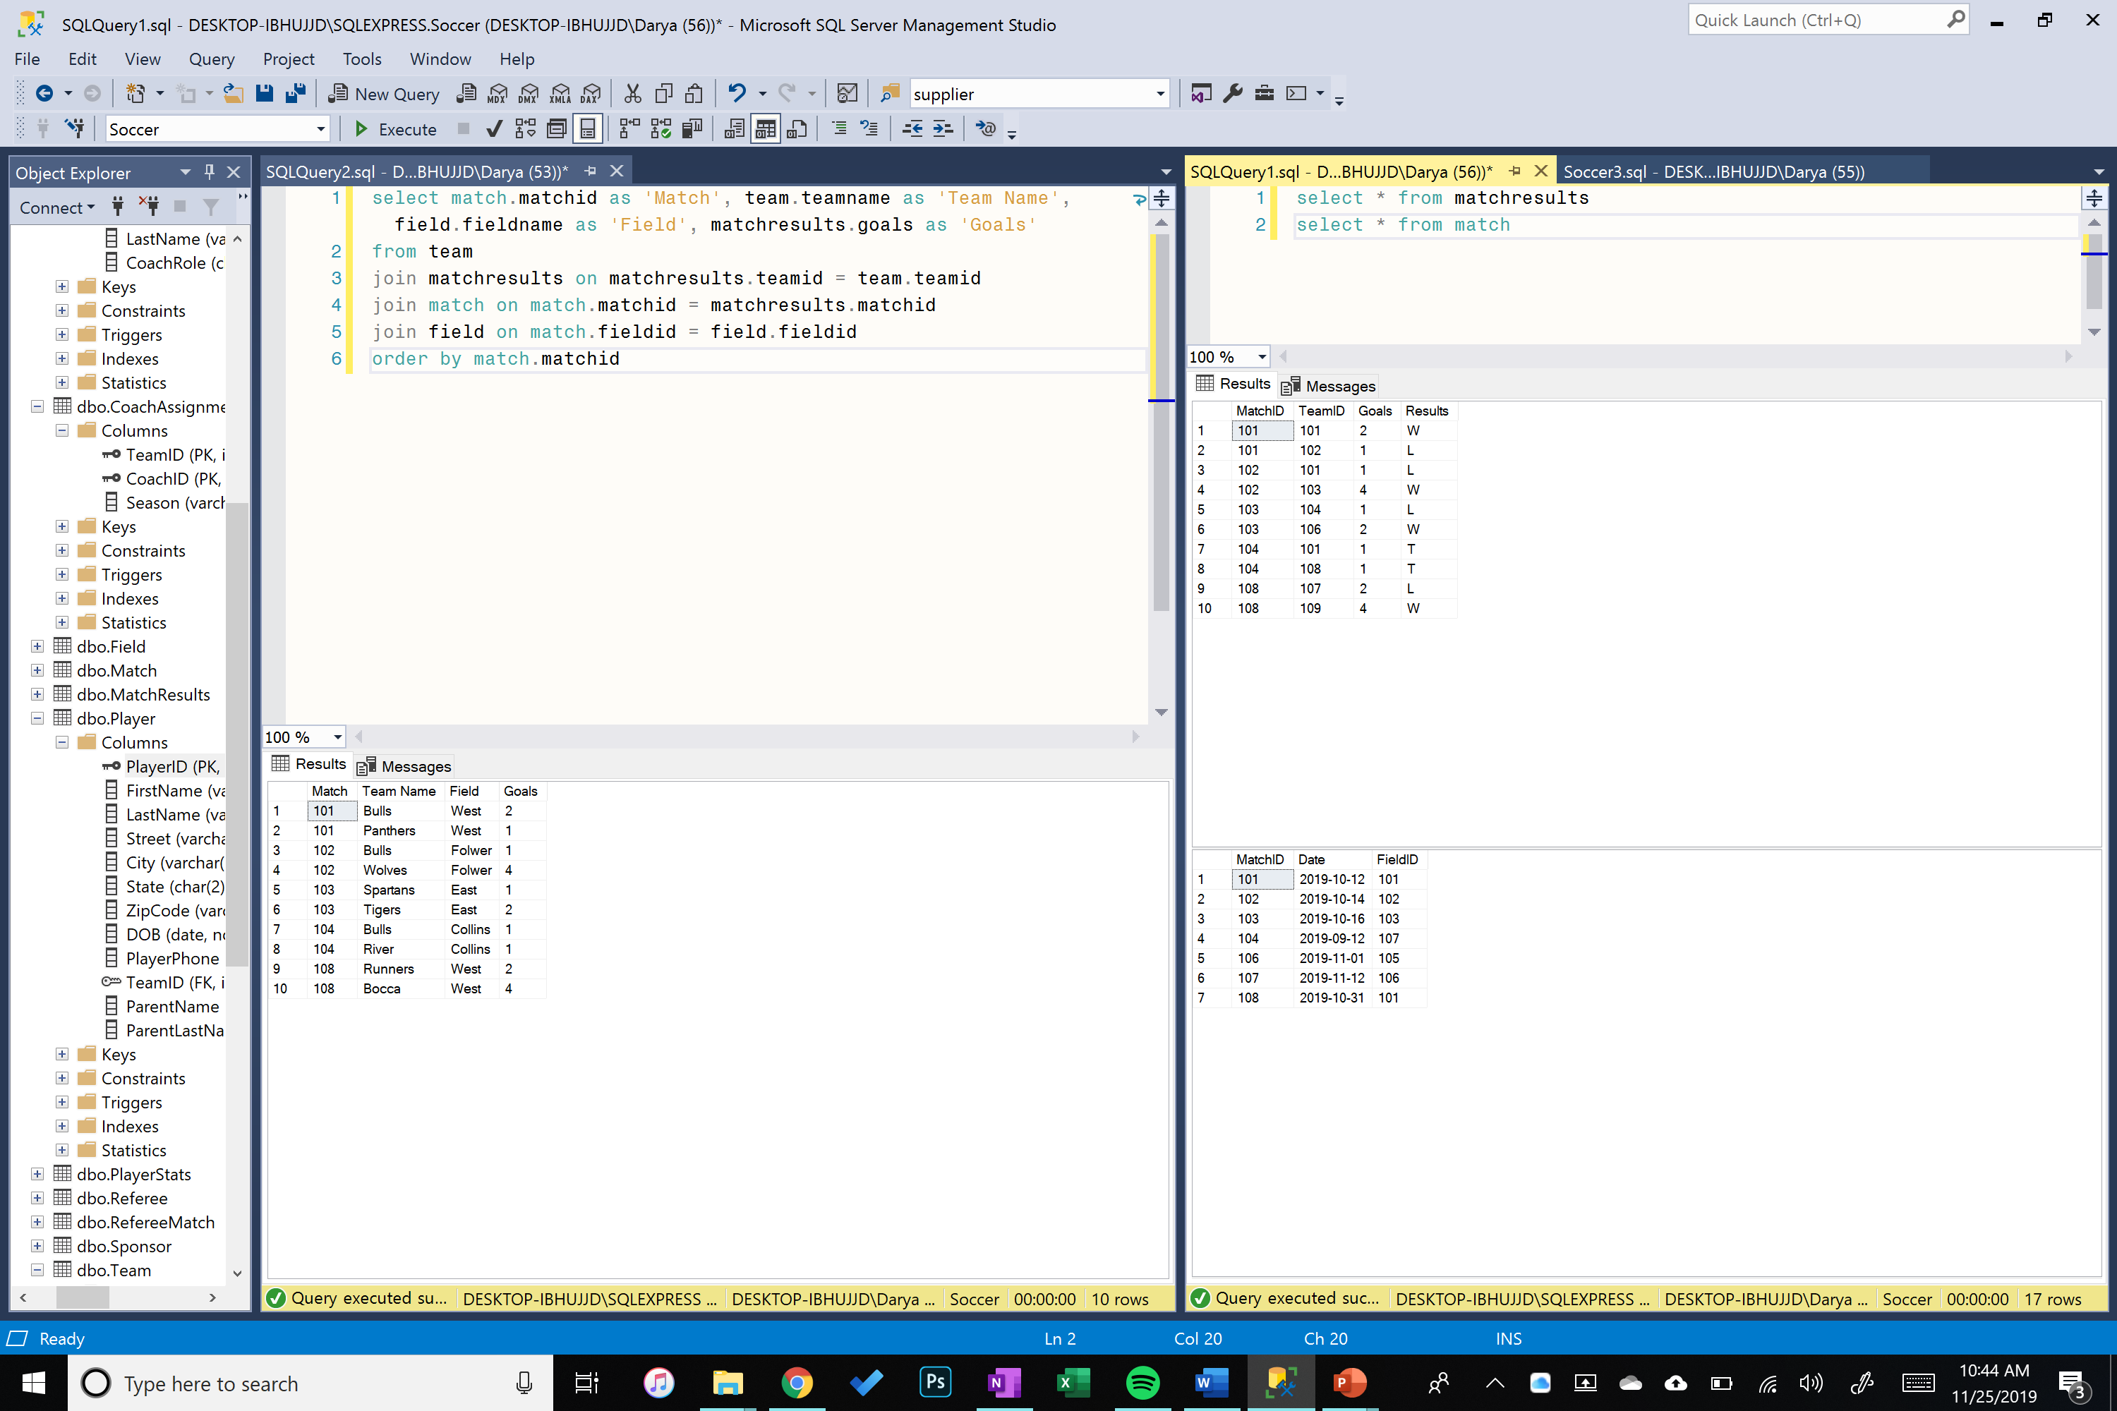

1. A separate list needs to be generated of the winning teams, the matches they won, the field they played on, and goal differential.

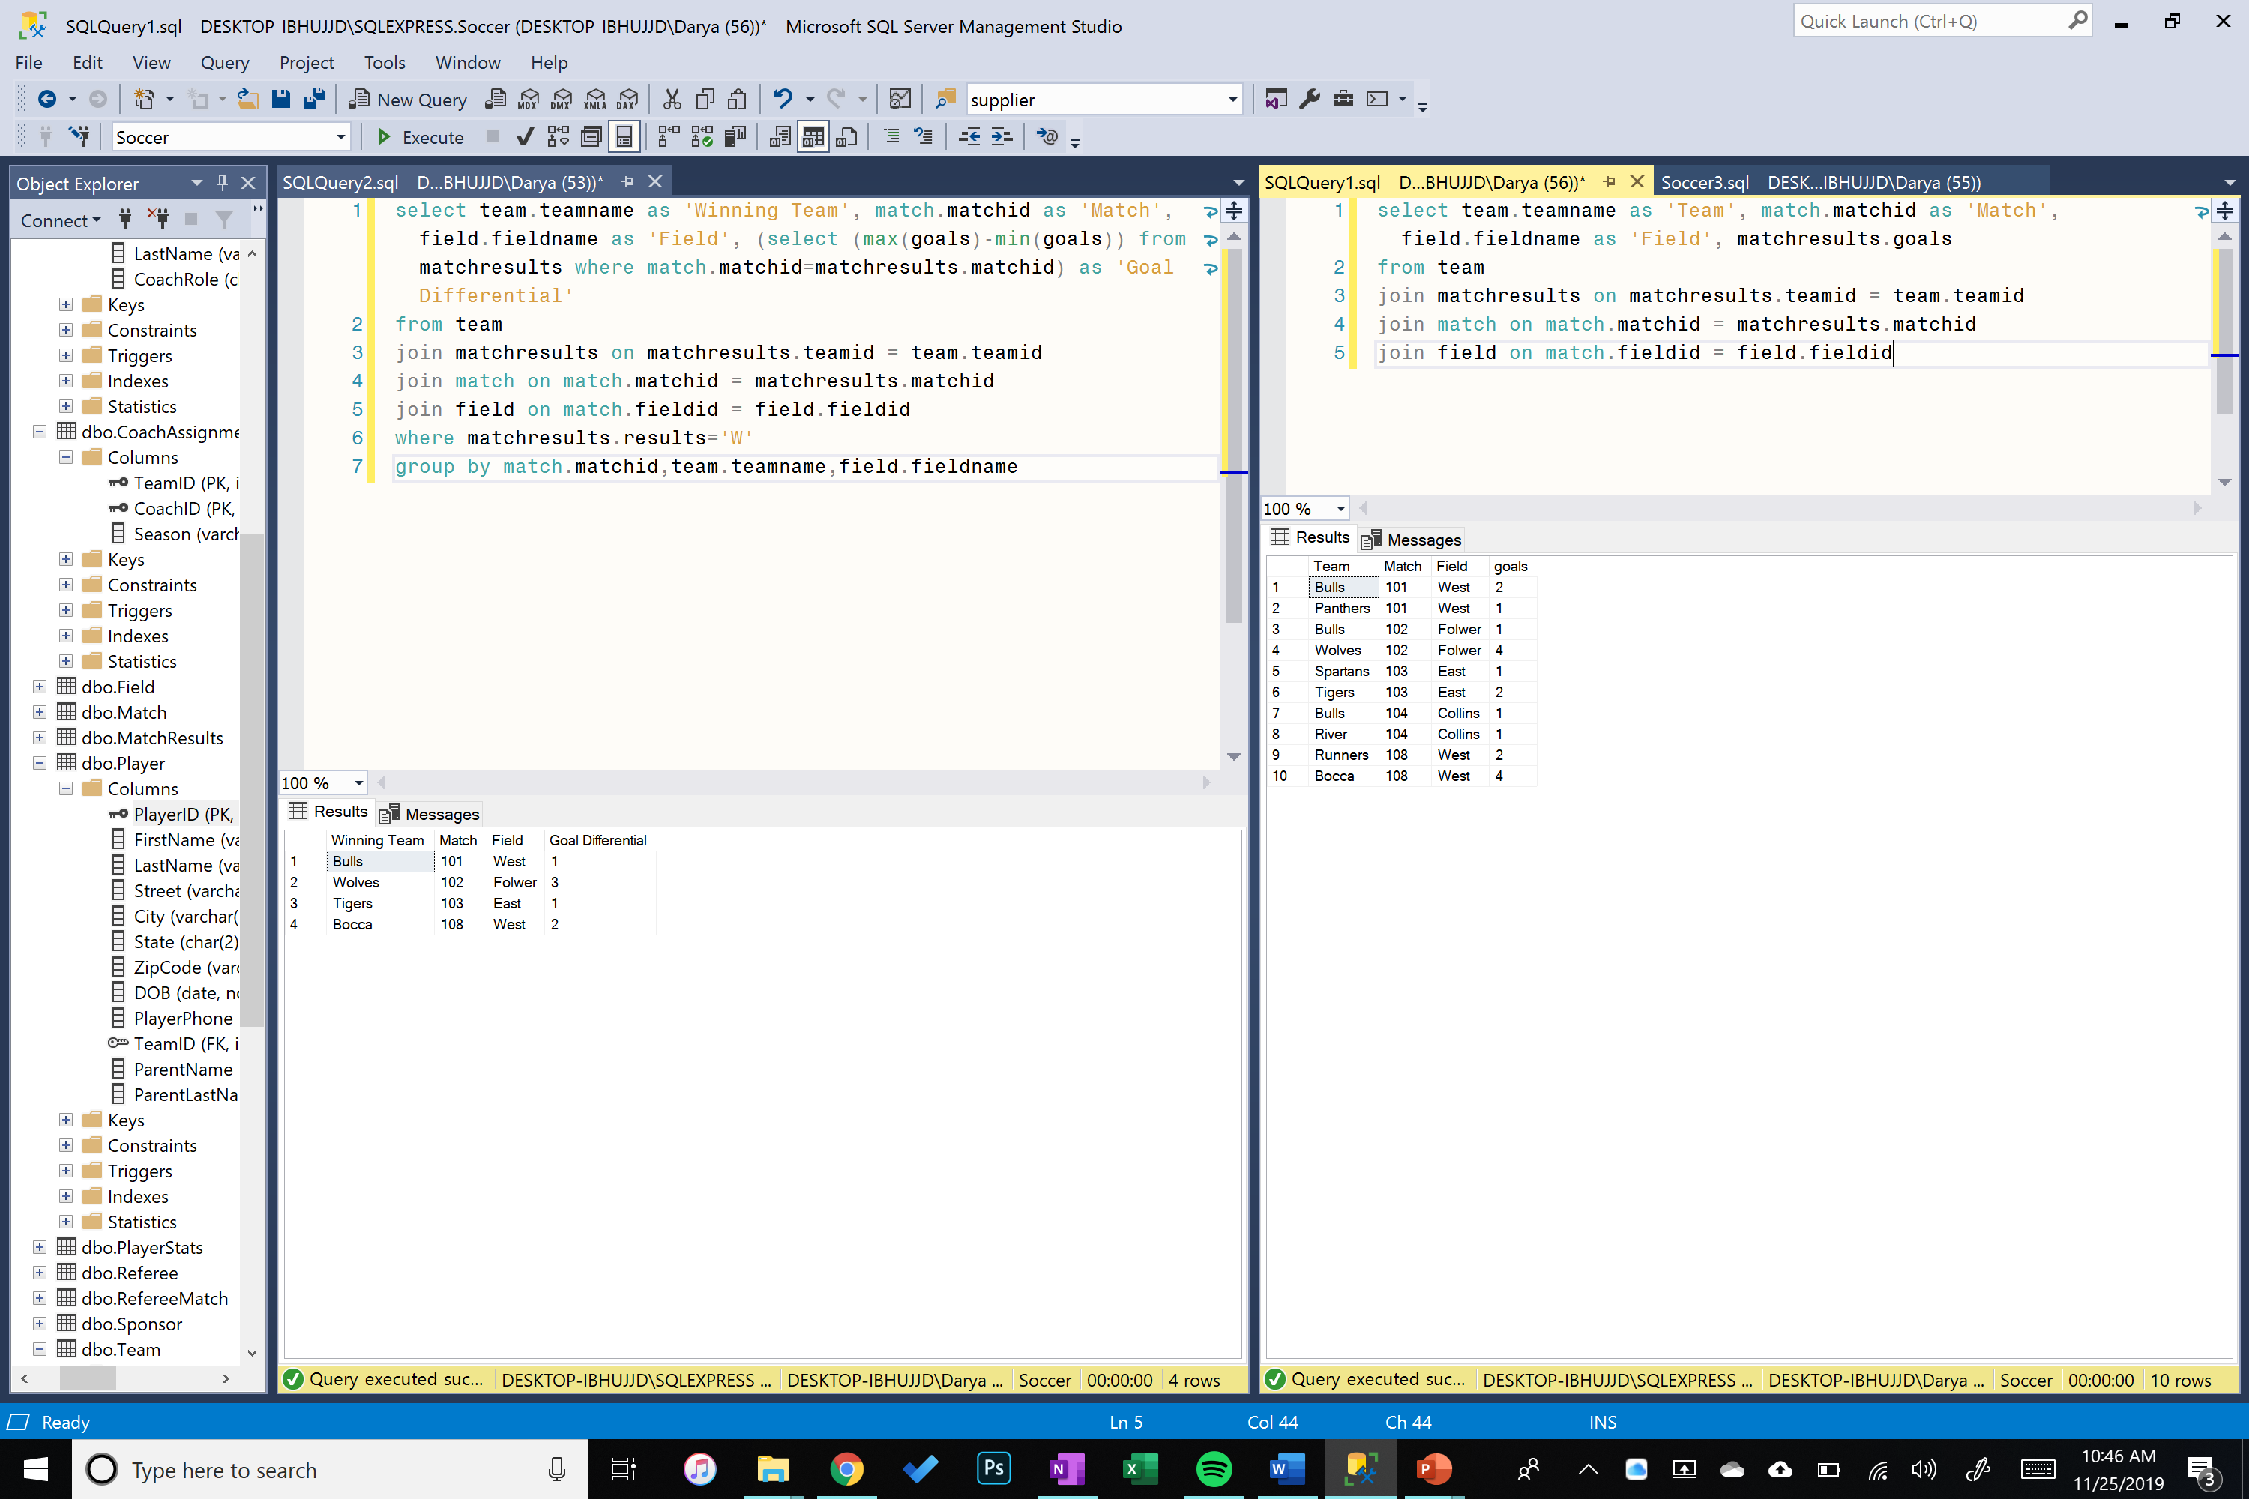

1. Protest report for a match needs to have teams participating, their respective head coaches, host field, referees assigned to the match, final score differential.

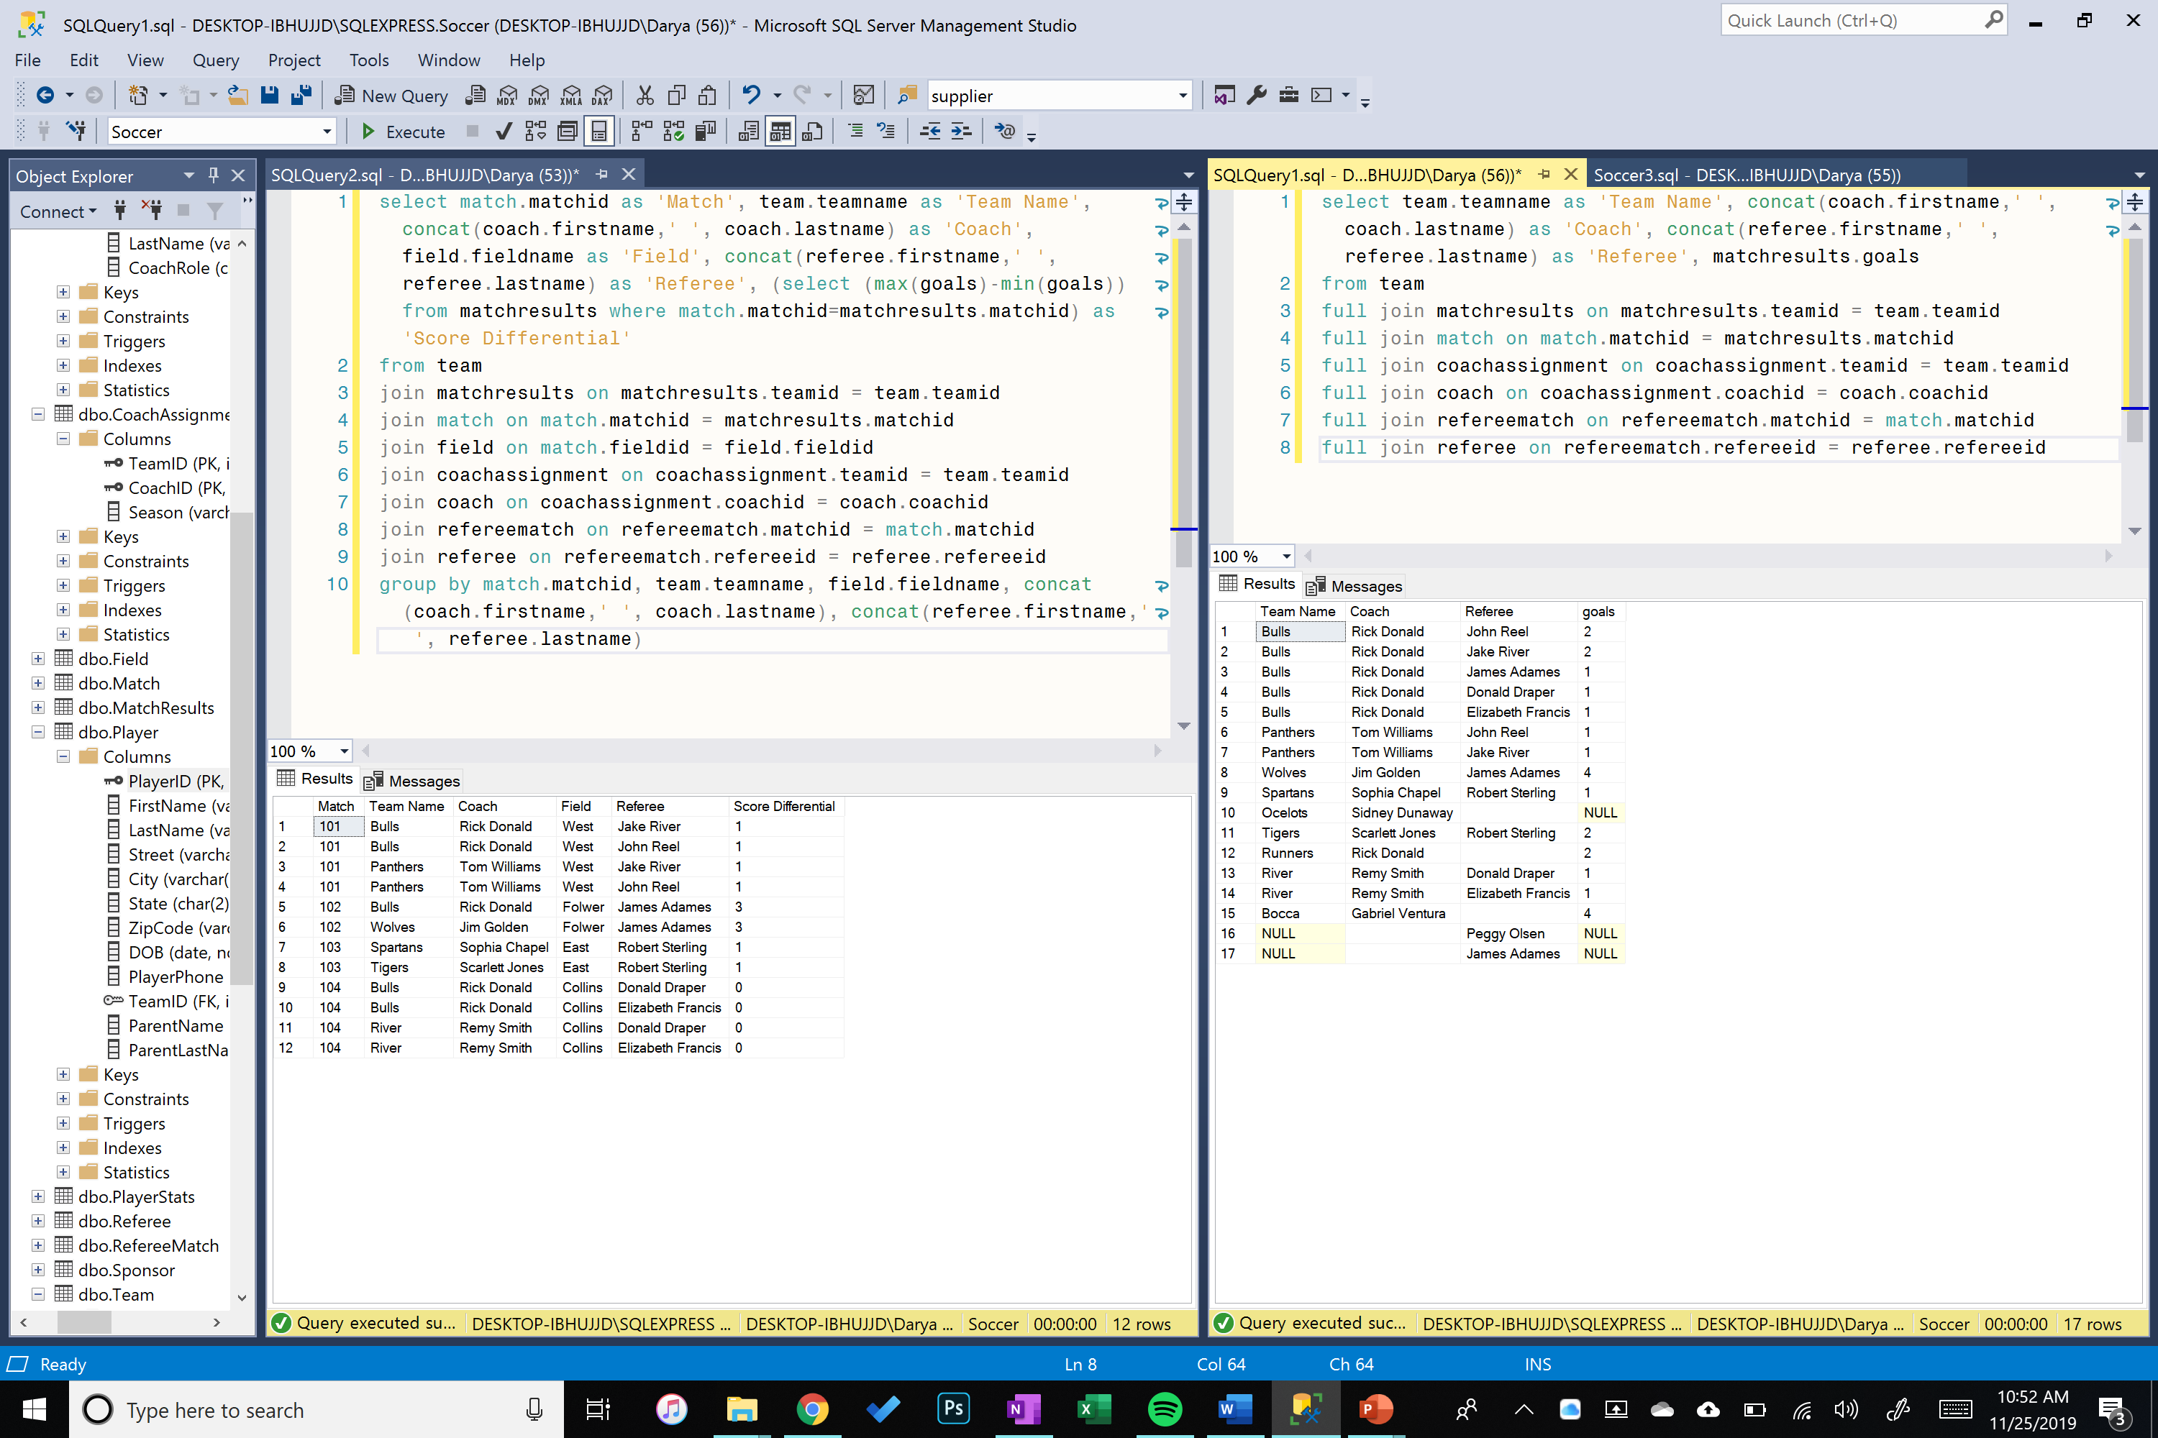

1. Create a team player roster SPROC with a parameter for team name.

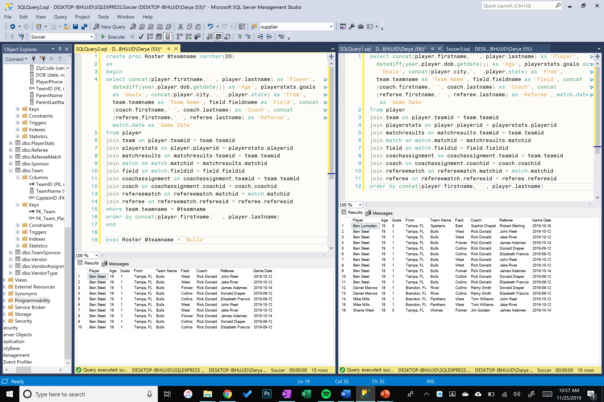

1. Create a view listing all teams by name, head coach full name, and contact number.

