Traduction EN (deepl)
Wash your hands thoroughly with warm water and soap Dry your hands thoroughly Do not use alcohol or cream Massage your finger Do not prick your thumb or index finger, or the pad of your finger Prick the side of your finger, not your index finger or thumb
Rotate around the finger 🖐 CAUTION: Change the lancet each time; use only once 6 checks per day - In the morning on an empty stomach
- 2 hours after starting breakfast - Before lunch - 2 hours after starting lunch - Before dinner - 2 hours after starting dinner Results No more than 0.95 g/L before meals No more than 120 2 hours after meals
Audio player QR:
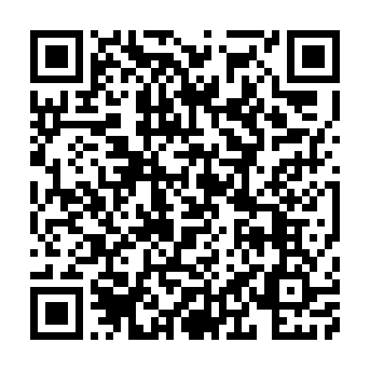
Audio player link: https://daryazdr.github.io/Gestion-de-projet-M1-IDL-UGA/player/surveillance_en_deepl.html

Images du document source
surveillance_docx_1.png
