Traduction EN (microsoft)
Wash your hands well with warm water and soap
Dry your hands thoroughly
Do not use alcohol or cream

Massage your finger
Do not prick the thumb and index finger, or on the pad of the finger
We prick on the side, not the index finger or the thumb
We turn around the finger 🖐
WARNING: Change the lancet each time, only 1 use

6 checks per day
- In the morning on an empty stomach
- 2 hours after the start of breakfast
- Before lunch
- 2 hours after the start of the meal
- Before the evening meal
- 2 hours after the start of the evening meal
Results
No more than 0.95 g/L before meals
No more than 120 hours after meals
Audio player QR:
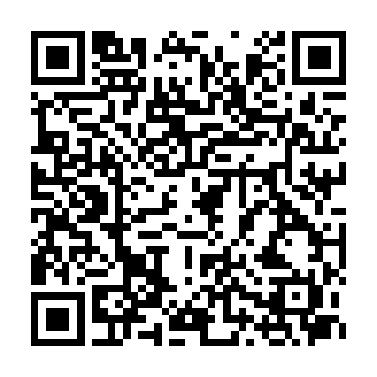
Audio player link: https://daryazdr.github.io/Gestion-de-projet-M1-IDL-UGA/player/surveillance_en_microsoft.html

Images du document source
surveillance_docx_1.png
