COMPSCI 345

Assignment 2 Registration Form for a Book Club Website

Develop a hi-fi prototype design as a mock-up web design using skills in high fidelity design, web technology, HTML, CSS, and JavaScript

Implement design principles and consider web accessibility

Report by:

Daryle Ji

dji058/990645618

31/05/2021

Table of Contents

Introduction 3

Overall Site Design 3

Functionality 3

Colour 3

Design Principles - Unity 3

Home Page 4

Heuristics 4

Gestalt Principles 4

Design Principles 4

Book Club Rego 5

Heuristics 5

Gestalt Principles 5

Design Principles 5

Appendix 6

Appendix 1 - References 6

Appendix 1.1 – Coding References 6

Appendix 2 - Pages 7

Home Page 7

Book Club Rego 8

Appendix 3 - Figures 9

Appendix 3.1 – Home Page 9

Appendix 3.2 – Registration Form 10

Word Count: 1093

# Introduction

The website “Book Program Discussion (BPD)” is owned and operated by a non-profit organisation. Their goal is to connect like-minded readers into a group, lend books and professional discussion notes to the participating book groups. Each week, members of the group selects books from an extensive book catalogue; they receive sufficient copies of the selected books allowing all members within their group to read the same books for discussion. The task is to redesign the website previously stated according to a given colour scheme (hash colour #3F888F); currently only has a registration page. Must be designed to have a Home page and a registration form.

# Overall Site Design

Refer to Appendix 2 for images of the website pages.

## Functionality

* Navigation bar elements are clickable and will update accordingly to display Visibility of System Status however will not change the page as is not required to be implemented.
* “Join Us!” button is clickable and will open a popup for the registration form.
* In the registration form
  + The cross on the upper right corner of the popup box is clickable to navigate out of the form, the same functionality applies to clicking outside of the popup box.
  + Clicking the “Register” button
    - When all compulsory fields are unfilled, will prompt the user to fill in the compulsory fields.
    - When all compulsory fields are filled, the page will end up on a crash page as no functionality is implemented from thereon as it is not required.

## Colour

The colour of the website follows the required colour scheme however does not overload the user with mass amounts of colour. Following an Aesthetic and Minimalistic design, the website mostly consists of monochromatic colours with accents added for emphasis. The given colour is used more often throughout texts, background colours and other elements on screen to show it is a dominant colour and the website is themed around it while keeping the site easy to look at.

## Design Principles - Unity

The website overall follows the Unity principle by consistently using rectangular shapes throughout. Although their shapes all vary, they all share a form of commonality forming unity.

# Home Page

## Heuristics

The designed Home page contains a navigation bar at the top of the screen. Below the bar is a title alongside a description of the goal and history of the non-profit organisation. Separated from this with a different background colour are two boxes detailing how to get involved and popular books from the current week (*refer to Figure 1 in Appendix 3.1*).

Following the “Visibility of System Status” Heuristic, the navigation bar displays the current page the user is accessing by highlighting and underlining the text with the required theme colour. When scrolling further down the page, the navigation bar is always visible solidifying the heuristic. Furthermore, when users hover their cursor on top; the text is highlighted yet again and the cursor changes to a pointer. This continues to implement the same heuristic alongside “Consistency and Standards” as it is common for the mouse cursor to change to a pointer when hovering a clickable object.

When the window size becomes too small to fit everything while maintaining an aesthetic distance between objects, or the user is accessing the website from a mobile device, the navigation changes to have a clickable dropdown menu on the top right (*refer to Figure 2 in Appendix 3.1*). The design follows conventional designs for dropdown menus and is easily recognisable by the user.

After clicking on the dropdown, a vertical navigation for the pages appears on the right side of the screen (*refer to Figure 3 in Appendix 3.1*). The elements are consistent with the Heuristics evaluated in the original full-size navigation bar.

## Gestalt Principles

The title text on the page is grouped together with the description below (*refer to Figure 4 in Appendix 3.1*). This follows the proximity principle to show they are a logical grouping and talk about the same information. Underneath the text is a background image; with these combined they span a large area of the screen. As stated in the Area principle, this makes the element to be a figure and not the ground.

## Design Principles

All elements follow a margin from the edge of the screen. This creates an invisible boundary box and forms symmetry through the site. Alongside this, asymmetry is used in the “Get Involved” and “Popular Books This Week” elements using the rule of thirds; one box is given one third and the other is given two thirds of the screen real estate within the margin (*refer to Figure 5 in Appendix 3.1*). These design choices create balance within the screen.

The title text is given emphasis using the techniques of placement and isolation. The title is centre aligned which matches users’ natural vision position and is slightly isolated from the text for emphasis. Another element on-screen is the “Join Us!” button which uses contrast for emphasis by using a red colour. However, the colour chosen maintains a darker hue which is consistent with the other colours on screen.

# Book Club Rego

## Heuristics

The registration form starts with a title, short text, then followed by the input boxes alongside their tags. Located at the bottom is a register button to finalise the details the user has inputted.

The password input field follows “Consistency and Standards” as the user’s input is concealed and not visible protecting their private data. To help users correctly complete the registration form, there is feedback when not all fields are entered prompting the user which follows “Help Users to Recognise, Diagnose, and Recover from Errors”.

“User Control and Freedom” is implemented by allowing the user to easily navigate out of the popup box by clicking outside of the box or by clicking the cross located at the top right.

## Gestalt Principles

Using the proximity principles, related elements are grouped together with a vertical proximity; the first name and surname boxes are a group, and the username and password boxes are a group (*refer to Figure 6 in Appendix 3.2*). Common fate principles are also used with the alignment of the input boxes to lead the user to the end of the form for submission.

## Design Principles

Symmetry is by centring the elements and aligning the edges of all elements with a margin. Input boxes next to each other also maintain similar sizing while revolving around the centre line.

The title text, like on the home page, is also designed with placement and isolation principles to add emphasis. It is centre aligned and slightly isolated from the text below it.

The “Register” button located at the bottom of the page is centre aligned and contrasted with the rest of the screen for emphasis. This makes the button very noticeable and attracts the user’s attention towards it.

# Appendix

## Appendix 1 - References

### Appendix 1.1 – Coding References

Navigation Bar Design

<https://www.youtube.com/watch?v=gXkqy0b4M5g>

Modal Code

<https://www.w3schools.com/howto/howto_css_modals.asp>

Two Column Layout

<https://www.w3schools.com/howto/howto_css_two_columns.asp>

Images for site

<https://images2.penguinrandomhouse.com/cover/9780679722762>

<https://images4.penguinrandomhouse.com/cover/9781400033423>

<https://images4.penguinrandomhouse.com/cover/9781400079988>

<https://images-na.ssl-images-amazon.com/images/I/41MT0PCoKZL._SX301_BO1,204,203,200_.jpg>

Registration Form

<https://www.w3schools.com/howto/howto_css_register_form.asp>

## Appendix 2 - Pages

### Home Page

**Full Size Home Page**

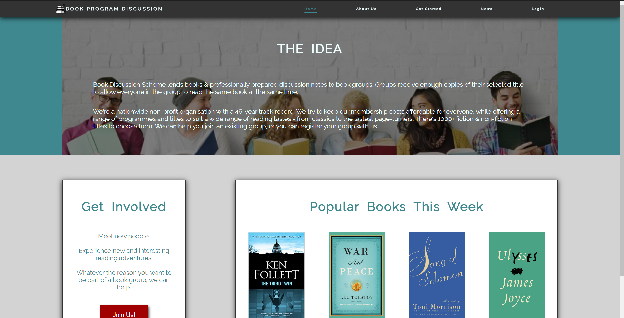

**Medium Size Home Page**



**Small Size Home Page**

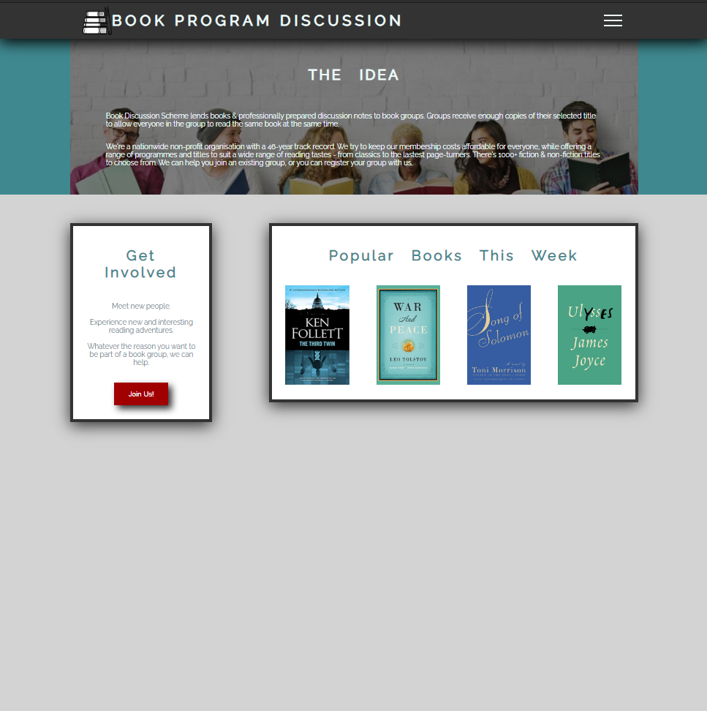

### Book Club Rego

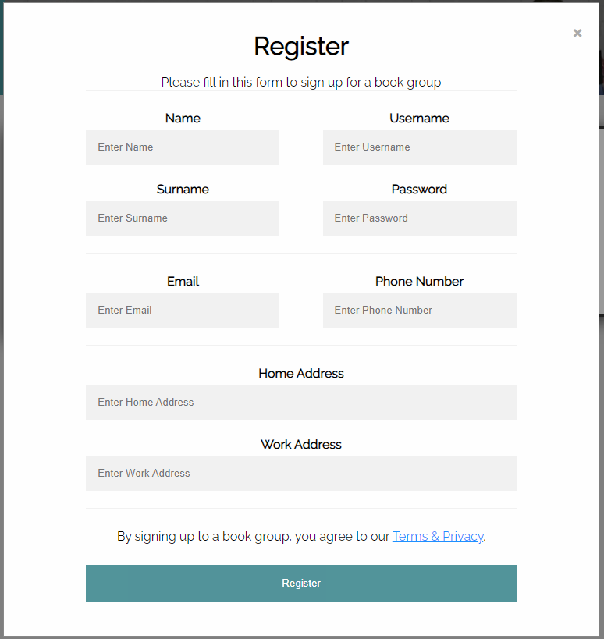

## Appendix 3 - Figures

### Appendix 3.1 – Home Page

Figure 1 – Full Navigation Bar



Figure 2 – Small Navigation Bar



Figure 3 – Expanded Small Navigation Bar

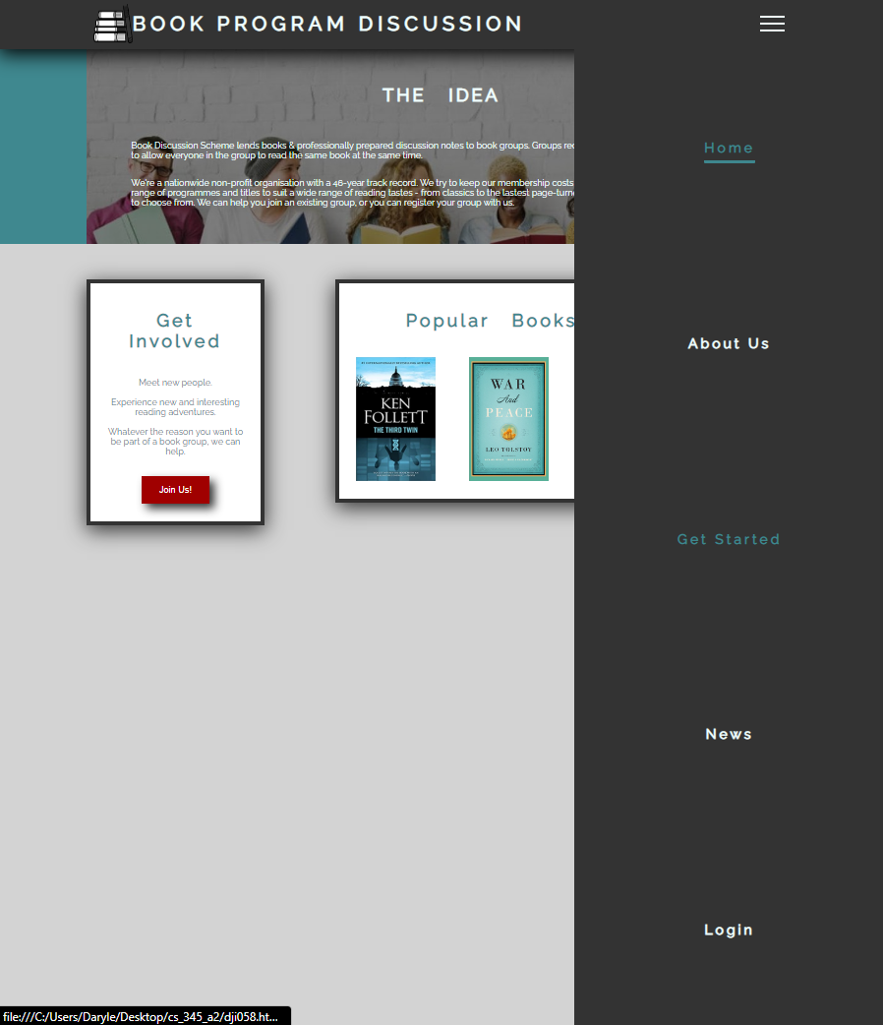

Figure 4 – Title text, description, and image



Figure 5 – Box Elements

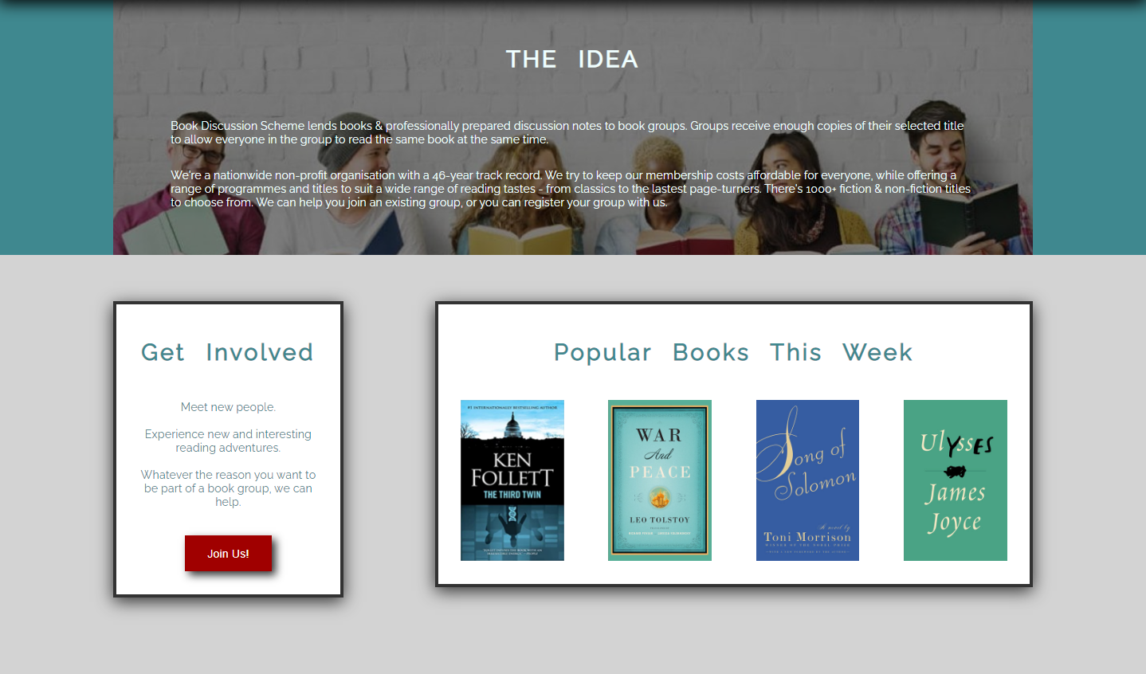

### Appendix 3.2 – Registration Form

Figure 6 – Registration Vertical Proximity

